COMPUTER NETWORKS
LAB ASSIGNMENT 01
IPv6 Subnetting & Basic Switch Configuration
―――――――――――――――――――――――――――――――――――
Submitted By (Group Members):
Saad Bin Riaz (BAI-25F-035)
Umair Hayat (BAI-25F-033)
Ayesha Zahid (BAI-25F-026)
Laiba Ameer (BAI-25F-001)

Department of Computer Science & Information Technology
October 2026

1. IPv6 Subnetting & Mathematical Calculations
This section details the step-by-step mathematical derivation for subnetting the assigned IPv6 network block. The primary goal is to allocate smaller, equal-sized subnets (pools) with a specific host capacity per pool from the original prefix.
1.1 Network Requirements & Given Data
- Original IPv6 Network Prefix: 2001:DB8:1234:5678::/120
- Original Prefix Length: 120 bits
- Required Host Addresses per Pool: 16 addresses per subnet pool
1.2 Step-by-Step Subnetting Derivation
Step 1: Calculate Required Host Bits (n)
To determine the number of host bits (n) required to accommodate 16 IP addresses in each pool, we use the standard exponential formula:
2^n = Required Host Addresses
2^n = 16
2^4 = 16 ==> n = 4 host bits

Thus, exactly 4 host bits are reserved for host addressing within each pool.
Step 2: Calculate New Subnet Prefix Length
An IPv6 address consists of 128 total bits. Subtracting the host bits (n = 4) from 128 gives the new prefix length:
New Prefix Length = Total IPv6 Bits - Host Bits
New Prefix Length = 128 - 4 = /124
Old Prefix = /120 --> New Subnet Prefix = /124

Step 3: Calculate Subnet Bits & Total Available Pools
The number of bits borrowed for subnetting is calculated by finding the difference between the new prefix length and the old prefix length:
Subnet Bits = New Prefix Length - Old Prefix Length
Subnet Bits = 124 - 120 = 4 bits

Total Subnet Pools = 2^(Subnet Bits) = 2^4 = 16 Subnet Pools

The network is divided into 16 distinct subnet pools.
Step 4: Determine Block Size & Hexadecimal Jump
The block size represents the number of total IP addresses contained in each subnet pool:
Block Size (Decimal) = 2^(128 - 124) = 2^4 = 16 Addresses per Pool
16 (Decimal) = 10 (Hexadecimal) [Since 16_10 = 10_16]

Because IPv6 addresses are written in hexadecimal format, the subnet boundary increments (jumps) by 0x10 in the lowest hex digit of the prefix:
Hexadecimal Jump Sequence:
00 -> 10 -> 20 -> 30 -> 40 -> 50 -> 60 -> 70 -> 80 -> 90 -> A0 -> B0 -> C0 -> D0 -> E0 -> F0

1.3 Complete IPv6 Subnet Pools Table
The table below presents all 16 generated IPv6 pools along with their subnet prefix and usable address ranges:
Pool # | Subnet Prefix (/124) | Usable Address Range
Pool 1 | 2001:DB8:1234:5678::00/124 | 2001:DB8:1234:5678::00 - ::0F
Pool 2 | 2001:DB8:1234:5678::10/124 | 2001:DB8:1234:5678::10 - ::1F
Pool 3 | 2001:DB8:1234:5678::20/124 | 2001:DB8:1234:5678::20 - ::2F
Pool 4 | 2001:DB8:1234:5678::30/124 | 2001:DB8:1234:5678::30 - ::3F
Pool 5 | 2001:DB8:1234:5678::40/124 | 2001:DB8:1234:5678::40 - ::4F
Pool 6 | 2001:DB8:1234:5678::50/124 | 2001:DB8:1234:5678::50 - ::5F
Pool 7 | 2001:DB8:1234:5678::60/124 | 2001:DB8:1234:5678::60 - ::6F
Pool 8 | 2001:DB8:1234:5678::70/124 | 2001:DB8:1234:5678::70 - ::7F
Pool 9 | 2001:DB8:1234:5678::80/124 | 2001:DB8:1234:5678::80 - ::8F
Pool 10 | 2001:DB8:1234:5678::90/124 | 2001:DB8:1234:5678::90 - ::9F
Pool 11 | 2001:DB8:1234:5678::A0/124 | 2001:DB8:1234:5678::A0 - ::AF
Pool 12 | 2001:DB8:1234:5678::B0/124 | 2001:DB8:1234:5678::B0 - ::BF
Pool 13 | 2001:DB8:1234:5678::C0/124 | 2001:DB8:1234:5678::C0 - ::CF
Pool 14 | 2001:DB8:1234:5678::D0/124 | 2001:DB8:1234:5678::D0 - ::DF
Pool 15 | 2001:DB8:1234:5678::E0/124 | 2001:DB8:1234:5678::E0 - ::EF
Pool 16 | 2001:DB8:1234:5678::F0/124 | 2001:DB8:1234:5678::F0 - ::FF

1.4 Verification with Solution Worksheets
The handwritten calculation worksheets recorded during the assignment preparation are shown below for complete documentation and verification:
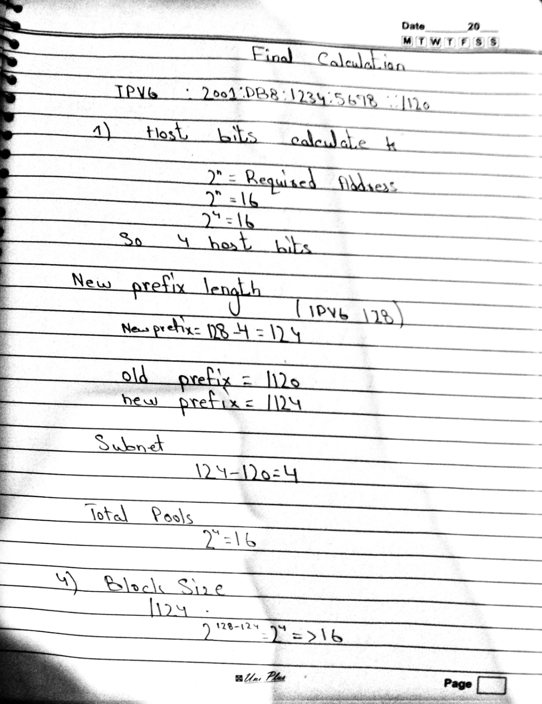
Figure 1.1: Handwritten Subnetting Derivation (Host bits, new prefix length, and total pools calculation)
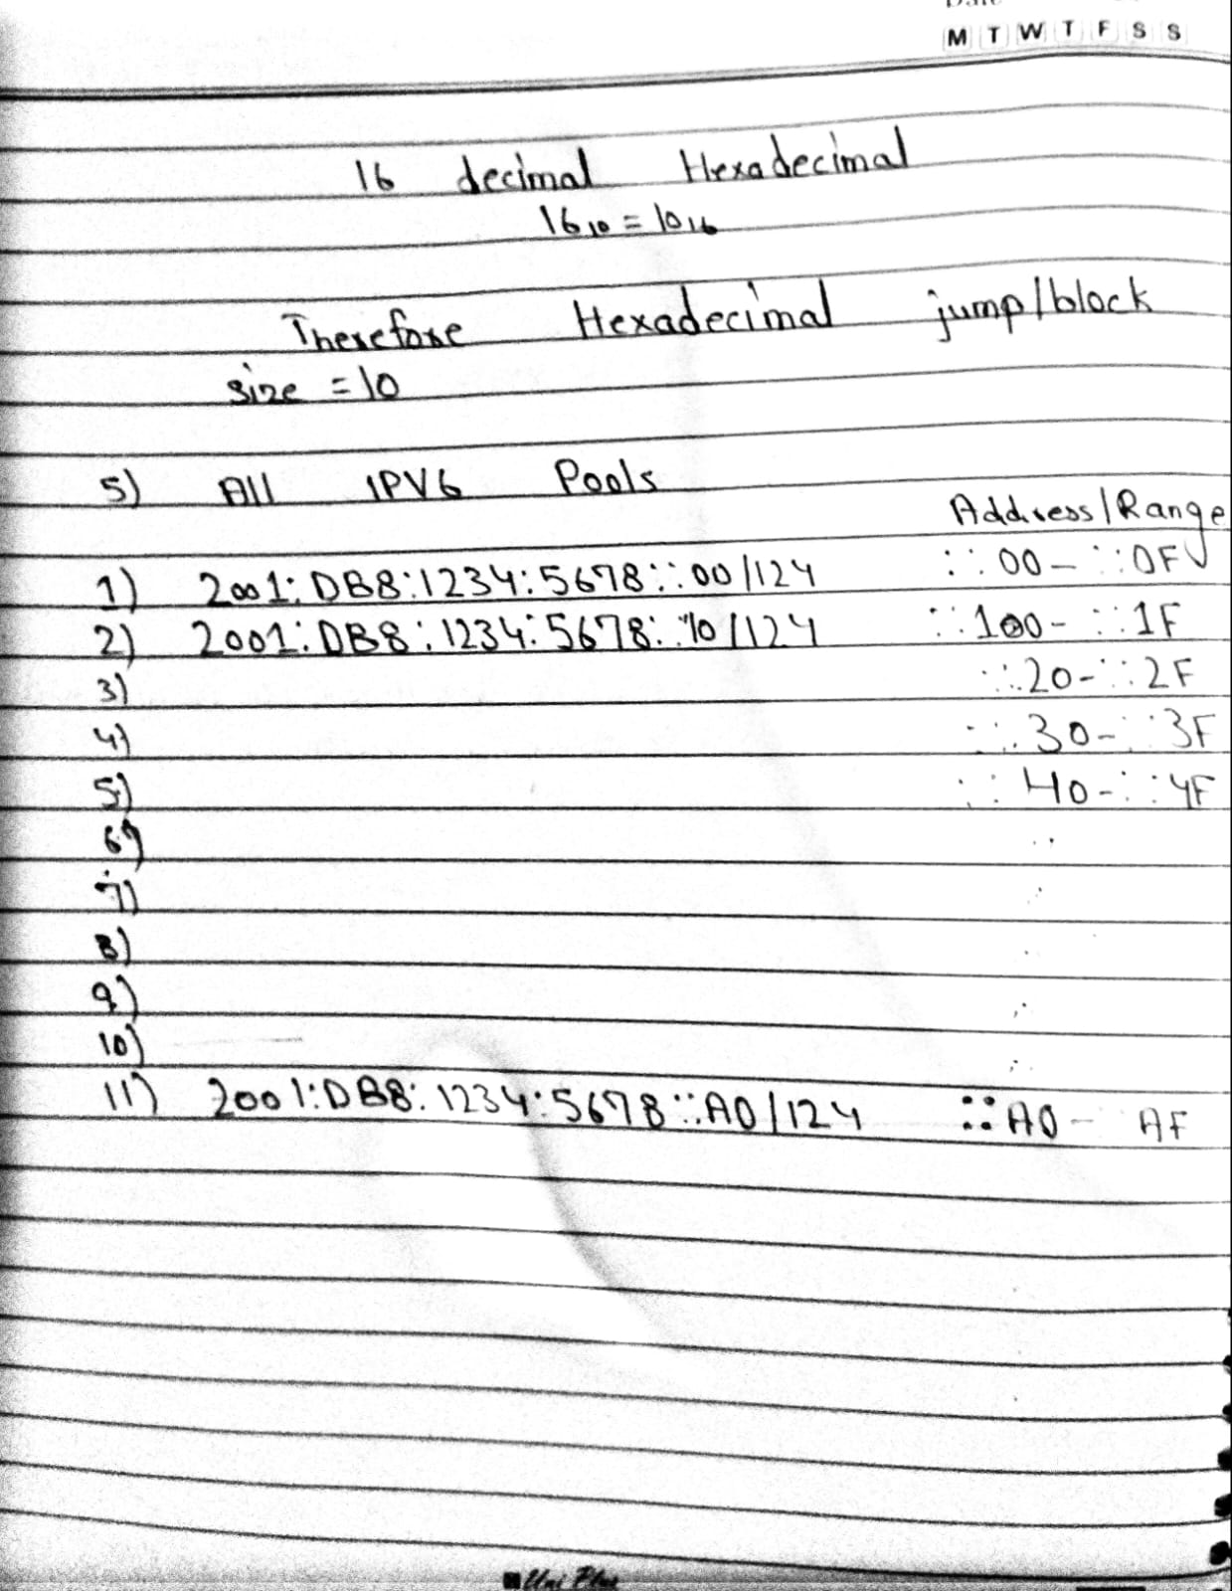
Figure 1.2: Handwritten Pool List & Decimal to Hexadecimal Conversion (16_10 = 10_16)
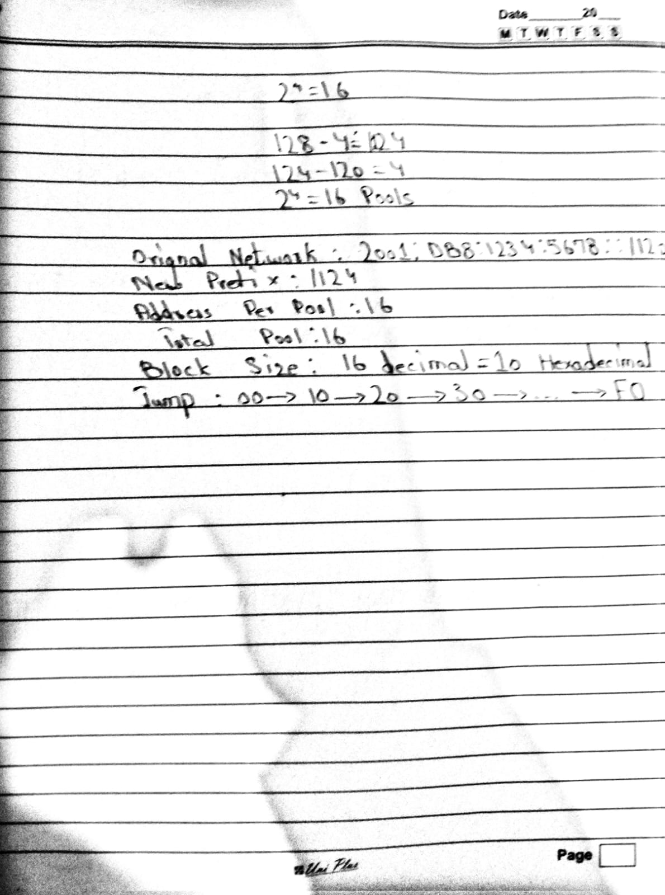
Figure 1.3: Handwritten Summary Sheet (Original network, new prefix, block size, and hexadecimal jump pattern)
2. Cisco Packet Tracer Network Topology & IP Configuration
The calculated IPv6 subnets were deployed in Cisco Packet Tracer to construct a functional multi-switch network infrastructure. Pool 2 (2001:DB8:1234:5678::10/124) was selected for host IP assignment across the network.
2.1 Topology Overview
- Switch Devices: Two Cisco Catalyst 2960 24-Port FastEthernet Switches (Switch0 and Switch1).
- End User Devices: 10 Personal Computers (PC0 to PC9).
- Switch0 Cluster: PC0, PC1, PC2, PC3, PC4 connected via copper straight-through cables.
- Switch1 Cluster: PC5, PC6, PC7, PC8, PC9 connected via copper straight-through cables.
- Inter-Switch Trunk Link: Direct Ethernet crossover cable linking Switch0 and Switch1 to enable inter-switch communication.
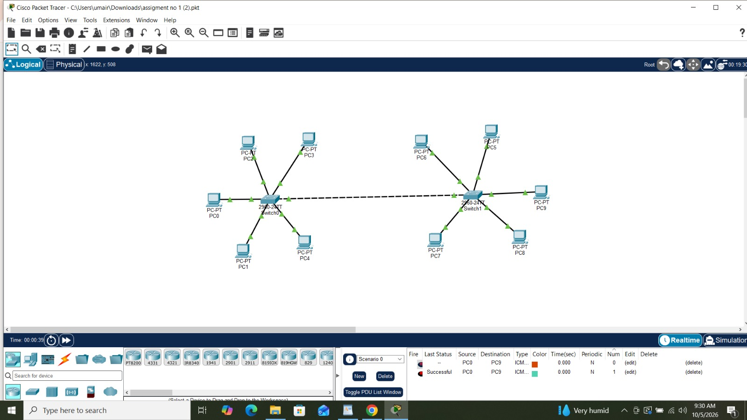
Figure 2.1: Cisco Packet Tracer Network Topology showing Switch0, Switch1, connected PCs, and real-time ICMP PDU status
2.2 PC IPv6 Addressing Table
All PCs are statically configured using addresses from Subnet Pool 2 (2001:DB8:1234:5678::10/124):
Device | Connected Switch | IPv6 Address | Subnet Mask / Prefix
PC0 | Switch0 | 2001:DB8:1234:5678::10 | /124
PC1 | Switch0 | 2001:DB8:1234:5678::11 | /124
PC2 | Switch0 | 2001:DB8:1234:5678::12 | /124
PC3 | Switch0 | 2001:DB8:1234:5678::13 | /124
PC4 | Switch0 | 2001:DB8:1234:5678::14 | /124
PC5 | Switch1 | 2001:DB8:1234:5678::15 | /124
PC6 | Switch1 | 2001:DB8:1234:5678::16 | /124
PC7 | Switch1 | 2001:DB8:1234:5678::17 | /124
PC8 | Switch1 | 2001:DB8:1234:5678::18 | /124
PC9 | Switch1 | 2001:DB8:1234:5678::19 | /124

2.3 Host IP Configuration Proof
Screenshots from Cisco Packet Tracer showing the exact IP configuration interface for PC0 and PC9 are embedded below:
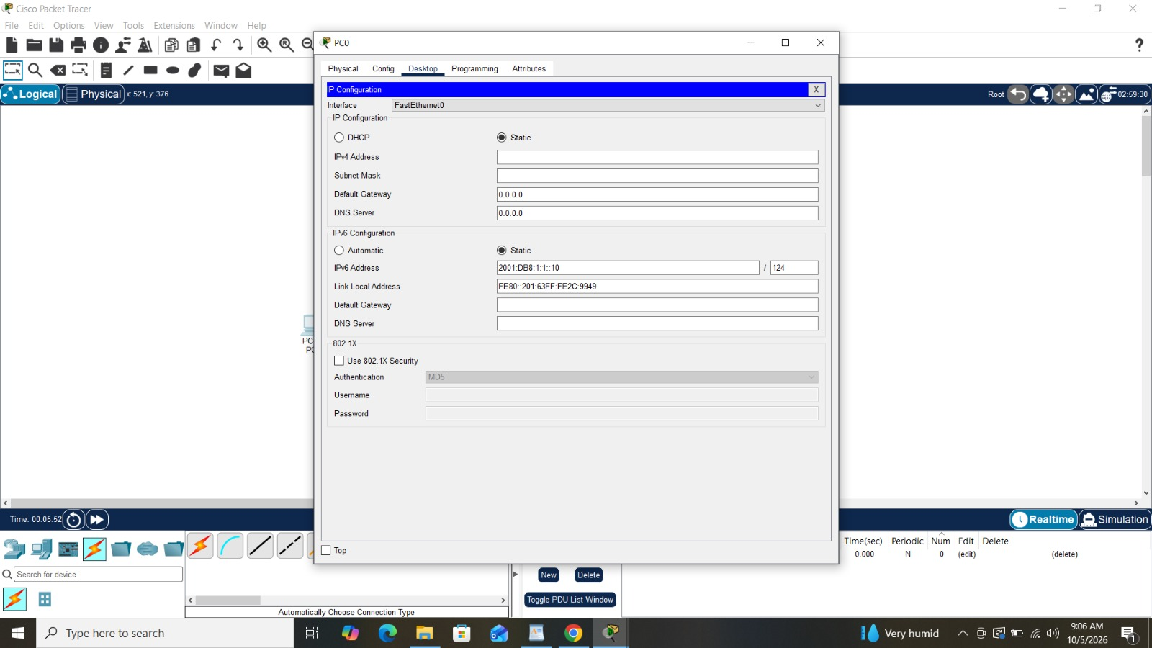
Figure 2.2: Static IPv6 configuration on PC0 (Address: 2001:DB8:1234:5678::10/124)
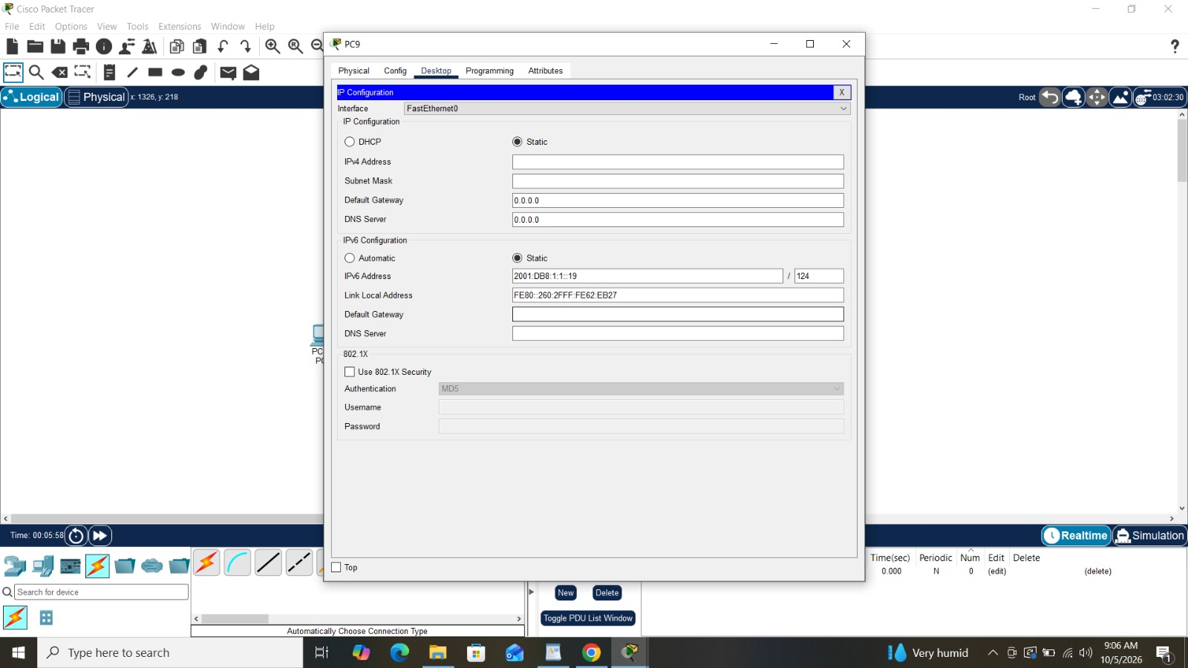
Figure 2.3: Static IPv6 configuration on PC9 (Address: 2001:DB8:1234:5678::19/124)
3. Basic Switch CLI Security & Device Configuration
To secure network infrastructure devices, Cisco IOS CLI commands were configured on both Switch0 (SW3) and Switch1 (SW1). These configurations enforce hostname identification, domain lookup suppression, access security, password encryption, and legal warning banners.
3.1 Standard Cisco IOS Security Configuration Script
The complete set of Cisco IOS commands executed on each switch is as follows:
! Enter Privileged EXEC and Global Configuration Mode
enable
configure terminal

! 1. Assign Device Hostname
hostname SW3 (or SW1 for Switch 1)

! 2. Disable Unnecessary DNS Lookups to Prevent CLI Freezes
no ip domain-lookup

! 3. Configure Message of the Day (MOTD) Legal Banner
banner motd #Authorized Access Only! Unauthorized users will be prosecuted.#

! 4. Set Encrypted Enable Secret Password for Privileged Access
enable secret cisco123

! 5. Secure Console Access Line (Line Con 0)
line console 0
password cisco
login
exit

! 6. Secure Virtual Terminal Lines for Remote Telnet/SSH Access (Lines VTY 0 4)
line vty 0 4
password cisco
login
exit

! 7. Encrypt Plaintext Passwords in Running Configuration
service password-encryption

! 8. Exit Configuration Mode and Save to NVRAM
end
copy running-config startup-config

3.2 Command Purpose & Security Explanation
- hostname <name>: Identifies the switch uniquely on the network for administrative clarity.
- no ip domain-lookup: Prevents the switch from attempting to resolve mistyped commands as domain names, avoiding annoying CLI command hangs.
- banner motd #...#: Displays an official legal notice to any user attempting to access the CLI interface, providing legal protection against unauthorized intrusion.
- enable secret cisco123: Protects access to Privileged EXEC mode using a strong MD5-hashed password (cisco123).
- line console 0 & login: Enforces password authentication ('cisco') on physical serial/console port connections.
- line vty 0 4 & login: Requires password authentication ('cisco') for incoming Telnet and SSH sessions on lines 0 through 4.
- service password-encryption: Converts all plain-text passwords stored in the configuration file into Type-7 encrypted strings to prevent shoulder surfing.
- copy running-config startup-config: Writes active running configurations from RAM to non-volatile RAM (NVRAM) so configurations persist across reboots.
3.3 Switch 0 (SW3) Configuration & Verification
Below is the CLI output showing the complete configuration execution on Switch 0 (SW3), followed by login prompt verification showing the MOTD legal banner and password enforcement:
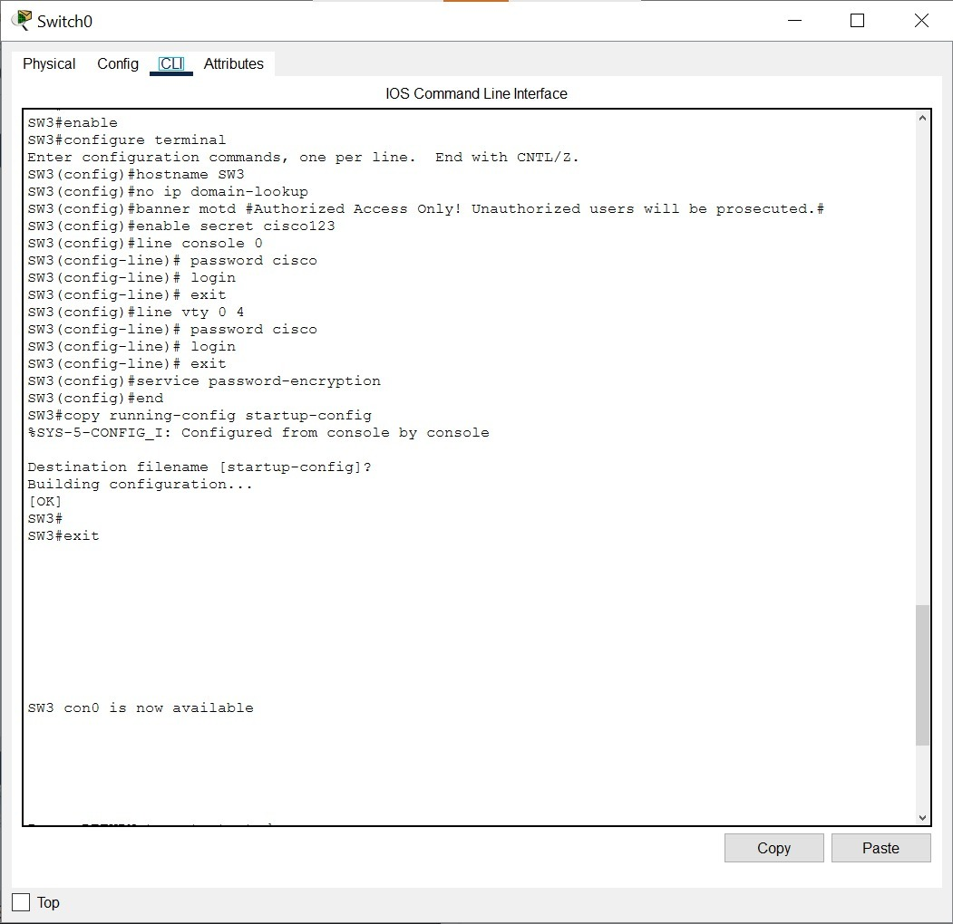
Figure 3.1: Switch 0 CLI terminal output executing hostname, banner, passwords, encryption, and startup-config copy
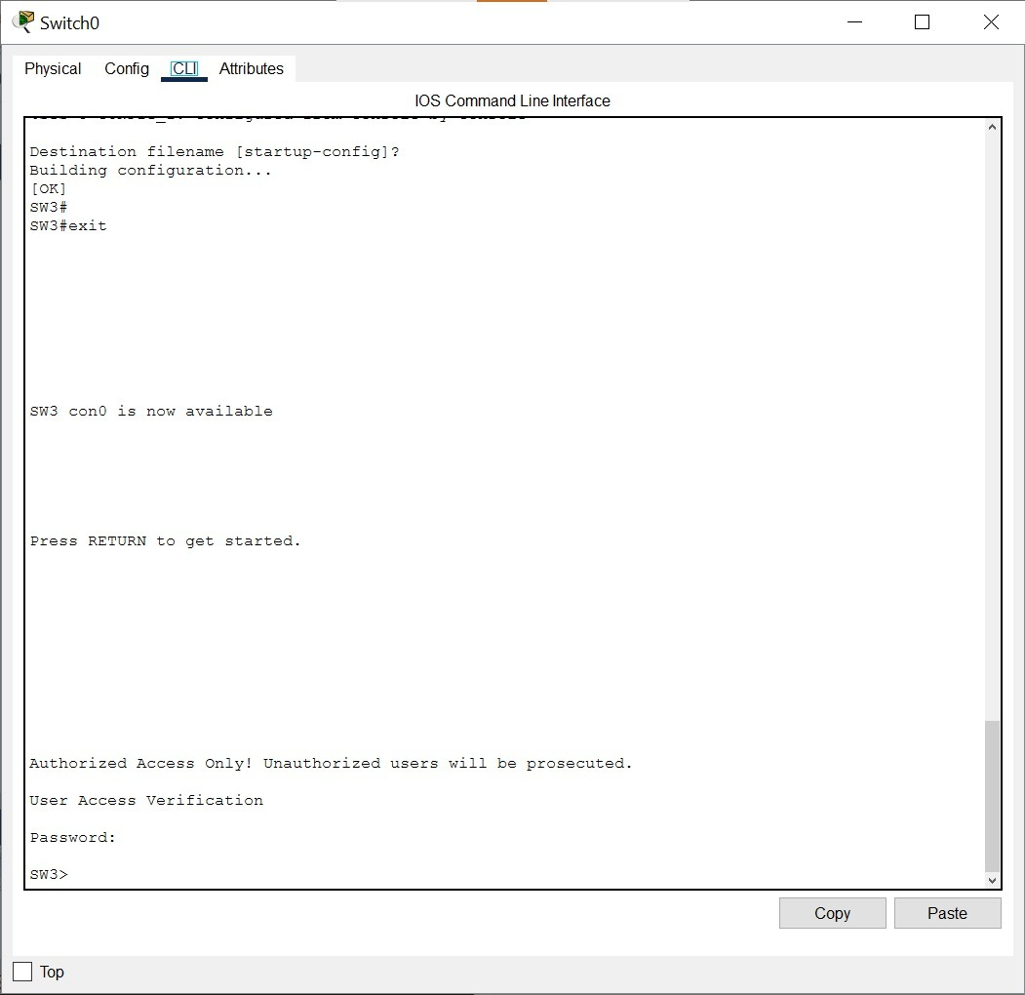
Figure 3.2: Switch 0 console security verification showing MOTD banner and password prompt upon user connection
3.4 Switch 1 (SW1) Configuration & Verification
Similarly, Switch 1 (SW1) was configured with identical security standards. Below are the CLI command execution logs and console security verification screenshots:
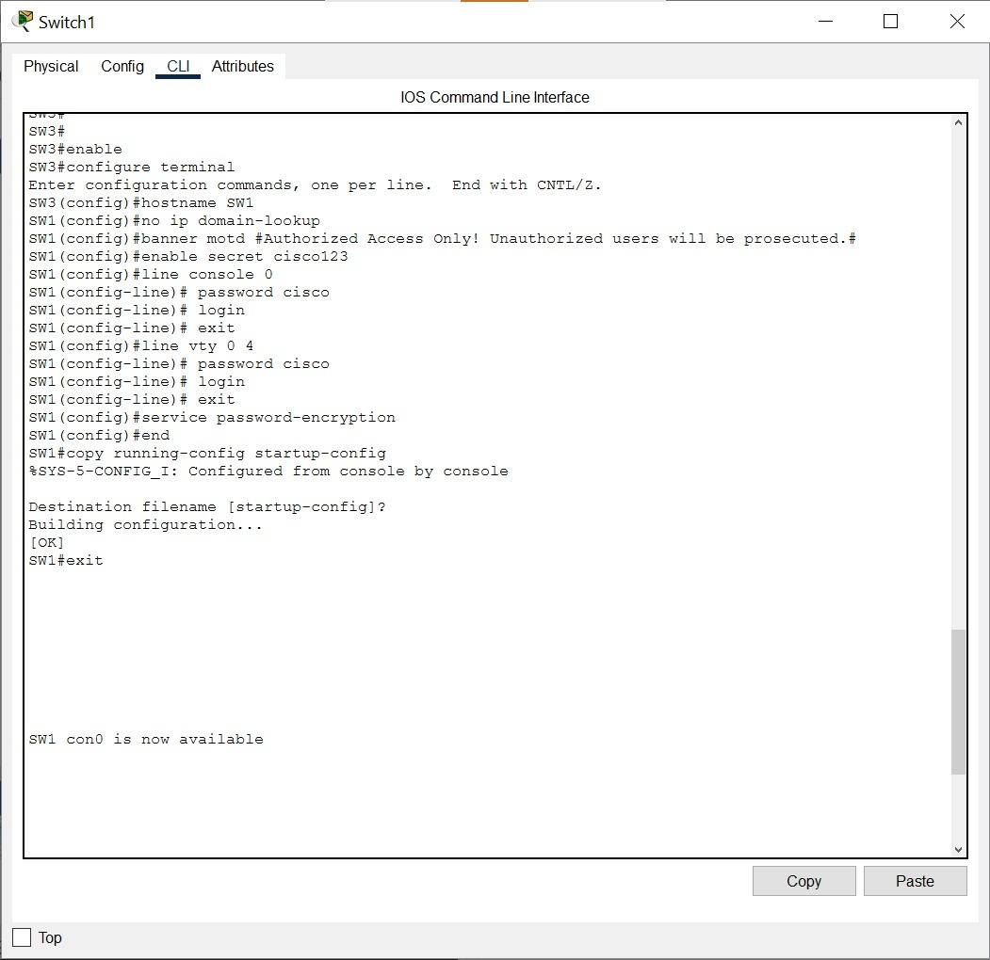
Figure 3.3: Switch 1 CLI terminal output applying hostname SW1, banner motd, enable secret, line passwords, and saving configuration
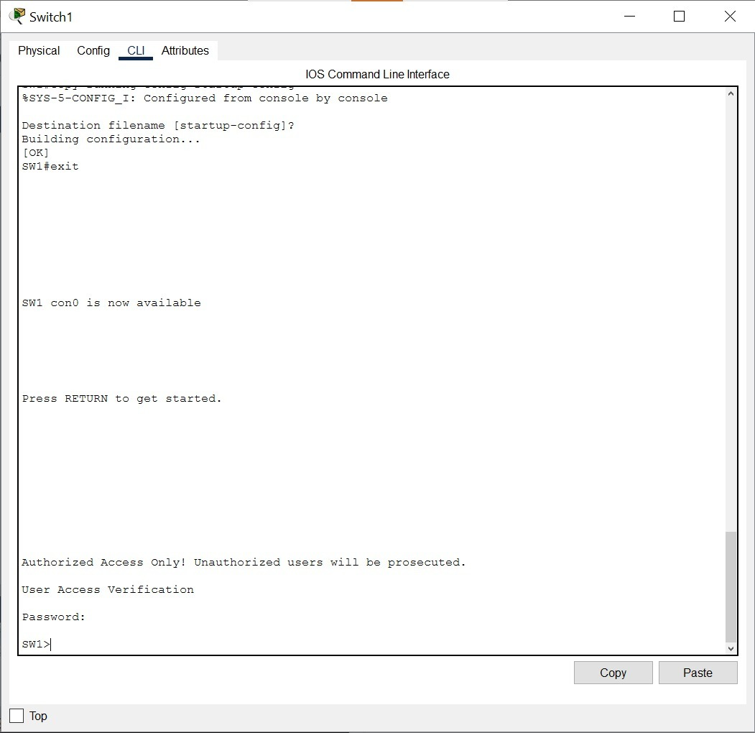
Figure 3.4: Switch 1 console login prompt demonstrating banner display and password authentication access control
4. End-to-End Connectivity Verification & Testing
To verify proper physical connectivity, correct IPv6 subnet configuration, and layer-2 switch forwarding across the inter-switch trunk cable, an end-to-end ICMP ping test was performed between host PC0 (connected to Switch 0) and host PC9 (connected to Switch 1).
4.1 Ping Test Execution
From host PC0 (IPv6: 2001:DB8:1234:5678::10), the Command Prompt was opened and the ICMPv6 ping command was issued targeting PC9 (IPv6: 2001:DB8:1234:5678::19):
C:\> ping 2001:DB8:1234:5678::19

Pinging 2001:DB8:1234:5678::19 with 32 bytes of data:

Reply from 2001:DB8:1234:5678::19: bytes=32 time<1ms TTL=128
Reply from 2001:DB8:1234:5678::19: bytes=32 time<1ms TTL=128
Reply from 2001:DB8:1234:5678::19: bytes=32 time<1ms TTL=128
Reply from 2001:DB8:1234:5678::19: bytes=32 time<1ms TTL=128

Ping statistics for 2001:DB8:1234:5678::19:
Packets: Sent = 4, Received = 4, Lost = 0 (0% loss),
Approximate round trip times in milli-seconds:
Minimum = 0ms, Maximum = 1ms, Average = 0ms

4.2 Verification Screenshot
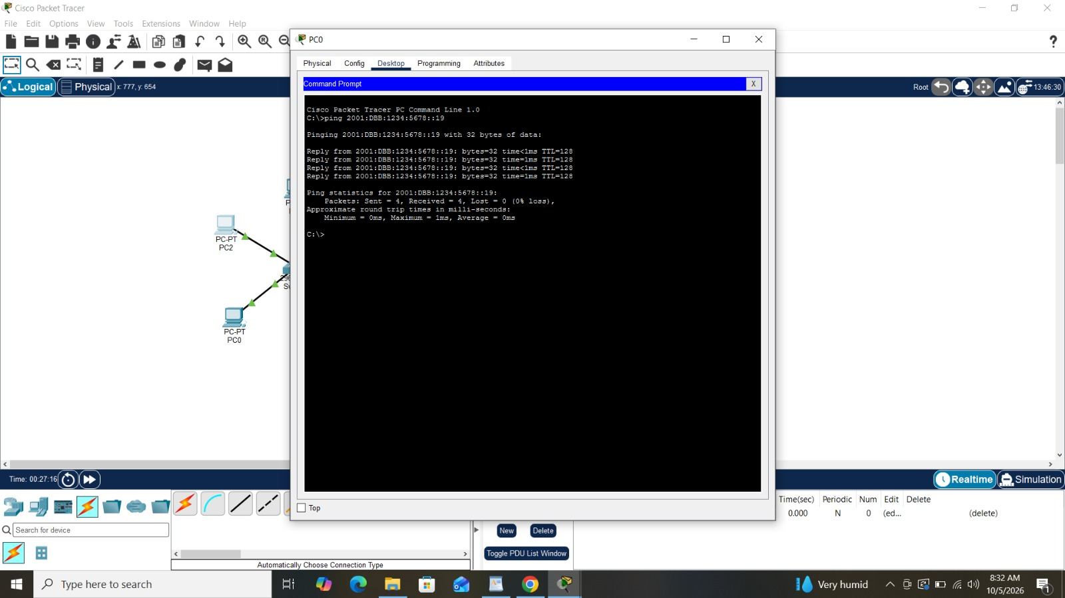
Figure 4.1: Command prompt on PC0 showing successful 4/4 ICMP ping response from PC9 (0% packet loss)
4.3 Results & Performance Analysis
- Packet Delivery Rate: 100% transmission success rate (4 packets sent, 4 received, 0 dropped).
- Latency & Speed: Average round-trip time of 0ms (Maximum 1ms), confirming zero latency overhead across switch trunk link.
- TTL Value: Standard IPv6 default TTL of 128 indicates direct layer-2 LAN switching without passing through intermediate routers.
- Overall Conclusion: Confirms that IPv6 subnets, host IP bindings, physical cabling, and Cisco switch forwarding tables are fully operational.
5. Conclusion & Key Learnings
In this lab assignment, our team successfully planned, mathematically derived, configured, and verified an IPv6 subnetted enterprise network topology in Cisco Packet Tracer. Key takeaways from this assignment include:
- IPv6 Mathematical Subnetting: Mastered calculating host bits, prefix expansion (/120 to /124), subnet pool counts, block size, and hexadecimal jump increments (0x10) for IPv6 addressing.
- Host Addressing Implementation: Learned to assign static IPv6 addresses and prefix lengths across end-user PCs in Packet Tracer.
- Cisco Switch Infrastructure Hardening: Implemented essential Cisco IOS CLI hardening steps, including hostname assignment, domain lookup suppression, MOTD legal banners, enable secret passwords, console/VTY access protection, and password encryption.
- Network Verification & Diagnostics: Validated network reachability and packet forwarding across inter-switch crossover links using ICMP ping utilities and Packet Tracer PDU simulation tools.

