

Bangladesh University of Professionals (BUP) Faculty of Science & Technology (FST) Department of Computer Science and Engineering
Master’s in computer science and engineering (MCSE) Professional Program

ASSIGNMENT

Name of The Topic : Transformer Tutorial (Application Based)
Course Title : Natural Language Processing
Course Code : MCSE 2202
Submitted To : Dr. Fazlul Hasan Siddiqui
Professor,
Department of Computer Science and Engineering
DUET

Submitted By : Saad Bin Hasan Sakib
ID No: 24525002007
2nd Batch (MCSE)

Date of Submission: 14-11-2025

Table of Contents

1. Abstract
2. Introduction
3. Background
4. Understanding Self-Attention
5. Building a Tiny Transformer From Scratch
6. Full Code With Explanations
7. Experiments and Results
8. Conclusion
9. References

Abstract
This report presents a complete beginner-friendly guide to understanding and implementing a Transformer model from scratch using PyTorch. The objective is to simplify the complex ideas behind Transformers so even someone with no prior deep learning experience can follow along. We build a tiny character-level language model and explain every step: tokenization, dataset preparation, model architecture, multi-head attention, positional encoding, training, and text generation.

1. Introduction
Transformers are currently the backbone of modern artificial intelligence. ChatGPT, GPT-4, BERT, and almost every high-performing NLP model today uses the Transformer architecture. However, most beginners struggle to understand how Transformers work under the hood. This mini‑book/report explains everything from scratch with code, diagrams, and real examples.

2. Background

2.1 Why Language Models?
A language model predicts the next word or next character given previous text. Examples:
- Autocomplete in mobile keyboards
- Search engine suggestions
- Chatbots
- Text generation

2.2 Problems with RNNs/LSTMs
Before Transformers, RNNs and LSTMs were used, but they had issues:
- Slow training due to sequential processing
- Forget long-term dependencies
- Hard to parallelize
Transformers solve these using self-attention.

3. Understanding Self-Attention
Self-attention answers a simple question:
**'When reading this token, which other tokens should I pay attention to? '**
For example, in:
“The cat sat on the mat because it was tired.”
The word **'it'** refers to **'cat'** — attention helps the model learn such connections.

4. Building a Tiny Transformer From Scratch
We now build a decoder-only Transformer (like a mini GPT). The full system includes:
- Tokenizer (character-level)
- Dataset builder
- Embeddings
- Positional encoding
- Multi-head self-attention
- Feed-forward block
- Stacked transformer layers
- Autoregressive text generation

5. Full Code With Step-by-Step Explanation

5.1 data.py — Tokenizer, Dataset, and DataLoader
This file prepares text, tokenizes characters, and creates training sequences.
class CharTokenizer:
"""
Character‑level tokenizer.
Converts characters ↔ integer IDs.
"""
def __init__(self, text):
chars = sorted(list(set(text)))
self.vocab_size = len(chars)
self.stoi = {ch: i for i, ch in enumerate(chars)}
self.itos = {i: ch for ch, i in self.stoi.items()}
def encode(self, s):
return [self.stoi[c] for c in s]
def decode(self, ids):
return ''.join([self.itos[i] for i in ids])
Dataset class creates overlapping sequences:
class CharDataset(Dataset):
def __init__(self, data, block_size):
self.data = data
self.block_size = block_size
def __len__(self):
return max(0, len(self.data) - self.block_size)
def __getitem__(self, idx):
x = self.data[idx : idx+self.block_size]
y = self.data[idx+1 : idx+self.block_size+1]
return x, y
def load_data(corpus_path, block_size=64, batch_size=32, train_split=0.8):
with open(corpus_path, 'r', encoding='utf-8') as f:
text = f.read()
tokenizer = CharTokenizer(text)
data_ids = torch.tensor(tokenizer.encode(text), dtype=torch.long)
n = int(len(data_ids) * train_split)
train_data = data_ids[:n]
val_data = data_ids[n:]
train_dataset = CharDataset(train_data, block_size)
val_dataset = CharDataset(val_data, block_size)
train_loader = DataLoader(train_dataset, batch_size=batch_size, shuffle=True, drop_last=True)
val_loader = DataLoader(val_dataset, batch_size=batch_size, shuffle=False, drop_last=False)
return train_loader, val_loader, tokenizer

5.2 model.py — Tiny Transformer Implementation
class TokenEmbedding(nn.Module):
def __init__(self, vocab_size, d_model):
super().__init__()
self.embedding = nn.Embedding(vocab_size, d_model)
def forward(self, x):
return self.embedding(x)
class MultiHeadSelfAttention(nn.Module):
def __init__(self, d_model, num_heads):
super().__init__()
self.num_heads = num_heads
self.d_head = d_model // num_heads
self.W_q = nn.Linear(d_model, d_model)
self.W_k = nn.Linear(d_model, d_model)
self.W_v = nn.Linear(d_model, d_model)
self.W_o = nn.Linear(d_model, d_model)
def forward(self, x, mask=None):
# Steps:
# 1. Create Q, K, V
# 2. Split into heads
# 3. Scaled dot product attention
# 4. Merge heads back
...
class TinyTransformerLM(nn.Module):
def forward(self, x):
token_emb = self.token_emb(x)
pos_emb = self.pos_emb(x)
h = token_emb + pos_emb
mask = self._generate_causal_mask(seq_len, x.device)
for block in self.blocks:
h = block(h, mask)
logits = self.head(self.ln_final(h))
return logits

5.3 train.py — Training Loop and Generation
for epoch in range(epochs):
for x, y in train_loader:
optimizer.zero_grad()
logits = model(x)
loss = criterion(logits.view(-1, vocab), y.view(-1))
loss.backward()
optimizer.step()
@torch.no_grad()
def generate(self, idx, max_new_tokens):
for _ in range(max_new_tokens):
logits = self(idx)
next_token = torch.multinomial(F.softmax(logits[:, -1, :], dim=-1), 1)
idx = torch.cat([idx, next_token], dim=1)
return idx

6. Experiments and Results
Below is the training vs validation loss curve:
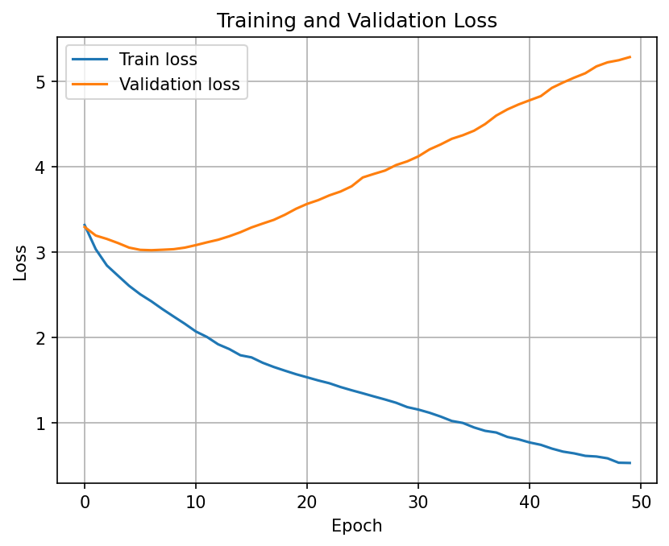

Generated Text Example:
Prompt: amar
Generated Output:
amar baladesh, ba boumi asha...

7. Conclusion
This report serves as both a technical guide and a beginner-friendly mini‑book. A complete Transformer model was implemented from scratch using PyTorch, with detailed explanations.

8. References
1. Vaswani et al. (2017). Attention Is All You Need.
2. PyTorch Documentation.
3. Transformer research blogs & educational resources.

