

# **Artificial Intelligence**

# **Project****#02**

Group members:

I180473 Muhammad Saad Tanveer

I180667 Tayyab Tariq

**Total Moves from both sides.**

* **26**

**Chess.com report**

[Event "vs Computer"]

[Site "Chess.com"]

[Date "2021.06.10"]

[Round "?"]

[White "Guest8488322607"]

[Black "Jimmy"]

[Result "1/2-1/2"]

[BlackElo "600"]

[WhiteElo "800"]

[TimeControl "-"]

**MOVES**

1. d3 e5

2. e3 e4

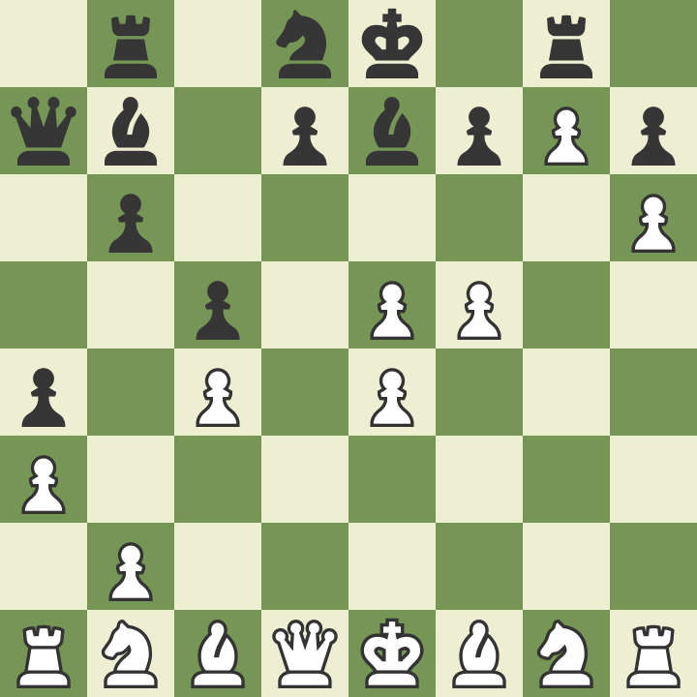3. dxe4 a5

4. e5 Nh6

5. e4 a4

6. f3 Ng8

7. f4 c6

8. f5 Be7

9.h3 b6

10. g3 c5

11. g4 Nc6

12. c3 Bf8

13. c4 Nh6

14. a3 Nb8

15. Ra2 Qc7

16. h4Qa7

17. h5 Bb7

18. g5 Rg8

19. gxh6 Nc6

20. hxg7 Be7

21. h6 Nd8

22. Ra1 Rb8

23. Ra2 Bc8

24. Ra1 Bb7

25. Ra2 Bc8

26. Ra1 Bb7 1/2-1/2

**CHESS GAME RESULT**

* **Draw**

**Analysis:**

ON chess board white was acting as User-AI and Black was acting chess.com AI simple forward moves were performed initially by both AI’s but the chess AI was defensive as it can be seen in the above result picture user AI was in a winning position captured chess-AI two pieces including one knight. But at 22nd move both AI started to move one piece forward and backward game resulted in draw. Chess-AI gave up and initiated a draw.

Below is a gif of a whole game.

