Total Moves from both sides.
- 26

Chess.com report
[Event "vs Computer"]
[Site "Chess.com"]
[Date "2021.06.10"]
[Round "?"]
[White "Guest8488322607"]
[Black "Jimmy"]
[Result "1/2-1/2"]
[BlackElo "600"]
[WhiteElo "800"]
[TimeControl "-"]

MOVES
1. d3 e5
2. e3 e4
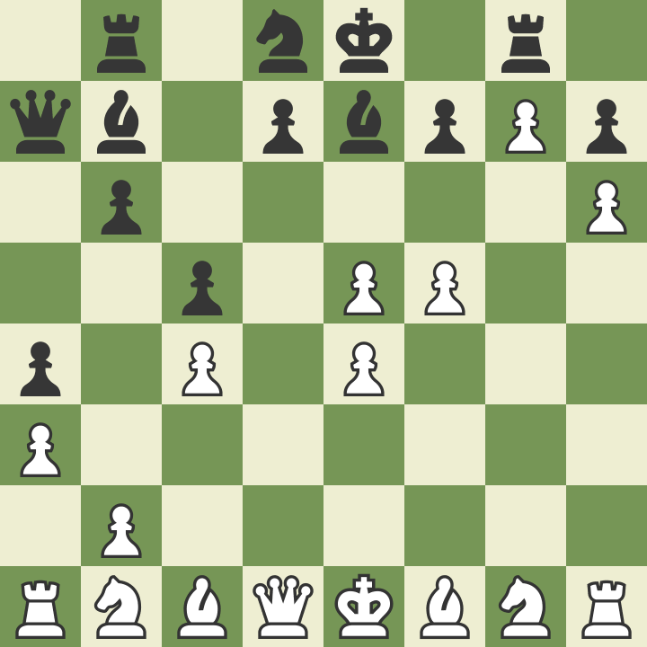
3. dxe4 a5
4. e5 Nh6
5. e4 a4
6. f3 Ng8
7. f4 c6
8. f5 Be7
9.h3 b6
10. g3 c5
11. g4 Nc6
12. c3 Bf8
13. c4 Nh6
14. a3 Nb8
15. Ra2 Qc7
16. h4Qa7
17. h5 Bb7
18. g5 Rg8
19. gxh6 Nc6
20. hxg7 Be7
21. h6 Nd8
22. Ra1 Rb8
23. Ra2 Bc8
24. Ra1 Bb7
25. Ra2 Bc8
26. Ra1 Bb7 1/2-1/2

CHESS GAME RESULT
- Draw

Analysis:

ON chess board white was acting as User-AI and Black was acting chess.com AI simple forward moves were performed initially by both AI’s but the chess AI was defensive as it can be seen in the above result picture user AI was in a winning position captured chess-AI two pieces including one knight. But at 22nd move both AI started to move one piece forward and backward game resulted in draw. Chess-AI gave up and initiated a draw.
Below is a gif of a whole game.

