**Saad Tariq**

**22f8785**

**Assignment 1**

**Algorithms**

**Task 4**

#include<iostream>

using namespace std;

void toggleLockers(bool* doors, int n);

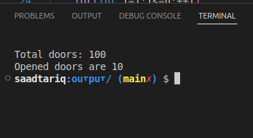int main()

{

system("clear");

int n =100;

bool * doors = new bool[n+1];

for(int i=1;i<=n;i++)

{

doors[i]=0;

}

toggleLockers(doors, n);

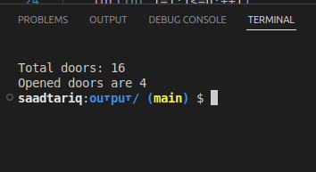

delete[] doors;

return 0;

}

void toggleLockers(bool* doors, int n)

{

for(int i=1;i<=n;++i)

{

for (int j = i; j <= n; j+=i)

{

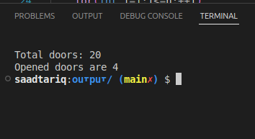doors[j]=!doors[j];

}

}

string door="";

int openDoors=0;

for (int i = 1; i <= n; i++)

{

if(doors[i]) openDoors++;

}

cout<<"\nTotal doors: "<<n;

cout<<"\nOpened doors are "<<openDoors<<"\n";

}