**COMSATS University Islamabad,**

**Lahore**



**Name: Saad Zaidi**

**Registration No.: SP22-BSE-015**

**Semester: Fourth**

**Section: B**

**Subject: Web Technologies**

**Teacher: Muhammad Ali Hassan**

**Assignment No.: 5**

**Restful APIs with Express**

**GitHub Repository:**

<https://github.com/SaadZaidi5/RestfulAPIOfBooks.git>

**Get Method:**

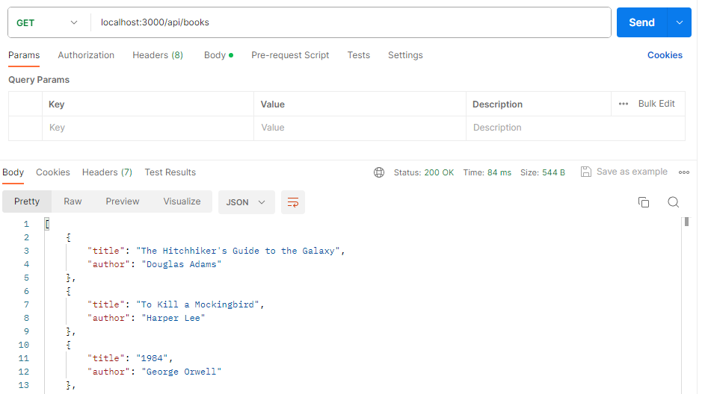

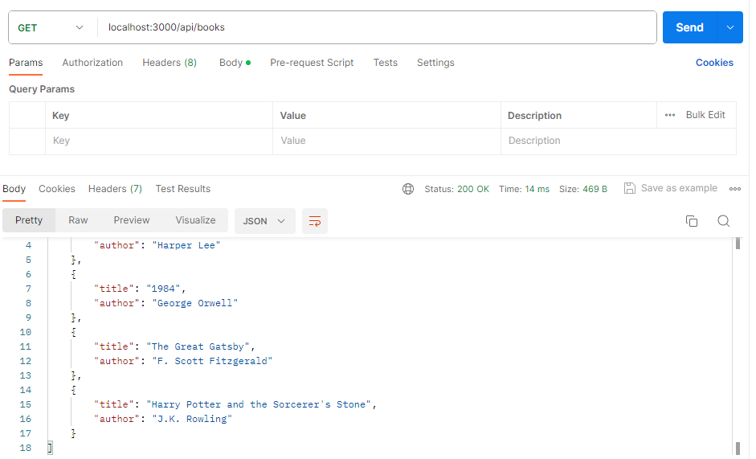

**Delete Method:**

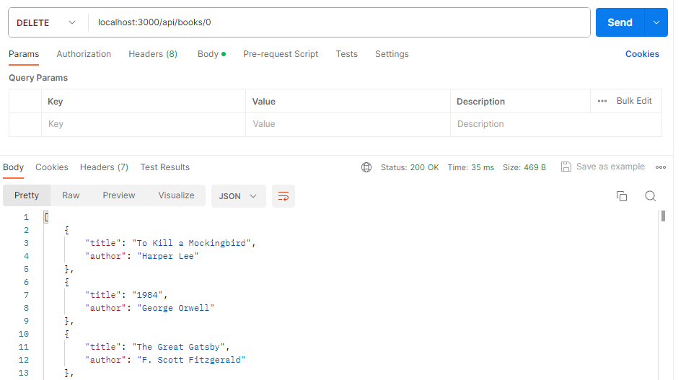

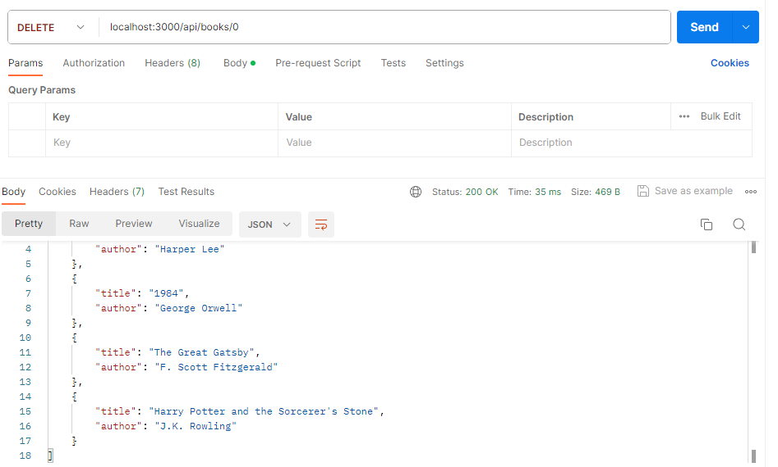

**Put Method:**

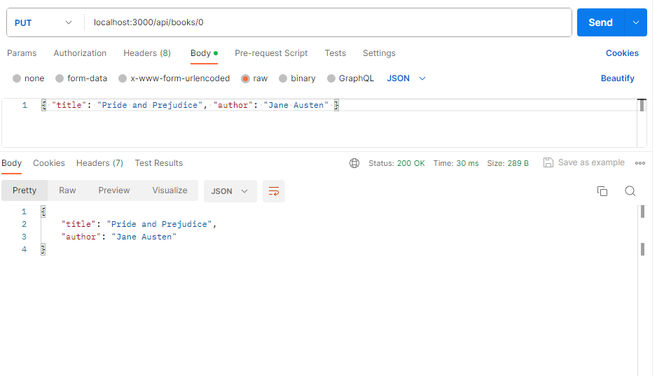

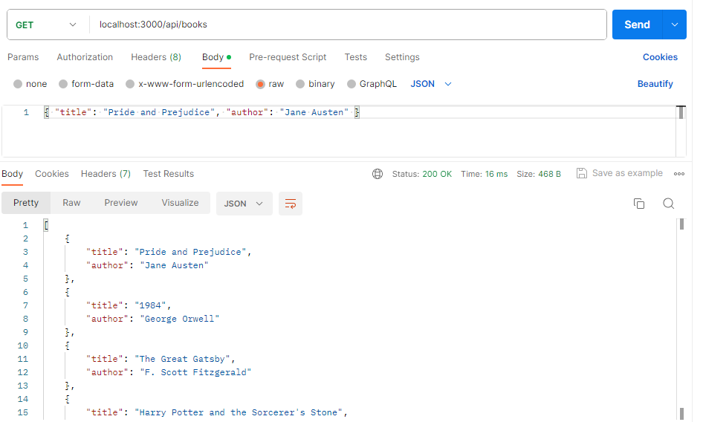

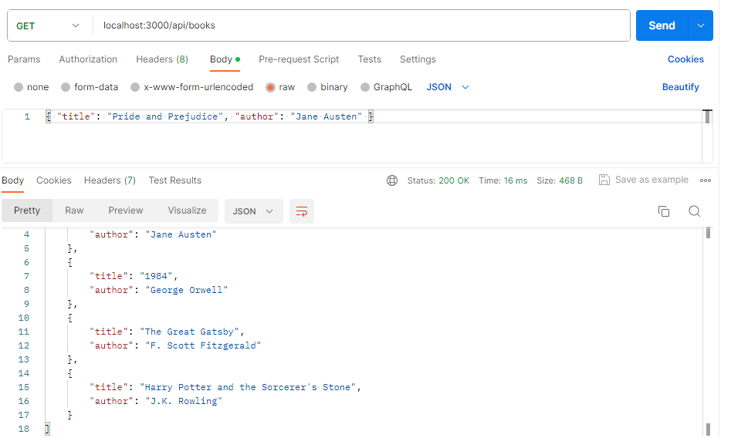

**Post Method:**

