## 

## e-Project

## 

## Batch Code

PR2-202205C

## Group Members

|  |  |  |
| --- | --- | --- |
| Serial Number | Enrollment Number | Student Name |
| 1 | 1372814 | Maham Riaz |
| 2 | 1372812 | Maria Ali Sheikh |
| 3 | 1377336 | Saadat Hussain |
| 4 | 1375979 | Umer Lodhi |

# **ACKNOWLEDGEMENT**

## 

The first, we would like to express my special thanks of gratitude to my teacher **Muhammed Aqueel**, who helped us a lot in finalizing this project within the limited time frame, valuable counselling and assistance for the accomplishment of this project.

Secondly, we would also like to thank the e-Project team at Aptech Head Office, who gave us the golden opportunity to do this wonderful project about brand of Chairs and thirdly, we also thank the e-Project team, some of the benefits are as under:

* Re-enforcement of skills happens in the experiential learning process.
* A mentor, ensuring that we do not get drifted, constantly guides us.
* It gives us a lot of confidence to face an interview as we have worked on a project. We can explain virtually everything on the subject we have learnt.

# **SYNOPSIS**

Follow the strong development of the internet, technology watches and the growing watch market, every business needs a website design to display products on the internet.

* Richfield is designed with many different designs, styles, fonts and much more.
* Richfield have 3 brands each having 3 categories with an amount of variety.
* Which is the most special suggestion from rich fields.
* So, the Richfield Chairs give the best product under your budget.
* However, purchases can be made directly from the website to your door step.

# **PROBLEM STATEMENT**

The "Rich Field" is the most stylish and well design web. Having user guide and most frequently solving queries of the users.

Richfield chairs are the one who always put the comfort on first and who else can deny the brand which can give u the style and comfort in one But When it comes to comfort vs. style and the qualities of a luxury chair, the material is one of the most important considerations.

The materials of your chair affect both how it looks and how it feels. Being comfortable in your office chair is about more than just feeling good.

A chair that properly supports your body as you work. Students always get bored with the study but they get attracted to the colors. The colors make the environment feel happy and fresh.

"Richfield" having its own website to provide information and also get connected with the customer:

Richfield Chairs is an organization selling Chairs. They produce various chairs of different types suiting every requirement and into various sizes, starting from kids to office to home and etc.

You are supposed to create a website for them with the below mentioned requirement specifications.

The website is to be developed for the Windows Platform using HTML5, JavaScript and Geolocation. The site should work well in all leading browsers including Chrome, IE, Firefox.

# **Requirement Specification:**

The Web site is to be created based on the following requirements.

1. The Home Page should be created making use of Sections with a suitable logo, the header section can be added which will show images chairs.
2. The site must contain the links to navigate through any category for the information.
3. The site should display a menu which will contain the options for brief introduction about the various furniture’s available, location of the shop and any other information if required.
4. The information should be categorized according to the brand names of the chairs like if a User wants to see only “LEO” chairs or any other companies chairs then he/she can click on a Link/button/menu etc. and can see only that Brand chairs.
5. When a user selects any particular brand, a list of chairs for that brand will be displayed.
6. A brief summary of features of the chairs should be displayed on the Web Page along with the picture but detailed Features should be stored in Individual Word documents which can be downloaded or viewed by the User who wishes to see the same.
7. The user should also be able to compare the various chairs of different as well as similar brands.
8. There should be a “Contact Us” page which will have the Address of the Company which should be displayed using Geolocation API (e.g. Google Maps) and the email address which when clicked will invoke the local mail client from where they can send an email.

# **Hardware/ Software Requirements**

***Hardware:***

* A minimum computer system that will help you access all the tools in the courses is a Pentium 166 or better.
* 64 Megabytes of RAM or better Software Notepad/HTML editor VS-Code IE 5.0/ Netscape 6.0.

***Software:***

* Notepad/Html Editor.
* Dreamweaver
* IE 5.0/ Netscape 6.0

# **Objectives of the project**

The Objective of this program is to give a sample project to work on real life projects. These applications help you build a larger more robust application.

The Objective is not to teach you HTML/JavaScript/Dreamweaver/HTML5 but to provide you with a real-life scenario and help you create basic applications using the tools.

You can revise the chapters before you start with the project.

This project is meant for students who have completed the module of Dreamweaver. These programs should be done in the Lab sessions with assistance of the faculty if required.

It is very essential that a student has a clear understanding of the subject. Students should go through the project and solve the assignments as per requirements given.

Kindly get back to eProjects Team in case of any doubts regarding the application or its objectives.

# **SCOPE OF THE WORK**

The website is to be developed for the Windows Platform using HTML5, JavaScript and jQuery bootstrap 5.1.3. The site should work well in all leading browsers including Chrome, IE, Firefox etc.

Homepage show Top best **Richfield’s Chairs** buy your stylish and comfortable chairs, new collection, new shop...

Every content direct to relative content.

# ***Screen Shots***

## Home Page

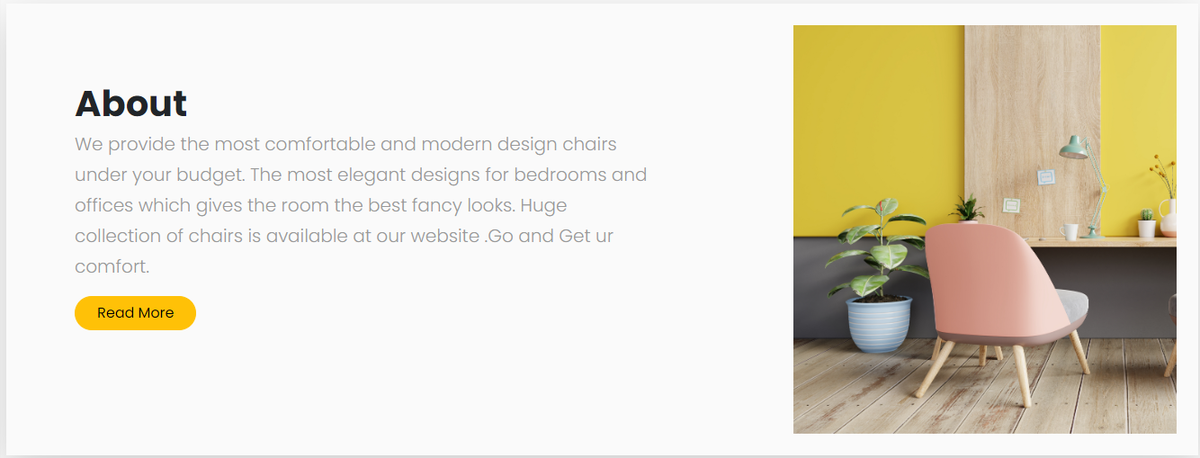

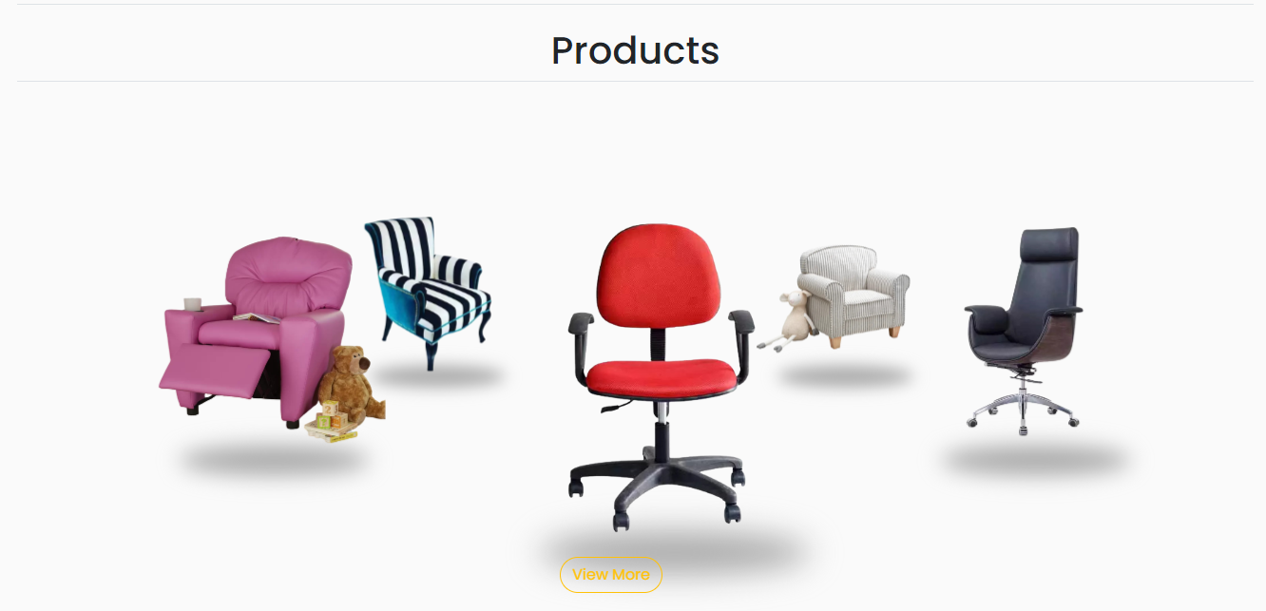



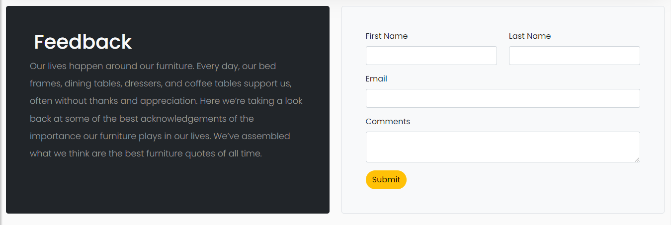

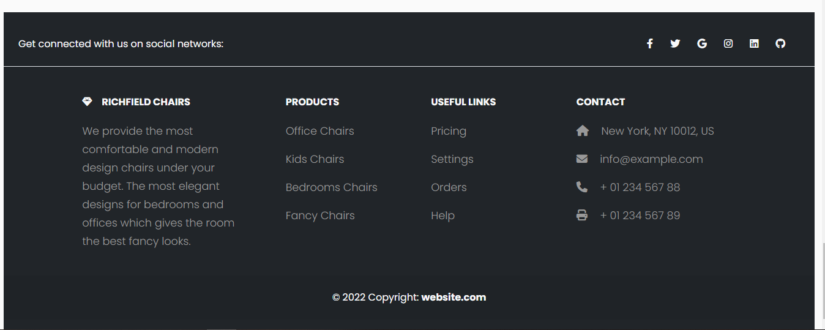

## 

***Product Page***

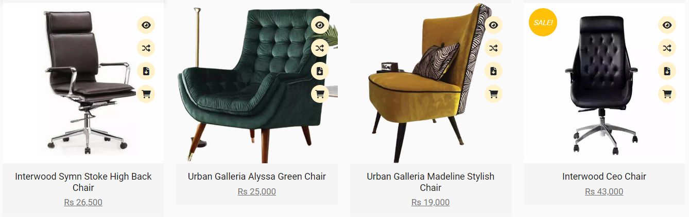

## 

***About Us***

***Conatct us:***

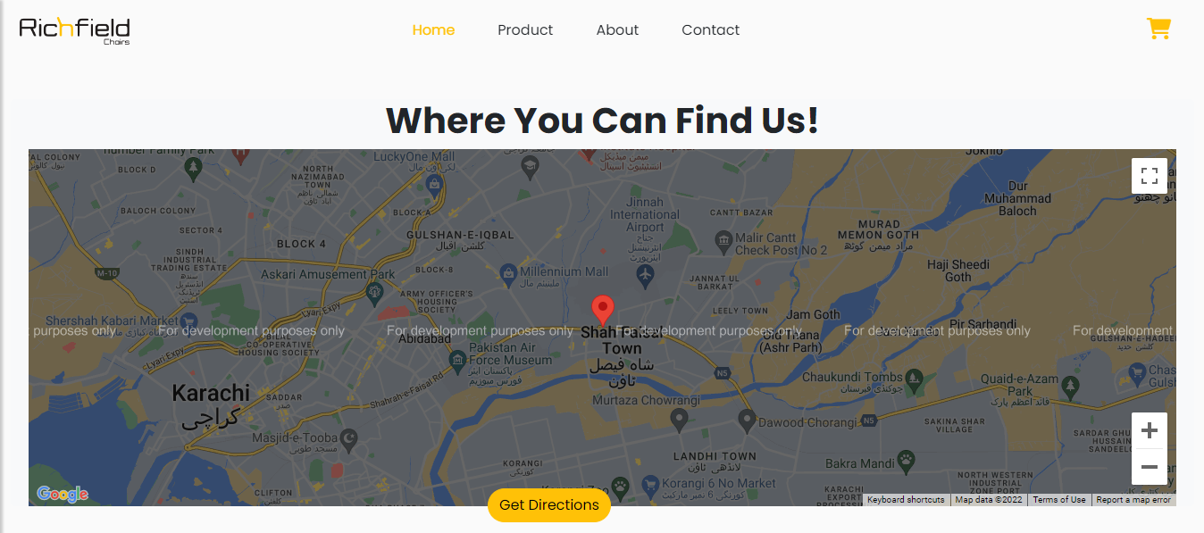

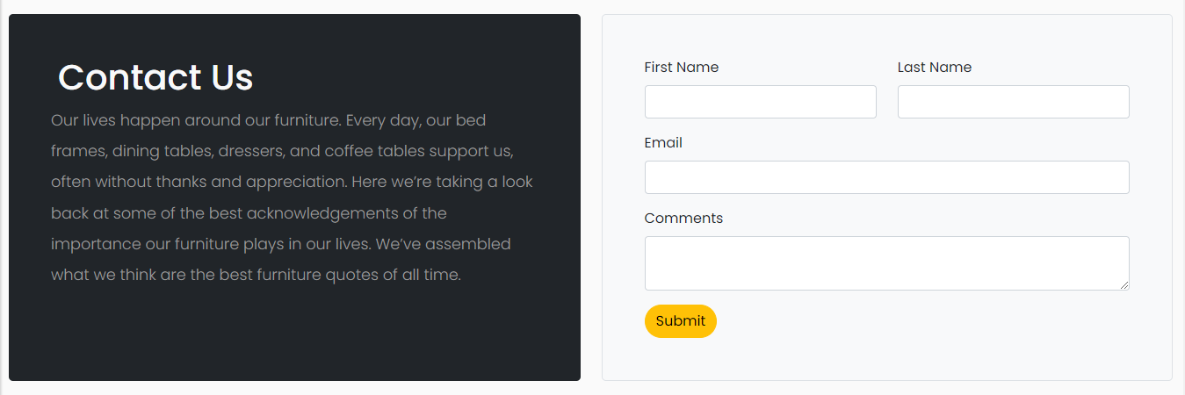

## WIRE FRAME

1. **Main Layout**

**Sliders**

**Navbar**

**Logo**

**Button**

**Background Image**

**Text**

Products

**Img**

**Img**

**Img**

**Text**

**Text**

**Text**

**Button**

**Image**

**TEXT**

**Text**

**Img**

**Img**

**Img**

**Img**

**Button**

**Products**

**Img**

**IMAGE**

**TEXT**

**Text**

2.**About Us Page**

**Footer**

**Submit**

**Form**

**TEXT**

**Text**

z

**IMAGE**

**IMAGE**

**IMAGE**

**IMAGE**

**IMAGE**

**IMAGE**

**IMAGE**

**IMAGE**

**IMAGE**

**IMAGE**

**IMAGE**

**IMAGE**

**IMAGE**

4**.Product Page**

## ­­Text Sheet Review

|  |  |  |  |
| --- | --- | --- | --- |
| **Serial Num** | **Names** | **Project Title** | **Task** |
|  | Maham Riaz | Richfield’s Chairs | Logo, Products Pics, Product documents, Eproject Documentation & Home Page |
|  | Maria Ali Sheikh | Richfield’s Chairs | About us & Contact Page |
|  | Saadat Hussain | Richfield’s Chairs | Product Page |
|  | Umer Lodhi | Richfield’s Chairs | Nothing |