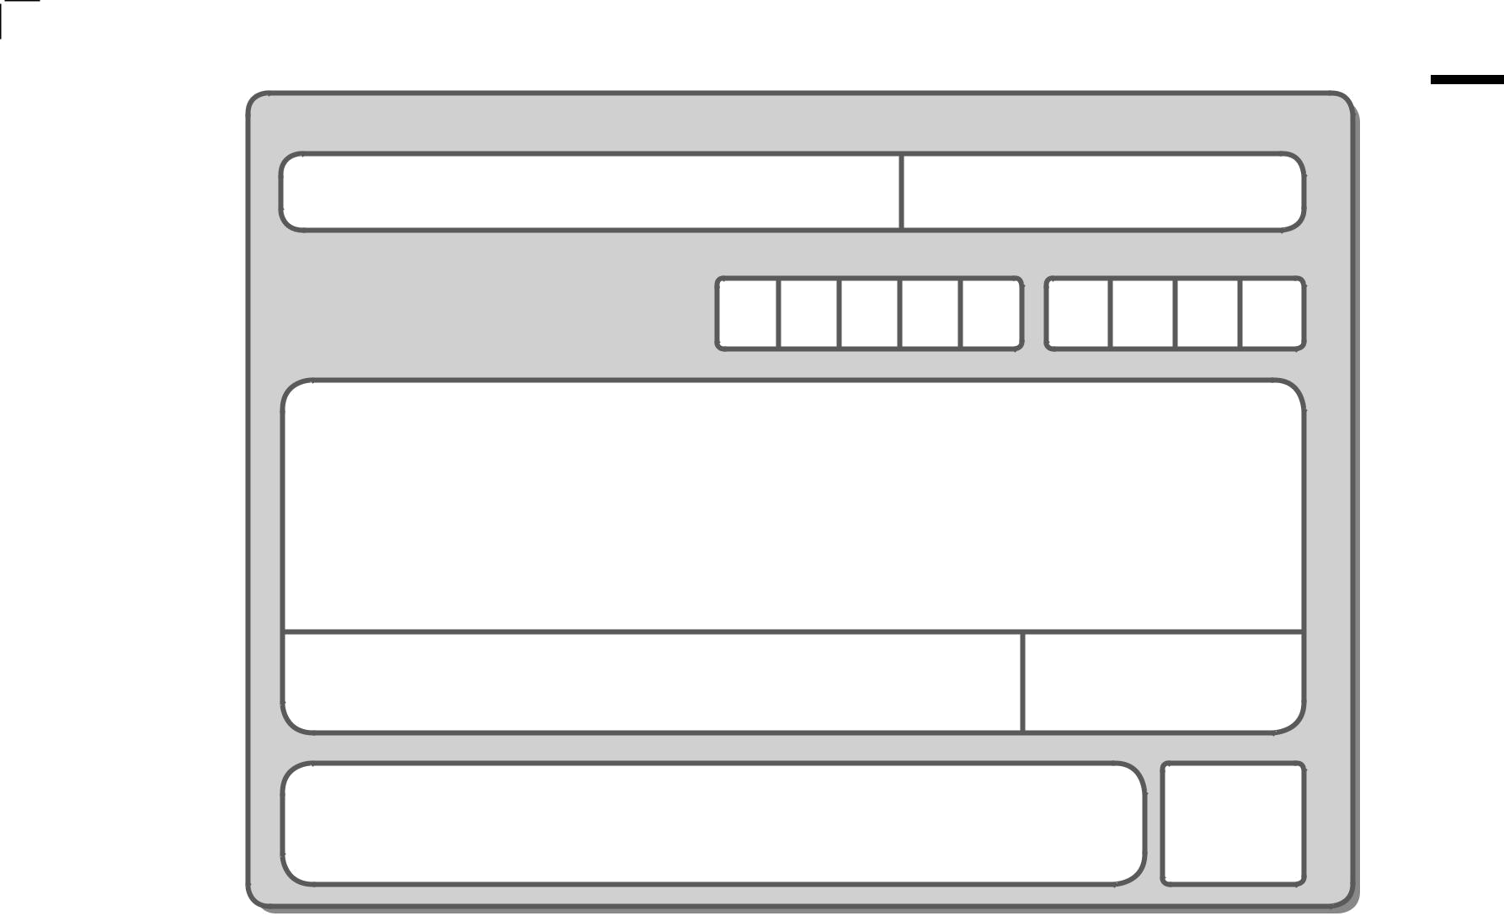
Write your name here

Surname Other names

Centre Number Candidate Number

Edexcel GCE

Chemistry

Advanced Subsidiary
Unit 1: The Core Principles of Chemistry

Monday 23 May 2011 – Afternoon Time: 1 hour 30 minutes

Candidates may use a calculator.

Instructions
- Use black ink or ball-point pen.

- Fill in the boxes at the top of this page with your name, centre number and candidate number.
- Answer all questions.

- Answer the questions in the spaces provided

– there may be more space than you need.

Information

Paper Reference
6CH01/01

Total Marks

- The total mark for this paper is 80.

- The marks for each question are shown in brackets

– use this as a guide as to how much time to spend on each question.

- Questions labelled with an asterisk (*) are ones where the quality of your written communication will be assessed

– you should take particular care with your spelling, punctuation and grammar, as well as the clarity of expression, on these questions.

- A Periodic Table is printed on the back cover of this paper.

Advice
- Read each question carefully before you start to answer it.

- Keep an eye on the time.

- Try to answer every question.

- Check your answers if you have time at the end.

P38433A *P38433A0124*

Turn over


©2011 Edexcel Limited.

7/7/5/2/


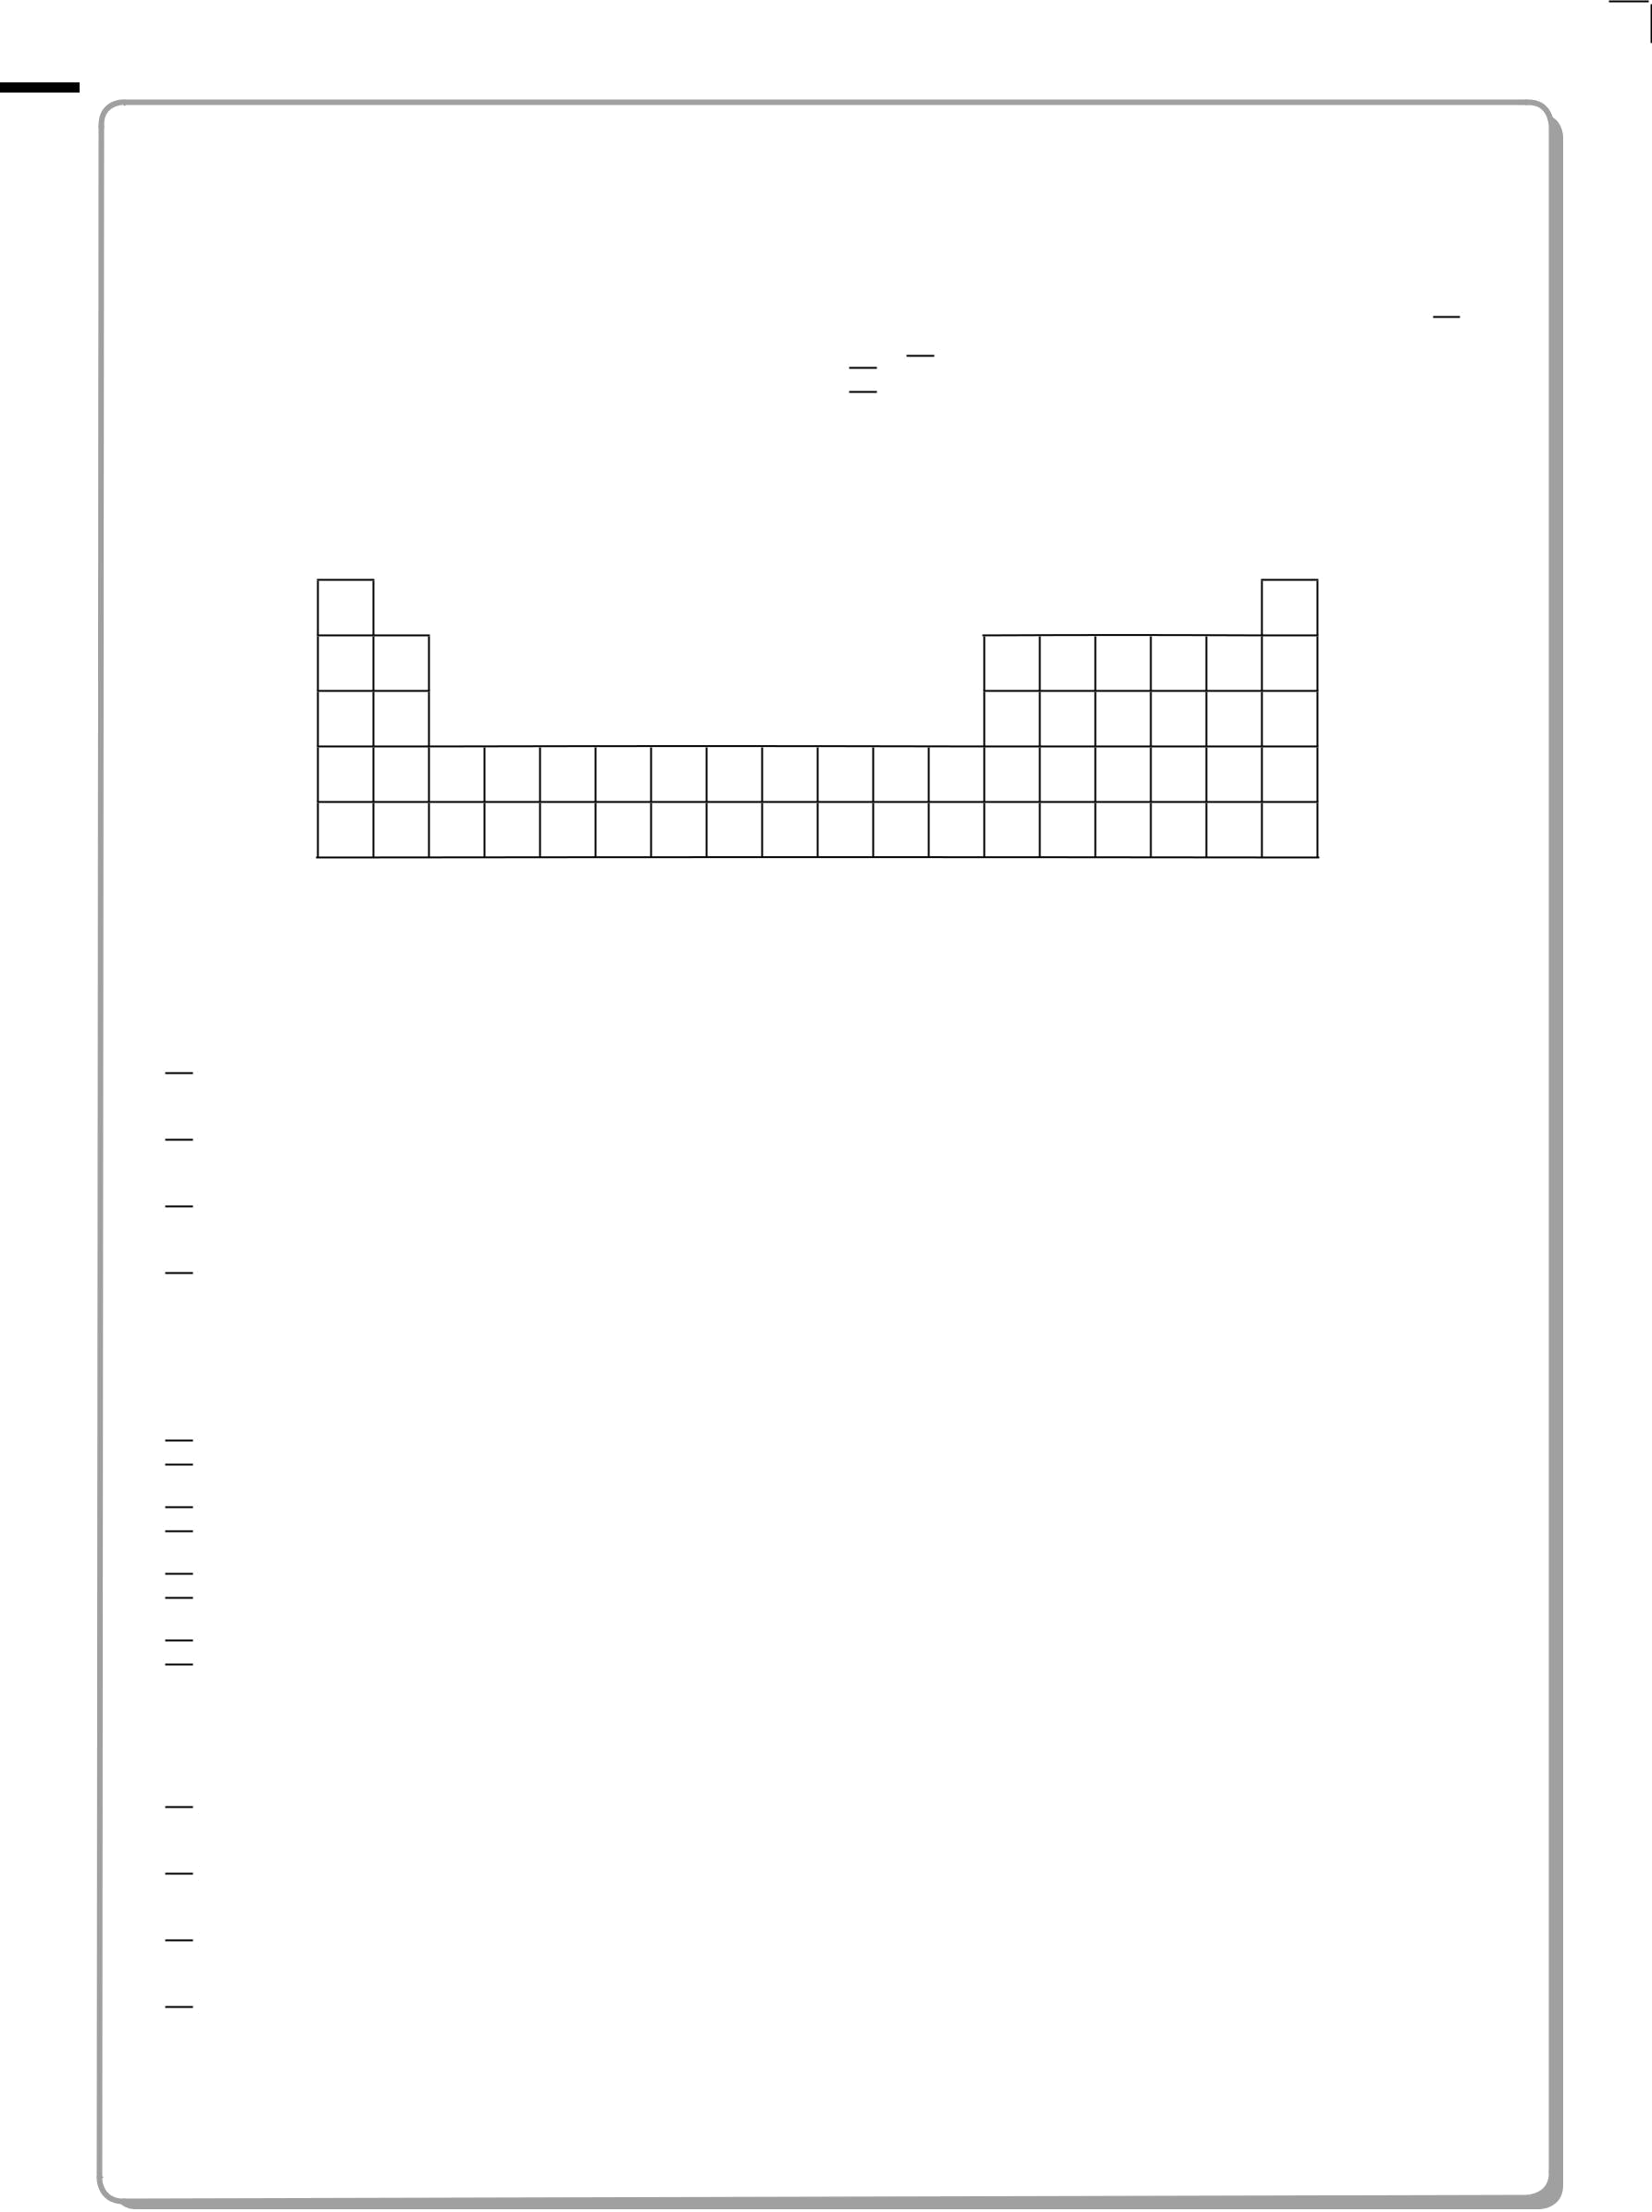
SECTION A

Answer ALL the questions in this section. You should aim to spend no more than 20 minutes on this section. For each question, select one answer from A to D and put a cross in the box . If you change your mind, put a line through the boxand then mark your new answer with
  - cross .

1 In the following outline of the Periodic Table, the letters A to D are not the symbols of the elements.

D

A C

B

Select from A to D the element which

(a) is a non-metal with a high melting temperature and boiling temperature.

(1)

 A

B

C

D

(b) is in the d block of the Periodic Table.

(1)

 A

B

C

D

(c) has a very stable electronic structure.

(1)

A

B

C

D

2 *P38433A0224*



(d) is a metal with a high melting temperature and boiling temperature.

(1)

A

B

C

D

(Total for Question 1 = 4 marks)

- The elements in Group 1 of the Periodic Table have very similar chemical properties. This is because

A they have the same number of outer electrons.

B they have the same number of filled shells of electrons.

C their outer electrons are in the s sub-shell.

D their outer electrons have very similar shielding.

(Total for Question 2 = 1 mark)

- The European Union has set a limit (with effect from January 2010) of 3.13 ppm for the proportion of the toxic gas carbon monoxide in the air that we breathe. This is equivalent to

A 3.13%

B 0.0313%

C 0.000313%

D 0.00000313%

(Total for Question 3 = 1 mark)

- For drivers in the UK, the legal limit of the concentration of ethanol (molar mass

46 g mol^{–1}) in the blood is 80 mg per 100 cm³. This is equivalent to a concentration of

 A 17.4 mol dm^{–3}

B 1.74 mol dm^{–3}

C 0.0174 mol dm^{–3}

D 0.00174 mol dm^{–3}

(Total for Question 4 = 1 mark)

*P38433A0324* | Turn over
 | 3




- An important reaction which occurs in the catalytic converter of a car is

2CO(g) + 2NO(g) o 2CO₂(g) + N₂(g)

In this reaction, when 500 cm³ of CO reacts with 500 cm³ of NO at 650 °C (the operating temperature of the catalyst) and at 1 atm, the total volume of gases produced at the same temperature and pressure is

A 500 cm³

B 750 cm³

C 1000 cm³

D impossible to calculate without knowing the molar volume of gases under these conditions.

(Total for Question 5 = 1 mark)

- When a solution of barium chloride is added to sulfuric acid, a white precipitate is formed. The ionic equation (including state symbols) for this reaction is

A H⁺(aq) + Cl–(aq) o HCl(s)

B Ba⁺(aq) + SO₄–(aq) o BaSO₄(s)

C Ba²⁺(aq) + 2SO₄–(aq) o Ba(SO₄)₂(s)

 D Ba²⁺(aq) + SO₄^{2–}(aq) o BaSO₄(s)

(Total for Question 6 = 1 mark)

- The enthalpy change for the reaction between hydrochloric acid and sodium hydroxide is –56 kJ mol^{–1}. Therefore

A the reaction is exothermic and the temperature rises.

B the reaction is exothermic and the temperature falls.

C the reaction is endothermic and the temperature rises.

D the reaction is endothermic and the temperature falls.

(Total for Question 7 = 1 mark)

4 *P38433A0424*


- The standard enthalpy changes of formation of some sulfur species are:

Species | ǻH_{f} | 9 | / kJ mol^{–1}
S₈(s) |  | 0
S₈(g) |  | +103
S(g) |  | +279

The enthalpy of atomization of sulfur is (in kJ mol^{–1})

A 103 ÷ 8

B 279 ÷ 8

C 279

D (103 ÷ 8) + 279

(Total for Question 8 = 1 mark)

- For which of the following reactions is the enthalpy change equal to the bond enthalpy of H–I?

A HI(g) o ½H₂(g) + ½I₂(s)

B HI(g) o ½H₂(g) + ½I₂(g)

C HI(g) o H(g) + I(g)

D HI(g) o H⁺(g) + I–(g)

(Total for Question 9 = 1 mark)

Use this space for any rough working. Anything you write in this space will gain no credit.

*P38433A0524* | Turn over
 | 5


- The equation for the complete combustion of pentane is

C₅H₁₂(g) + 8O₂(g) o 5CO₂(g) + 6H₂O(l) ǻH_{c}⁹ = –3509 kJ mol^{–1}

The standard enthalpy change of formation of CO₂(g) is –394 kJ mol^{–1} and that of H₂O(l) is –286 kJ mol^{–1}.

The standard enthalpy change of formation of pentane (in kJ mol^{–1}) is A 5(–394) + 6(–286) + (–3509)
B 5(–394) + 6(–286) – (–3509)

C –5(–394) – 6(–286) + (–3509)

D –5(–394) – 6(–286) – (–3509)

(Total for Question 10 = 1 mark)

- All alkenes have

A the same empirical formula and the same general formula.

B the same molecular formula and the same general formula.

C the same molecular formula and the same empirical formula.

D the same empirical formula and the same structural formula.

(Total for Question 11 = 1 mark)

- Covalent bonding results from the strong electrostatic attractions between A instantaneous dipoles.

B electron clouds.

C electrons in the bonding pair.

D bonding pairs of electrons and nuclei.

(Total for Question 12 = 1 mark)

Use this space for any rough working. Anything you write in this space will gain no credit.

6 *P38433A0624*


- This question concerns the reaction of hydrogen bromide with propene.

(a) This reaction requires

(1)

A normal laboratory conditions.

B the presence of UV light.

C the presence of a suitable catalyst.

D heating under reflux.

(b) The reaction is best described as

(1)

A nucleophilic substitution.

B electrophilic substitution.

C nucleophilic addition.

D electrophilic addition.

(c) The major product of the reaction will be

(1)

A 1-bromopropane

B 2-bromopropane

C 1,2-dibromopropane

D 2-bromopropene

(Total for Question 13 = 3 marks)

- Many organic compounds have toxic vapours. For this reason

A a naked flame should never be used when carrying out experiments with organic compounds.

B gloves should usually be worn when carrying out experiments with organic compounds.

C a fume cupboard should be used wherever possible when carrying out experiments with organic compounds.

D most experiments with organic compounds are banned in schools and colleges.

(Total for Question 14 = 1 mark)

*P38433A0724* | Turn over
 | 7


- Ethanol (molar mass 46 g mol^{–1}) is manufactured by the hydration of ethene (molar mass 28 g mol^{–1}):
C₂H₄ + H₂O o C₂H₅OH

In a typical process 28 tonnes of ethene produces 43.7 tonnes of ethanol. The percentage yield of ethanol in this process is

A 64%

B 95%

C 100%

D 156%

(Total for Question 15 = 1 mark)

TOTAL FOR SECTION A = 20 MARKS

8 *P38433A0824*



BLANK PAGE

*P38433A0924* | Turn over
 | 9

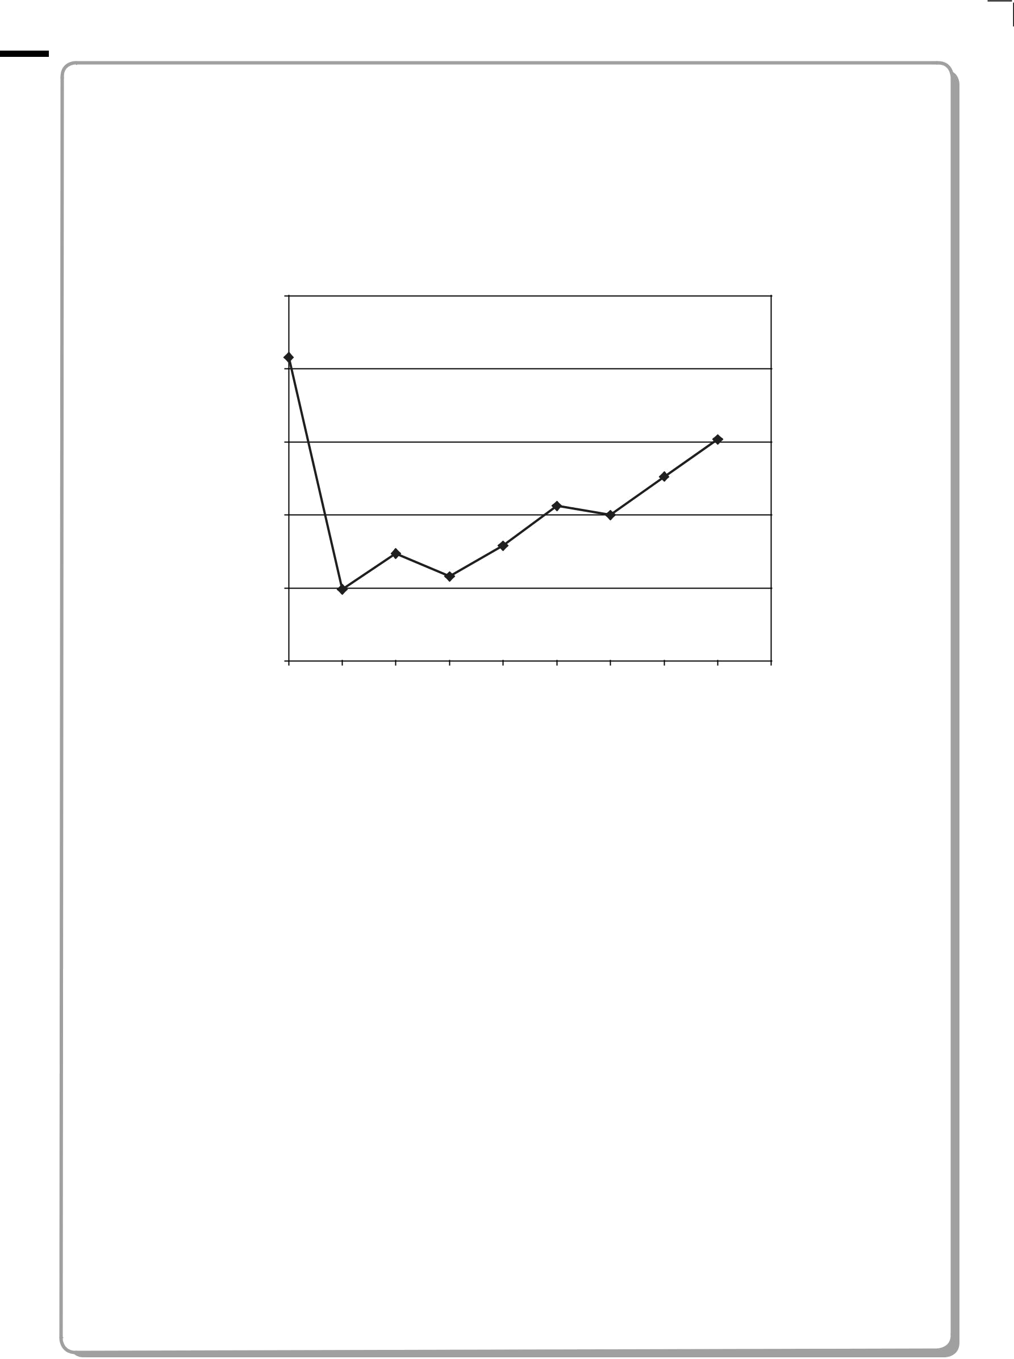
SECTION B

Answer ALL the questions. Write your answers in the spaces provided.

- The first ionization energy of each of the elements from neon to argon is shown on the graph below. The first ionization energy of potassium has been omitted.

2500

2000

1500
Ionization

energy /
kJ mol^{–1} ₁₀₀₀

500

0
Ne Na Mg Al Si P S Cl Ar K

Elements

- Define the term first ionization energy.

(3)

................................................................................................................................................................................................................................................

................................................................................................................................................................................................................................................

................................................................................................................................................................................................................................................

................................................................................................................................................................................................................................................

................................................................................................................................................................................................................................................

................................................................................................................................................................................................................................................

10 *P38433A01024*


- Explain why, in moving from Na to Ar, the general trend is for the first ionization energy to increase.

(3)

................................................................................................................................................................................................................................................

................................................................................................................................................................................................................................................

................................................................................................................................................................................................................................................

................................................................................................................................................................................................................................................

................................................................................................................................................................................................................................................

................................................................................................................................................................................................................................................

(c) Explain why the first ionization energy decreases from P to S.

(2)

................................................................................................................................................................................................................................................

................................................................................................................................................................................................................................................

................................................................................................................................................................................................................................................

................................................................................................................................................................................................................................................

- Estimate the value of the first ionization energy of potassium, K, and write your answer below.

(1)

................................................... kJ mol^{–1}

(Total for Question 16 = 9 marks)

*P38433A01124* | Turn over
 | 11


- 0.400 g of magnesium ribbon reacted with exactly 22.2 cm³ of hydrochloric acid of concentration 1.50 mol dm^{–3}.

400 cm³ of hydrogen gas was formed, the volume being measured at room temperature and pressure.

In the calculations that follow, use the following molar masses:

Mg = 24.0 g mol^{í1}
Cl = 35.5 g mol^{í1}

(a) Calculate the amount (in moles) of magnesium used.

(1)

(b) Calculate the amount (in moles) of hydrochloric acid used.

(1)

- Calculate the amount (in moles) of hydrogen produced.

[Molar volume of any gas at room temperature and pressure = 24 000 cm³ mol^{í1}]
(1)

- Show that the calculated amounts of magnesium, hydrochloric acid and hydrogen are consistent with the following equation for the reaction

Mg + 2HCl o MgCl₂ + H₂

(1)

12 *P38433A01224*


- Calculate the maximum mass of magnesium chloride that would be formed in this reaction. Give your answer to three significant figures.

(3)

(Total for Question 17 = 7 marks)

*P38433A01324* | Turn over
 | 13


- Copper(II) sulfate exists as blue hydrated crystals and white anhydrous crystals. The enthalpy changes of solution for these two substances may be represented by the following simplified equations:

CuSO₄.5H₂O(s) + aq o CuSO₄(aq) | ǻH₁ | = +11.5 kJ mol^{–1}
blue
CuSO₄(s) + aq o CuSO₄(aq) | ǻH₂ | = –66.1 kJ mol^{–1}
white

- (i) Fill in the box and add labelled arrows to complete the Hess cycle to enable you to calculate ǻH_{reaction}.
(3)

ǻHreaction
CuSO₄.5H₂O(s) o CuSO₄(s) + 5H₂O(l)

(ii) Calculate a value for the enthalpy change ǻH_{reaction}.

(2)

- Suggest why it is not possible to directly measure the enthalpy change for the conversion of the blue hydrated copper(II) sulfate crystals into the white anhydrous crystals.

(1)

................................................................................................................................................................................................................................................

................................................................................................................................................................................................................................................

................................................................................................................................................................................................................................................

................................................................................................................................................................................................................................................

14 *P38433A01424*


*(c) (i) CuSO₄.5H₂O(s) + aq o CuSO₄(aq) ǻH₁ = +11.5 kJ mol^{–1}

Describe briefly the experimental procedure that you would use to obtain the data necessary to calculate ǻH₁, given a known mass of hydrated copper(II) sulfate crystals, CuSO₄.5H₂O(s).

You should state the apparatus that you would use and any measurements that you would make.

You are not required to calculate the amounts of substances or to explain how you would use the data obtained.

(4)

................................................................................................................................................................................................................................................

................................................................................................................................................................................................................................................

................................................................................................................................................................................................................................................

................................................................................................................................................................................................................................................

................................................................................................................................................................................................................................................

................................................................................................................................................................................................................................................

................................................................................................................................................................................................................................................

................................................................................................................................................................................................................................................

- The value for the enthalpy change from (c)(i) obtained by experiments in a school laboratory is likely to be significantly different from a data book value.

List three possible reasons for this which do not relate to the quality of the apparatus or chemicals used or possible mistakes in carrying out the procedure.

(3)

1 ...........................................................................................................................................................................................................................................

................................................................................................................................................................................................................................................

2 ...........................................................................................................................................................................................................................................

................................................................................................................................................................................................................................................

3 ...........................................................................................................................................................................................................................................

................................................................................................................................................................................................................................................

(Total for Question 18 = 13 marks)

*P38433A01524* | Turn over
 | 15


- This question is about alkanes.

(a) The skeletal formulae of two alkanes (A and B) are shown below.

A B

(i) Write the general formula of the alkanes.

(1)

(ii) Compounds A and B are ...................................................................... of each other.

(1)

(iii) Draw the displayed formula of compound A.

(1)

(iv) Give the systematic name of compound B.

(1)

................................................................................................................................................................................................................................................

16 *P38433A01624*

- The largest use for alkanes is as fuels. However, there are problems associated with the combustion of alkanes, whether complete or incomplete.

  - An incomplete combustion of methane, CH₄, results in the formation of carbon monoxide and water only.

Write the equation for this reaction. State symbols are not required.

(2)

(ii) When does incomplete combustion occur?

(1)

................................................................................................................................................................................................................................................

................................................................................................................................................................................................................................................

(iii) State two problems that result from the incomplete combustion of alkane fuels.

(2)

1 ...........................................................................................................................................................................................................................................

................................................................................................................................................................................................................................................

2 ...........................................................................................................................................................................................................................................

................................................................................................................................................................................................................................................

*(iv) State and explain the main environmental problem arising from the complete combustion of alkane fuels.

(3)

................................................................................................................................................................................................................................................

................................................................................................................................................................................................................................................

................................................................................................................................................................................................................................................

................................................................................................................................................................................................................................................

................................................................................................................................................................................................................................................

................................................................................................................................................................................................................................................

*P38433A01724* | Turn over
 | 17


- The reactions of organic compounds, including alkanes, may be broken down into a series of steps; this is the mechanism for the reaction. The reaction between methane and chlorine may be represented by a mechanism involving three stages – initiation, propagation and termination.

  - Reaction mechanisms often involve the use of ‘curly arrows’. Explain the meaning of the curly arrows shown below.

(2)

Arrow I Arrow II

Arrow I ............................................................................................................................................................................................................................

................................................................................................................................................................................................................................................

Arrow II ..........................................................................................................................................................................................................................

................................................................................................................................................................................................................................................

- Using the curly arrow notation, show the initiation step of the reaction between methane and chlorine.

(2)

18 *P38433A01824*


- Give the two propagation steps of the reaction between methane and chlorine. Curly arrows are not required.

(2)

- Suggest why a small amount of UV light can result in the formation of a large amount of product.

(1)

................................................................................................................................................................................................................................................

................................................................................................................................................................................................................................................

- Ethane is a trace product of this reaction. By means of an equation, show how the ethane is formed.

(1)

- Scientists never detect molecular hydrogen, H₂, amongst the products of the chlorination of methane.

Use the data below to suggest why this is so.

The frequency of UV light used corresponds to an energy of about 400 kJ mol^{–1}.

Bond Bond enthalpy/kJ mol^{–1}

C H 435

Cl Cl 243

(2)

................................................................................................................................................................................................................................................

................................................................................................................................................................................................................................................

................................................................................................................................................................................................................................................

................................................................................................................................................................................................................................................

(Total for Question 19 = 22 marks)

*P38433A01924* | Turn over
 | 19

- Metals are good conductors of heat and electricity and usually have high melting temperatures and boiling temperatures.

  - (i) Describe the structure of a metal.

(2)

................................................................................................................................................................................................................................................

................................................................................................................................................................................................................................................

................................................................................................................................................................................................................................................

................................................................................................................................................................................................................................................

................................................................................................................................................................................................................................................

(ii) Describe the bonding in a metal.

(2)

................................................................................................................................................................................................................................................

................................................................................................................................................................................................................................................

................................................................................................................................................................................................................................................

................................................................................................................................................................................................................................................

................................................................................................................................................................................................................................................

- Explain why the melting temperature of magnesium (650 °C) is much higher than that of sodium (98 °C).

(3)

................................................................................................................................................................................................................................................

................................................................................................................................................................................................................................................

................................................................................................................................................................................................................................................

................................................................................................................................................................................................................................................

................................................................................................................................................................................................................................................

................................................................................................................................................................................................................................................

20 *P38433A02024*


(c) Explain how metals conduct electricity.

(2)

................................................................................................................................................................................................................................................

................................................................................................................................................................................................................................................

................................................................................................................................................................................................................................................

................................................................................................................................................................................................................................................

(Total for Question 20 = 9 marks)

TOTAL FOR SECTION B = 60 MARKS

TOTAL FOR PAPER = 80 MARKS

*P38433A02124* 21

BLANK PAGE

22 *P38433A02224*

BLANK PAGE

*P38433A02324* 23

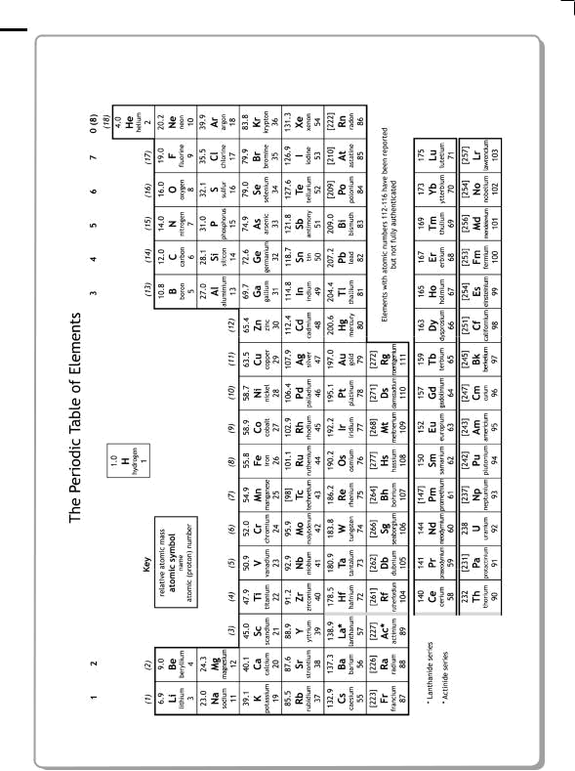

24 *P38433A02424*

