

MSc Data Science Project
7PAM2002
Department of Physics, Astronomy and Mathematics

Data Science FINAL PROJECT REPORT

Project Title:
Sentiment Analysis of Amazon Reviews Using Machine Learning and Transformer Models

Student Name and SRN:
Muhammad Saad Bin Sagheer
23086746
Supervisor: Klaas Wiersema
Date Submitted: Enter the date you are submitting this report
Word Count: Enter the word count excluding references and appendices
GitHub Link: https://github.com/Saadi222/MSc-Final-Project.git

DECLARATION STATEMENT

This report is submitted in partial fulfilment of the requirement for the degree of Master of Science in Data Science at the University of Hertfordshire.
I have read the detailed guidance to students on academic integrity, misconduct and plagiarism information at Assessment Offences and Academic Misconduct and understand the University process of dealing with suspected cases of academic misconduct and the possible penalties, which could include failing the project or course.
I certify that the work submitted is my own and that any material derived or quoted from published or unpublished work of other persons has been duly acknowledged. (Ref. UPR AS/C/6.1, section 7 and UPR AS/C/5, section 3.6)
I did not use human participants in my MSc Project.

I hereby give permission for the report to be made available on module websites provided the source is acknowledged.

Student Name printed: Muhammad Saad Bin Sagheer

Student Name signature

Student SRN number: 23086746

UNIVERSITY OF HERTFORDSHIRE
SCHOOL OF PHYSICS, ENGINEERING AND COMPUTER SCIENCE

ABSTRACT
The aim of this project is to analyse Amazon product reviews using Natural Language Processing (NLP) techniques to automatically classify customer sentiments. The study investigates whether transformer-based models, specifically DistilBERT, outperform classical machine-learning algorithms such as Logistic Regression and Random Forest when applied to noisy, imbalanced textual data. The dataset consists of publicly available Amazon customer reviews, which were pre-processed through cleaning, tokenisation, TF-IDF representation, and class-imbalance handling, followed by exploratory data analysis to understand rating distributions, review patterns, and linguistic characteristics. Sentiment classification models were trained and evaluated using accuracy and F1-scores.The project concludes by comparing model behaviours, discussing the strengths of transformer architectures in contextual understanding, and outlining practical implications for businesses seeking to automate large-scale review analysis.

Table of Contents:

List of Figures:

List of Tables:

Introduction
Online product reviews have become one of the most influential sources of information in modern digital marketplaces. On platforms such as Amazon, millions of customers rely on written reviews and ratings to make informed purchasing decisions, while businesses depend on this feedback to assess product quality, monitor customer satisfaction, and guide future development. However, the vast volume of reviews generated daily makes manual analysis impractical, creating the need for automated methods capable of extracting meaningful insights at scale. The industry increasingly uses Natural Language Processing (NLP) and machine learning to analyse consumer opinions, detect sentiment, and summarise feedback into concise forms that support decision-making processes.
Sentiment analysis has been widely explored using traditional machine learning techniques such as Logistic Regression and Random Forests, which typically rely on bag-of-words or TF-IDF representations. More recently, transformer-based models like BERT and DistilBERT have set new performance benchmarks due to their ability to capture contextual meaning within text. Despite these developments, challenges remain in handling noisy user-generated text, addressing class imbalance in datasets, and ensuring the generalisability of models across diverse product categories.
Research Question:
Can machine learning and transformer-based models accurately classify sentiment in Amazon product reviews, and how do their performances compare on the same dataset?
Aims and Objectives:
The primary aim of this project is to build and evaluate multiple sentiment classification models using Amazon review data, and to compare the performance of classical machine learning algorithms with a transformer-based model (DistilBERT). The main objectives are:
- To perform exploratory data analysis (EDA) to understand review distributions, text characteristics, and sentiment patterns.
- To clean and preprocess review text using standard NLP techniques such as tokenisation, stopword removal, and lemmatisation.
- To implement baseline machine learning models (Logistic Regression, Random Forest) using TF-IDF features.
- To fine-tune a DistilBERT transformer model for sentiment classification.
- To perform hyperparameter tuning on all models to improve performance and address class imbalance.
- To evaluate and compare model performance using accuracy, macro F1-score, weighted F1-score, and confusion matrices.
- To interpret results and identify which modelling approach is most effective for sentiment classification of Amazon reviews.
This project contributes to understanding how modern NLP techniques can improve automated review analysis to support businesses and consumers.
Literature Review
I have used 3 different types of models in this project which are
1. Logistic Regression
Logistic Regression has been widely adopted as a baseline model for sentiment analysis due to its computational efficiency and strong performance on high-dimensional sparse text representations. Pang and Lee (2008) demonstrated that linear classifiers, when combined with bag-of-words features, can effectively classify sentiment despite originally being designed for topic classification. Their work showed that sentiment classification poses unique challenges, as sentiment often depends on subtle linguistic cues rather than dominant topic words.
Joachims (2002) further established the suitability of linear models for text classification by showing that they scale efficiently with large feature spaces generated by TF-IDF representations. Logistic Regression benefits from this property and often generalises well when regularisation is applied. However, a key limitation highlighted in the literature is that Logistic Regression ignores word order and semantic context, treating text as an unordered set of features. As a result, it struggles with negation, sarcasm, and contextual polarity shifts. In this project, Logistic Regression is used as a strong and interpretable baseline against which more complex models are evaluated.
2. Random Forest
Random Forest is an ensemble learning algorithm that aggregates predictions from multiple decision trees to improve robustness and reduce variance. Kowsari et al. (2019) analysed Random Forest performance across multiple text classification tasks and reported that while ensemble methods can capture non-linear patterns, they often perform poorly on sparse, high-dimensional feature spaces such as TF-IDF matrices. The study highlighted that decision trees tend to memorise training examples, leading to overfitting when applied to textual data.
This limitation is particularly problematic for sentiment analysis datasets that are imbalanced, where dominant sentiment classes can bias tree splits. Although Random Forest can outperform linear models in some structured datasets, its effectiveness in NLP tasks is often limited without dimensionality reduction or feature selection. The findings of Kowsari et al. align closely with the results observed in this project, where Random Forest achieved very high training accuracy but lower validation accuracy, indicating overfitting. Despite this, Random Forest provides a useful comparison point as it represents a fundamentally different modelling approach from linear classifiers.
3. Transformer-Based Models (DistilBERT)
Transformer architectures have significantly advanced sentiment analysis by enabling contextual understanding of text. Devlin et al. (2019) introduced BERT, which employs bidirectional self-attention to model word meaning based on surrounding context. Their experiments demonstrated substantial performance improvements over traditional machine learning models across several NLP tasks, including sentiment classification. Unlike TF-IDF-based models, BERT captures semantic relationships, negation, and long-range dependencies.
However, BERT’s large model size and computational cost limit its practicality in some applications. Sanh et al. (2019) proposed DistilBERT, a compressed version of BERT trained using knowledge distillation. Their results showed that DistilBERT retains approximately 97% of BERT’s performance while being significantly smaller and faster. This makes DistilBERT particularly suitable for real-world sentiment analysis tasks where computational efficiency is important.
Despite their advantages, transformer models are sensitive to hyperparameters and training configuration. Sun et al. (2020) demonstrated that inappropriate learning rates, excessive training epochs, or lack of regularisation can lead to overfitting during fine-tuning. These findings directly inform the methodological choices in this project, where DistilBERT is fine-tuned with reduced epochs, weight decay, and early stopping to improve generalisation on Amazon review data.

Dataset Description
The dataset used in this project consists of customer reviews collected from the Amazon e-commerce platform. The dataset was obtained from Kaggle, a widely used online platform for data science datasets and competitions. This dataset hosted on Kaggle is a curated version of the Amazon Reviews data originally compiled by McAuley and Leskovec (2015) at the University of California, San Diego. The original dataset was created for academic research purposes, particularly in the areas of recommender systems, sentiment analysis, and consumer behaviour modelling.
Each record in the dataset represents a single customer review and includes textual and metadata attributes such as the review text, review title, star rating (ranging from one to five), review date, and limited reviewer information. In this project, the review text is used as the primary input feature for sentiment classification models. The target sentiment labels are derived from the star ratings, where ratings of one and two indicate negative sentiment, three indicates neutral sentiment, and ratings of four and five indicate positive sentiment.
This dataset was chosen because it is well suited to addressing the research question of automated sentiment analysis using Natural Language Processing techniques. The large volume of real-world, user-generated text allows for meaningful evaluation of classical machine learning models and transformer-based models such as DistilBERT. Additionally, the dataset presents realistic challenges including class imbalance, noisy text, varying review lengths, and diverse writing styles, making it an appropriate benchmark for evaluating model robustness and generalisation.
Overall, the Amazon Reviews dataset provides a realistic foundation for investigating sentiment classification methods and directly supports the aims and objectives of this project.
Data Pre-processing and Feature Engineering
The csv file contains data which required extensive data pre-processing before it could be used for sentimental analysis. The first step involved loading the dataset and performing a structural inspection to identify missing values, duplicate records, and inconsistent formatting. Column names were standardised by removing unnecessary whitespace to ensure consistency across processing steps.
One of the key challenges in the dataset was the inconsistent representation of the rating information, which in some cases appeared as textual strings rather than numeric values. To address this, a custom parsing function was implemented to extract the numerical rating from the rating column. These numeric ratings were then used to derive sentiment labels, categorising reviews as negative, neutral, or positive. Reviews with missing or invalid rating values were excluded from supervised model training
The textual review data required significant cleaning due to the noisy nature of user-generated content. A comprehensive text preprocessing pipeline was implemented, which included converting text to lowercase, removing HTML tags, URLs, non-ASCII characters, punctuation, and excessive whitespace. Common English stopwords were removed to reduce noise, and lemmatisation was applied to normalise word forms. This resulted in a cleaned version of the review text, which was stored as a separate column and used as the primary input for all models.
Duplicate reviews were identified and removed using a combination of reviewer identifiers and review text to prevent data leakage and biased learning. Rows with missing review text were also dropped, as they provide no useful information for sentiment classification.
To support exploratory data analysis and feature engineering, additional numerical features were created from the cleaned text, including word count, character count, number of unique words, and average word length. These features were used to analyse review length distributions and their relationship with sentiment polarity.
Since the dataset exhibited class imbalance, with certain sentiment categories being overrepresented, class balancing techniques were applied during model training. For classical machine learning models, random oversampling was used to balance the training data, while for transformer-based models (DistilBert), class weights were incorporated into the loss function to mitigate bias towards majority classes.
Finally, for classical machine learning models such as Logistic Regression and Random Forest, the cleaned text data was transformed into numerical representations using TF-IDF vectorisation. This produced high-dimensional sparse feature matrices suitable for linear and ensemble classifiers. For the DistilBERT model, the cleaned text was tokenised using a pre-trained tokenizer, ensuring compatibility with the transformer architecture.
Overall, the data pre-processing pipeline ensured that the dataset was clean, consistent, and suitable for both traditional machine learning and deep learning approaches, while preserving the semantic content necessary for accurate sentiment analysis.
Exploratory Data Analysis
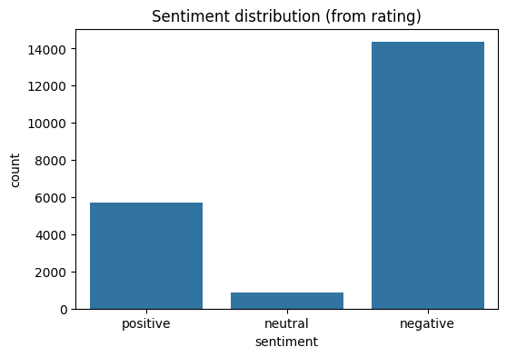
Figure 1: Distribution of Sentiment Classes
Figure 1 illustrates the distribution of sentiment classes derived from the review ratings. The diagram shows a clear class imbalance, with negative reviews forming majority of the observations, followed by positive reviews, while neutral reviews represent a very small proportion of the data.
This imbalance indicates that customers are more likely to leave reviews when they have a negative experience, a phenomenon commonly observed in online review platforms. The relatively low number of neutral reviews suggests that users tend to express strong opinions rather than moderate feedback. Such skewed class distributions pose challenges for supervised learning models, as classifiers may become biased towards the majority class and achieve misleadingly high accuracy without correctly identifying minority sentiment categories.
The observed class imbalance motivated the use of class balancing strategies during model training. For classical machine learning models, random oversampling was applied to balance the sentiment classes in the training set. For transformer-based models, class weights were incorporated into the loss function to reduce bias towards the dominant negative class. Addressing this imbalance was essential to ensure fair model evaluation and to improve the reliability of sentiment predictions across all classes.
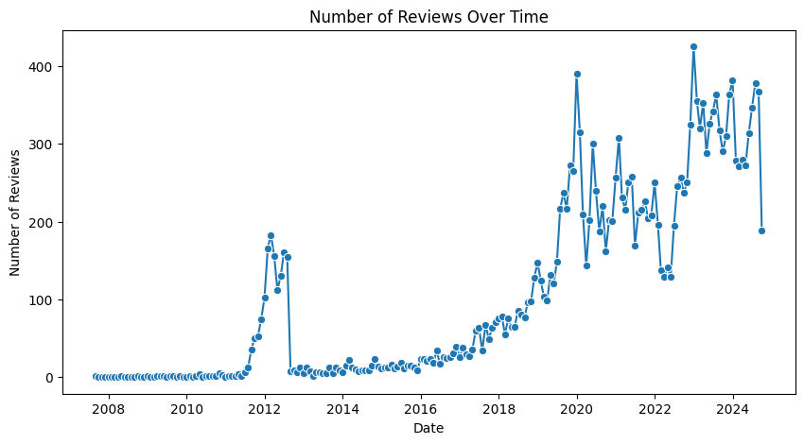
Figure 2: Number of reviews over time
Figure 2 shows the number of reviews submitted over time. There is a clear upward trend in review activity, particularly after 2017, indicating increasing user engagement on the platform. Earlier years exhibit very low review counts, which suggests limited data availability or lower platform usage during that period. The sharp increase in later years reflects the growth of e-commerce adoption and higher customer participation in online feedback. This trend highlights that the dataset is dominated by more recent reviews, which may influence sentiment patterns and model learning.
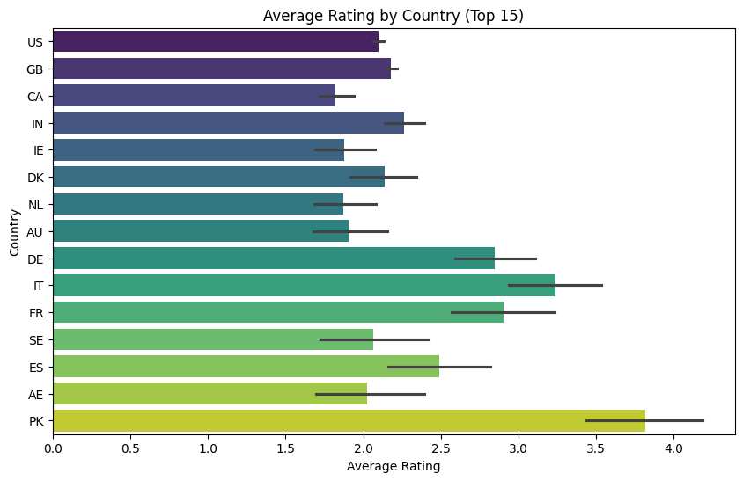
Figure 3: Average Review Rating by Countries (Top 15)
Figure 3 represents the average review rating across the top 15 countries in the dataset. The results show noticeable variation in average ratings between countries, indicating differences in customer satisfaction or reviewing behaviour across regions. Some countries exhibit consistently higher average ratings, suggesting more positive feedback, while others show lower averages, which may reflect stricter rating tendencies or differing expectations among customers. The error bars indicate variability in ratings within each country, highlighting that while average sentiment differs, substantial diversity in individual opinions exists across all regions. This geographical variation provides useful context for understanding potential regional biases in sentiment distribution.
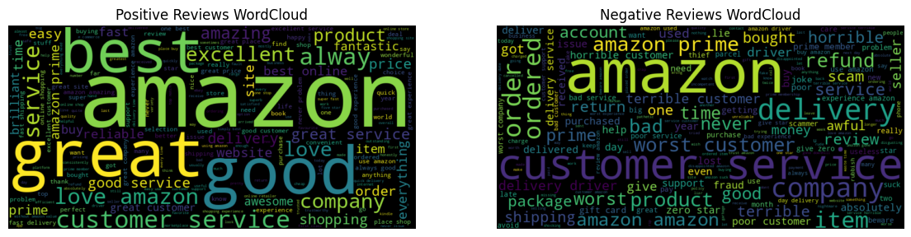
Figure 4: Word Cloud for positive and negative reviews
Figure 4 illustrates word clouds generated from positive and negative reviews. In the positive reviews, frequently occurring words such as “good,” “great,” “excellent,” “love,” and “best” dominate, reflecting overall customer satisfaction and favourable product experiences. These terms are commonly associated with product quality, value, and service reliability.
In contrast, the negative reviews are characterised by words such as “bad,” “worst,” “problem,” “refund,” “delivery,” and “customer service,” indicating dissatisfaction related to product defects, delayed delivery, and service-related issues. The presence of transactional terms such as “refund” and “order” suggests that negative sentiment is often linked to post-purchase experiences rather than the product itself.
This visual comparison highlights clear linguistic differences between positive and negative sentiment classes, supporting the suitability of text-based features for sentiment classification and reinforcing the importance of contextual modelling in sentiment analysis.

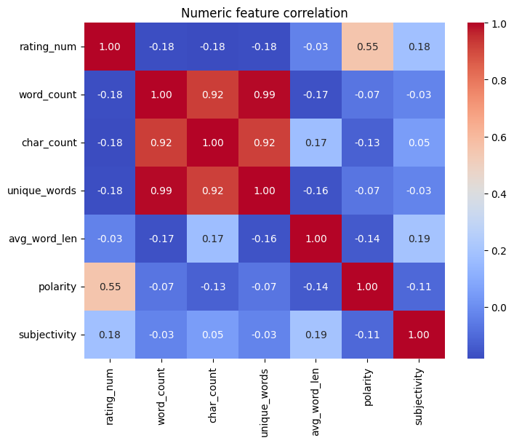
Figure 5: Correlation matrix of numeric features
Figure 5 shows the correlation between numeric features from the review’s dataset. Strong correlations are observed among review length-related features such as word count, character count, and number of unique words. A moderate positive correlation between rating and sentiment polarity suggests general agreement between numerical ratings and textual sentiment, although the relationship is not perfect. Other features show weak correlations, which means that sentiment is better captured through textual content rather than numeric attributes alone.

Model Selection and Evaluation Metrics
Based on the findings of literature review, and the objectives of this project, I selected 3 models for classification of amazon reviews sentiments. These 3 models are Logistic Regression, Random Forest and DistilBERT. The reason for there selection is that they follow 2 distinct modelling paradigms which are machine learning, ensemble learning and transformer based deep learning. The aim was to do comprehensive analysis of these techniques.
The model selection was guided by the following criteria:
- Logistic Regression: Logistic Regression is a widely used baseline model for text classification tasks due to its simplicity, interpretability, and strong performance on high-dimensional sparse features such as TF-IDF representations. It serves as a benchmark model to evaluate whether more complex approaches provide meaningful performance improvements.
- Random Forest: Random Forest is an ensemble learning algorithm that combines multiple decision trees to capture non-linear relationships in data. Its inclusion enables the assessment of whether ensemble-based methods can improve sentiment classification performance over linear models, particularly in the presence of complex feature interactions.
- DistilBERT: DistilBERT is a transformer-based deep learning model that leverages contextual embeddings to capture semantic relationships within text. As a lightweight variant of BERT, it offers a balance between performance and computational efficiency, making it suitable for large-scale sentiment analysis. This model represents the state-of-the-art approach in NLP and is included to evaluate the benefits of contextual learning over traditional feature-based methods.
I divided the dataset into training and testing subsets using an 80–20 split, which means 80% of the data was used for training while 20% was used for testing. The training set was used to fit the models, while the test set was reserved for evaluating performance on unseen data to assess generalisation ability.
Since class imbalance was present in the dataset, accuracy alone was not sufficient to evaluate model performance. Therefore, I used multiple classification metrics ensure a robust evaluation. These included accuracy, precision, recall, and F1-score. The F1-score was considered particularly important, as it provides a balanced measure of model performance by accounting for both false positives and false negatives, making it well-suited for imbalanced classification problems.
To further assess model behaviour, confusion matrices were used to visualise classification performance across sentiment classes. For the classical machine learning models, learning curves were also plotted to examine potential underfitting or overfitting by comparing training and validation performance across increasing training set sizes. For the DistilBERT model, training and validation loss curves were analysed across epochs to monitor convergence and detect overfitting.
Overall, this evaluation framework ensured that the selected models were assessed not only based on predictive performance but also on their ability to generalise effectively to unseen data, providing a reliable comparison between traditional machine learning approaches and transformer-based models.
Accuracy
It measures the proportion of correctly classified instances among all predictions made by the model. It provides a general overview of model performance; however, it can be misleading in the presence of class imbalance, as a model may achieve high accuracy by favouring the majority class.
$$\text{Accuracy}=\frac{TP+TN}{TP+TN+FP+FN}$$Where:
- $TP$= True Positives
- $TN$= True Negatives
- $FP$= False Positives
- $FN$= False Negatives
F1-Score
The F1-score is the harmonic mean of precision and recall and provides a balanced evaluation of a model’s performance, particularly in imbalanced classification problems. It penalises models that perform well on one metric but poorly on the other, making it more reliable than accuracy when class distributions are skewed.
$$\text{F1-score}=2×\frac{\text{Precision}×\text{Recall}}{\text{Precision}+\text{Recall}}$$
Where:
$$\text{Precision}=\frac{TP}{TP+FP} \\ \text{Recall}=\frac{TP}{TP+FN}$$
In this project, I used weighted F1-score to account for class imbalance by weighting each class’s F1-score according to its support (number of samples). This ensures that the evaluation reflects model performance across all sentiment classes rather than being dominated by the majority class.

References

Devlin, J., Chang, M.W., Lee, K. and Toutanova, K. (2019) BERT: Pre-training of Deep Bidirectional Transformers for Language Understanding. Proceedings of NAACL-HLT 2019. Available at: https://arxiv.org/abs/1810.04805
Joachims, T. (2002) ‘Learning to Classify Text Using Support Vector Machines’, Proceedings of the European Conference on Machine Learning (ECML), pp. 137–142. Available at: https://www.cs.cornell.edu/people/tj/publications/joachims_02a.pdf

Kowsari, K. et al. (2019) ‘Text Classification Algorithms: A Survey’, Information, 10(4), pp. 1–68. Available at: https://www.mdpi.com/2078-2489/10/4/150
Pang, B. and Lee, L. (2008) ‘Opinion Mining and Sentiment Analysis’, Foundations and Trends in Information Retrieval, 2(1–2), pp. 1–135. Available at: https://www.cs.cornell.edu/home/llee/omsa/omsa.html
Sanh, V. et al. (2019) DistilBERT, a Distilled Version of BERT: Smaller, Faster, Cheaper and Lighter. Available at: https://arxiv.org/abs/1910.01108
Sun, C., Qiu, X., Xu, Y. and Huang, X. (2020) ‘How to Fine-Tune BERT for Text Classification?’, Proceedings of the China National Conference on Chinese Computational Linguistics, pp. 194–206. Available at: https://arxiv.org/abs/1905.05583
McAuley, J. and Leskovec, J. (2015) From Amateurs to Connoisseurs: Modeling the Evolution of User Expertise through Online Reviews. Proceedings of the 24th International World Wide Web Conference (WWW).
Available at: https://nijianmo.github.io/amazon/index.html
Kaggle (n.d.) Amazon Reviews Dataset. [Online]
Available at: https://www.kaggle.com/

.

