Geometry or Grounding? Hyperbolic Embeddings and Multi-Hop Hallucination in Biomedical Knowledge-Graph Retrieval
Saadia Asghar  Faculty of Computer Science and Engineering  Ghulam Ishaq Khan Institute of Engineering Sciences and Technology  Topi, Khyber Pakhtunkhwa, Pakistan | Zakarya Ahmed  Faculty of Computer Science and Engineering  Ghulam Ishaq Khan Institute of Engineering Sciences and Technology  Topi, Khyber Pakhtunkhwa, Pakistan

Abstract—Knowledge-graph retrieval-augmented generation (KG-RAG) can hallucinate across hops: a multi-hop retriever may return an entity that no real chain of relations connects to the question. Hyperbolic embeddings are often proposed as a remedy because curved space represents hierarchical, multi-hop structure with low distortion, but this has rarely been tested under controlled conditions. We define a graph-grounded hop-hallucination rate (HHR@1), the fraction of queries whose top-ranked answer has no exact typed path from the query in the training graph, and compare Euclidean and Poincaré retrievers with matched triplets, mini-batches, negatives and epochs and with validation-selected learning rates. On leakage-controlled 2-hop and 3-hop gene–disease–compound tasks built from Hetionet v1.0, a pre-registered sweep over dimension (2–16), curvature (1 and 10) and ten seeds shows that Poincaré geometry reduced 3-hop hop hallucination at dimension 8 (HHR@1 0.553 vs. 0.694; Holm-adjusted p = 0.030; lower in 10 of 10 seeds) with unchanged accuracy (MRR 0.079 vs. 0.080). The other seven pre-registered comparisons were not significant. On 2-hop queries, Poincaré embeddings of dimension 4 and 8 hallucinated 3–6 points less in 8–10 of 10 seeds (Holm p < 0.02) at equal MRR, whereas at dimension 16 the advantage faded. Explicit typed-path verification reduced 3-hop HHR@1 to 0.026 for both geometries. Hyperbolic geometry thus gives a modest, dimension-dependent reduction in hop hallucination, while structural grounding is far more effective. We also show that under-training and mismatched optimisers can each manufacture or hide geometry effects.
Index Terms—knowledge graphs, retrieval-augmented generation, hallucination, hyperbolic embeddings, Poincaré ball, biomedical retrieval, multi-hop reasoning, reproducibility
I. Introduction
Retrieval-augmented generation (RAG) reduces hallucination in language models by grounding their output in retrieved knowledge [1]. When the knowledge source is a graph, retrieval must follow relational paths, which has motivated graph-based RAG [2] and biomedical KG-augmented prompting [3]. Multi-hop retrieval, however, introduces its own failure mode. A retriever asked which compound acts on a gene associated with a disease may return a compound that is close to the query in embedding space but connected to it by no real chain of relations. We call this a hop hallucination. The answer looks plausible, yet the path that would justify it does not exist, and in a RAG system it becomes ungrounded context for the generator.
Hyperbolic geometry is a natural candidate remedy. Hyperbolic space grows exponentially with radius, so trees and hierarchies embed with low distortion [6], [7], and Poincaré embeddings [5], hyperbolic neural networks [8] and hyperbolic KG embeddings [9], [10] have reported advantages over Euclidean ones, especially at low dimension. If curved space preserves multi-hop structure better, a hyperbolic retriever should place path-connected answers closer to the query and hallucinate fewer hops.
Testing this fairly is difficult. Changing the geometry usually also changes the optimiser, effective learning rate, training budget or negative sampling, and KG-embedding results are highly sensitive to such choices [15], [16]. Single-seed comparisons can be dominated by random variation [19], and multi-hop evaluation risks answer leakage. We therefore ask: under matched, leakage-controlled conditions, does Poincaré geometry reduce multi-hop hallucination in biomedical KG retrieval, and how does it compare with explicit structural grounding? Our contributions are:
• a graph-grounded, measurable definition of hop hallucination (HHR@1, Unsupported@10), always reported alongside accuracy;
• a controlled framework (RMF-RAG) in which Euclidean and Poincaré retrievers share identical triplets, mini-batches, negatives and epochs, evaluated on a leakage-controlled Hetionet v1.0 benchmark;
• a pre-registered sweep over dimension, curvature and ten seeds showing a modest, dimension-dependent reduction in hop hallucination from hyperbolic geometry at unchanged accuracy;
• evidence that typed-path verification removes almost all hop hallucination regardless of geometry, and an analysis of its cost;
• two documented optimisation confounds that would otherwise have produced misleading geometry conclusions.
II. Related Work
Retrieval-augmented generation. RAG couples a generator with non-parametric retrieval [1]. GraphRAG summarises entity graphs for query-focused summarisation [2], and biomedical KG-RAG retrieves context from a curated KG to improve LLM answers [3]. These systems assume that retrieved graph context is connected to the question; HHR@1 measures when this assumption fails at retrieval time, before any text is generated.
KG embeddings and multi-hop queries. TransE [12] embeds entities so that true triples are close, and query-embedding methods such as GQE [13] and Query2box [14] compose embeddings along relational paths without traversing them, so their answers need not be path-supported. Re-evaluations show that training configuration often matters as much as architecture [15], [16].
Hyperbolic representations. Real networks can have latent hyperbolic geometry [6]. Poincaré embeddings trained with Riemannian SGD [5], [11] were followed by hyperbolic neural networks [8], MuRP [9], AttH [10] and mixed-curvature spaces [20]. These works evaluate link-prediction accuracy; to our knowledge, none tests whether hyperbolic geometry reduces unsupported multi-hop answers.
Biomedical KGs. Hetionet integrates 29 public resources into 47,031 nodes and 2,250,197 relationships [4], [18]. Bonner et al. [17] review biomedical KGs and highlight the licensing and provenance issues that motivate our relation filtering.
III. Methodology
Fig. 1 summarises the evaluation pipeline.
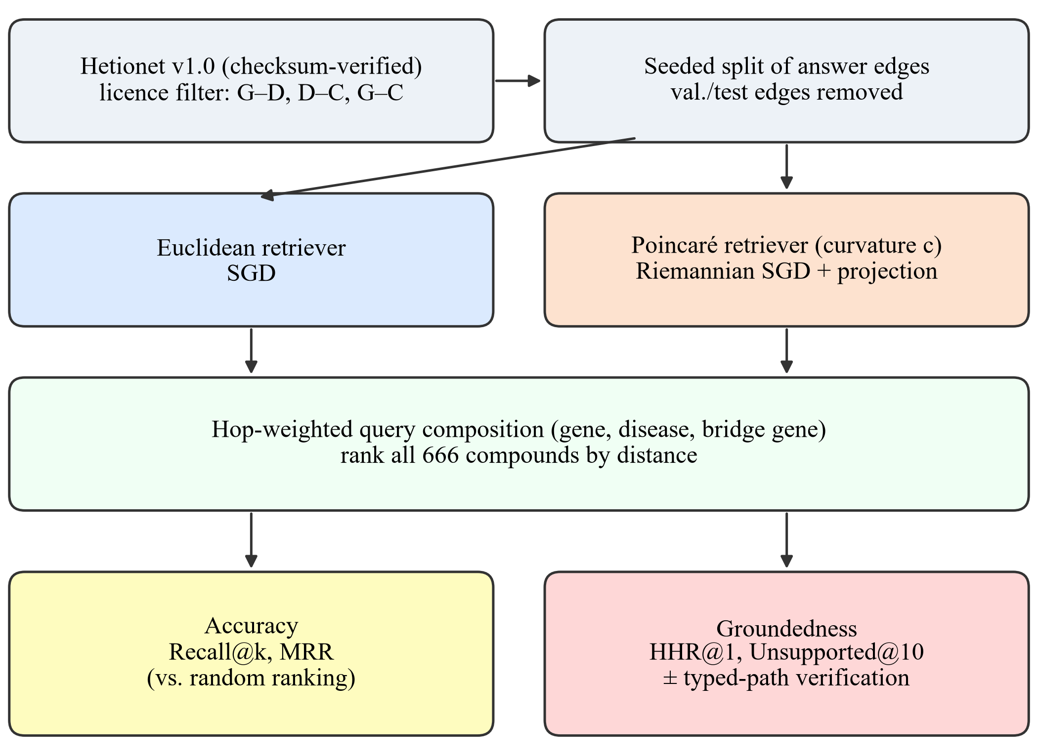
Fig. 1. RMF-RAG evaluation pipeline. Both retrievers receive identical triplets, mini-batches, negatives and epochs; learning rates are selected on validation data only; validation and test answer edges are removed before training.
A. Data and Relation Filtering
We use the official Hetionet v1.0 snapshot [18], verified against its published MD5 checksum (SHA-256 of the extracted file recorded with every run). To keep every relation traceable to a reusable source, we retain Gene–Disease associates edges from DISEASES (CC BY 4.0; 3,200), Disease–Compound treats/palliates edges from PharmacotherapyDB (CC0; 1,145) and Gene–Compound binds edges from DrugCentral (CC BY 4.0; 823). The graph has 3,039 nodes: 2,240 genes, 133 diseases and 666 compounds.
B. Tasks and Leakage Control
Every query ranks all 666 compounds. In the 2-hop task, given a gene g and an associated disease d, retrieve a compound c that treats or palliates d. In the 3-hop task, given g, d and a bridge gene g′ associated with d, retrieve a compound c that binds g′. Terminal answer edges are split per seed (Disease–Compound within each disease, 15%/15% validation/test; Gene–Compound globally, 10%/10%), and all validation and test answer edges are removed from the training graph before training and path verification. Queries are capped at 500 per task, split and seed and frozen to JSONL.
C. Retrievers and Training
Each node has a trainable embedding initialised from N(0, 0.01²). The Euclidean retriever uses L2 distance and SGD. The Poincaré retriever lives in the ball of radius 1/√c and uses the geodesic distance d_c(x, y) = c^(−1/2) arcosh(1 + 2c‖x − y‖² / ((1 − c‖x‖²)(1 − c‖y‖²))). Its Euclidean gradients are rescaled by ((1 − c‖x‖²)/2)² (Riemannian SGD [5], [11]), and the points are projected back into the ball after each step. Both minimise max(0, γ + d(a, p) − d(a, n)) with γ = 0.45 over every directed training edge, with one type-matched, non-neighbouring negative per positive. Both receive identical triplets in identical mini-batch order (batch size 256). A query embedding is a hop-weighted combination of the query entities, with weights (0.5, 1) for (g, d) and (1/3, 1/2, 1) for (g, d, g′), formed in Euclidean space or, for Poincaré, in the tangent space at the origin via the logarithmic and exponential maps. An identifier-only TF-IDF ranker serves as a non-learned baseline.
D. Hop Hallucination and Path Verification
A compound is path-supported if an exact typed path links it to the query in the training graph: a treats/palliates edge from d (2-hop), or a binds edge to any gene associated with d (3-hop). HHR@1 is the fraction of queries whose top-ranked compound is unsupported, and Unsupported@10 is the mean unsupported fraction of the top 10. Because held-out answer edges are removed, the correct 2-hop answer is never supported. HHR therefore measures groundedness, not correctness, and is always read with MRR and Recall@k. Typed-path verification reranks supported compounds first while keeping the geometric order within each group.
E. Experimental Protocol
Main benchmark. 16 dimensions, curvature 1, 60 epochs and seeds {7, 17, 29, 43, 101}. The learning rate is selected separately for each geometry from {0.03, 0.1, 0.3, 1, 3} on seed-7 validation MRR; both selected 0.1. Ablations remove geodesic ranking, hop weighting or tangent-space composition, or add path verification.
Pre-registered sweep. Exploratory analysis of the main benchmark suggested more path-supported 3-hop answers for Poincaré retrieval. Before training any sweep model, we saved a pre-registration fixing the hypothesis, configurations, metrics and tests. The sweep trains Euclidean models with d ∈ {2, 4, 8, 16} and Poincaré models with the same d and c ∈ {1, 10} for 150 epochs. The learning rate of each configuration is selected from {0.1, 0.3, 1} on seed-7 validation MRR. Each configuration is evaluated over ten seeds, five of them never inspected before. The primary test compares each of the 8 Poincaré configurations with the Euclidean model of the same dimension using a two-sided paired t-test over seeds on 3-hop test HHR@1, with Holm–Bonferroni correction (α = 0.05). Secondary outcomes (2-hop HHR@1, Unsupported@10, MRR) are corrected within their own families.
Metrics. Recall@k and MRR use raw ranking over all 666 candidates. Random ranking gives Recall@10 = 0.015 and MRR = H₆₆₆/666 ≈ 0.011. Intervals are two-sided 95% t-intervals across seeds.
IV. Results
A. Training and Accuracy
In the main benchmark, the loss fell from 0.448 to about 0.335 for both geometries with nearly identical curves. Both geometries learn the 3-hop task far above random ranking (Table I): MRR is 0.095 for Euclidean and 0.091 for Poincaré retrieval, against 0.011 for random ranking. 2-hop accuracy is only marginally above random (Section V). Paired accuracy differences between the geometries were not significant for any task or metric.
TABLE I
Main Benchmark Test Accuracy (d = 16, Five Seeds, Mean ± 95% CI Half-Width)
Method | 2-hop R@10 | 2-hop MRR | 3-hop R@10 | 3-hop MRR
Lexical | 0.001±0.002 | 0.004±0.000 | 0.008±0.021 | 0.010±0.011
Euclidean | 0.032±0.008 | 0.017±0.004 | 0.221±0.085 | 0.095±0.018
Poincaré | 0.043±0.025 | 0.019±0.006 | 0.242±0.121 | 0.091±0.040
Random (666) | 0.015 | 0.011 | 0.015 | 0.011

B. Hop Hallucination Across Dimensions
Fig. 2, Fig. 3 and Tables II–III report the pre-registered sweep. At d = 2 both geometries fail. 3-hop MRR is 0.021–0.035, barely above random, and over 90% of top-ranked 3-hop answers are unsupported. At intermediate dimension, Poincaré geometry reduces hop hallucination. In the primary test, the Poincaré retriever with d = 8 and c = 1 hallucinated fewer 3-hop top answers than its Euclidean counterpart: HHR@1 0.553 vs. 0.694, a difference of −0.141 (95% CI [−0.224, −0.059], Holm p = 0.030), lower in all 10 seeds. MRR was unchanged (0.079 vs. 0.080). The other seven primary comparisons were not significant. On the five never-inspected seeds alone, the difference was −0.114 and lower in all five, but not significant on its own. On 2-hop queries, Poincaré embeddings with d ∈ {4, 8} reduced HHR@1 by 3.4–6.0 points (Holm p < 0.02; 8–10 of 10 seeds) with |ΔMRR| ≤ 0.002. At d = 16 the advantage fades: no HHR@1 difference is significant, and 2-hop Unsupported@10 is slightly higher for Poincaré retrieval. Higher curvature (c = 10) pushed embeddings closer to the boundary of the ball but did not increase the benefit.
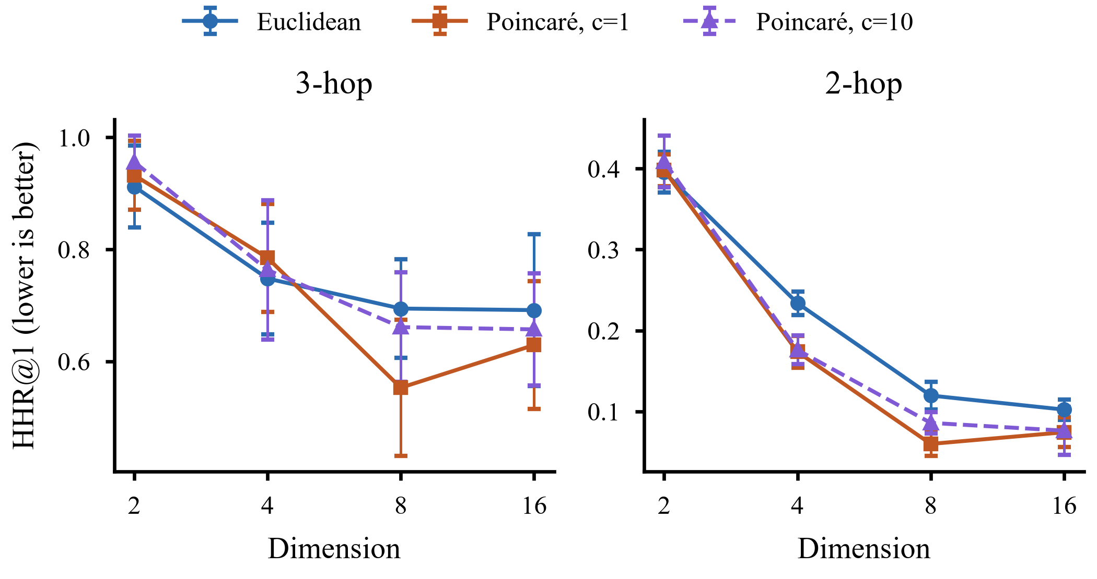
Fig. 2. Hop-hallucination rate HHR@1 against embedding dimension (mean and 95% CI over ten seeds; lower is better).
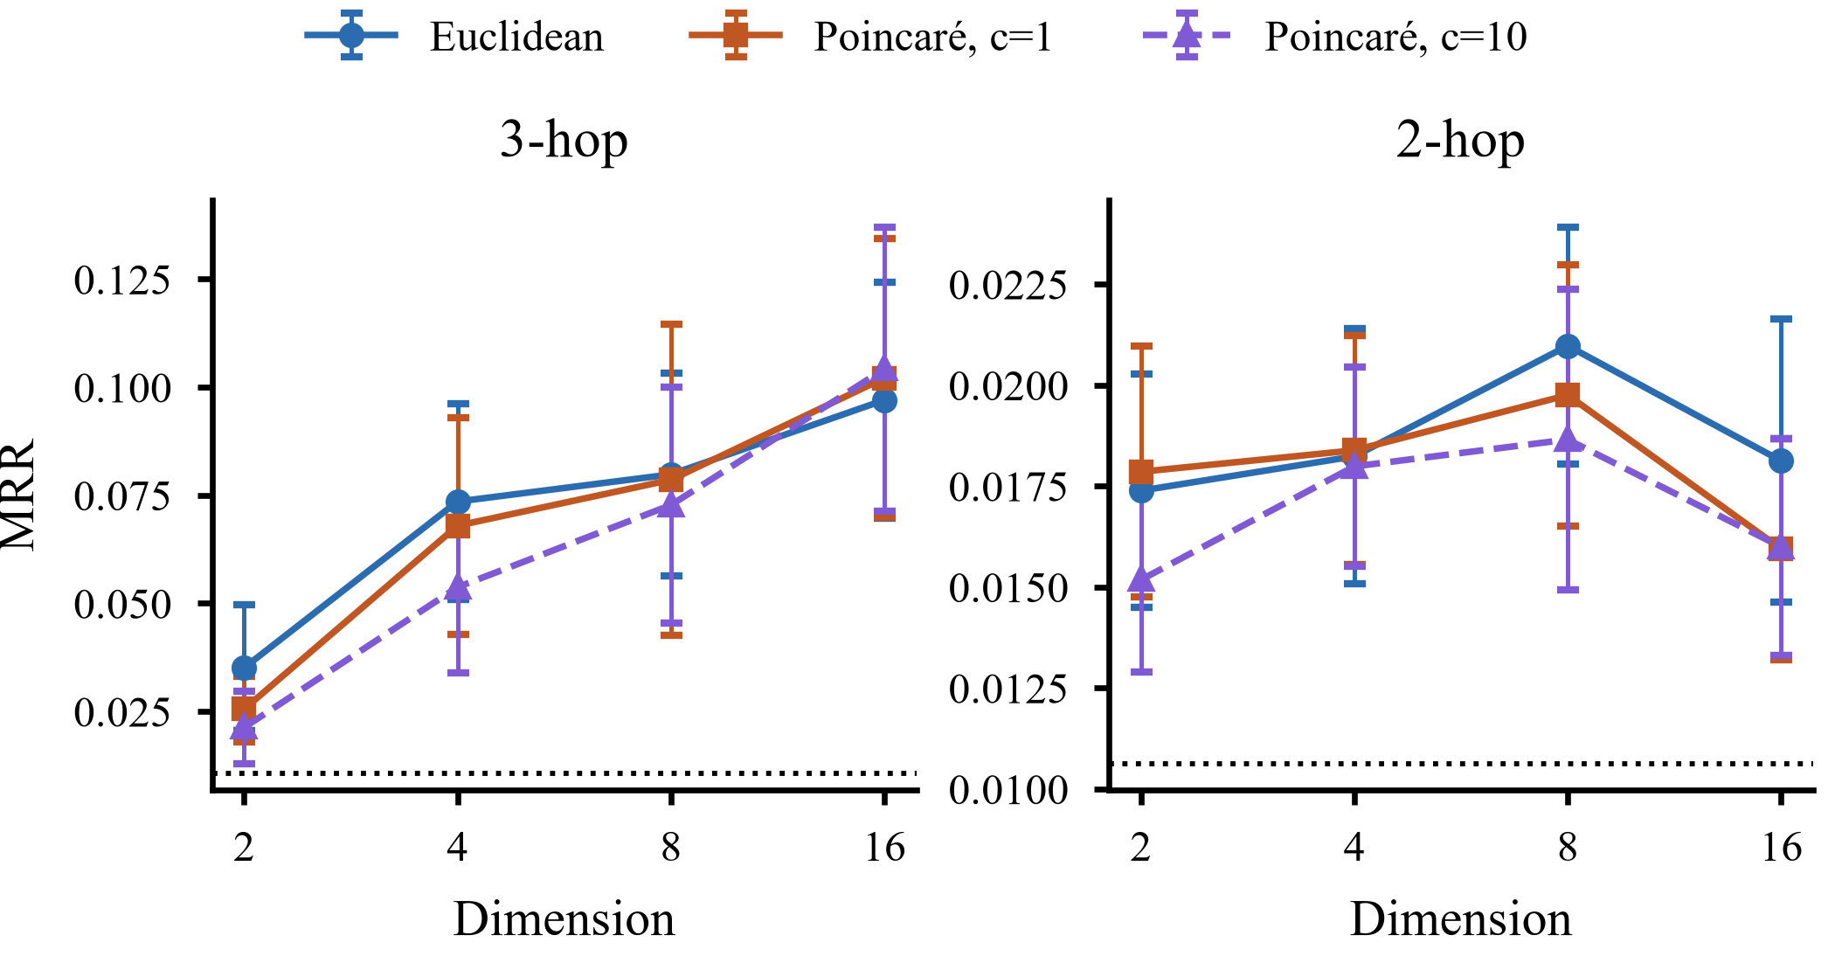
Fig. 3. Accuracy (MRR) against embedding dimension; the dotted line marks random ranking. Lower hallucination at d = 4–8 (Fig. 2) is not bought with lower accuracy.
TABLE II
Sweep Test Results (Ten Seeds, Mean ± 95% CI Half-Width); E = Euclidean, P = Poincaré
Config. | 3-hop MRR | 3-hop HHR@1 | 2-hop MRR | 2-hop HHR@1
E, d=2 | 0.035±0.015 | 0.912±0.073 | 0.017±0.003 | 0.396±0.025
P, d=2, c=1 | 0.026±0.008 | 0.932±0.062 | 0.018±0.003 | 0.398±0.020
P, d=2, c=10 | 0.021±0.008 | 0.956±0.047 | 0.015±0.002 | 0.409±0.032
E, d=4 | 0.074±0.023 | 0.748±0.100 | 0.018±0.003 | 0.234±0.014
P, d=4, c=1 | 0.068±0.025 | 0.785±0.096 | 0.018±0.003 | 0.174±0.020
P, d=4, c=10 | 0.054±0.020 | 0.763±0.125 | 0.018±0.002 | 0.176±0.018
E, d=8 | 0.080±0.023 | 0.694±0.088 | 0.021±0.003 | 0.120±0.017
P, d=8, c=1 | 0.079±0.036 | 0.553±0.122 | 0.020±0.003 | 0.060±0.015
P, d=8, c=10 | 0.073±0.027 | 0.661±0.098 | 0.019±0.004 | 0.086±0.013
E, d=16 | 0.097±0.027 | 0.691±0.136 | 0.018±0.004 | 0.102±0.012
P, d=16, c=1 | 0.102±0.032 | 0.629±0.114 | 0.016±0.003 | 0.074±0.018
P, d=16, c=10 | 0.104±0.033 | 0.657±0.100 | 0.016±0.003 | 0.076±0.030

TABLE III
Paired Differences, Poincaré − Euclidean at Equal d (Ten Seeds). Negative ΔHHR@1 = Fewer Hallucinations; Parentheses: Seeds Lower
P vs E | 3-hop ΔHHR@1 | p_Holm | 2-hop ΔHHR@1 | p_Holm | 3-hop ΔMRR
d=2, c=1 | +0.020 (4/10) | 1.000 | +0.002 (5/10) | 1.000 | -0.010
d=2, c=10 | +0.044 (2/10) | 1.000 | +0.013 (3/10) | 1.000 | -0.014
d=4, c=1 | +0.037 (3/10) | 1.000 | -0.060 (10/10) | <0.001 | -0.006
d=4, c=10 | +0.015 (3/10) | 1.000 | -0.058 (10/10) | <0.001 | -0.020
d=8, c=1 | -0.141 (10/10) | 0.030 | -0.060 (10/10) | <0.001 | -0.001
d=8, c=10 | -0.033 (5/10) | 1.000 | -0.034 (8/10) | 0.019 | -0.007
d=16, c=1 | -0.062 (4/10) | 1.000 | -0.028 (9/10) | 0.166 | +0.005
d=16, c=10 | -0.034 (4/10) | 1.000 | -0.026 (9/10) | 0.500 | +0.007

C. Grounding by Typed-Path Verification
Path verification removes far more hop hallucination than any geometry choice. In the sweep it lowered 3-hop HHR@1 to 0.026 for every configuration (the remaining queries have no supported candidate at all) and 2-hop HHR@1 to 0. On 3-hop queries it costs little or no accuracy: in the main benchmark MRR is 0.092 with verification vs. 0.091 without (Table IV). On 2-hop queries it lowers MRR from 0.019 to 0.010, because the held-out answer is never path-supported. Grounding therefore prevents hallucination but also blocks discovery of new links.
TABLE IV
Main Benchmark Ablations and Grounding (d = 16, Five Seeds, Means); HHR@1 = 1 − Top-1 Path-Supported Rate
Configuration | 3-hop MRR | 3-hop HHR@1 | 2-hop MRR | 2-hop HHR@1
Euclidean | 0.095 | 0.666 | 0.017 | 0.080
Poincaré (full) | 0.091 | 0.534 | 0.019 | 0.170
– geodesic ranking | 0.091 | 0.534 | 0.019 | 0.170
– hop weighting | 0.070 | 0.663 | 0.019 | 0.296
– tangent composition | 0.091 | 0.534 | 0.019 | 0.170
+ path verification | 0.092 | 0.032 | 0.010 | 0.000

D. Ablations and Optimisation Confounds
Hop weighting is the only composition component with a clear effect: removing it lowers 3-hop MRR from 0.091 to 0.070. Geodesic ranking and tangent-space composition change nothing at three decimals, because the main-benchmark embeddings stay within radius 0.29, where the ball is nearly Euclidean. Three confounds would have misled us. A pilot that trained the Euclidean model with Adam and the Poincaré model with full-batch Riemannian SGD showed a spurious Euclidean advantage (MRR 0.107 vs. 0.020) that vanished with matched optimisers (0.074 vs. 0.059). An under-trained configuration (24 full-batch steps; loss 0.4495 → 0.4486) put both geometries at chance level. A single-seed validation comparison favoured Poincaré retrieval by about 30% but did not replicate across seeds.
V. Discussion
Geometry. Hyperbolic embeddings did not improve accuracy in any configuration, but at intermediate dimension they made rankings more grounded. Curved space keeps path-connected neighbourhoods compact in few dimensions, so a query composed from connected entities lands nearer to reachable compounds. The effect is modest, confined to d = 4–8 and, on 3-hop queries, significant in one of eight pre-registered configurations. It also depends on the training budget: in the 60-epoch main benchmark, 2-hop Poincaré answers were less often supported than Euclidean ones (HHR@1 0.170 vs. 0.080; Table IV). This is evidence that geometry can contribute to groundedness, not a general guarantee.
Geometry versus grounding. Path verification lowered 3-hop HHR@1 to its floor of 0.026, far more than the best geometry (14 points). For KG-RAG systems whose priority is to avoid ungrounded hops, structural grounding should come first, with geometry as a secondary refinement. Geometry still orders candidates within each group and is the only mechanism available when no supported candidate exists or new links are sought.
Low 2-hop accuracy. The 2-hop task asks for a treatment whose edge is hidden. The disease's training compounds, which are also true treatments, rank first and count as errors under raw ranking. Filtered ranking [12] would raise absolute 2-hop scores.
Limitations. HHR@1 measures graph groundedness, not hallucination in generated text, and a supported answer is not necessarily correct or clinically meaningful (binds measures molecular connectivity, not treatment). On 3-hop queries only one pre-registered comparison was significant, and the 2-hop effects are secondary outcomes. All results come from one licence-filtered subset of one KG, use distance-based embeddings with a fixed margin and dimension-specific learning rates tuned on one seed, and do not evaluate relation-specific hyperbolic models [9], [10] or generation.
VI. Conclusion
We tested whether hyperbolic geometry reduces multi-hop hallucination in biomedical KG retrieval, using matched training, leakage control and a pre-registered sweep. Hyperbolic embeddings did not make retrieval more accurate, but at intermediate dimension they made it more grounded. At d = 8, Poincaré retrieval hallucinated 14 points fewer 3-hop top answers in every seed, and at d = 4–8 it consistently hallucinated fewer 2-hop answers, both at unchanged accuracy. Typed-path verification reduced hop hallucination much further, at the cost of novel-link discovery on 2-hop queries. Our answer to “geometry or grounding?” is grounding first, geometry as a modest complement. Code, the pre-registration, frozen query sets, predictions and results are available at https://github.com/Saadia-Asghar/kg-rag-rmf-rag-research.
Acknowledgment
The authors thank Prof. Shahabuddin Ansari, Ghulam Ishaq Khan Institute of Engineering Sciences and Technology, for supervising this research.
References
[1] P. Lewis et al., “Retrieval-augmented generation for knowledge-intensive NLP tasks,” in Proc. Adv. Neural Inf. Process. Syst. (NeurIPS), vol. 33, 2020, pp. 9459–9474.
[2] D. Edge et al., “From local to global: A graph RAG approach to query-focused summarization,” arXiv:2404.16130, 2024.
[3] K. Soman et al., “Biomedical knowledge graph-optimized prompt generation for large language models,” Bioinformatics, vol. 40, no. 9, Art. no. btae560, 2024.
[4] D. S. Himmelstein et al., “Systematic integration of biomedical knowledge prioritizes drugs for repurposing,” eLife, vol. 6, Art. no. e26726, 2017.
[5] M. Nickel and D. Kiela, “Poincaré embeddings for learning hierarchical representations,” in Proc. Adv. Neural Inf. Process. Syst. (NeurIPS), vol. 30, 2017, pp. 6338–6347.
[6] D. Krioukov, F. Papadopoulos, M. Kitsak, A. Vahdat, and M. Boguñá, “Hyperbolic geometry of complex networks,” Phys. Rev. E, vol. 82, no. 3, Art. no. 036106, 2010.
[7] R. Sarkar, “Low distortion Delaunay embedding of trees in hyperbolic plane,” in Proc. Int. Symp. Graph Drawing (GD), LNCS vol. 7034, 2012, pp. 355–366.
[8] O.-E. Ganea, G. Bécigneul, and T. Hofmann, “Hyperbolic neural networks,” in Proc. Adv. Neural Inf. Process. Syst. (NeurIPS), vol. 31, 2018, pp. 5345–5355.
[9] I. Balažević, C. Allen, and T. Hospedales, “Multi-relational Poincaré graph embeddings,” in Proc. Adv. Neural Inf. Process. Syst. (NeurIPS), vol. 32, 2019, pp. 4463–4473.
[10] I. Chami, A. Wolf, D.-C. Juan, F. Sala, S. Ravi, and C. Ré, “Low-dimensional hyperbolic knowledge graph embeddings,” in Proc. 58th Annu. Meeting Assoc. Comput. Linguistics (ACL), 2020, pp. 6901–6914.
[11] S. Bonnabel, “Stochastic gradient descent on Riemannian manifolds,” IEEE Trans. Autom. Control, vol. 58, no. 9, pp. 2217–2229, Sep. 2013.
[12] A. Bordes, N. Usunier, A. Garcia-Durán, J. Weston, and O. Yakhnenko, “Translating embeddings for modeling multi-relational data,” in Proc. Adv. Neural Inf. Process. Syst. (NeurIPS), vol. 26, 2013, pp. 2787–2795.
[13] W. L. Hamilton, P. Bajaj, M. Zitnik, D. Jurafsky, and J. Leskovec, “Embedding logical queries on knowledge graphs,” in Proc. Adv. Neural Inf. Process. Syst. (NeurIPS), vol. 31, 2018, pp. 2026–2037.
[14] H. Ren, W. Hu, and J. Leskovec, “Query2box: Reasoning over knowledge graphs in vector space using box embeddings,” in Proc. Int. Conf. Learn. Represent. (ICLR), 2020.
[15] M. Ali et al., “Bringing light into the dark: A large-scale evaluation of knowledge graph embedding models under a unified framework,” IEEE Trans. Pattern Anal. Mach. Intell., vol. 44, no. 12, pp. 8825–8845, Dec. 2022.
[16] D. Ruffinelli, S. Broscheit, and R. Gemulla, “You CAN teach an old dog new tricks! On training knowledge graph embeddings,” in Proc. Int. Conf. Learn. Represent. (ICLR), 2020.
[17] S. Bonner et al., “A review of biomedical datasets relating to drug discovery: A knowledge graph perspective,” Briefings Bioinf., vol. 23, no. 6, Art. no. bbac404, 2022.
[18] D. S. Himmelstein et al., “Hetionet v1.0,” Zenodo, 2017. [Online]. Available: https://zenodo.org/records/268568
[19] X. Bouthillier et al., “Accounting for variance in machine learning benchmarks,” in Proc. Mach. Learn. Syst. (MLSys), vol. 3, 2021, pp. 747–769.
[20] A. Gu, F. Sala, B. Gunel, and C. Ré, “Learning mixed-curvature representations in product spaces,” in Proc. Int. Conf. Learn. Represent. (ICLR), 2019.

