Name: Muhammad Saad Khan
Roll no: 232423
BSCS-ev-3B

DATA STRUCTURES LAB 11

Activity 1
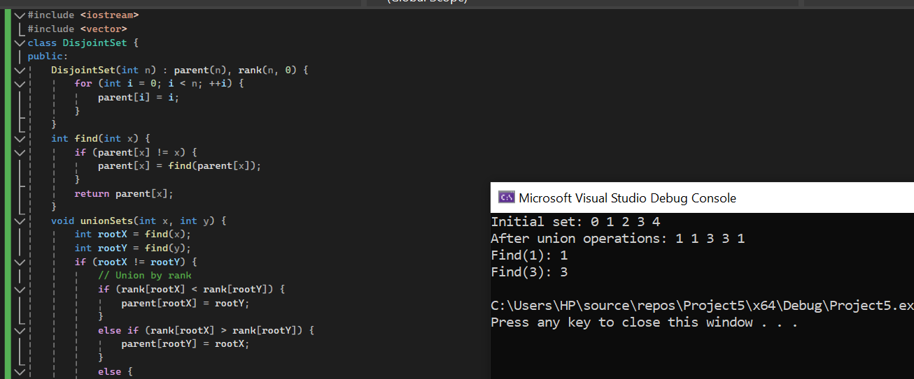
CODE
#include <iostream>
#include <vector>
class DisjointSet {
public:
DisjointSet(int n) : parent(n), rank(n, 0) {
for (int i = 0; i < n; ++i) {
parent[i] = i;
}
}
int find(int x) {
if (parent[x] != x) {
parent[x] = find(parent[x]);
}
return parent[x];
}
void unionSets(int x, int y) {
int rootX = find(x);
int rootY = find(y);
if (rootX != rootY) {
// Union by rank
if (rank[rootX] < rank[rootY]) {
parent[rootX] = rootY;
}
else if (rank[rootX] > rank[rootY]) {
parent[rootY] = rootX;
}
else {
parent[rootX] = rootY;
rank[rootY]++;
}
}
}
private:
std::vector<int> parent;
std::vector<int> rank;
};
int main() {
int n = 5; // Number of elements in the set
DisjointSet ds(n);
std::cout << "Initial set:";
for (int i = 0; i < n; ++i) {
std::cout << " " << ds.find(i);
}
std::cout << std::endl;
// Perform some union operations
ds.unionSets(0, 1);
ds.unionSets(2, 3);
ds.unionSets(0, 4);

std::cout << "After union operations:";
for (int i = 0; i < n; ++i) {
std::cout << " " << ds.find(i);
}
std::cout << std::endl;
// Perform some find operations
std::cout << "Find(1): " << ds.find(1) << std::endl;
std::cout << "Find(3): " << ds.find(3) << std::endl;

return 0;
}
Activity 2
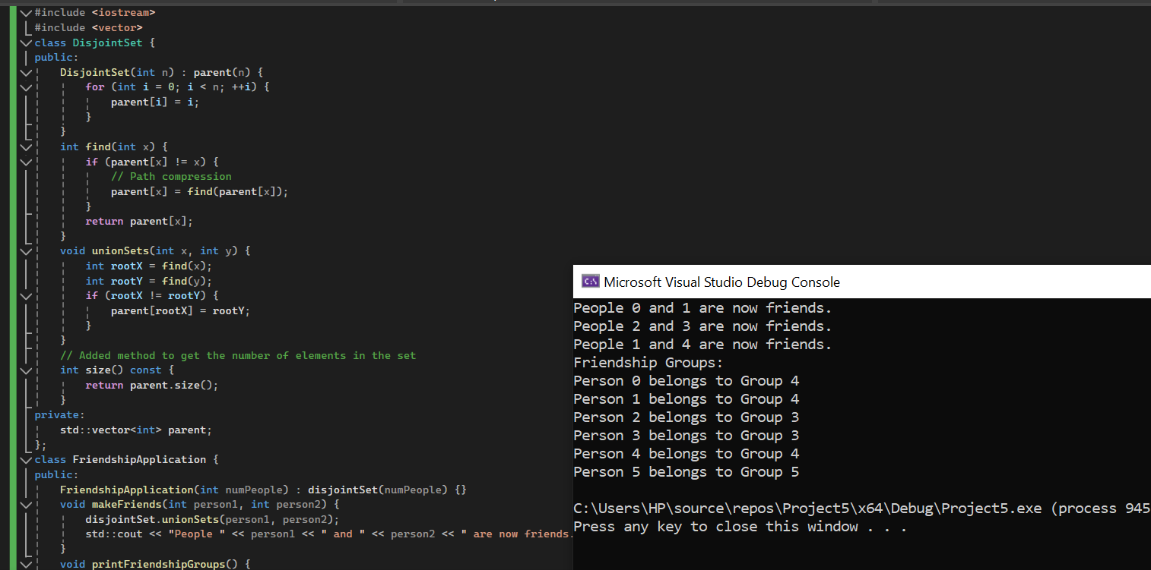
CODE
#include <iostream>
#include <vector>
class DisjointSet {
public:
DisjointSet(int n) : parent(n) {
for (int i = 0; i < n; ++i) {
parent[i] = i;
}
}
int find(int x) {
if (parent[x] != x) {
// Path compression
parent[x] = find(parent[x]);
}
return parent[x];
}
void unionSets(int x, int y) {
int rootX = find(x);
int rootY = find(y);
if (rootX != rootY) {
parent[rootX] = rootY;
}
}
// Added method to get the number of elements in the set
int size() const {
return parent.size();
}
private:
std::vector<int> parent;
};
class FriendshipApplication {
public:
FriendshipApplication(int numPeople) : disjointSet(numPeople) {}
void makeFriends(int person1, int person2) {
disjointSet.unionSets(person1, person2);
std::cout << "People " << person1 << " and " << person2 << " are now friends." << std::endl;
}
void printFriendshipGroups() {
std::cout << "Friendship Groups:" << std::endl;
for (int i = 0; i < disjointSet.size(); ++i) {
std::cout << "Person " << i << " belongs to Group " << disjointSet.find(i) << std::endl;
}
}
private:
DisjointSet disjointSet;
};
int main() {
int numPeople = 6; // Number of people
FriendshipApplication app(numPeople);
app.makeFriends(0, 1);
app.makeFriends(2, 3);
app.makeFriends(1, 4);
app.printFriendshipGroups();
return 0;
}
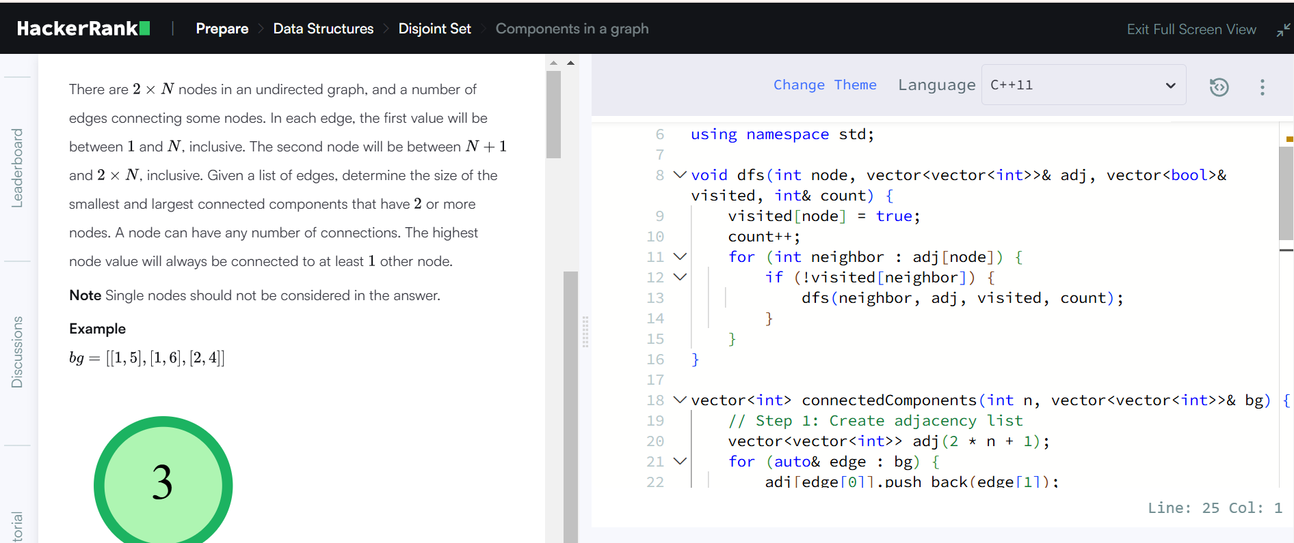
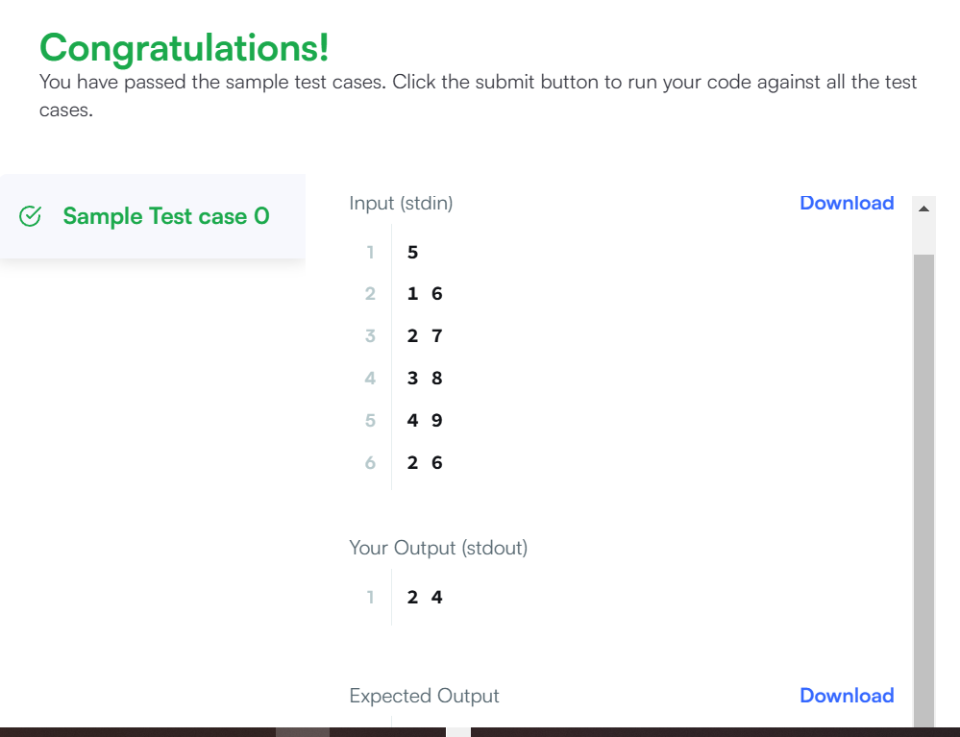
Q2:
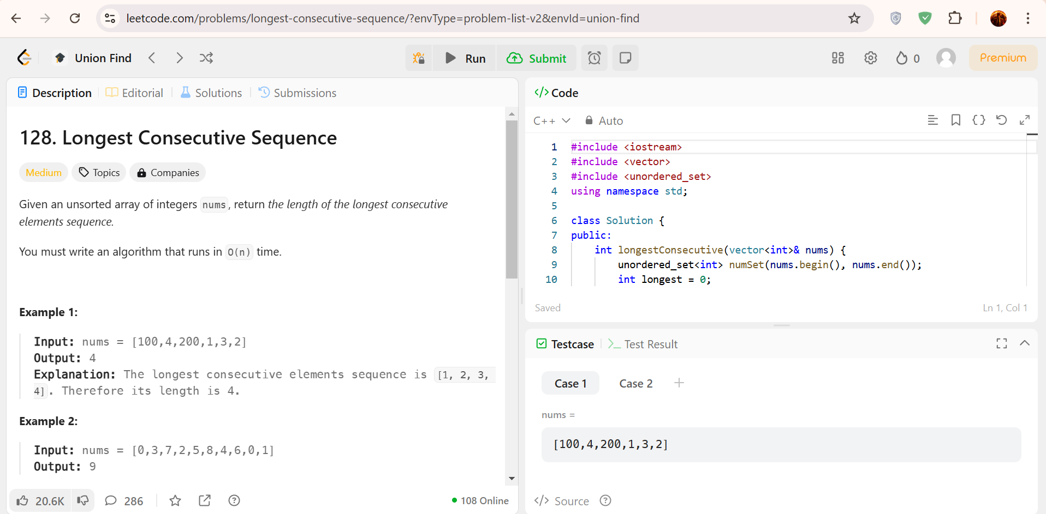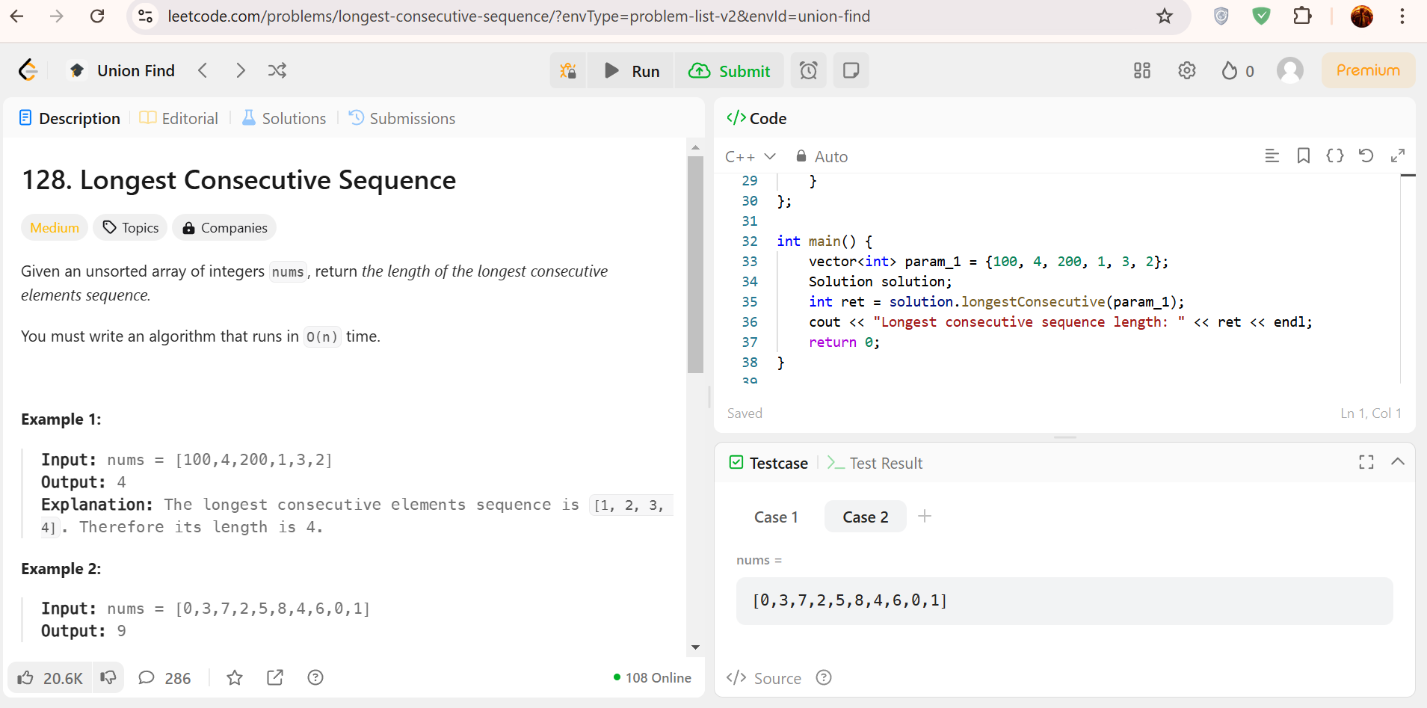

Question 1
Implement a data structure called Disjoint Set (or Union-Find) understanding the Union-Find Algorithm and its Application in Connected Components

Task 1

CODE
#include <iostream>
#include <vector>
using namespace std;
class DisjointSet {
public:
DisjointSet(int size) {
parent.resize(size);
rank.resize(size, 0);
for (int i = 0; i < size; ++i) {
parent[i] = i;
}
}
int find(int x) {
if (parent[x] != x) {
parent[x] = find(parent[x]);
}
return parent[x];
}
void unionSets(int x, int y) {
int rootX = find(x);
int rootY = find(y);
if (rootX != rootY) {
if (rank[rootX] > rank[rootY]) {
parent[rootY] = rootX;
} else if (rank[rootX] < rank[rootY]) {
parent[rootX] = rootY;
} else {
parent[rootY] = rootX;
rank[rootX]++;
}
}
}
bool areConnected(int x, int y) {
return find(x) == find(y);
}
private:
vector<int> parent;
vector<int> rank;
};
int main() {
DisjointSet ds(6);
ds.unionSets(0, 1);
ds.unionSets(1, 2);
ds.unionSets(3, 4);
cout << "Are 0 and 2 connected? ";
if (ds.areConnected(0, 2)) {
cout << "Yes" << endl;
} else {
cout << "No" << endl;
}
cout << "Are 2 and 3 connected? ";
if (ds.areConnected(2, 3)) {
cout << "Yes" << endl;
} else {
cout << "No" << endl;
}
cout << "Are 3 and 4 connected? ";
if (ds.areConnected(3, 4)) {
cout << "Yes" << endl;
} else {
cout << "No" << endl;
}
return 0;
}

OUTPUT:
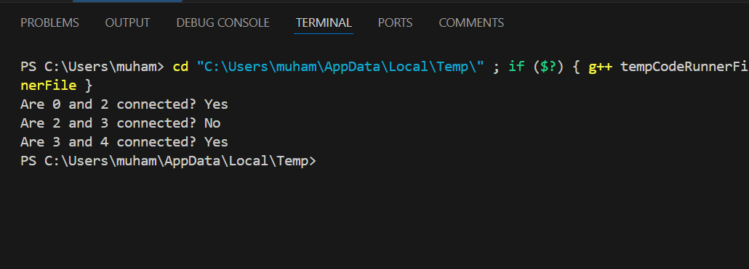

Question 2
Implement Disjoint Set (Union-Find) on tracking distinct sets of items, for instance, managing the merging of disjoint sets representing groups of students in different clubs.

Task 2

CODE
#include <iostream>
#include <vector>
using namespace std;
class DisjointSet {
public:
DisjointSet(int size) {
parent.resize(size);
rank.resize(size, 0);
for (int i = 0; i < size; ++i) {
parent[i] = i;
}
}
int find(int x) {
if (parent[x] != x) {
parent[x] = find(parent[x]);
}
return parent[x];
}
void unionSets(int x, int y) {
int rootX = find(x);
int rootY = find(y);
if (rootX != rootY) {
if (rank[rootX] > rank[rootY]) {
parent[rootY] = rootX;
} else if (rank[rootX] < rank[rootY]) {
parent[rootX] = rootY;
} else {
parent[rootY] = rootX;
rank[rootX]++;
}
}
}
int getDistinctSetsCount() {
int count = 0;
for (int i = 0; i < parent.size(); ++i) {
if (parent[i] == i) {
count++;
}
}
return count;
}
private:
vector<int> parent;
vector<int> rank;
};
int main() {
DisjointSet ds(6);
ds.unionSets(0, 1);
ds.unionSets(2, 3);
ds.unionSets(3, 4);
cout << "Number of distinct sets: " << ds.getDistinctSetsCount() << endl;
ds.unionSets(1, 3);
cout << "Number of distinct sets after merging 1 and 3: " << ds.getDistinctSetsCount() << endl;
return 0;
}

OUTPUT:
