**1st Assignment of devops**

**1. Create a New Project with Spring Initializr**

* Go to [Spring Initializr](https://start.spring.io/).
* Set up your project dependencies as needed.
* Generate and download the project.

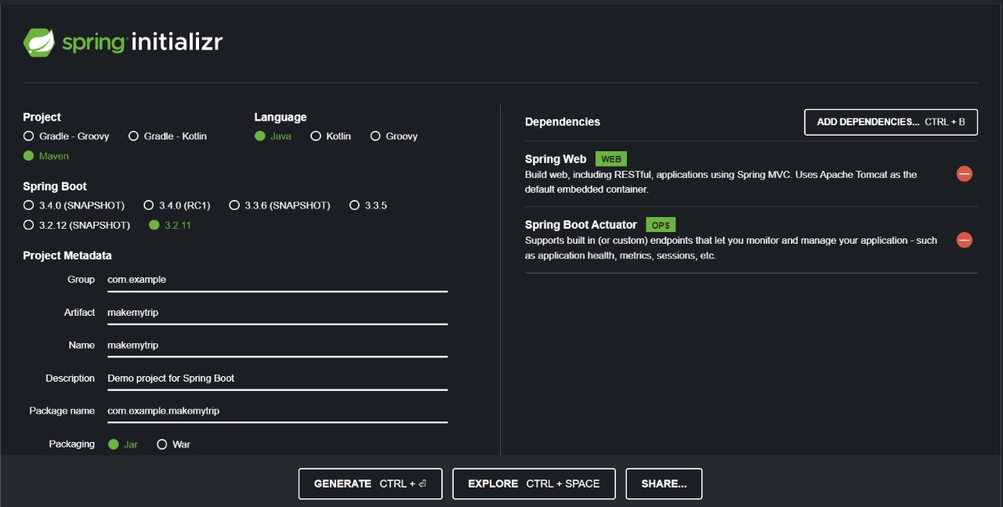

**2. Set Up Workspace**

* Create a folder named myworkspace.
* Extract the downloaded project into the myworkspace folder.

**3. Create a GitHub Repository**

* Go to GitHub and create a new repository.
* Copy the repository URL.

**4. Build and Run the Spring Boot Application**

* Open a terminal and navigate to your project folder in myworkspace.
* Run the following commands:

bash

Copy code

mvn clean compile # Compiles the project

mvn clean package # Packages the project as a JAR file

mvn spring-boot:run # Runs the Spring Boot application

**5. Connect to GitHub**

* Open your IDE (e.g., IntelliJ or VS Code).
* Click on **VCS** (Version Control System) and select **Git**.
* Connect to the GitHub repository by pasting the repository URL.
* Push the code to GitHub using:

bash

Copy code

git push origin master

**6. Create Branches**

* Create the following branches:
  + master
  + prod
  + preprod
  + dev
* In the terminal, use these commands:

bash

Copy code

git branch master # Creates master branch (if not already created)

git branch prod # Creates prod branch

git branch preprod # Creates preprod branch

git branch dev # Creates dev branch

**7. Fetch and Work on the dev Branch**

* Fetch the branches from the remote repository:

bash

Copy code

git fetch origin

* Check out the dev branch:

bash

Copy code

git checkout dev

* Stage, commit, and push changes to the dev branch:

bash

Copy code

git add .

git commit -m "Initial commit on dev branch"

git push origin dev

**8. Merge dev into preprod on GitHub**

* Go to your GitHub repository.
* Open a **Pull Request** to merge the dev branch into the preprod branch.
* Review and merge the pull request.