**2nd DevOps Assignment: Create and Connect to an AWS EC2 Instance**

**Part 1: Create an EC2 Instance on AWS**

1. **Log in to AWS Console**
   * Open the [AWS Management Console](https://aws.amazon.com/console/) and log in to your account.
2. **Navigate to EC2 Service**
   * In the AWS Console, go to **Services** → **Compute** → **EC2**.
3. **Launch a New Instance**
   * Click **Launch Instance** to start creating a new instance.
4. **Configure Instance Details**
   * **Name:** Enter a name for your instance.
   * **Amazon Machine Image (AMI):** Choose **Amazon Linux**.
   * **Instance Type:** Select **t2.micro** (eligible for the free tier).
5. **Choose or Create a Key Pair**
   * In the **Key pair (login)** section, select an existing key pair or create a new one:
     + If creating a new key pair, choose a name and download it in .pem format.
     + Convert the .pem file to .ppk format using PuTTYgen for use with PuTTY:
       - Open **PuTTYgen**, load the .pem file, and save it as .ppk.

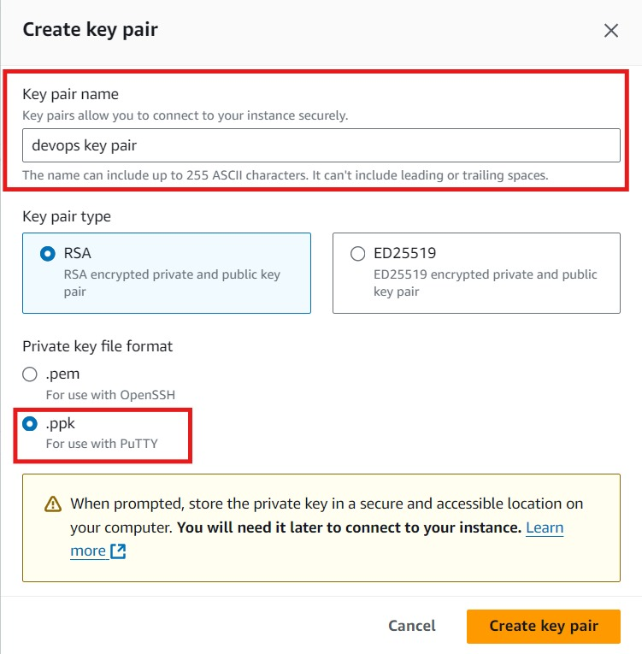

1. **Configure Network Settings**
   * Leave the default network settings, or customize if needed.
2. **Launch the Instance**
   * Review the configuration and click **Launch Instance**.
3. **Wait for the Instance to Initialize**
   * Once launched, wait for the instance status to change to **running**.

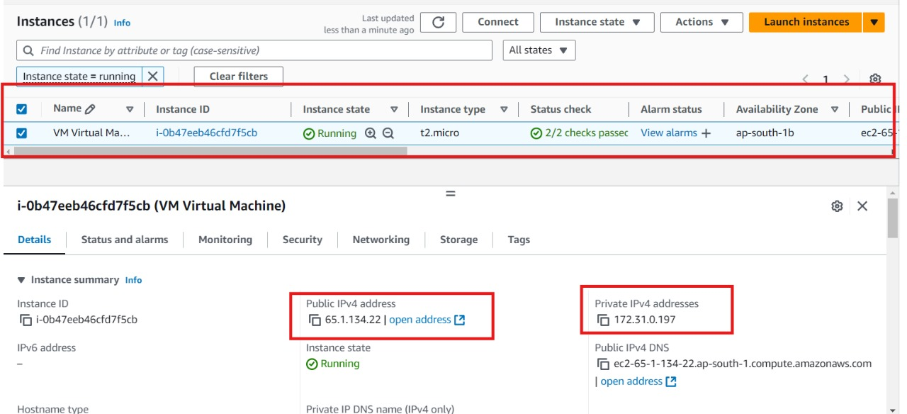

**Part 2: Connect to the EC2 Instance Using PuTTY**

1. **Gather Connection Information**
   * In the EC2 Dashboard, select your instance.
   * Note the **Public IP address**, which you will use to connect.
   * Ensure you have the **private key (.ppk) file** and the **default username** (ec2-user for Amazon Linux).

1. **Open PuTTY and Configure Connection**
   * Open **PuTTY** on your computer.
   * **Host Name:** Enter the **Public IP** of your instance.
   * **Port:** Use the default **22** for SSH.
2. **Add the Private Key**
   * In the PuTTY sidebar, go to **Connection** → **SSH** → **Auth**.
   * Under **Private key file for authentication**, browse to select your .ppk file.

1. **Open the Connection**
   * Click **Open** to start the SSH session.
2. **Log In to the EC2 Instance**
   * A terminal will open, and you will be prompted to **login as**:
     + Enter ec2-user as the username.
3. **Switch to Root User (Optional)**
   * After logging in, you can switch to the root user with:

bash

Copy code

sudo su –

Your EC2 instance is now successfully created and connected through PuTTY. You can start working on your virtual machine as needed.