Programming Assignment 1

POE PART 1  
PROG6212

DISD0601

PART 1

Student Number: ST10446806  
Student Name: Insaaf Behardien  
Date of Submission: 09/09/2025

Contents

Indroduction 2

Project Plan 3

GITHUB Version Control 4

UML DIAGRAM 5

Conclusion 5

Referencing 5

Introduction  
  
The Contract Monthly Claim System will be used to manage, process and track the claims made by the lecturers. Part 1 will include why the specific design, database structure, GUI Layout were chosen. The Assumptions, Constraints and planning that came with the choices of designing the CMCS.  
  
  
Design Choices  
WPF is user intuitive, it supports modern UIs, uses XAML, it allows for much easier design buttons and adjustment to styles layouts. It allows you to see the all the changes being made making it easier to maintain, because the XAML UI and the C# code is separate from each other allowing functionality to be added later (Microsoft, 2025).  
  
The colours chosen is vibrant and aesthetically pleasing to the eye, and the layout is designed for efficient accessibility, allowing lecturers to monitor the status of their claims in the same window, claims are submitted ensuring its efficient and hassle free. The coordinator and manager window has approval or rejection buttons next to the claims making it easier and quicker for them to review claims. Role window to allow user to choose their window (Figma, 2025).  
  
Gui Layout  
1. Role selection – lecturer, Coordinator, Manager (Replaces login system to make it neat for part 1).  
2. Lecturer Dashboard – Submission of Claim, Upload supporting documents, Claim status  
3. Coordinator - View and Approve or reject Claims  
4. Manager – View and Approve or reject Claims  
  
Assumptions  
We can assume the hourly rates are already stored in the system, the lecturers are already registered with profiles, and no real authentication are instilled processes yet. Everything displayed are just examples of what the System would display once the functionality is included (QAT,2025).   
Constraints  
Uploading documentation does not work yet will have functionality in part 2, as well as the submit, approve and reject buttons. There is no database, so nothing entered is stored processed or updated (PM Study Circle,2025).  
  
Database Structure

|  |  |  |
| --- | --- | --- |
| Entity | Attributes | Relationships |
| Lecturer | LecturerID, Name, HourlyRates | 1 to Many, Claims |
| Claim | ClaimID LecturerID CoordinatorID TotalHours Amount Status  SubmissionDate DocID | 0 to Many Documents  0 to Many Claims 1 is to 1 Lecturer 1 to 1 Coordinator |
| Documentation | DocID, ClaimID, FileName | 1 to 1 Claim |
| Coordinator | CoordinatorID, Name, AcademicManagerID | 1 is to 1 Manager 0 to Many Claims |
| AcademicManager | AcademicManagerID, Name | 1 to Many Coordinator |

### Project Plan

|  |  |  |  |
| --- | --- | --- | --- |
| Task | Duration | Start/End Dates | Dependencies |
| Research | 1 week | 21/08/2025 -28/08/2025 | None |
| Designing and Planning System | 3 Days | 30/08/2025 - 2/09/2025 | Research |
| Lecturer Window | 1 Day | 3/09/2025 | System Design |
| Coordinator window | 1 Day | 4/09/2025 | Lecturer Window |
| Manager Window | 1 Day | 5/09/2025 | Coordinator Window |
| Debugging and committing | 3 Days | 8/09/2025 | All windows |
| Report Document | 1 Day | 9/09/2025 | Testing and debug |
| Final Presentation preparation | 2 hours | 9/09/2025 | Document |

### GITHUB Version Control

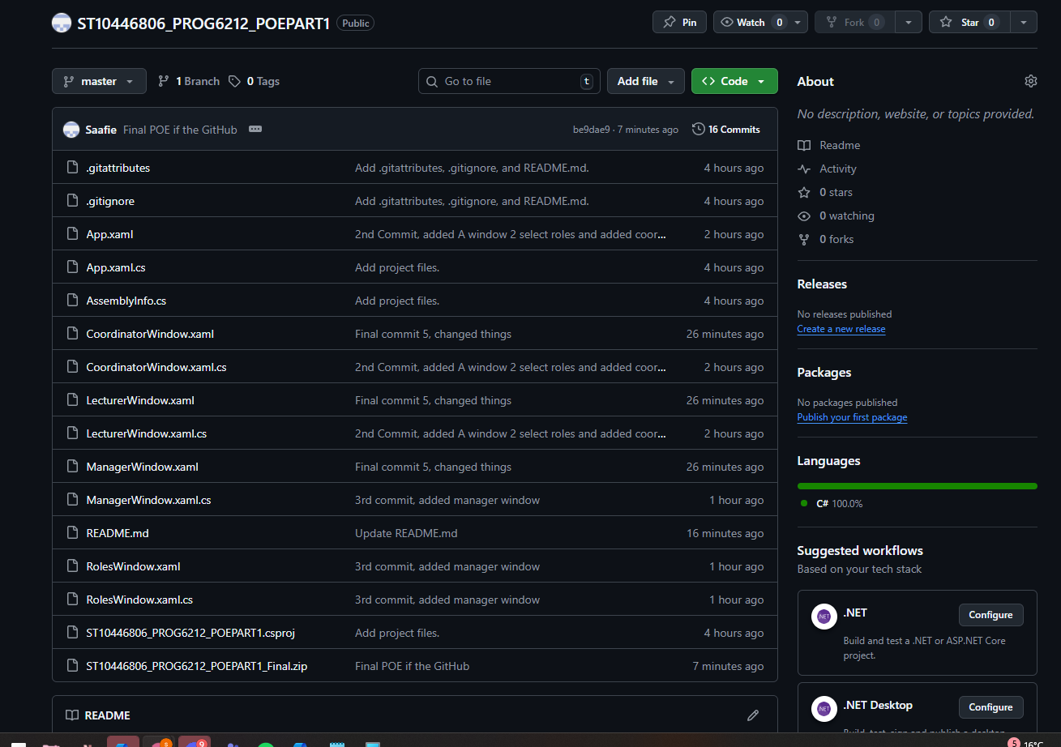

### UML DIAGRAM

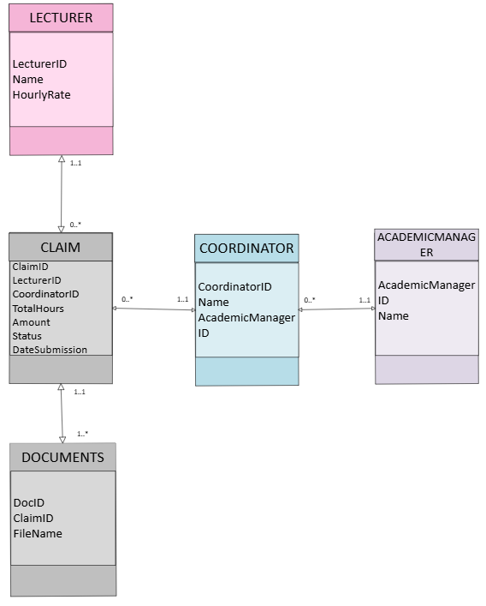

### Conclusion

All design for the CMCS is front end and is user friendly, in part 2 all the buttons will gain functionality, so all buttons will work and allow for data to be stored. Later there will be a log in system that determines the role of the user instead of the Role window.

Referencing

1. Figma, 2025. *UI Design Principles*. [online] Available at: [https://www.figma.com/resource-library/ui-design-principles/](https://www.figma.com/resource-library/ui-design-principles/?utm_source=chatgpt.com) [Accessed 21 September 2025].
2. Microsoft, 2025. *XAML Overview for WPF*. [online] Available at: [https://learn.microsoft.com/en-us/dotnet/desktop/wpf/xaml/](https://learn.microsoft.com/en-us/dotnet/desktop/wpf/xaml/?utm_source=chatgpt.com) [Accessed 24 September 2025].
3. PM Study Circle, 2025. *Assumptions and Constraints in Project Management*. [online] Available at: [https://pmstudycircle.com/assumptions-and-constraints-in-project-management/](https://pmstudycircle.com/assumptions-and-constraints-in-project-management/?utm_source=chatgpt.com) [Accessed 25 September 2025].

1. QAT, 2025. *Writing Assumptions and Constraints in SRS*. [online] Available at: [https://qat.com/writing-assumptions-constraints-srs/](https://qat.com/writing-assumptions-constraints-srs/?utm_source=chatgpt.com) [Accessed 30 September 2025].