Task 1 Report
Problem Statement: Explore whether the no. of cases, deaths, CFR … of malaria increases every year. From scratch.
About dataset:
• Malaria is a life-threatening disease caused by parasites that are transmitted to people through the bites of infected female Anopheles mosquitoes.
• It is preventable and curable.
• In 2018, there were an estimated 228 million cases of malaria worldwide.
• The estimated number of malaria deaths stood at 405 000 in 2018.
• Children aged under 5 years are the most vulnerable group affected by malaria; • in 2018, they accounted for 67% (272 000) of all malaria deaths worldwide.
• The WHO African Region carries a disproportionately high share of the global malaria burden.
• In 2018, the region was home to 93% of malaria cases and 94% of malaria deaths.

Content of dataset:
• reported_numbers.csv - Reported no. of cases across the world
• estimated_numbers.csv - Estimated no of cases across the world
• incidenceper1000popat_risk.csv - Incidence per 1000 people at risk area

Objective :

• Analyze the pattern in the data
• Get insights from data
• Build a model with better accuracy
• Predict the no. of cases, deaths, CFR of malaria

- Feature engineering
- Get dummies has been applied to the 'Country' feature of the reported data, thereby one hot encoding it.
- We use a Label Encoder to convert the 'Country' and 'WHO Region' features from categorical to numerical.
- Now, an incidence feature is added to the reported data, followed by binning the cases and incidence features.
- Next, log transform and box cox features have been added to the reported data frame.
- We also add a minmax, standardized and normalized set of variables.

- Data visualization:
- Afterwards, we must now visualise our new feature engineered data with comparison to their original
- Firstly, we look at the binned data which has come from the cases and incidence features
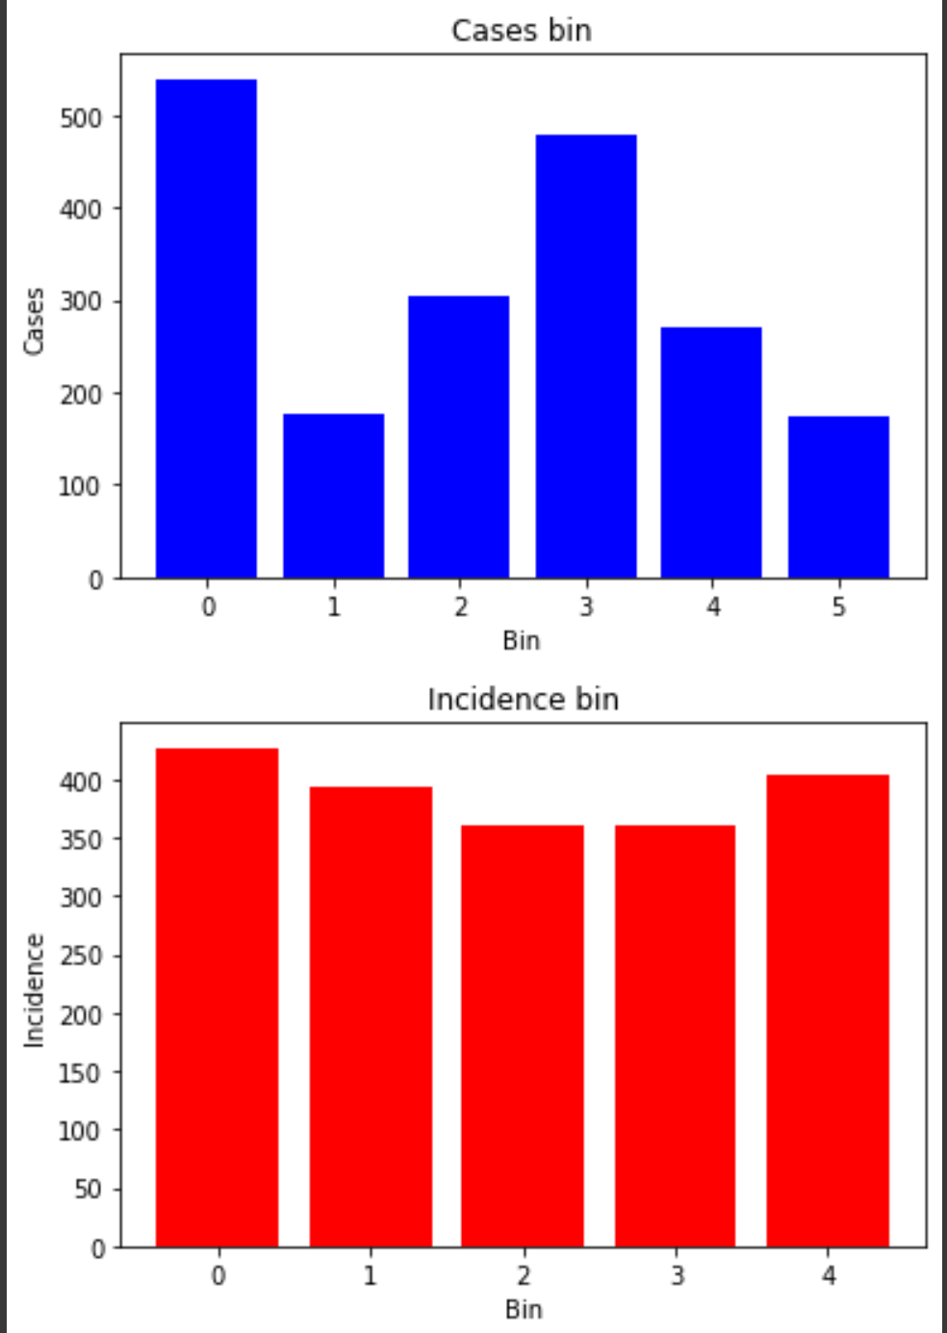

- Secondly, the log transform and box cox of our X is visualised and compared to the original data.

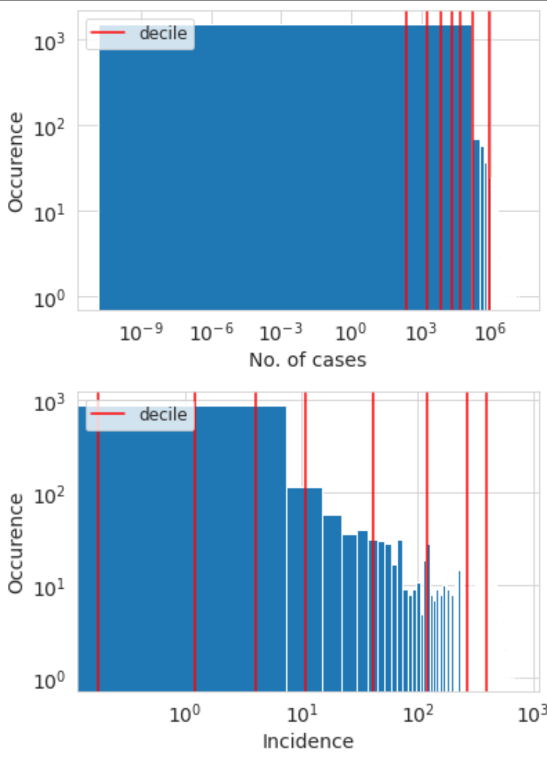
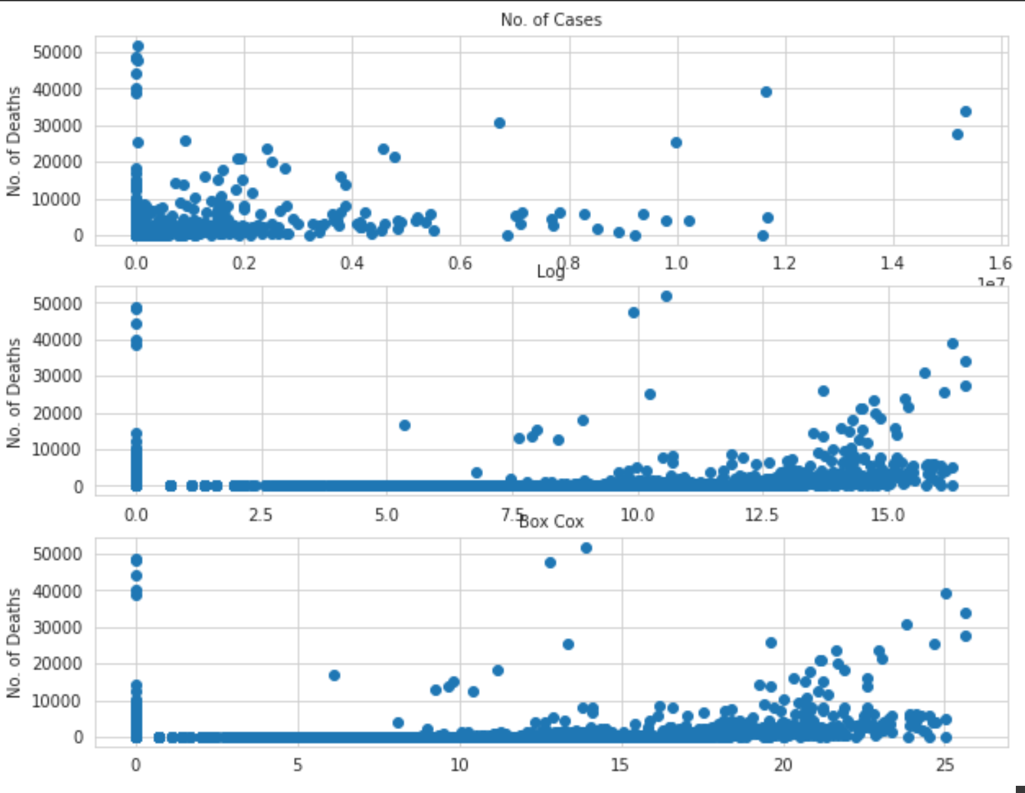

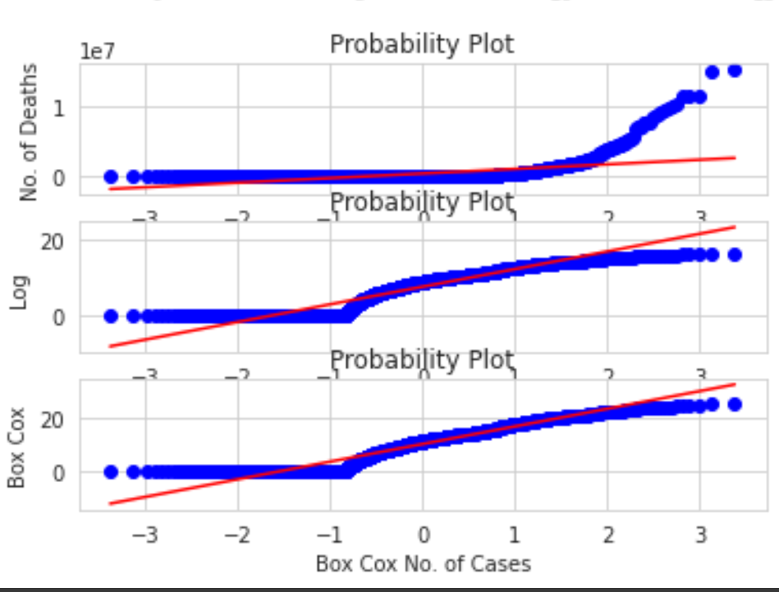

- This is done for the cases, WHO Region and incidence features

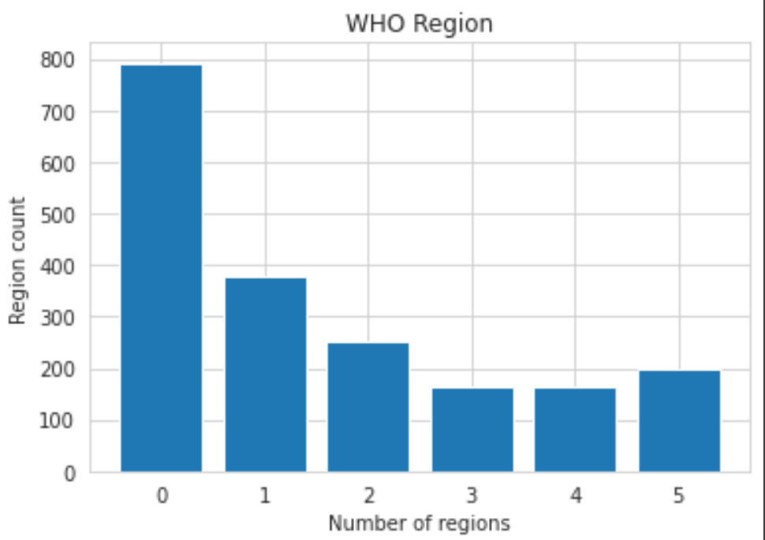

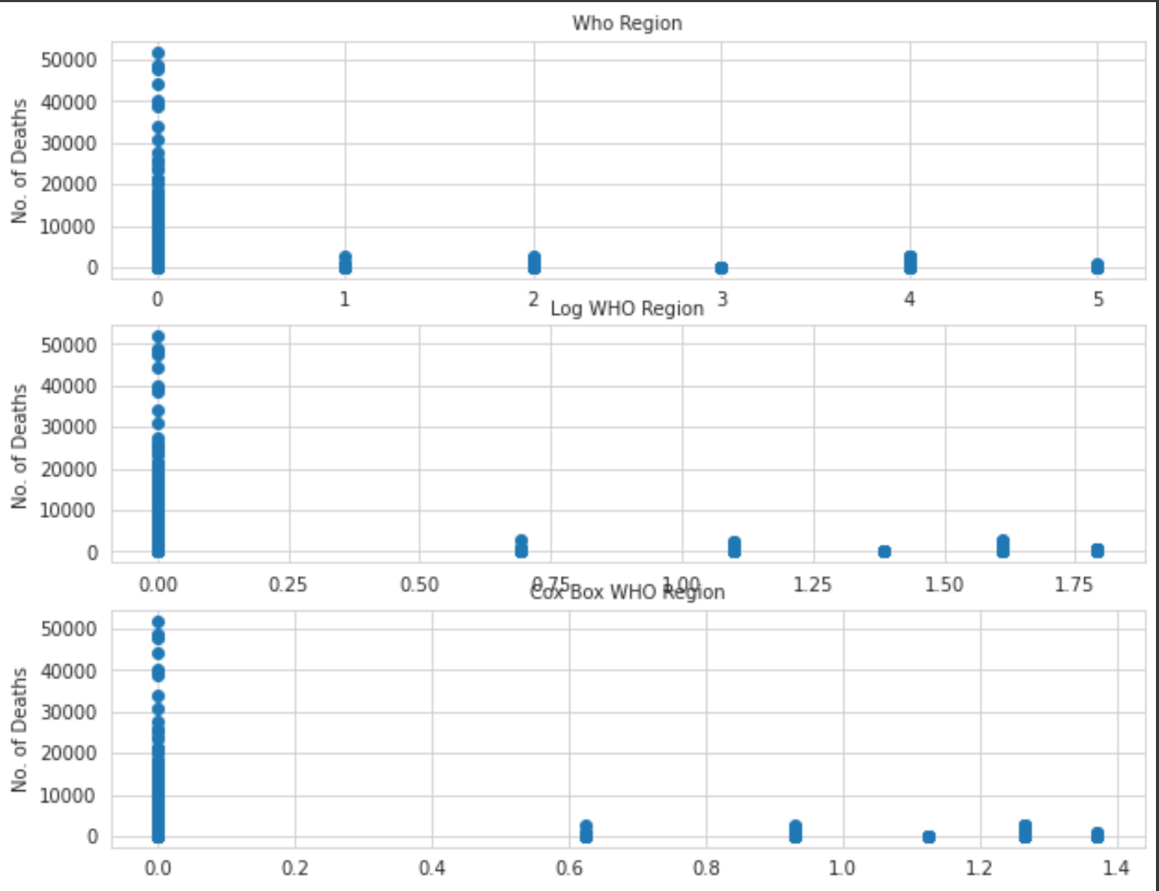

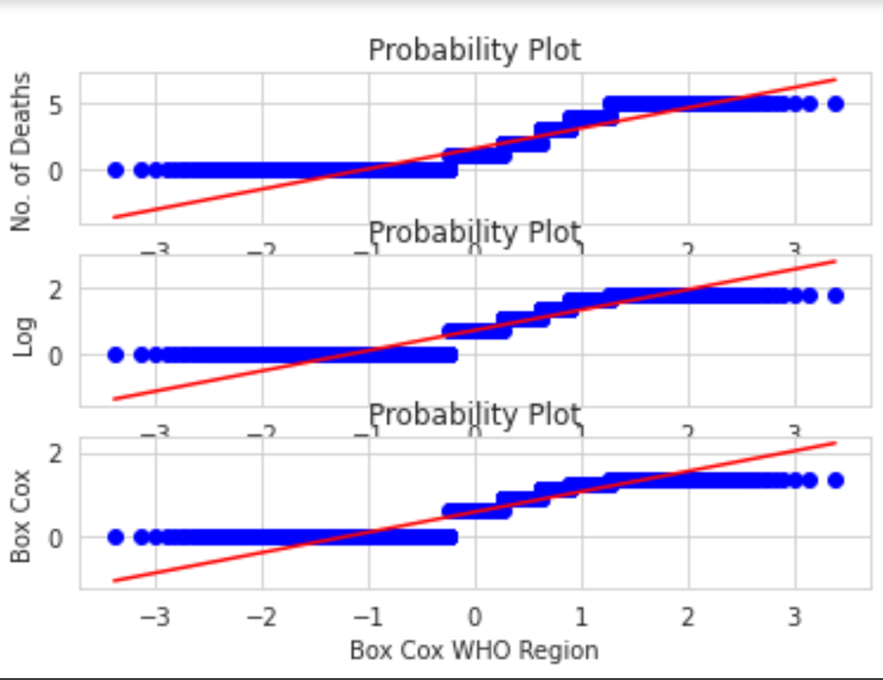

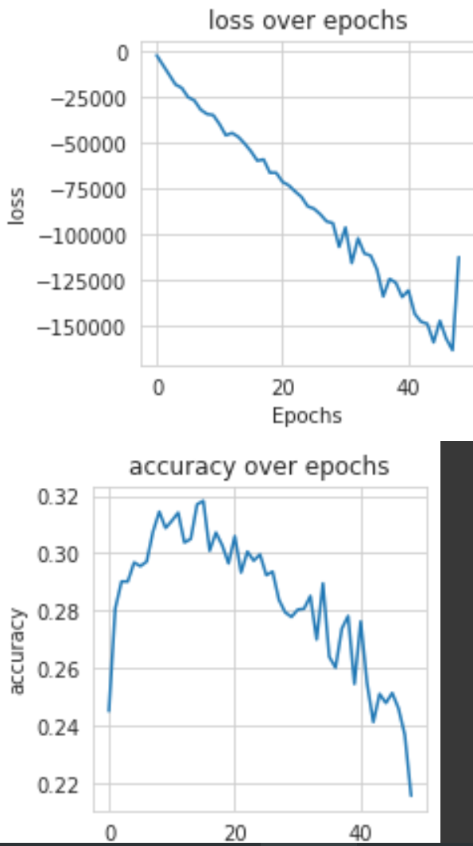

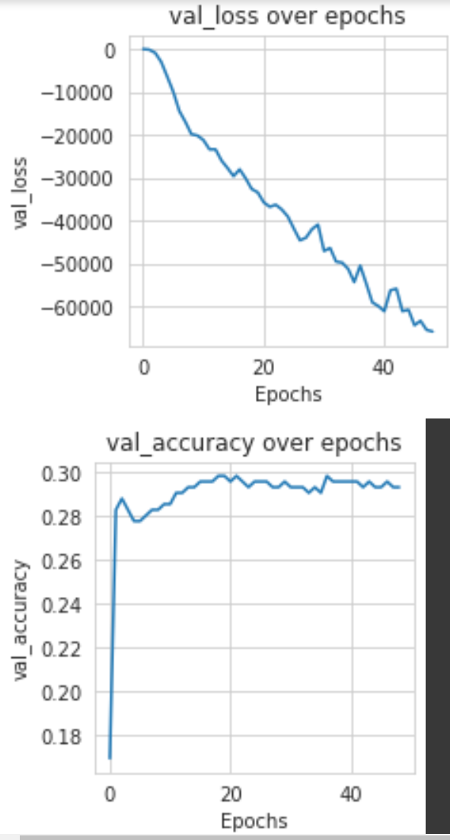

- Splitting the data:

- In preparation for inputting the X and y to our model, we must first split it into train and val sets.

- After that, the X_train and X_val are scaled with a min max scaler.

- Model prediction

- We have created a Multilayer perceptron (MLP) which is a feedforward artificial neural network that generates a set of outputs from a set of inputs.

- An MLP is characterized by several layers of input nodes connected as a directed graph between the input and output layers.

- MLP uses backpropagation for training the network.

- Multilayer Perceptron with 3 hidden layers, 3 dropouts which have a dropout rate of 0.325 and an output activation of sigmoid.

- The loss is a binary cross entropy and the optimizer is an Adam which has a learning rate of 0.0001 and an epsilon of 2e-06. which gives moderate accuracy.

Task 2 Report

Problem Statement: Predict which patient has diabetes from Diabetes Database.csv and try to understand the dataset attributes and try to figure out type ML model suits and build from scratch.

Objectives:

- Data Visualization ( Exploratory Data Analysis )
- Data Pre-processing
- Feature Engineering
- Model Fitting

- Data Visualization
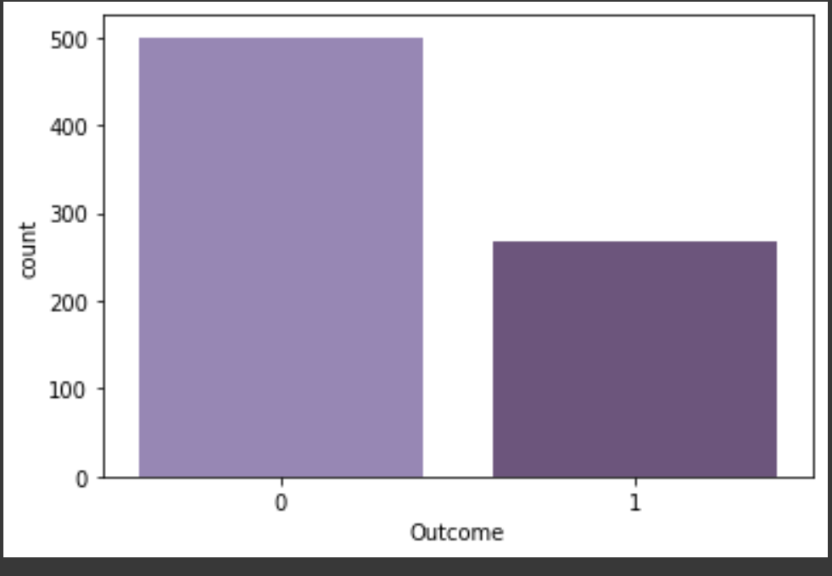

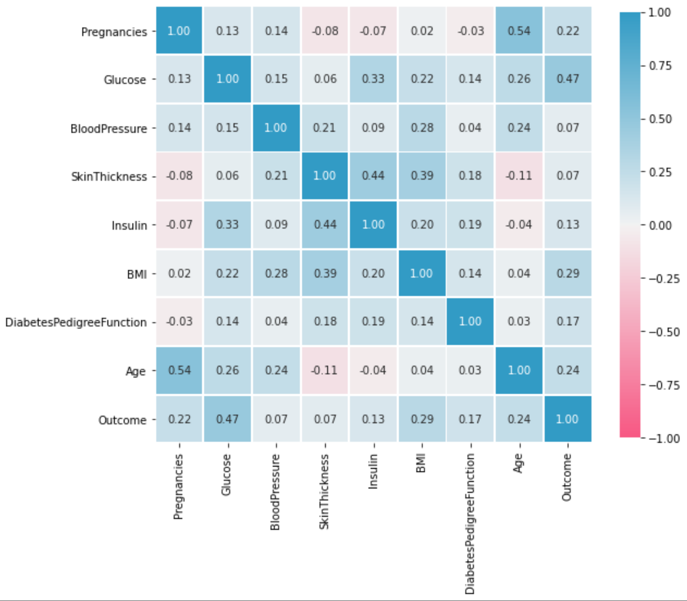

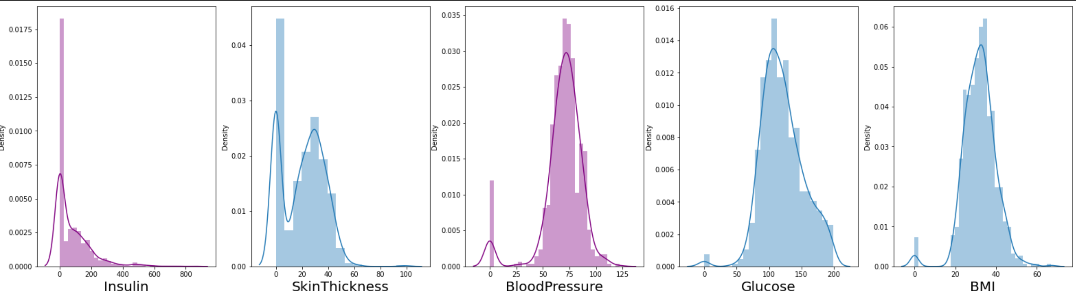

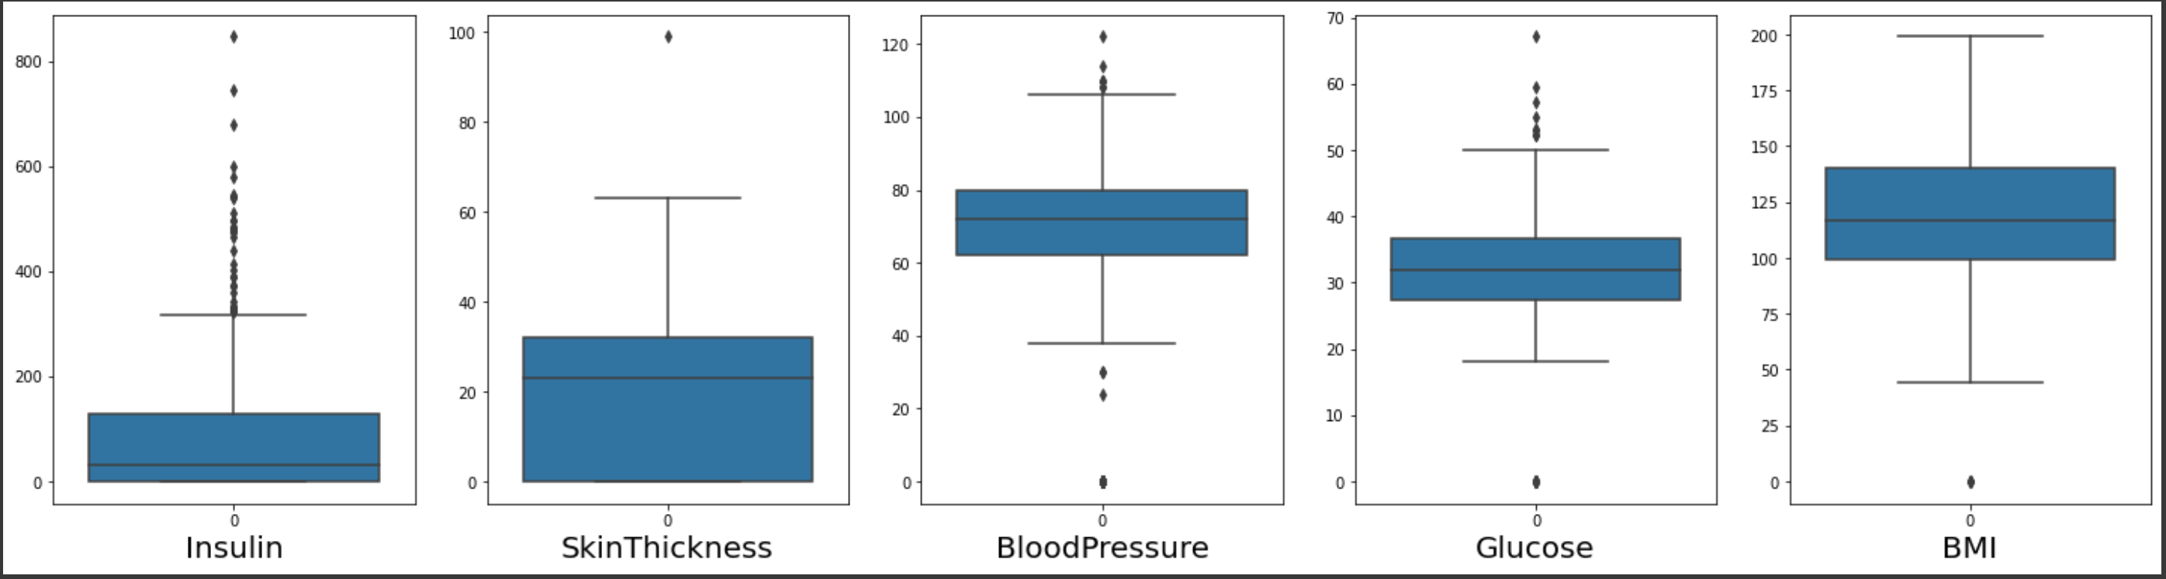

- Data Pre-Processing

- Checking the null values of the dataset and replacing the necessary attributes with mean and median.
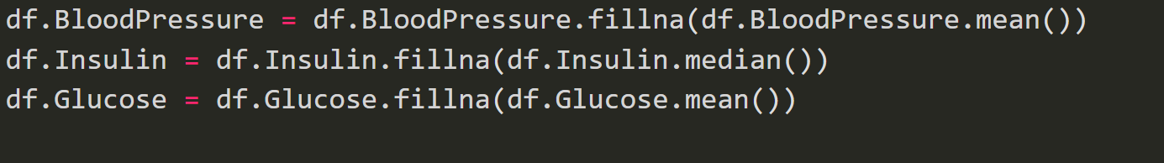
- Outlier Analysis for the dataset
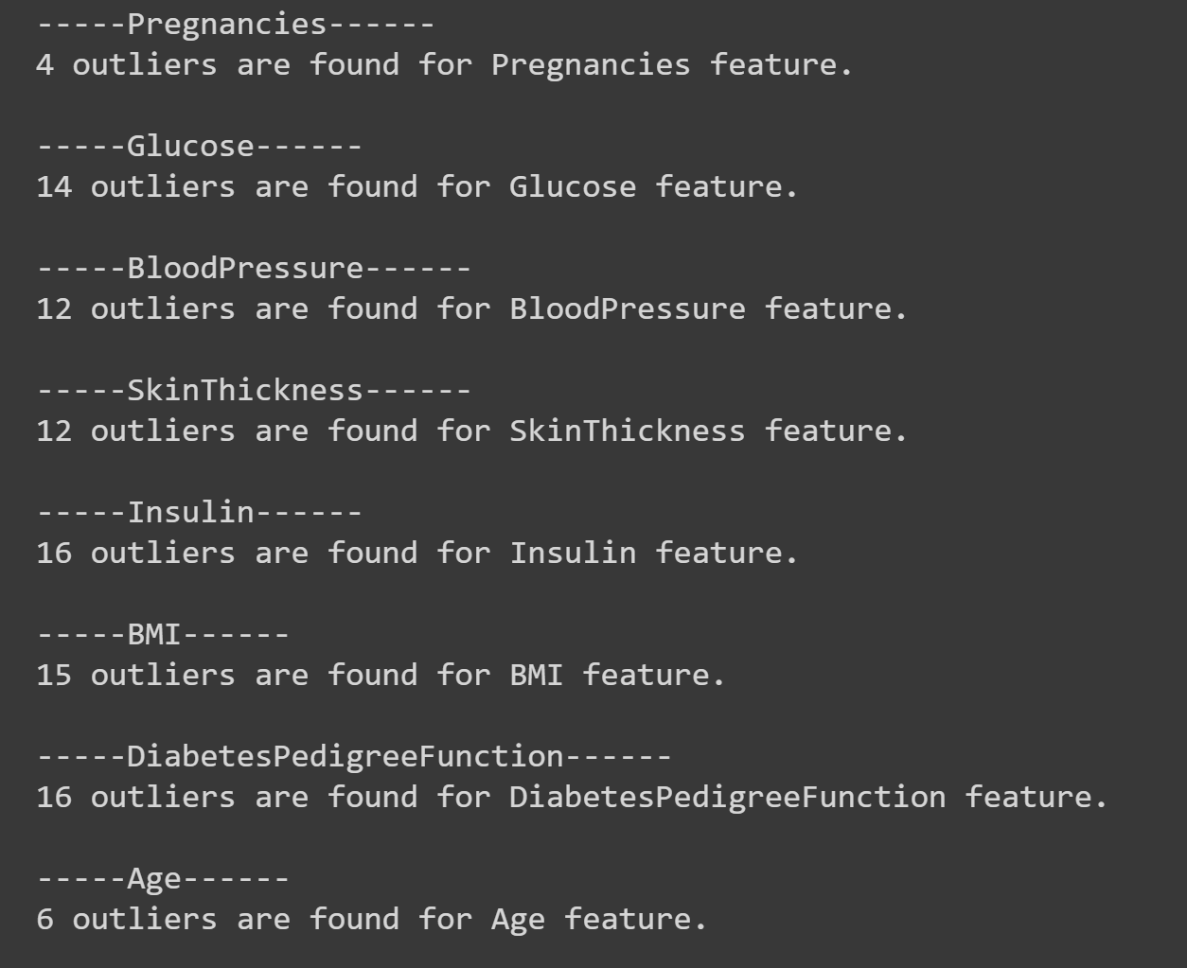

- Quartile Analysis of the SkinThickness attribute:

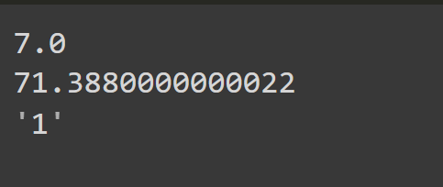

- Feature Engineering

- Categorizing the age into three categories:
    - Age <= 18: Kid
    - Age <=30: Young
    - Age > 30 and Age < 50: Mature
    - Age > = 50: Senior

- Categorizing glucose into three categories:
    - Glucose <= 70: Hipoglisemi
    - Glucose <=100: Normal
    - Glucose <= 125 and Glucose > 100: Pre-Diabetes
    - Glucose > 125: Diabetes

  - By using RobustScaler (), we can remove the outliers and then use either StandardScaler or MinMaxScaler for pre-processing the dataset. It scales features using statistics that are robust to outliers. This method removes the median and scales the data in the range between 1st quartile and 3rd quartile.

- Model Fitting
The model that I have used for model fitting is the Decision Tree Classifier. Decision Trees (DTs) are a non-parametric supervised learning method used for classification and regression. The goal is to create a model that predicts the value of a target variable by learning simple decision rules inferred from the data features. A tree can be seen as a piecewise constant approximation.

Model’s Accuracy:

In Machine Learning, performance measurement is an essential task. So when it comes to a classification problem, we can count on an AUC - ROC Curve. When we need to check or visualize the performance of the multi-class classification problem, we use the AUC (Area Under the Curve) ROC (Receiver Operating Characteristics) curve. It is one of the most important evaluation metrics for checking any classification model’s performance. It is also written as AUROC (Area Under the Receiver Operating Characteristics)

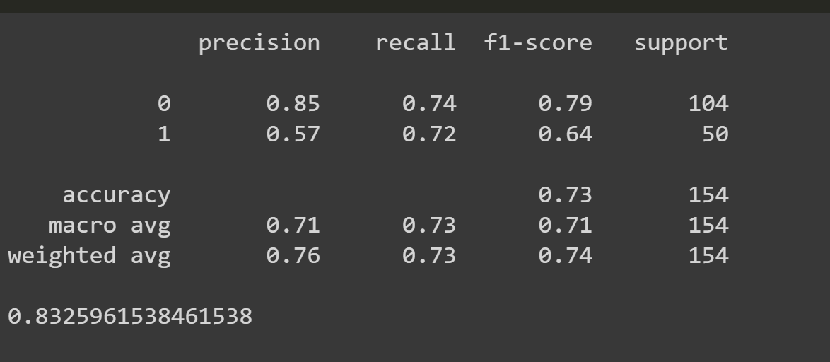

Confusion Matrix:
Confusion Matrix is a performance measurement for machine learning classification problem where output can be two or more classes. It is a table with 4 different combinations of predicted and actual values.

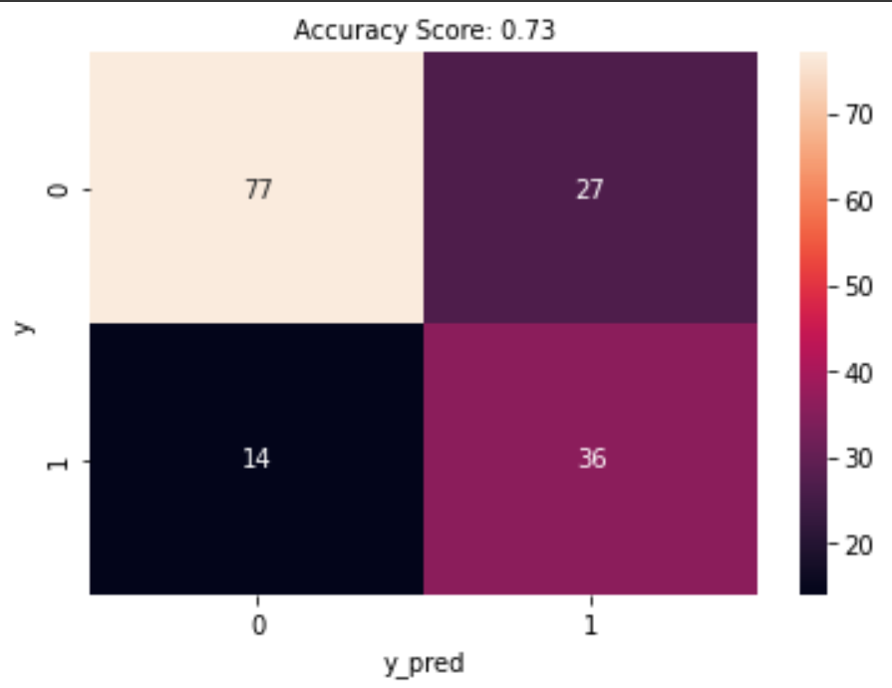

- ROC Curve: Plot of False Positive Rate (x) vs. True Positive Rate (y).
The true positive rate is a fraction calculated as the total number of true positive predictions divided by the sum of the true positives and the false negatives (e.g., all examples in the positive class). The true positive rate is referred to as the sensitivity or the recall.

