What I'd do
1. Use $6,860.56 as July's AI cost (the invoices). The dashboard said $6,310.49 and is not a true estimate.
2. Hold off shipping onboarding_v2. The test is broken on Android, and the PM quoted a metric we didn't agree on.
3. Test sending shorter summaries to the cheaper nimbus-mini model. If quality holds, that saves up to about $825 a month.
Why was the dashboard $550 short
I rebuilt July from our logs and matched every invoice line to the unit. The dashboard misses in six ways:
Amount | Cause
+$418 | New model nimbus-large-0526 (live July 10) has no price on our table, so it was dropped
+$62 | Nimbus raised nimbus-large output price on July 15 (15 to 18 per million tokens). Table did not have an update
+$98 | Providers bill timed-out calls. The dashboard skips them
+$52 | Invoices use UTC months, the dashboard uses Pacific dates
+$31 | Vox rounds each request up to 15 seconds. The dashboard uses exact seconds
-$111 | The dashboard counts duplicate log rows that providers bill once
+$550 | Total gap: $6,310.49 (dashboard) to $6,860.56 (invoices)
June was only off at about $87 because the new model and price change hadn't happened yet. I can't fully explain that $87.
July AI spend at a glance
Measure | Result
Active users, cost per user | About 985 a day, at about $0.22 each per day
Where the money goes | Transcription 66%, summarization 31%
First-week cost per new user | $0.61 for June signups, $0.60 for July (flat)
Who drives cost | 83% of users who never started a trial. Top 1% of users: 7%
AI cost vs subscription cash | 39% of $17,378 cash (71% on monthly plans; annual prepay for flatters in July)

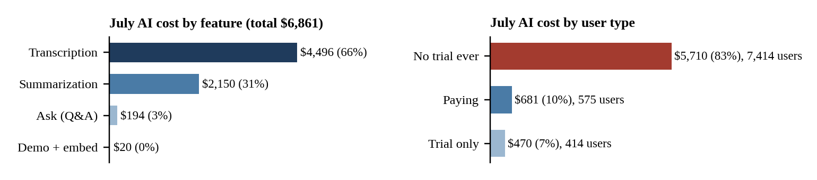

The onboarding_v2 test
The PM's day-1 numbers are right (41.9% to 51.0%), but we agreed to judge the test on activity on days 7 to 13:
Group (days 7 to 13) | Lift | 95% range | Read
All users (agreed metric) | +1.8 pts | -1.0 to +4.5 | Could easily be zero
iOS | +4.4 pts | +0.9 to +7.9 | Encouraging, chosen after the fact
Android, app 4.2.1 | -5.3 pts | -10.8 to +0.3 | Trends negative
Android, app 4.1.3 | n/a | n/a | 209 users never assigned
Because of those 209 users, the arms are 2,404 vs 2,160 instead of even. The demo costs about 1.6 cents per user. I'd change my mind with an even split on every platform, a lift whose range stays above zero, and no drop on Android.
Next two weeks
Add the new model and price change to the pricing table, and count timeouts, duplicates and UTC months on the dashboard. Engineering fixes the Android 4.1.3 bug, then we re-run the test. Run a small summary quality test on nimbus-mini and ask the providers about credits for timed-out calls (about $98 a month).
What the data supports: Invoice units match the logs on all six lines, so $6,860.56 is firm. The dashboard rules are inferred, the $87 June gap is unexplained, the $825 saving is untested on summary quality, and the iOS lift (p = 0.014) is a post-hoc subgroup.

