ICT for HEART MONITORING

Federico Mason

federico.mason@unipd.it

PART 2

HEART RATE VARIABILITY 2

**SINGLE LEAD ECG RECORDING**

The recording of a single-lead ECG can be achieved via **minimal invasive** devices, such as wearables or subcutaneous patches

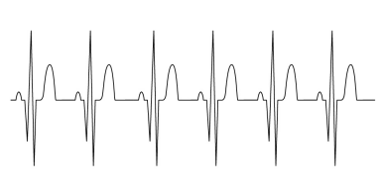➢ A single-lead ECG is sufficient to analyze the heartbeats and estimate both the heart rate and its variability

3

**SINGLE LEAD ECG RECORDING**

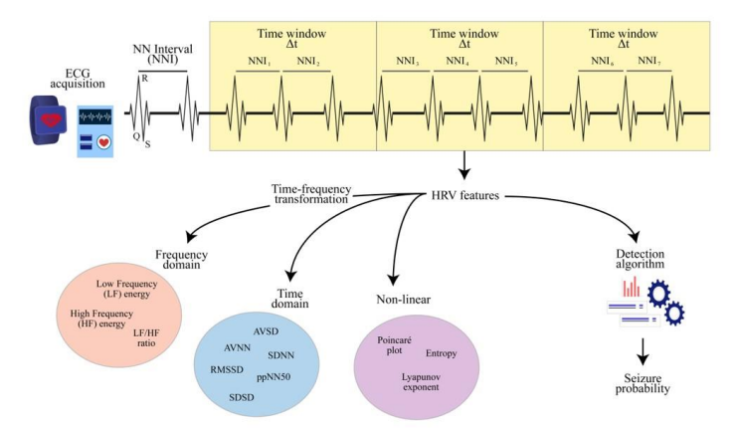4

**HEART RATE VARIABILITY ESTIMATION**

To estimate the HRV, it is first necessary to compute the **Normal-to-Normal Intervals** (NNIs), i.e., the intervals between consecutive R peaks

To make the HRV estimation time-dependent, a common choice is to select a **time window** ∆��, so that any feature ������(��) is computed according to the NNIs measured between time �� and time �� + ∆��

The selection of ∆�� trades off between **estimation accuracy** and **time sensitivity** → A value of at least ∆�� = 4 ������ is usually recommended!

5

**TIME DOMAIN (I)**

The **average of the NNI series** (AVNN) represents the reciprocal of the heart rate, while the **standard deviation of the NNI series** (SDNN) represents a naïve HRV estimation

�������� �� =σ����+∆�� ��������

��(��)

��������(��) =σ����+∆�� �������� − ��������(��)2

��(��)

6

**TIME DOMAIN (II)**

More advanced metrics can be derived from the **series SD of subsequent NNI differences** ������ = ��������+1 − ��������

��������(��) =σ����+∆�� ������

�� �� − 1

��������(��) =σ����+∆�� ������ − ��������(��)2

�� �� − 1

��������(��) =σ����+∆�� ������2

�� �� − 1

7

**NNI DISTRIBUTION (I)**

Another HRV metric is the **probability** (ppNN��) **that two consecutive NNIs differ more than** �� **milliseconds**, where �� is usually set to 50 ���� or 20 ����

����������(��) =σ����+∆�� ��(������ > ��)

�� �� − 1

�� ������ > �� = ቊ1 ������ > ��

0 ����ℎ������������

Both RMSD and ppNN�� are considered markers of the **vagal** (i.e., parasympathetic) **tone** of the nervous system

8

**NNI DISTRIBUTION (II)**

The **triangular index (TI)** is defined as the ratio between the total number of NNIs and the number of NNIs in the modal bin

����(��) =��(��)

σ����+∆�� ��(�������� = �������� ������(��) )

The **triangular interpolation (TINN)** of NNIs is defined as the baseline width of the NNI distribution

�������� �� ≅ ������ ������ �� − min[������(��)]

In the case of TI and TINN, we should consider ∆�� ≥ 20 ������

9

**FREQUENCY DOMAIN (I)**

We can implement a **time-frequency transformation** (e.g., the Fourier transform) and analyze the NNI spectrum

Given the spectrum ������(��, ��) of NNI, we can compute the energy of significant frequency bands:

• the **low-frequency (LF) band** 0.06, 0.10 ���� reflects both the sympathetic and vagal tones

• the **high-frequency (HF) band** 0.15, 0.40 ���� reflects the vagal tone

10

**FREQUENCY DOMAIN (II)**

0.10

������ �� = න

0.06

0.40

������ �� = න

0.15

������(��, ��)2 ���� ������(��, ��)2 ����

The **energy ratio** between the LF and HF bands is considered a marker of the sympathetic–vagal balance

���� �� =������ ��

������ ��

*\*Before implementing a time-frequency transformation, we need to interpolate the NNI series to operate with equidistant samples!!!*

11

**POINCARÉ PLOT**

The **Poincaré plot** represents subsequent NNI values in a two-dimensional coordinate system where each point is given by a couple ��������+1, �������� 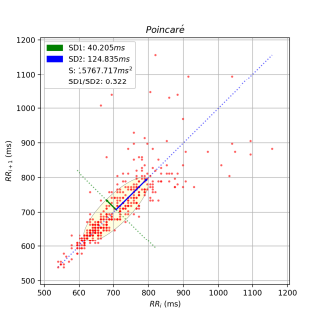

We consider the **standard deviation**

perpendicular to (����1) and along (����2)

the **line-of-identity**

����12 =12��������2

����22 = 2��������2 −12��������2

12

**POINCARÉ PLOT**

The **Poincaré plot** represents subsequent NNI values in a two-dimensional coordinate system where each point is given by a couple ��������+1, �������� 

From SD1 and SD2, we can compute

the **Cardiac Sympathetic Index** and

the **Cardiac Vagal Index**

����1����2

������ = ൗ

������ = log ����1 × ����2

13

**ACTIVITY: SEIZURE DETECTION**

HRV has been recognized as a useful biomarker for **detecting** or even **predicting seizures** in people with epilepsy

This makes it possible to trigger alarms 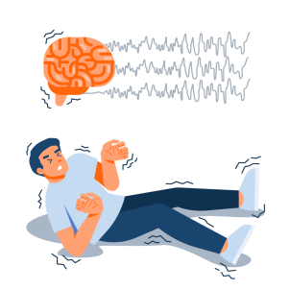

to caregivers by using a wearable device

On the other hand, scientific findings show

that HRV is effective only in patients

with **relevant autonomic changes** during

the seizure events

14

**ACTIVITY: SEIZURE DETECTION**

**You are provided with:**

➢ 5 single-lead ECG recordings of approximately 1.5 hours, during which an epileptic seizure occurs

➢ a Python framework to extract the NN intervals from the single-lead ECG

**You are asked to:**

➢ compute at least two HRV metrics among those discussed during the lecture

➢ analyze the HRV metrics in time and try to determine when the epileptic seizure occurs

15

**ACTIVITY: SEIZURE DETECTION**

**Recommendation:**

➢ ECG data (like any kind of real-world data) is characterized by noise and artifacts

➢ we can assume that all the NN intervals larger than 1.5 �� are associated with recording errors

������∗= [�������� ∈ ������: �������� ≤ 1.5 ��]

➢the time domain of time-based HRV features and frequency based HRV features may be different since the second are obtained after the NNI series interpolation

16

**PYTHON FRAMEWORK**

**Basic usage:**

➢ You can decide which file to process and what part of the code to run by using the command line options

➢ to plot the ECG signal associated with *./epoch_0/,* write:

➢ To compute and plot the NNI intervals associated with *./epoch_0/,* write:

17

**PYTHON FRAMEWORK**

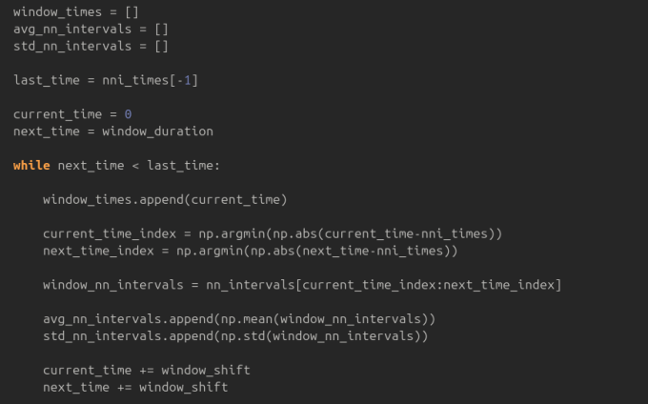18

Thank you!

Federico Mason

federico.mason@unipd.it