**Adapted J1 - Deliv-e-droid**

https://cemc.uwaterloo.ca/sites/default/files/documents/2023/juniorEF.pdf

Request:

POST: localhost:xx/api/J1/Delivedroid Content-Type: application/x-www-form-urlencoded Request Body: Collisions=2&Deliveries=5

Curl command:

*curl -X POST "http://localhost:5021/api/J1/Delivedroid" -H "Content-Type: application/x-www-form-urlencoded" -d "Collisions=2&Deliveries=5"*

Output:



Request:

POST: localhost:xx/api/J1/Delivedroid Content-Type: application/x-www-form-urlencoded Request Body: Collisions=2&Deliveries=5

Curl command:

*curl -X POST "http://localhost:5021/api/J1/Delivedroid" -H "Content-Type: application/x-www-form-urlencoded" -d "Collisions=10&Deliveries=0"*

Output:



Request:

POST: localhost:xx/api/J1/Delivedroid Content-Type: application/x-www-form-urlencoded Request Body: Collisions=2&Deliveries=5

Curl command:

*curl -X POST "http://localhost:5021/api/J1/Delivedroid" -H "Content-Type: application/x-www-form-urlencoded" -d "Collisions=3&Deliveries=2"*

Output:



**Adapted J2 - Chili Peppers Source:**

[**https://cemc.uwaterloo.ca/sites/default/files/documents/2023/juniorEF.pdf**](https://cemc.uwaterloo.ca/sites/default/files/documents/2023/juniorEF.pdf)

Request:

GET: localhost:xx/api/J2/ChiliPeppers&Ingredients=Poblano, Cayenne,Thai,Poblano

Curl command:

*curl -X GET "http://localhost:5021/api/J2/ChiliPeppers?ingredients=Poblano,Cayenne,Thai,Poblano"*



Request:

GET: localhost:xx/api/J2/ChiliPeppers&Ingredients=Habanero ,Habanero,Habanero,Habanero,Habanero

Curl command:

*curl -X GET "http://localhost:5021/api/J2/ChiliPeppers?ingredients=Habanero,Habanero,Habanero,Habanero,Habanero"*

Output:



Request:

GET: localhost:xx/api/J2/ChiliPeppers&Ingredients=Poblano, Mirasol,Serrano,Cayenne,Thai,Habanero,Serrano

Curl command:

*curl -X GET "http://localhost:5021/api/J2/ChiliPeppers?ingredients=Poblano,Mirasol,Serrano,Cayenne,Thai,Habanero,Serrano"*

Output:



**Problem J1: Roller Coaster Ride**

<https://cemc.uwaterloo.ca/sites/default/files/documents/2025/2025CCCJuniorEF.pdf>

Sample Input:

1 14 3 2

Curl command:

*curl -X GET “*[*http://localhost:5021/api/J1/RollerCoasterRide?n=14&c=3&p=2*](http://localhost:5021/api/J1/RollerCoasterRide?n=14&c=3&p=2)*”*

Output:



Sample Input:

1 14 3 2

Curl command:

*curl -X GET "http://localhost:5021/api/J1/RollerCoasterRide?n=12&c=4&p=3"*

Output:



**Problem J2: Donut Shop**

<https://cemc.uwaterloo.ca/sites/default/files/documents/2025/2025CCCJuniorEF.pdf>

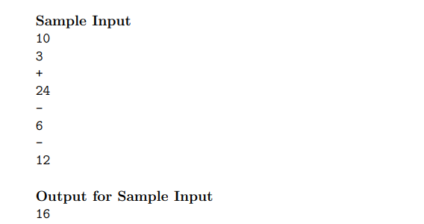

Curl command:

*curl -X POST "http://localhost:5021/api/J2/DonutShop" -H "Content-Type: application/json" -d "{\"d\":10,\"events\":[{\"action\":\"+\",\"quantity\":24},{\"action\":\"-\",\"quantity\":6},{\"action\":\"-\",\"quantity\":12}]}"*

Output:



**Problem J3: Product Codes**

https://cemc.uwaterloo.ca/sites/default/files/documents/2024/2024CCCJrProblems.html

Input:

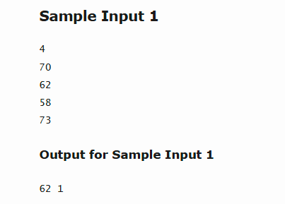

Curl command:

*curl -X POST "http://localhost:5021/api/J3/BronzeCount" -H "Content-Type: application/json" -d "{\"scores\":[70,62,58,73]}"*

Output:



Input:

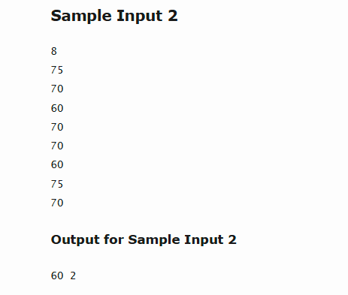

Curl command:

*curl -X POST "http://localhost:5021/api/J3/BronzeCount" -H "Content-Type: application/json" -d "{\"scores\":[75,70,60,70,70,60,75,70]}"*

Output:

