LAB EXPERIMENT REPORT
PrepTrack: ML-Based Taxi Trip Prediction Tool
Using Apache Pig and Machine-Learning Algorithms
Data Science / Big Data Analytics Laboratory
Name | ____________________________________________
Register Number | ____________________________________________
Course / Class | ____________________________________________
Date | ____________________________________________

1. Title
PrepTrack: ML-Based Taxi Trip Prediction Tool Using Apache Pig and Machine-Learning Algorithms

2. Aim
To develop a taxi trip-duration prediction system by preprocessing the Kaggle NYC Taxi Trip Duration dataset with Apache Pig and comparing multiple machine-learning regression algorithms.

3. Objectives
- To clean and prepare taxi trip records using Apache Pig.
- To remove missing, invalid, and unrealistic records from the dataset.
- To generate useful time-based and trip-location features for prediction.
- To train and compare Linear Regression, Decision Tree, Random Forest, and Gradient Boosting models.
- To evaluate model performance using MAE, RMSE, and R² metrics.
- To select the most suitable model for estimating taxi trip duration.

4. Dataset
The experiment uses the Kaggle NYC Taxi Trip Duration competition dataset. Each record contains information such as taxi trip ID, vendor ID, pickup date and time, passenger count, pickup coordinates, drop-off coordinates, store-and-forward flag, and trip duration. The target variable is trip_duration, measured in seconds.
Dataset source: https://www.kaggle.com/competitions/nyc-taxi-trip-duration/team

5. Role of Apache Pig
Apache Pig is used as the data-preprocessing layer before model training. It is suitable for expressing data-cleaning and transformation operations in a simple data-flow format and can process large datasets efficiently. In this experiment, the Pig scripts:
- clean and transform the raw taxi records;
- filter missing and invalid values;
- remove unrealistic passenger counts, coordinates, and trip durations;
- prepare hourly trip statistics for analysis; and
- export a clean, machine-learning-ready dataset for Python.
Using Pig separates large-scale data preparation from model training and helps produce consistent, reproducible input data.

6. Algorithms Used
Algorithm | Description
Linear Regression | A baseline regression method that predicts trip duration as a weighted linear combination of the input features. It is simple, interpretable, and useful for comparison.
Decision Tree Regression | Splits records into feature-based regions and predicts a duration for each region. It can model non-linear relationships but may overfit when not properly constrained.
Random Forest Regression | Combines predictions from many decision trees trained on different samples and feature subsets. This generally improves stability and reduces overfitting compared with a single tree.
Gradient Boosting Regression | Builds decision trees sequentially, where each new tree corrects errors from earlier trees. It can learn complex patterns but requires suitable parameter tuning.

7. Methodology
1. Load the raw Kaggle taxi trip data.
2. Use Apache Pig scripts to clean records and export the prepared data.
3. Load the Pig output into Python using Pandas.
4. Convert numeric and datetime columns to the required data types.
5. Apply data-quality filters for passenger count, coordinates, and trip duration.
6. Create pickup hour, day, month, and weekday features.
7. Split the data into training and testing subsets.
8. Train the four regression algorithms using scikit-learn.
9. Evaluate the predictions using MAE, RMSE, and R².
10. Compare the results and select the best-performing model.

8. Features Used
The model uses vendor ID, passenger count, pickup longitude and latitude, drop-off longitude and latitude, pickup hour, pickup day, pickup month, and pickup weekday. These features represent the trip location, trip context, and time-related travel patterns.

9. Results
The Random Forest model achieved the best reported performance on the held-out test set.
Metric | Random Forest Result
MAE | 243.90 seconds
RMSE | 361.69 seconds
R² | 0.7032
The R² score indicates that the model explained approximately 70% of the variation in trip duration for this evaluation.
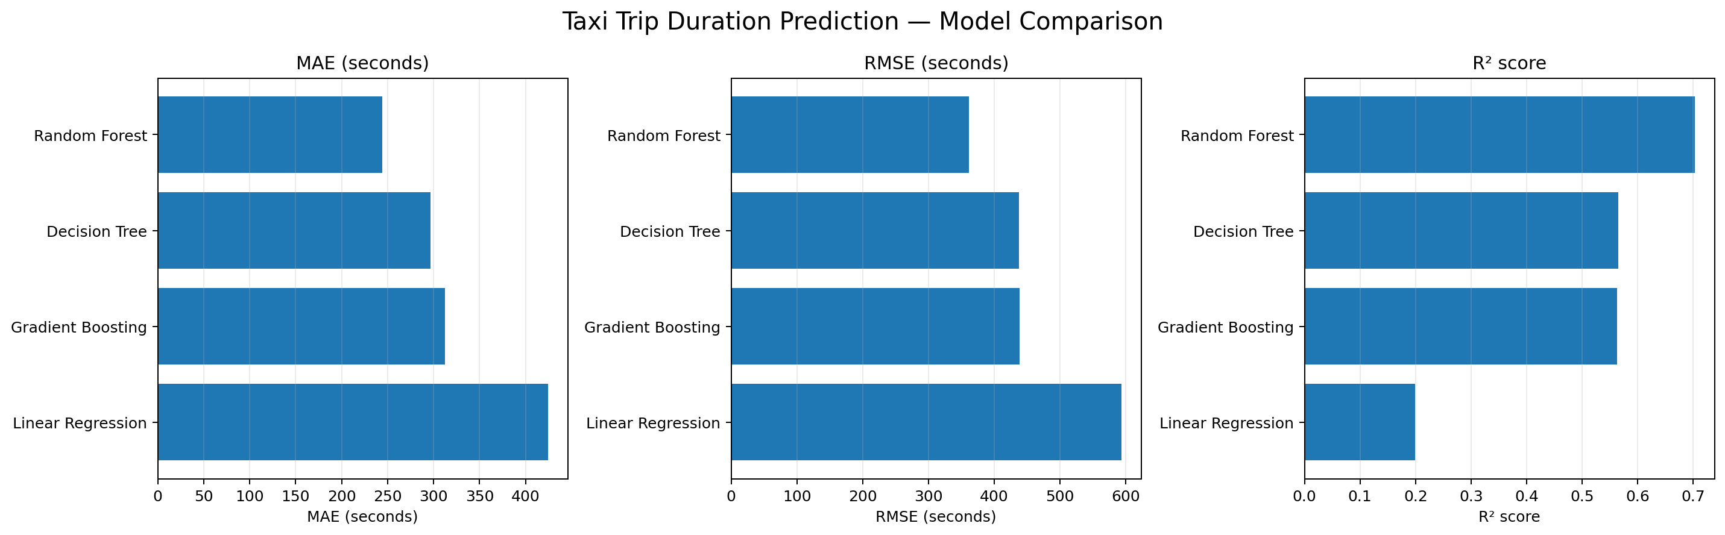
Figure 1. Model comparison
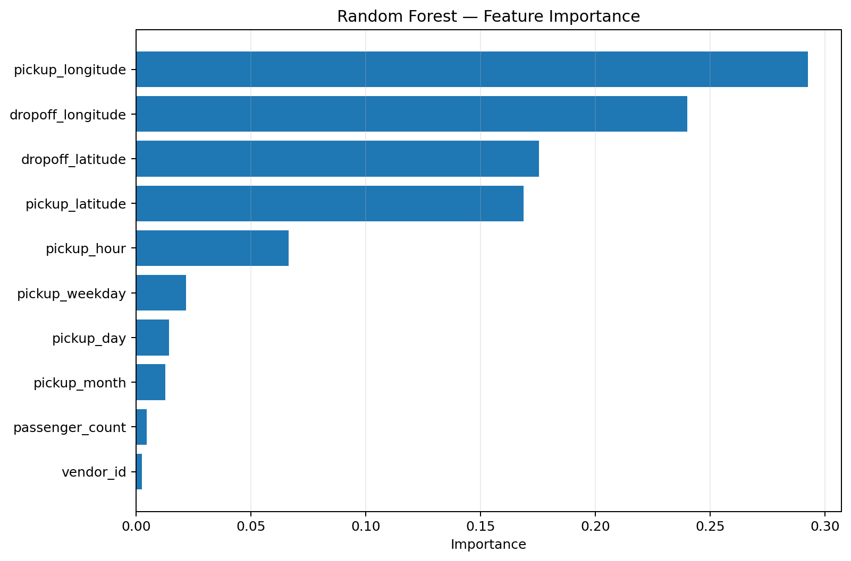
Figure 2. Random Forest feature importance

10. Judgement / Conclusion
The experiment demonstrates that machine-learning algorithms can predict taxi trip duration from historical trip data. Apache Pig improves the reliability of the workflow by performing structured data cleaning and preprocessing before model training. Among the tested algorithms, Random Forest Regression produced the best reported results and was selected as the most suitable model for this project.
The prediction tool can support travel-duration estimation, taxi-service planning, passenger information, and transportation analysis. However, the prediction may be affected by traffic conditions, weather, road closures, accidents, and other real-time factors that are not included in the dataset.

11. Software and Tools
- Apache Pig
- Python
- Pandas and NumPy
- Scikit-learn
- Matplotlib
- Kaggle NYC Taxi Trip Duration dataset

12. Result
A complete taxi trip-duration prediction workflow was implemented using Apache Pig for preprocessing and Python machine-learning algorithms for prediction. Random Forest Regression was identified as the best-performing model among the algorithms compared.

