Saaim Ali Khan – 2022519 – CE408
Github link: https://github.com/SaaimAK/CE408-Final
- Authentication Service
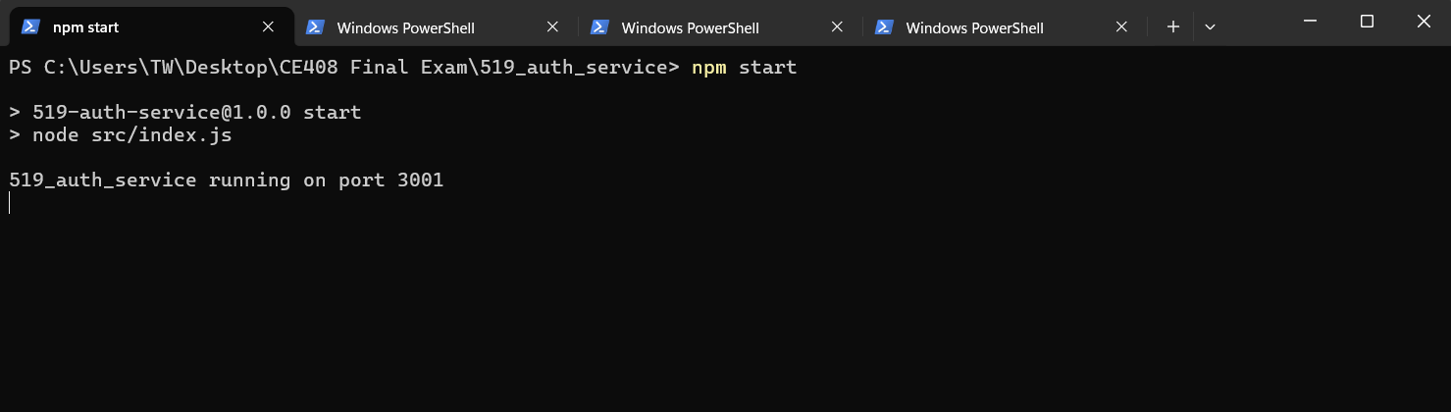
- Event Service
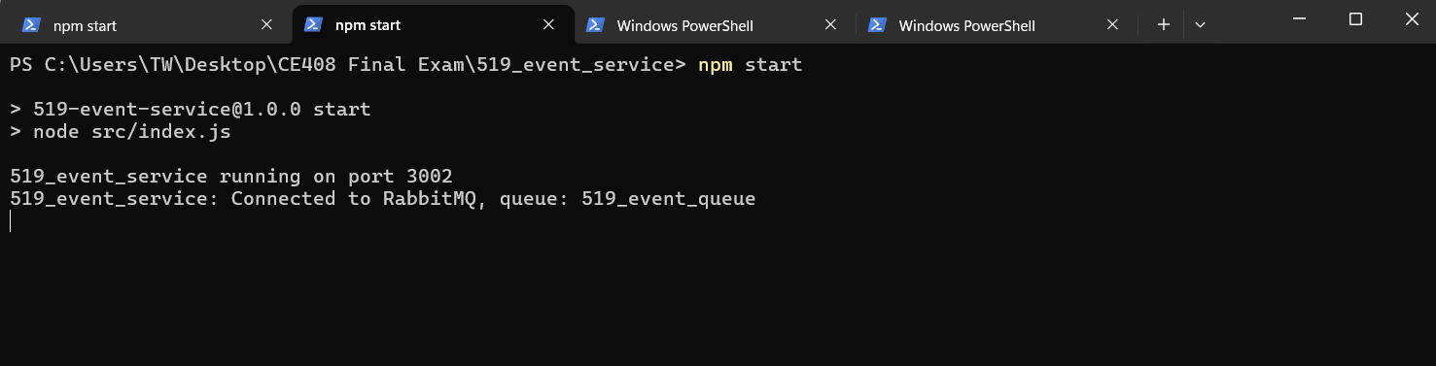

- Notification Service:
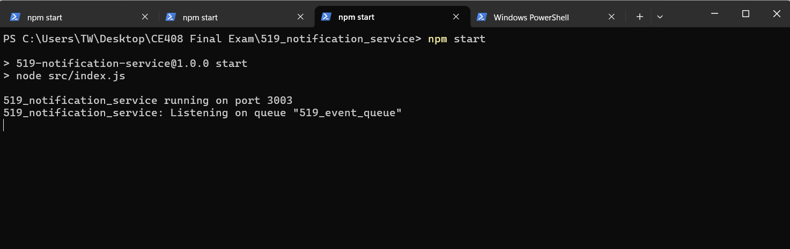

- Containers of Auth and Event Service:
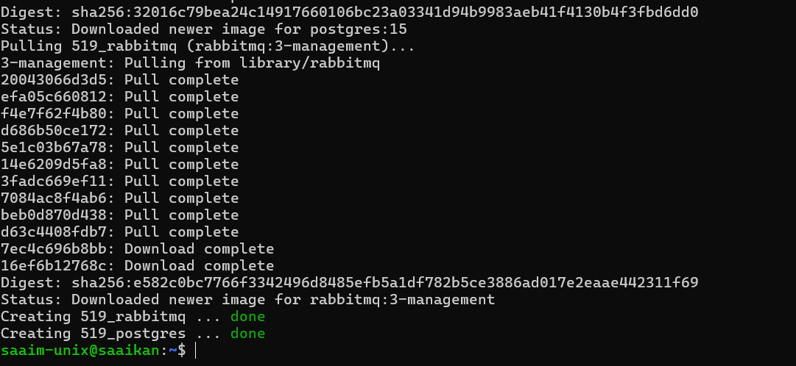
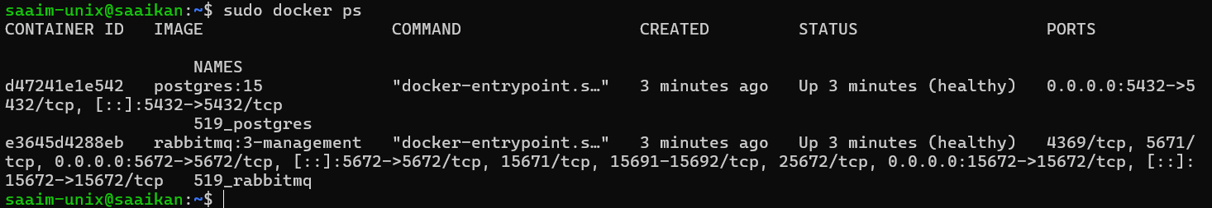

- Registering User
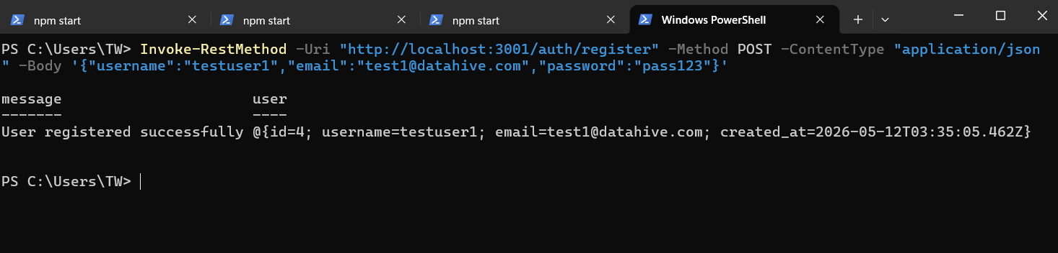

- REST API development of Auth, Event and Notification service testing using CURL
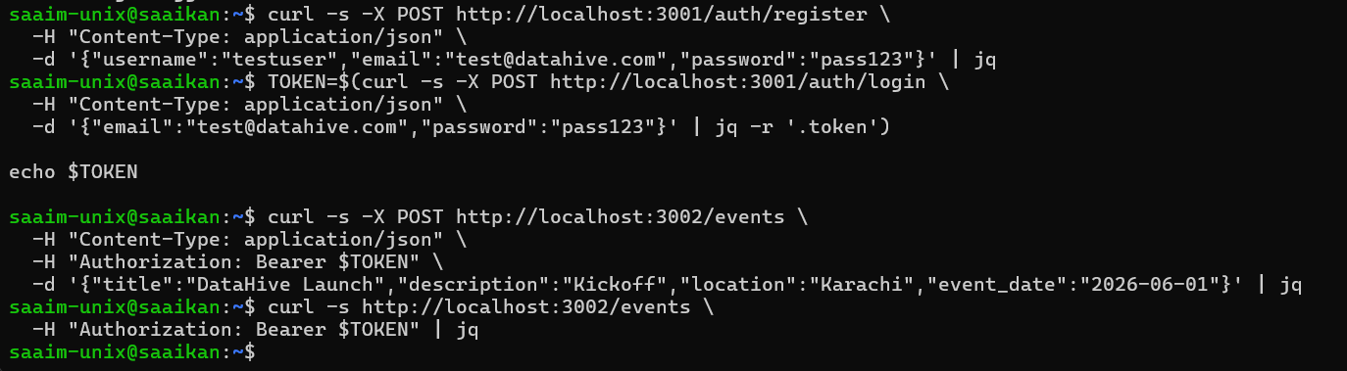

- Deployed Containers
