Mean-Variance Portfolio Optimization and Risk Analysis of 10 NIFTY 50 Stocks
Diversification, the efficient frontier, Value at Risk, and an out-of-sample backtest (MATLAB)
Saaj Mulik | Independent project | October 2026
Summary of findings
Diversification works. An equal-weight portfolio of the 10 stocks had 13.6% annual volatility, versus an average of 23.1% for the individual stocks, a 9.5 percentage-point reduction with no sacrifice in expected return.
Optimization looks excellent in-sample. The maximum-Sharpe portfolio reached a Sharpe ratio of 0.60 on the full 5-year sample (16.5% return at 15.6% volatility), against negative Sharpe ratios for the equal-weight portfolio and the NIFTY 50.
It did not generalize. When weights were fitted on the first 3 years and tested on the next 2, the max-Sharpe portfolio’s Sharpe ratio fell from 1.53 to −1.02. The optimizer had placed the maximum 30% weight in ITC on the strength of a 32.5% training return; ITC then lost 27.6% a year.
Lesson: risk (volatility and correlation) can be estimated far more reliably than expected returns, and mean-variance optimization amplifies errors in the return estimates.

1. Introduction and objectives
Portfolio theory asks how an investor should split money across assets. The central idea, due to Markowitz (1952), is that an asset should be judged by how it changes the risk and return of the whole portfolio, not on its own. Holding assets that do not move together lets some of their individual risk cancel out.
This project applies that framework to ten large Indian stocks from eight sectors and has three goals:
- Measure diversification: how much risk is removed by holding all ten stocks rather than one?
- Find the best weights: compute the efficient frontier and the minimum-variance and maximum-Sharpe portfolios, and quantify downside risk using Value at Risk (VaR) and Conditional VaR (CVaR).
- Test robustness: check whether optimized weights still perform well on data they were not fitted to.

2. Data and methodology

2.1 Data
Daily adjusted closing prices (adjusted for dividends and stock splits) were downloaded programmatically from Yahoo Finance into MATLAB for ten NIFTY 50 constituents and for the NIFTY 50 index (^NSEI), covering 4 October 2021 to 1 October 2026. Only dates on which every asset traded were kept, giving 1,235 price observations and 1,234 daily returns. A sanity check of the largest single-day moves (all within about ±13%) and a rebased price chart showed no data errors.
Table 1. Assets used
Sector | Stock | Ann. return | Ann. volatility
Energy | Reliance Industries | 2.67% | 22.36%
IT | Tata Consultancy Services | −6.77% | 22.64%
Banking | HDFC Bank | 1.63% | 21.04%
IT | Infosys | −3.64% | 26.10%
FMCG | ITC | 8.48% | 19.98%
FMCG | Hindustan Unilever | −3.88% | 20.56%
Pharma | Sun Pharma | 18.78% | 20.01%
Auto | Maruti Suzuki | 13.12% | 23.44%
Infrastructure | Larsen & Toubro | 19.71% | 24.48%
Metals | Tata Steel | 13.64% | 30.18%
Benchmark | NIFTY 50 index | 5.80% | 13.83%

2.2 Return, risk and correlation
For each stock, the daily simple return is (today’s price ÷ yesterday’s price) − 1. Average returns were annualized by multiplying the daily mean by 252 trading days. Risk was measured as volatility, the standard deviation of returns, annualized by multiplying the daily figure by √252. Co-movement between stocks was measured with the correlation matrix and the covariance matrix Σ.
For a portfolio with weights w, expected return is the weighted average of the stock returns, but portfolio volatility is √(wᵀΣw). It is lower than the weighted average of the individual volatilities whenever correlations are below 1, and this gap is the benefit of diversification.

2.3 Optimization
Portfolios were optimized using MATLAB’s Financial Toolbox (Portfolio object) under three constraints: no short selling, weights summing to 100%, and a maximum of 30% in any single stock (to avoid unrealistic concentration). Three portfolios were compared with the NIFTY 50:
- Equal weight: 10% in each stock.
- Minimum variance: the lowest-risk portfolio on the efficient frontier.
- Maximum Sharpe: the portfolio with the highest Sharpe ratio, defined as (portfolio return − risk-free rate) ÷ portfolio volatility.
The risk-free rate was set at 7.2%, in line with the 10-year Indian government bond yield in early October 2026 (about 7.2%).

2.4 Value at Risk
One-day 95% and 99% VaR were computed by the historical method (the 5th and 1st percentile of daily portfolio returns) and, at 95%, by the parametric method (assuming normally distributed returns). CVaR (expected shortfall) was computed as the average loss on days worse than the VaR threshold. Weights were assumed fixed over time.

2.5 Out-of-sample design
The sample was split chronologically. Weights were optimized using only the first 740 trading days (5 October 2021 to 3 October 2024). They were then held fixed and evaluated on the remaining 494 days (4 October 2024 to 1 October 2026), data the optimizer had never seen.

3. Results

3.1 Correlation and diversification
Pairwise correlations of daily returns ranged from 0.11 (Tata Steel and Hindustan Unilever) to 0.73 (TCS and Infosys). The most correlated pair are two IT-services companies exposed to the same drivers (US technology demand, the rupee), while the least correlated pair come from unrelated industries (metals and consumer goods). This confirms that sector diversification lowers correlation.
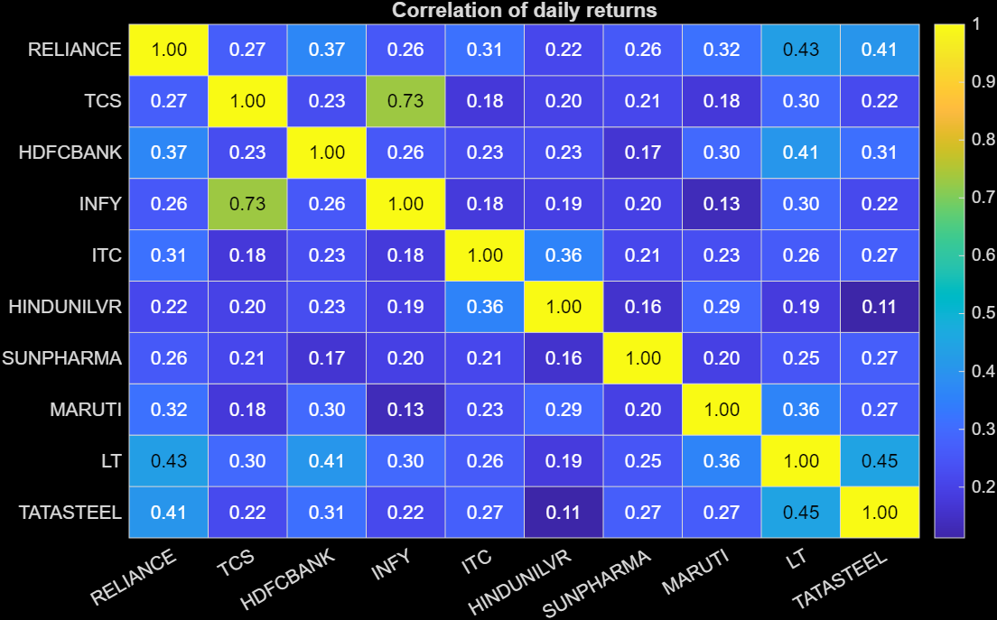
Figure 1. Correlation matrix of daily returns. Same-sector stocks (TCS, Infosys) are the most correlated; cross-sector pairs are mostly 0.2 to 0.4.
The effect on risk is large. Individual stock volatilities range from 20.0% to 30.2% (average 23.1%), but the equal-weight portfolio has a volatility of only 13.6% while its return (6.37%) is simply the average of the stocks’ returns. Diversification therefore removed 9.5 percentage points of risk without reducing expected return. Even the NIFTY 50 index (13.8%) was slightly riskier than this simple ten-stock mix.
Figure 2 shows 5,000 randomly weighted portfolios. The cloud extends far to the left of every individual stock, but has a hard left boundary at roughly 12.8% volatility. All correlations are positive, so a core of market-wide (systematic) risk remains; only company-specific (idiosyncratic) risk is diversified away.
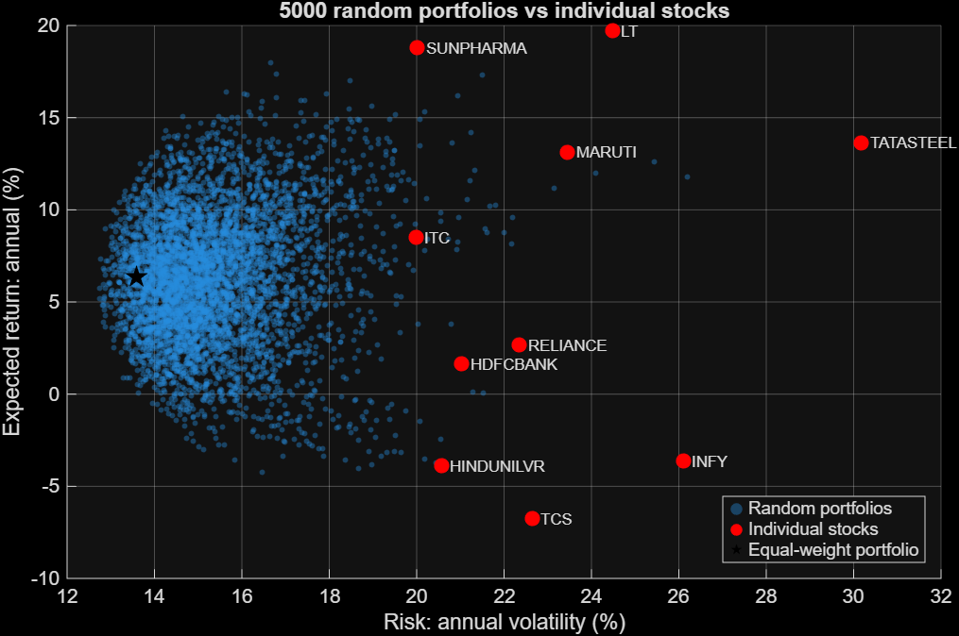
Figure 2. 5,000 random portfolios versus individual stocks. Portfolios reach lower risk than any single stock but cannot fall below about 12.8% volatility.

3.2 Efficient frontier and optimal portfolios
The efficient frontier (Figure 3) is the upper-left edge of the achievable set: for each level of risk, the portfolio with the highest return. It starts at the minimum-variance portfolio (12.45% volatility) and ends at about 17% return, where the 30% cap binds.
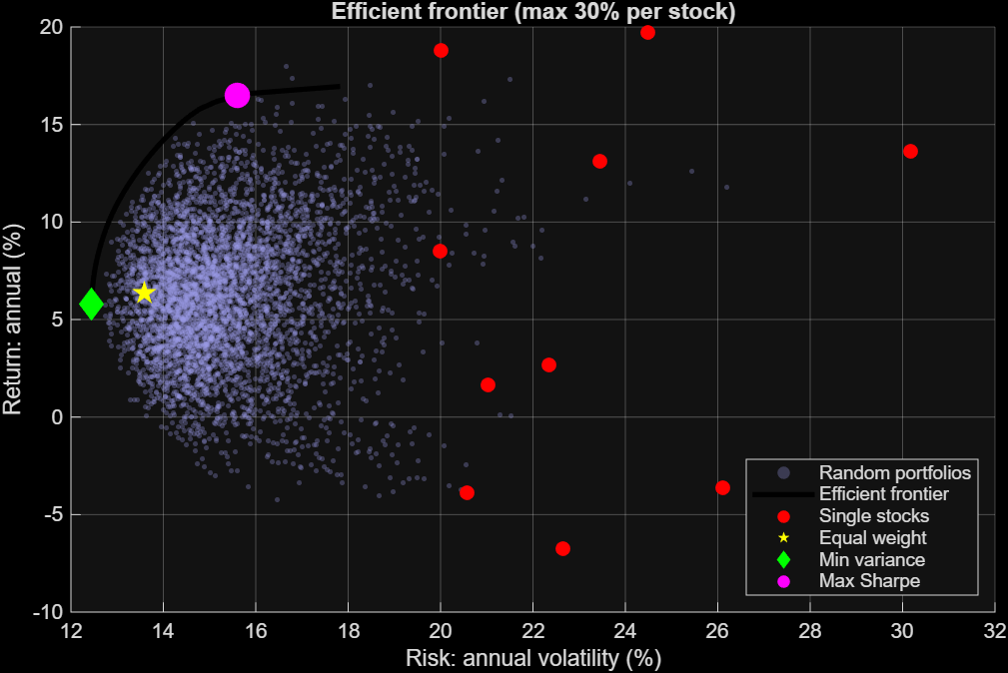
Figure 3. Efficient frontier with a 30% cap per stock, showing the equal-weight, minimum-variance and maximum-Sharpe portfolios.
Table 2. Full-sample portfolio comparison (risk-free rate 7.2%)
Portfolio | Return | Volatility | Sharpe ratio
Equal weight | 6.37% | 13.59% | −0.06
Minimum variance | 5.77% | 12.45% | −0.11
Maximum Sharpe | 16.48% | 15.60% | 0.60
NIFTY 50 | 5.80% | 13.83% | −0.10

Three of the four portfolios have negative Sharpe ratios because their returns (5.8% to 6.4%) were below the 7.2% risk-free rate: over this window, government bonds would have matched or beaten them with no equity risk. The maximum-Sharpe portfolio earned a 16.5% return, but this is an in-sample result: it is built from the same data on which it is measured.
Table 3. Optimal weights, full sample
Stock | Equal weight | Min variance | Max Sharpe
Reliance | 10.0% | 5.5% | 0.0%
TCS | 10.0% | 13.6% | 0.0%
HDFC Bank | 10.0% | 15.4% | 0.0%
Infosys | 10.0% | 0.3% | 0.0%
ITC | 10.0% | 17.1% | 7.5%
Hindustan Unilever | 10.0% | 16.4% | 0.0%
Sun Pharma | 10.0% | 22.6% | 30.0%
Maruti Suzuki | 10.0% | 8.5% | 26.2%
L&T | 10.0% | 0.7% | 30.0%
Tata Steel | 10.0% | 0.0% | 6.3%

The minimum-variance portfolio spreads money across low-correlation, calmer stocks and largely ignores return. The maximum-Sharpe portfolio holds only five stocks and is concentrated in the three highest-returning names (Sun Pharma, L&T, Maruti), which is a warning sign that it may be rewarding past luck (Section 4).
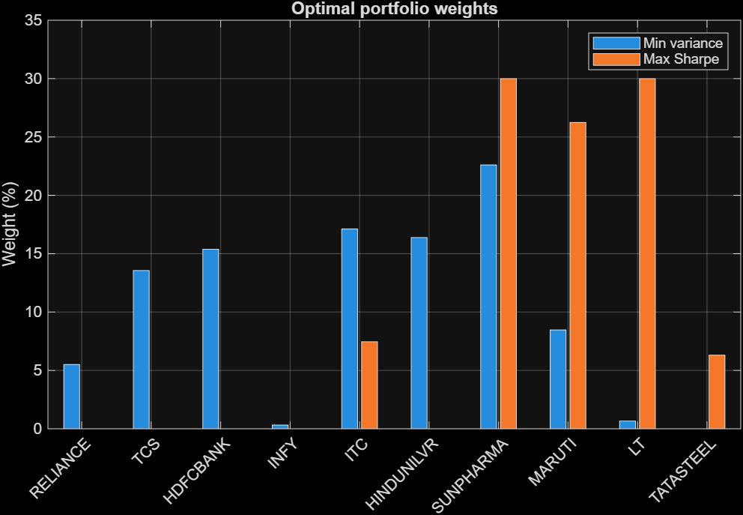
Figure 4. Optimal weights. Minimum variance is diversified; maximum Sharpe is concentrated in three stocks.

3.3 Value at Risk
Table 4. One-day risk as a percentage of portfolio value (Rs 10 lakh invested)
Portfolio | Hist. VaR 95% | Param. VaR 95% | CVaR 95% | Hist. VaR 99% | CVaR 99% | VaR 95% (Rs)
Equal weight | 1.42% | 1.38% | 1.94% | 2.32% | 2.85% | 14,173
Min variance | 1.25% | 1.27% | 1.75% | 1.98% | 2.38% | 12,534
Max Sharpe | 1.51% | 1.55% | 2.27% | 2.79% | 3.53% | 15,146
NIFTY 50 | 1.41% | 1.41% | 2.02% | 2.35% | 3.23% | 14,121

A 95% one-day VaR of 1.42% means that on about 19 days out of 20 the equal-weight portfolio is expected to lose less than 1.42% (Rs 14,173 on Rs 10 lakh). CVaR is always larger than VaR: on the worst 5% of days the average loss was 1.94%. As expected, the concentrated maximum-Sharpe portfolio has the highest risk on every measure and the minimum-variance portfolio the lowest.
Historical and parametric VaR at 95% are close (1.42% versus 1.38% for equal weight), so a normal distribution is a reasonable approximation at that level. Further into the tail it is not: for equal weight, the normal model implies a 99% VaR of about 1.97% against a historical 2.32%, and the worst single day (about −4.4%) lies roughly five standard deviations from the mean. Returns therefore have fat tails, which is why CVaR is the more informative measure of extreme losses.
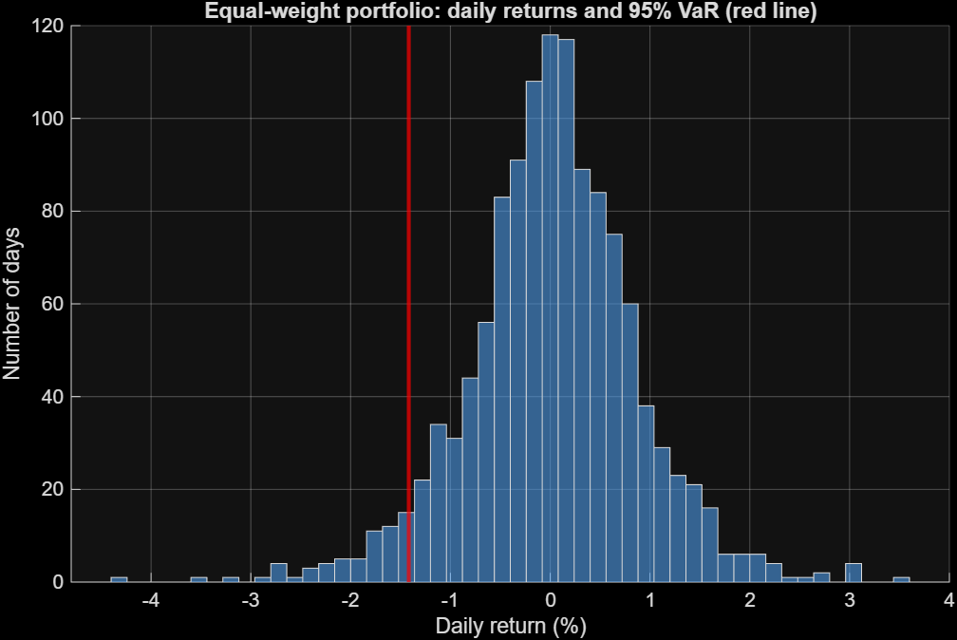
Figure 5. Distribution of daily equal-weight returns; the red line marks the 95% historical VaR (−1.42%). The left tail is longer than a normal curve would produce.

4. Out-of-sample backtest
Re-optimizing on the 740-day training window produced weights that differ noticeably from the full-sample ones (Table 5). The maximum-Sharpe portfolio held the maximum 30% in ITC and 30% in Sun Pharma, plus 24% in L&T and 16% in Maruti, whereas the full-sample version holds only 7.5% in ITC. This instability is itself a sign that the optimizer’s answer depends heavily on which years it saw.
Table 5. Weights fitted on the training period only
Stock | Equal weight | Min variance | Max Sharpe
Reliance | 10.0% | 5.1% | 0.0%
TCS | 10.0% | 17.1% | 0.0%
HDFC Bank | 10.0% | 13.2% | 0.0%
Infosys | 10.0% | 0.0% | 0.0%
ITC | 10.0% | 16.3% | 30.0%
Hindustan Unilever | 10.0% | 17.1% | 0.0%
Sun Pharma | 10.0% | 21.2% | 30.0%
Maruti Suzuki | 10.0% | 8.5% | 16.1%
L&T | 10.0% | 1.4% | 23.9%
Tata Steel | 10.0% | 0.0% | 0.0%

In the training period the maximum-Sharpe portfolio looked outstanding: 29.65% return, 14.67% volatility, Sharpe ratio 1.53. Held fixed on the unseen 494-day test period, the results were very different:
Table 6. Out-of-sample results (test period: Oct 2024 to Oct 2026)
Portfolio | Return (ann.) | Volatility | Sharpe ratio | Max drawdown
Equal weight | −9.68% | 13.12% | −1.29 | −20.5%
Min variance | −13.80% | 12.21% | −1.72 | −24.8%
Max Sharpe | −6.95% | 13.86% | −1.02 | −16.9%
NIFTY 50 | −5.21% | 13.07% | −0.95 | −15.2%

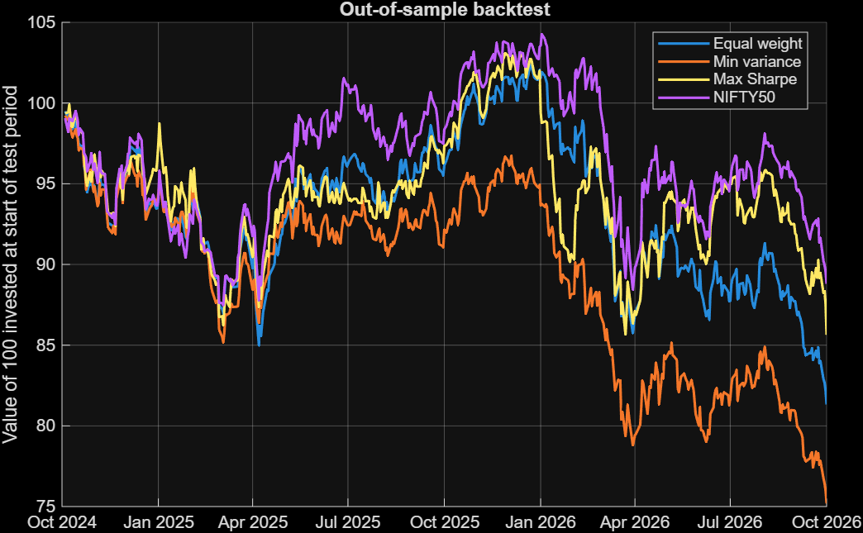
Figure 6. Growth of 100 invested at the start of the test period. All four portfolios lost money; none beat the index.
Three findings stand out:
- The Sharpe ratio collapsed from 1.53 to −1.02. The maximum-Sharpe portfolio’s edge in training was largely an artefact of fitting to past returns.
- The market was weak, so every portfolio lost money. The NIFTY 50 itself fell 5.2% a year, and no optimized portfolio beat it. Maximum Sharpe (−7.0%) did, however, lose less than equal weight (−9.7%) and minimum variance (−13.8%).
- Minimum variance controlled volatility but not losses. It had the lowest test volatility (12.2%), because covariances are estimated more reliably than returns, but its largest holdings (TCS, Hindustan Unilever and ITC, about half the portfolio) lost 19% to 30% a year in the test period.

4.1 Why did the optimized portfolio fail?
Table 7 compares each stock’s annualized return in the training and test periods.
Table 7. Annualized stock returns, training versus test period
Stock | Training return | Test return | Change | Max-Sharpe weight
Reliance | 9.08% | −6.93% | −16.0 | 0%
TCS | 8.39% | −29.48% | −37.9 | 0%
HDFC Bank | 5.63% | −4.36% | −10.0 | 0%
Infosys | 9.74% | −23.68% | −33.4 | 0%
ITC | 32.54% | −27.56% | −60.1 | 30.0%
Hindustan Unilever | 6.21% | −19.00% | −25.2 | 0%
Sun Pharma | 31.36% | −0.06% | −31.4 | 30.0%
Maruti Suzuki | 23.03% | −1.72% | −24.8 | 16.1%
L&T | 28.36% | 6.75% | −21.6 | 23.9%
Tata Steel | 16.60% | 9.20% | −7.4 | 0%

The explanation has two parts. First, estimation error: mean-variance optimization takes each stock’s historical average return as a forecast and tilts the portfolio heavily toward the highest ones. But a 3-year average is a noisy estimate. A stock with 22% annual volatility has a standard error on its measured mean return of about 22% ÷ √3 ≈ 13 percentage points, which is as large as the differences between the stocks the optimizer was ranking. Here the best past performers did not repeat: ITC went from +32.5% to −27.6%, and Sun Pharma and Maruti fell to roughly zero. Second, the market itself weakened: every stock’s return fell between the two periods, and only L&T and Tata Steel were positive in the test period, so even a perfectly chosen long-only portfolio would have struggled. The correct conclusion is therefore not that diversification failed, but that expected-return estimates are the weakest input to the optimizer, and that the optimizer magnifies whatever errors they contain.

5. Limitations
- Single split, short test window. One train/test split over about 2 years is suggestive rather than conclusive. A rolling re-optimization would be more robust.
- Survivorship and hindsight bias. The ten stocks are today’s large, well-known companies, not a list chosen in 2021.
- No frictions. Transaction costs, taxes and rebalancing are ignored, and weights are assumed constant over time.
- Benchmark mismatch. Stock prices are adjusted for dividends, but the ^NSEI series is likely a price index, which slightly understates the benchmark’s total return.
- Data source. The data come from an unofficial Yahoo Finance endpoint and were checked for obvious errors but not reconciled against exchange data.
- Statistical assumptions. Parametric VaR assumes normal returns, and historical VaR assumes the past 5 years represent the future. Sharpe ratios are hard to interpret when excess returns are negative, as in the test period.

6. Conclusion and extensions
The project reproduces the central results of portfolio theory on real Indian market data: diversification across sectors cut portfolio volatility by 9.5 percentage points relative to the average stock, and mean-variance optimization found a portfolio with a markedly higher in-sample Sharpe ratio. The out-of-sample test then showed that this advantage was not robust: the optimizer concentrated in stocks whose past returns did not persist. In practice, a simple equal-weight or minimum-variance approach, which depends less on return forecasts, is a safer starting point.
Natural extensions are: (i) longer price histories and rolling-window re-optimization; (ii) shrinkage estimators for the covariance matrix and for expected returns; (iii) the Black-Litterman model, which combines market equilibrium returns with the investor’s views; (iv) adding bonds or gold to bring in assets with low or negative correlation to equities; and (v) transaction costs and turnover constraints.

Appendix A. Glossary
Term | Meaning
Return | Percentage gain over a period: (new price − old price) ÷ old price.
Volatility | Standard deviation of returns; the standard measure of risk.
Correlation | How closely two assets move together, from −1 to +1.
Efficient frontier | The set of portfolios with the highest return for each level of risk.
Sharpe ratio | (Return − risk-free rate) ÷ volatility; excess return per unit of risk.
VaR | Loss threshold that is exceeded only on a given share of days (e.g. 5%).
CVaR | Average loss on the days when the VaR threshold is exceeded.
Maximum drawdown | Largest peak-to-trough fall in portfolio value.
In-sample / out-of-sample | Data used to build a model versus data held back to test it.

Appendix B. Code and reproducibility
All analysis was run in MATLAB R2025b with the Financial Toolbox. Scripts are run in this order: get_data.m (download and clean prices), analyze_returns.m (returns, volatility, correlation), portfolio_basics.m (random portfolios), efficient_frontier.m (optimization), var_analysis.m (VaR and CVaR), backtest.m (out-of-sample test).

Github repository: https://github.com/Saaj-Mulik-0809/nifty-portfolio-optimization

