EXPLORATORY DATA ANALYSIS & VISUALIZATION
Diagnosing Delivery Performance, Cost Drivers and Bottlenecks in a Logistics Network
Analysis of 12,000 simulated shipments using Python (pandas, seaborn, matplotlib, SciPy)
Date: 29 October 2026
Dataset: Hypothetical shipment-level data, 1 January to 31 December 2025
Tools: Python 3, pandas, NumPy, seaborn, matplotlib, SciPy

Contents
1. Introduction and Objectives
2. Data Simulation
3. Methodology
4. Exploratory Data Analysis (central tendency, distributions, correlation)
5. Visualizations and Interpretation (eight figures)
6. Statistical Confirmation and Cost-Driver Model
7. Synthesis: Efficiency, Cost Drivers and Bottlenecks
8. Recommendations
9. Limitations
10. Conclusion
Appendix A: Data generation code
Appendix B: Full analysis code

1. Introduction and Objectives
A logistics network is judged on three questions: do shipments arrive when promised, what does it cost to move them, and where does the process break down? Answering these requires more than averages. A single on-time percentage hides which carrier, warehouse, lane or season is responsible, and a single average cost hides whether the cost is driven by distance, weight or the choice of transport mode.
This report analyses a year of shipment records for a hypothetical distribution network with four warehouses, three carriers, three transport modes and five delivery zones. The objectives are to:
- describe the dataset and its key variables (delivery time, shipment volume, transport cost);
- perform exploratory data analysis covering central tendency, spread, distributions and correlations;
- build eight visualizations, justifying the chart type chosen for each question;
- interpret them to find efficiency problems, cost drivers and bottlenecks; and
- convert the findings into prioritised, evidence-based recommendations.
All code in this report was executed, and every figure and number quoted is taken from that run.

2. Data Simulation

2.1 Dataset definition
The dataset contains 12,000 shipments dispatched between 1 January and 31 December 2025. Each row is one shipment. It has 18 raw columns, and three more (month, cost per kg, delay days) are derived during analysis. There are no missing values or duplicate shipment IDs, so the analysis can concentrate on exploration rather than cleaning (data cleaning is covered in the companion preprocessing report).
Variable | Type | Description
shipment_id, ship_date | ID, date | Unique identifier and dispatch date
warehouse | Categorical | Origin: WH-Hyderabad, WH-Mumbai, WH-Delhi, WH-Chennai
zone | Categorical | Destination: North, South, East, West, Central
carrier | Categorical | FastTrack, RoadLink, EcoFreight
mode | Categorical | Road, Rail, Air
priority | Categorical | Standard or Express
distance_km | Numeric | Route distance (80 to 4,200 km)
weight_kg, volume_m3, units | Numeric | Shipment size: the volume measures
fuel_index | Numeric | Fuel price index (base 100) at dispatch, with a seasonal cycle
shipping_cost | Numeric | Total transport cost for the shipment
dwell_hours | Numeric | Hours the shipment spent in the warehouse before dispatch
weather_delay | Binary | 1 if a weather disruption affected the shipment
promised_days / delivery_days | Numeric | Committed and actual delivery time
on_time | Binary | 1 if delivery_days is no more than promised_days

2.2 How the data was generated
The data is generated by a transparent model so that relationships exist for the analysis to discover, but they are mixed with random noise so that nothing is perfectly clean. The main rules are:
- Cost rises with distance and weight (weight with a power below 1, giving economies of scale), differs by mode (air is far more expensive per kilometre), carrier and priority, scales with the fuel index, and has log-normal noise.
- Delivery time is a base handling time plus transit time (distance divided by mode speed), warehouse dwell time, a carrier-specific random delay, a weather delay, and noise.
- Conditions built in include slower dwell at one warehouse, higher weather risk in July to September, and different reliability by carrier. The analysis does not use this knowledge: it must find these effects from the data, as an analyst would in real life.
The generation script is in Appendix A. The resulting mix is: Road 72.2%, Rail 15.1% and Air 12.6% of shipments; FastTrack 40.7%, RoadLink 37.2% and EcoFreight 22.0%; and Express orders 22.2%.

3. Methodology
Step | Activity | Tools
1 | Overview: size, data types, completeness, category mix | pandas shape, isna, value_counts
2 | Descriptive statistics: mean, median, mode, spread, skewness | describe, skew, mode
3 | Correlation analysis (Spearman rank) | DataFrame.corr
4 | Visual exploration: distributions, comparisons, trends, relationships, heatmaps | seaborn, matplotlib
5 | Statistical confirmation of visual findings | SciPy: Kruskal-Wallis, chi-square, Spearman
6 | Cost-driver model on standardized variables | NumPy least squares
7 | Synthesis and recommendations | groupby KPI tables

Two methodological choices are worth stating. First, Spearman rather than Pearson correlation is used because shipment weight and cost are strongly right-skewed, and rank correlation is robust to skew and captures monotonic relationships. Second, every visual finding is checked with a formal test or a numeric table, since a chart can suggest a difference that is not statistically real.

4. Exploratory Data Analysis

4.1 Overview and descriptive statistics
for c in ["warehouse","carrier","mode","priority","zone"]:

SHAPE (12000, 21) | missing cells: 0 | duplicate ids: 0
DATES 2025-01-01 to 2025-12-31
OVERALL on-time rate: 78.2%

num = ["distance_km","weight_kg","volume_m3","shipping_cost","dwell_hours","delivery_days","promised_days"]
desc = df[num].describe().T[["mean","50%","std","min","max"]]
desc["skew"] = df[num].skew(); desc["cv"] = desc["std"]/desc["mean"]

Variable | Mean | Median | Std dev | Max | Skew | CV | Min
distance_km | 1,163.9 | 1,035.5 | 614.2 | 4,200 | 1.15 | 0.53 | 80
weight_kg | 100.1 | 66.6 | 109.6 | 1,750.5 | 4.19 | 1.10 | 2.0
volume_m3 | 0.59 | 0.38 | 0.70 | 15.00 | 5.07 | 1.18 | 0.01
shipping_cost | 1,196.7 | 690.8 | 1,695.5 | 29,516 | 4.95 | 1.42 | 148.0
dwell_hours | 11.1 | 9.2 | 8.5 | 111.9 | 3.04 | 0.76 | 0.4
delivery_days | 3.93 | 3.60 | 1.74 | 17.3 | 1.24 | 0.44 | 0.8
promised_days | 4.43 | 4.00 | 1.52 | 12 | 0.80 | 0.34 | 2
Table 1. Descriptive statistics (CV = coefficient of variation, std dev divided by mean).
Central tendency. For every variable the mean exceeds the median, which is the signature of right-skewed data. The gap is largest for shipping cost (mean 1,197 against median 691): a minority of heavy or air shipments pull the average well above what a typical shipment costs. For delivery time the mean is 3.93 days, the median 3.60 and the mode 2.9, so the 'typical' shipment arrives in about three to four days, but a long tail stretches to 17 days. Reporting the mean alone would misrepresent both cost and service.
Spread. The coefficient of variation shows relative variability: cost (1.42), volume (1.18) and weight (1.10) are highly dispersed, whereas delivery time (0.44) is comparatively consistent. Dwell time has a skewness of 3.04 and a maximum of 112 hours against a median of 9.2, suggesting occasional severe warehouse delays, which are examined in Section 5.6.
Implication for method. Because cost, weight and volume are so skewed, medians, rank correlation, log scales and non-parametric tests are used wherever appropriate.

4.2 Correlation analysis
corr = df[["distance_km","weight_kg","volume_m3","shipping_cost","dwell_hours","delivery_days","fuel_index"]].corr(method="spearman")

The Spearman matrix is shown graphically in Figure 5. The relationships that matter:
Pair | Spearman | Reading
distance_km and delivery_days | 0.72 | Strongest operational driver: longer routes take longer
distance_km and shipping_cost | 0.52 | Moderate: distance matters, but mode and weight matter too
weight_kg and shipping_cost | 0.51 | Moderate: heavier shipments cost more
weight_kg and volume_m3 | 0.96 | Near-duplicate measures: using both in a model adds no information
dwell_hours and delivery_days | 0.17 | Weak overall, but concentrated in specific warehouses (Section 5.6)
fuel_index and shipping_cost | 0.09 | Fuel cost has only a small effect on cost

Two cautions apply. A weak overall correlation does not mean an unimportant factor: dwell time correlates only 0.17 with delivery time across the whole network, yet it will prove decisive at one warehouse. And the 0.96 correlation between weight and volume is multicollinearity, so only weight is carried into the cost model.

5. Visualizations and Interpretation
Each subsection states the question, justifies the chart type, shows the code, presents the figure and interprets it. Colours and axes are kept consistent across figures so they can be compared.

5.1 Distribution of delivery time and cost
Question. What does a typical shipment look like, and how reliable is the process?
Why this chart. A histogram with a kernel density curve shows the full shape of a continuous variable, including skew and tail, which a single mean cannot. Mean and median lines are overlaid to make the skew visible. Cost spans two orders of magnitude, so a logarithmic axis is used to reveal its structure instead of compressing most shipments into a narrow spike.
fig, ax = plt.subplots(1, 2, figsize=(10, 3.8))
sns.histplot(df.delivery_days, bins=40, kde=True, ax=ax[0], color="#2E5C8A")
ax[0].axvline(df.delivery_days.mean(), color="#C0392B", ls="--", label=f"Mean {df.delivery_days.mean():.1f}")
ax[0].axvline(df.delivery_days.median(), color="#27AE60", ls=":", label=f"Median {df.delivery_days.median():.1f}")
ax[0].set(title="Distribution of delivery time", xlabel="Delivery days", ylabel="Shipments"); ax[0].legend()
sns.histplot(df.shipping_cost, bins=40, kde=True, ax=ax[1], color="#7B4F9E", log_scale=True)
ax[1].set(title="Shipping cost (log scale)", xlabel="Cost (log axis)", ylabel="Shipments")
plt.tight_layout(); plt.savefig("fig1_distributions.png"); plt.close()

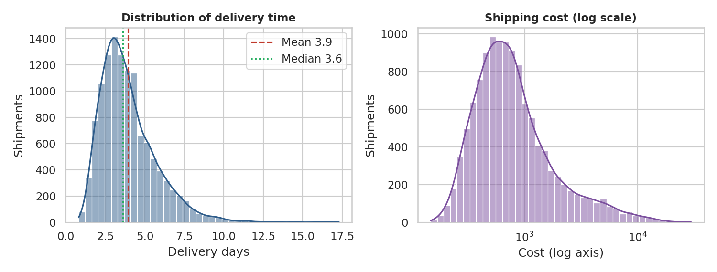
Figure 1. Delivery time (left) and shipping cost on a log scale (right).
Interpretation. Delivery time is right-skewed: most shipments cluster around three days, but a tail extends beyond ten. The mean (3.9) sits right of the median (3.6), confirming that late outliers drag the average upward. On the log scale, cost is roughly bell-shaped, meaning cost is approximately log-normal, so percentage differences (not absolute differences) are the natural way to compare shipments. The planning lesson is to manage the tail: the long right-hand tail of delivery time is where customer complaints originate.

5.2 Delivery time by carrier and transport mode
Question. Do carriers and modes differ in speed and consistency?
Why this chart. Box plots compare a numeric variable across categories and show the median, the interquartile range (consistency) and the whiskers (extremes) in one compact graphic. Extreme points are hidden here so the central comparison is legible; the full tail was shown in Figure 1. Categories are ordered by median to make ranking immediate.
fig, ax = plt.subplots(1, 2, figsize=(10, 3.8))
order = df.groupby("carrier").delivery_days.median().sort_values().index
sns.boxplot(data=df, x="carrier", y="delivery_days", order=order, ax=ax[0], showfliers=False)
ax[0].set(title="Delivery time by carrier", xlabel="", ylabel="Delivery days")
sns.boxplot(data=df, x="mode", y="delivery_days", order=["Air","Road","Rail"], ax=ax[1], showfliers=False)
ax[1].set(title="Delivery time by transport mode", xlabel="", ylabel="Delivery days")
plt.tight_layout(); plt.savefig("fig2_boxplots.png"); plt.close()

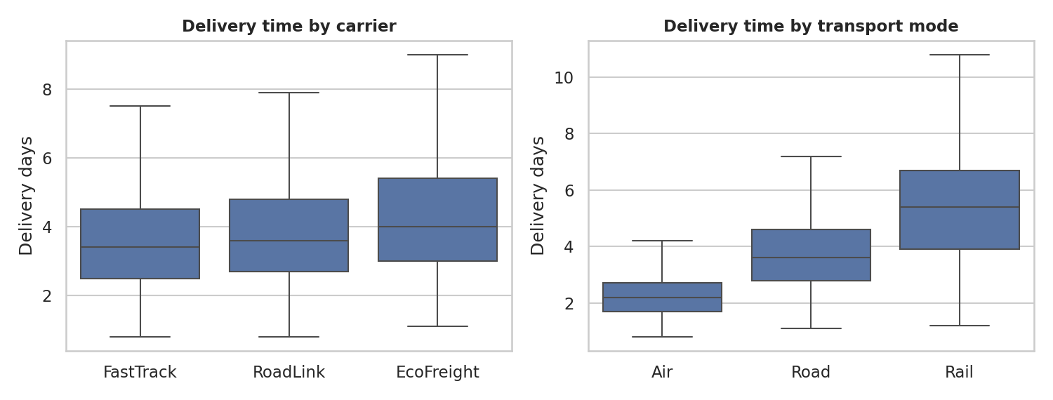
Figure 2. Delivery time by carrier (left) and by transport mode (right).
Interpretation. Carriers are ranked FastTrack, RoadLink, EcoFreight from fastest to slowest, and EcoFreight is also the least consistent, with the widest box and highest whisker. By mode, air is fastest (average 2.4 days) with little spread, road is intermediate (3.9 days), and rail is the slowest (5.5 days) with the greatest variability. Rail's variability is a planning problem as much as its slowness: a customer can be promised an average, but the spread determines how often the promise is broken.

5.3 Monthly trend in volume and on-time rate
Question. Is service performance stable over the year, and is it linked to workload?
Why this chart. A time-series combination chart is the standard way to show a trend: bars for volume (a quantity) and a line for on-time rate (a rate) on a secondary axis. Placing them together allows the eye to test whether the rate moves with workload.
m = df.groupby("month").agg(shipments=("shipment_id","count"), on_time=("on_time","mean"), cost=("shipping_cost","mean"))
fig, ax = plt.subplots(figsize=(10, 3.8))
ax.bar(m.index, m.shipments, color="#BFD3E6", label="Shipments")
ax.set(xlabel="Month (2025)", ylabel="Shipments", title="Monthly shipment volume and on-time delivery rate"); ax.set_xticks(range(1,13))
ax2 = ax.twinx(); ax2.plot(m.index, m.on_time*100, color="#C0392B", marker="o", lw=2, label="On-time %")
ax2.set_ylabel("On-time rate (%)"); ax2.grid(False); ax2.set_ylim(0, 100)
h1,l1 = ax.get_legend_handles_labels(); h2,l2 = ax2.get_legend_handles_labels(); ax.legend(h1+h2, l1+l2, loc="lower left")
plt.tight_layout(); plt.savefig("fig3_monthly_trend.png"); plt.close()

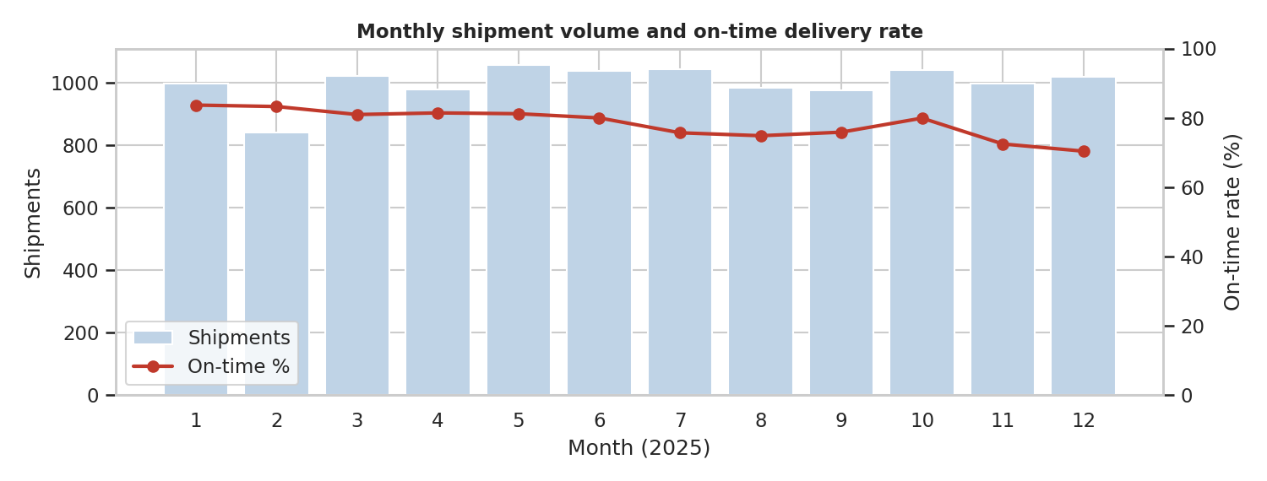
Figure 3. Monthly shipments (bars) and on-time delivery rate (line).
Interpretation. Monthly volume is flat at about 840 to 1,060 shipments, yet the on-time rate drifts from 83.7% in January to 70.4% in December, with two dips: July to September (about 75%) and November to December (72.4% and 70.4%). Because volume does not rise in those months, the decline cannot be explained by demand. This is the most useful finding in the trend: service is deteriorating for operational reasons (weather, capacity at specific sites) and not because the network is busier. Figures 6 and 8 identify those reasons.

5.4 Cost drivers: distance, weight and mode
Question. What makes a shipment expensive?
Why this chart. Scatter plots show the relationship between two numeric variables, and colouring by mode adds a third dimension. A sample of 3,000 points avoids overplotting. The weight panel uses log-log axes because both variables are skewed; on these axes, a straight line indicates a power-law relationship.
fig, ax = plt.subplots(1, 2, figsize=(10, 4))
s = df.sample(3000, random_state=1)
sns.scatterplot(data=s, x="distance_km", y="shipping_cost", hue="mode", alpha=.55, s=14, ax=ax[0])
ax[0].set(title="Cost vs distance by transport mode", xlabel="Distance (km)", ylabel="Shipping cost")
sns.scatterplot(data=s, x="weight_kg", y="shipping_cost", hue="mode", alpha=.55, s=14, ax=ax[1], legend=False)
ax[1].set(xscale="log", yscale="log", title="Cost vs weight (log-log)", xlabel="Weight kg (log)", ylabel="Cost (log)")
plt.tight_layout(); plt.savefig("fig4_cost_drivers.png"); plt.close()

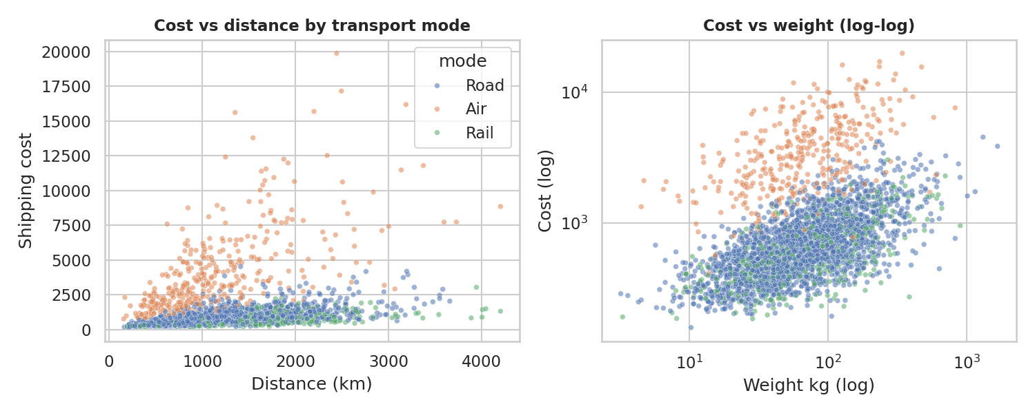
Figure 4. Shipping cost against distance (left) and against weight on log-log axes (right), by mode.
Interpretation. Three distinct bands appear in the distance panel. Air forms a steep, widely scattered upper band, while road and rail sit in a much lower, tighter band: transport mode sets the cost level, and distance then determines how far up that band a shipment sits. Rail is slightly cheaper than road for the same distance. In the log-log panel the points rise roughly linearly, but air is shifted upwards, confirming the pattern. The business message is that choosing air costs a large premium that no amount of route optimisation within road or rail can offset.

5.5 Correlation heatmap
Question. Which variables move together, and which are redundant?
Why this chart. A heatmap presents a whole correlation matrix at once and allows strong relationships to be seen through colour intensity. A diverging palette centred on zero separates positive from negative, with values annotated for precision.
fig, ax = plt.subplots(figsize=(6.2, 4.8))
sns.heatmap(corr, annot=True, fmt=".2f", cmap="RdBu_r", center=0, vmin=-1, vmax=1, ax=ax, cbar_kws={"shrink": .8})
ax.set_title("Spearman correlation matrix"); plt.tight_layout(); plt.savefig("fig5_corr_heatmap.png"); plt.close()

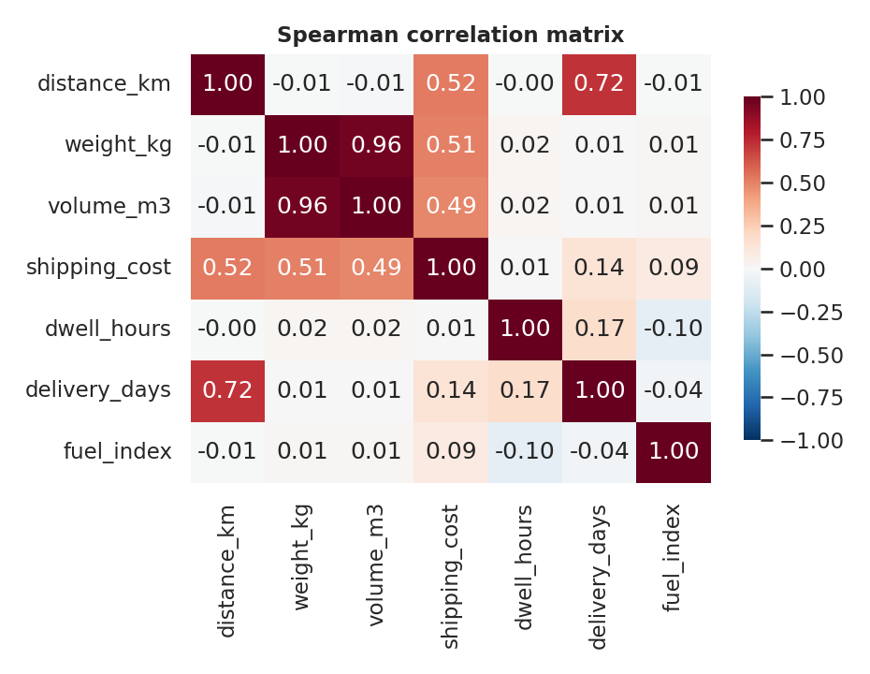
Figure 5. Spearman correlation matrix of the numeric variables.
Interpretation. The heatmap confirms Section 4.2: delivery time is driven by distance (0.72), cost by distance and weight (about 0.5 each), and weight and volume are interchangeable (0.96). Most other cells are close to zero, which is informative: dwell time and fuel index have little network-wide relationship with delivery time or cost, so their importance, if any, must be local and needs a more targeted view. This is what the next figure provides.

5.6 Warehouse dwell time: locating a bottleneck
Question. Is any site slowing shipments down, and when?
Why this chart. A heatmap of mean dwell time by warehouse (rows) and month (columns) shows two dimensions of variation at once. A sequential colour scale, with annotations, makes the hot spot stand out immediately. A bar chart would need twelve bars for each of four sites.
piv = df.pivot_table(index="warehouse", columns="month", values="dwell_hours", aggfunc="mean")
fig, ax = plt.subplots(figsize=(10, 3.4))
sns.heatmap(piv, annot=True, fmt=".0f", cmap="YlOrRd", ax=ax, cbar_kws={"label": "Mean dwell (h)"})
ax.set(title="Average warehouse dwell time (hours) by month", xlabel="Month (2025)", ylabel="")
plt.tight_layout(); plt.savefig("fig6_dwell_heatmap.png"); plt.close()

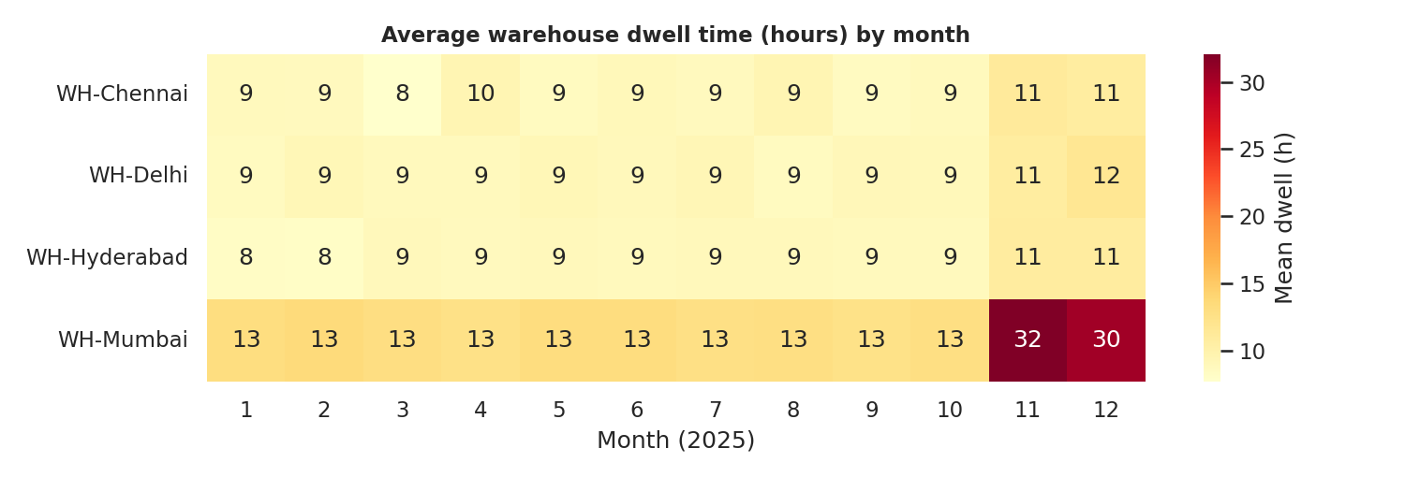
Figure 6. Average warehouse dwell time (hours) by warehouse and month.
Mean dwell, WH-Mumbai: ~13 h from Jan to Oct, 32.1 h in Nov, 30.4 h in Dec
Other warehouses: ~9 h in Jan to Oct, ~11 h in Nov to Dec

Interpretation. This is the clearest bottleneck in the data. WH-Mumbai is slower than its peers all year (about 13 hours against about 9) and then collapses in November and December, when mean dwell rises to 32 and 30 hours, roughly 2.4 times its normal level. The other three warehouses show only a mild seasonal rise from about 9 to 11 hours, so peak season itself is not the problem. Mumbai's handling process cannot absorb seasonal pressure. It also explains why dwell time showed only a weak 0.17 network-wide correlation: the effect is concentrated at one site.

5.7 On-time performance by carrier, zone and warehouse
Question. Where does service fall short: which carrier, which lane, which origin?
Why this chart. A carrier-by-zone heatmap displays 15 combinations at a glance and highlights weak lanes using a red-to-green scale with fixed limits. A sorted horizontal bar chart is used for warehouses because it ranks a single measure across a few categories most clearly.
ot = df.pivot_table(index="carrier", columns="zone", values="on_time", aggfunc="mean")*100
fig, ax = plt.subplots(1, 2, figsize=(10, 3.6), gridspec_kw={"width_ratios":[1.2,1]})
sns.heatmap(ot, annot=True, fmt=".0f", cmap="RdYlGn", vmin=40, vmax=100, ax=ax[0], cbar_kws={"label": "On-time %"})
ax[0].set(title="On-time rate (%) by carrier and zone", xlabel="", ylabel="")
w = df.groupby("warehouse").on_time.mean().sort_values()*100
sns.barplot(x=w.values, y=w.index, ax=ax[1], color="#2E5C8A"); ax[1].set(title="On-time rate (%) by warehouse", xlabel="%", ylabel="")
for i,v in enumerate(w.values): ax[1].text(v+.5, i, f"{v:.0f}", va="center")
plt.tight_layout(); plt.savefig("fig7_ontime.png"); plt.close()

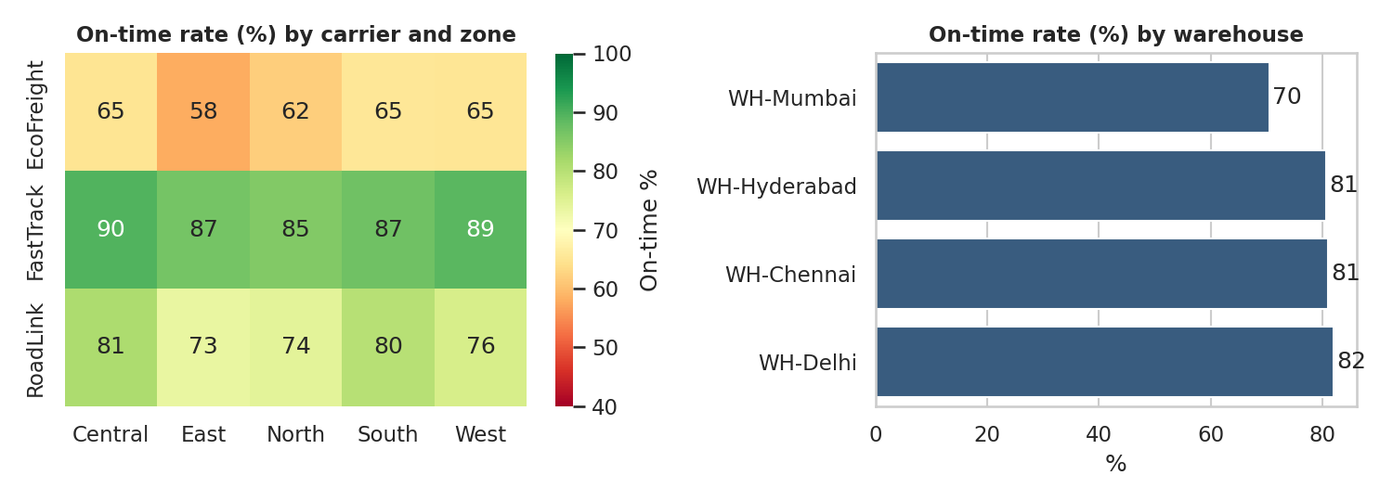
Figure 7. On-time rate by carrier and zone (left) and by origin warehouse (right).
Interpretation. FastTrack is consistently strong in every zone (85% to 90%). RoadLink is acceptable in Central and South (80% to 81%) but weaker in East, North and West (73% to 76%). EcoFreight is the weakest in every zone, between 58% and 66%, with East the worst at 58%. East is the weakest zone for all three carriers, indicating a lane-level issue (distance, infrastructure) beyond any single carrier. For origins, Hyderabad, Chennai and Delhi sit tightly at 81% to 82%, while Mumbai is at 70.5%: a gap of more than 10 points.

5.8 Which factors are over-represented among late shipments?
Question. Of the factors we can observe, which are disproportionately linked to lateness?
Why this chart. A paired bar chart compares each factor's share of late shipments against its share of all shipments. A factor whose late bar is much longer than its baseline bar is over-represented, which is a more honest comparison than simply counting late shipments, because a common factor such as a large carrier will always account for many late shipments by sheer volume.
delay_df = df[df.on_time==0]
causes = pd.Series({
"High warehouse dwell (>24h)": (delay_df.dwell_hours>24).mean(),
"Weather disruption": delay_df.weather_delay.mean(),
"Carrier: EcoFreight": (delay_df.carrier=="EcoFreight").mean(),
"Carrier: RoadLink": (delay_df.carrier=="RoadLink").mean(),
"Peak season (Nov-Dec)": delay_df.month.isin([11,12]).mean()}).sort_values()*100
base = pd.Series({
"High warehouse dwell (>24h)": (df.dwell_hours>24).mean(), "Weather disruption": df.weather_delay.mean(),
"Carrier: EcoFreight": (df.carrier=="EcoFreight").mean(), "Carrier: RoadLink": (df.carrier=="RoadLink").mean(),
"Peak season (Nov-Dec)": df.month.isin([11,12]).mean()})*100
fig, ax = plt.subplots(figsize=(8.5, 3.6))
y = np.arange(len(causes))
ax.barh(y+.2, causes.values, .4, label="Share of LATE shipments", color="#C0392B")
ax.barh(y-.2, base[causes.index].values, .4, label="Share of ALL shipments", color="#9DB4CC")
ax.set_yticks(y); ax.set_yticklabels(causes.index); ax.set_xlabel("%"); ax.set_title("Over-representation of factors among late shipments"); ax.legend(loc="lower right")
plt.tight_layout(); plt.savefig("fig8_delay_causes.png"); plt.close()

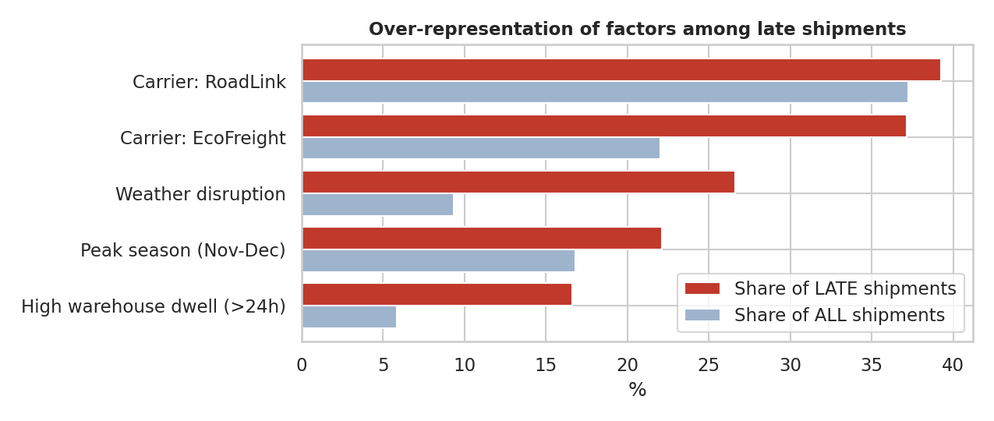
Figure 8. Share of late shipments versus share of all shipments for each factor.
Factor Share of late Share of all
High warehouse dwell (>24h) 16.6% 5.8%
Peak season (Nov-Dec) 22.1% 16.8%
Weather disruption 26.6% 9.3%
Carrier: EcoFreight 37.1% 22.0%
Carrier: RoadLink 39.2% 37.2%

Interpretation. Weather disruption, 9.3% of shipments, accounts for 26.6% of late ones. Dwell above 24 hours is 5.8% of shipments but 16.6% of late ones, and EcoFreight is 22.0% of volume but 37.1% of late shipments. RoadLink is barely over-represented (39.2% of late against 37.2% of shipments), so it is performing near the network average on a volume-adjusted basis, even though its raw on-time rate is below FastTrack's. Shipments that dwell more than 24 hours are on time only 38.0% of the time, against 80.7% for the rest. These factors are associations, not proven causes, and they can overlap (a Mumbai shipment in December may be both a long dwell and a peak shipment).

6. Statistical Confirmation and Cost-Driver Model

6.1 Are the visual differences statistically real?
groups = [g.delivery_days.values for _, g in df.groupby("carrier")]
H, p = stats.kruskal(*groups); print("KRUSKAL carriers: H=%.1f p=%.2e" % (H, p))
ct = pd.crosstab(df.carrier, df.on_time); chi, p2, _, _ = stats.chi2_contingency(ct); print("CHI2 carrier x on_time: chi2=%.1f p=%.2e" % (chi, p2))
rho, p3 = stats.spearmanr(df.dwell_hours, df.delivery_days); print("SPEARMAN dwell~delivery: rho=%.2f p=%.1e" % (rho, p3))
X = pd.get_dummies(df[["distance_km","weight_kg","fuel_index","mode","priority","carrier"]], drop_first=True).astype(float)
Xl = X.copy(); Xl["weight_kg"] = np.log(Xl["weight_kg"]); y_ = np.log(df.shipping_cost)
Xs = (Xl - Xl.mean())/Xl.std(); A = np.c_[np.ones(len(Xs)), Xs.values]
beta, *_ = np.linalg.lstsq(A, y_.values, rcond=None)
r2 = 1 - ((y_ - A@beta)**2).sum()/((y_ - y_.mean())**2).sum()
coef = pd.Series(beta[1:], index=Xs.columns).sort_values(key=abs, ascending=False)

KRUSKAL carriers: H=247.6 p=1.74e-54
CHI2 carrier x on_time: chi2=588.8 p=1.41e-128
SPEARMAN dwell~delivery: rho=0.17 p=1.6e-80
LOG-COST OLS R2 = 0.949

- Kruskal-Wallis (non-parametric, suited to skewed delivery times) rejects equal delivery time across carriers: the differences in Figure 2 are not chance.
- Chi-square on the carrier by on-time table confirms that on-time performance depends on carrier (p far below 0.001).
- Spearman confirms the dwell and delivery time association is statistically significant, although weak in size (0.17). With 12,000 observations almost any non-zero effect is 'significant', so effect size is what matters.

6.2 What drives cost? A standardized regression
To rank cost drivers on a common scale, shipping cost is modelled on a log scale (matching the log-normal shape in Figure 1) against distance, log weight, fuel index and dummy variables for mode, priority and carrier. All predictors are standardized so that coefficients are comparable: each shows the change in log-cost for a one-standard-deviation change in the predictor. Air, Express and EcoFreight are the reference categories.
Predictor | Coefficient | Reading
mode: Road (vs Air) | -0.662 | Largest effect: moving off air cuts cost most
mode: Rail (vs Air) | -0.651 | Almost identical to road
distance_km | +0.384 | Longer routes cost more
weight_kg (log) | +0.369 | Heavier shipments cost more
carrier: FastTrack (vs EcoFreight) | +0.110 | FastTrack carries a price premium
priority: Standard (vs Express) | -0.091 | Express carries a premium
carrier: RoadLink (vs EcoFreight) | +0.062 | Smaller premium
fuel_index | +0.061 | Smallest effect
Table 2. Standardized coefficients of the log-cost model (R-squared = 0.949).
The model explains about 95% of variation in log cost. Transport mode is the single largest cost lever, followed by distance and weight, which are about equally important. Carrier choice and service priority are second-order effects, and fuel index has the smallest influence. The model describes association in this dataset; it should not be read as a forecast of price changes.

7. Synthesis: Efficiency, Cost Drivers and Bottlenecks
kpi = df.groupby("carrier").agg(shipments=("shipment_id","count"), avg_days=("delivery_days","mean"), on_time=("on_time","mean"),
avg_cost=("shipping_cost","mean"), cost_per_kg=("cost_per_kg","median"))
kpi["on_time"] *= 100; print(kpi.round(2).to_string())
modek = df.groupby("mode").agg(shipments=("shipment_id","count"), avg_days=("delivery_days","mean"), on_time=("on_time","mean"),
avg_cost=("shipping_cost","mean"), cost_per_kg=("cost_per_kg","median")); modek["on_time"]*=100
wk = df.groupby("warehouse").agg(shipments=("shipment_id","count"), dwell=("dwell_hours","mean"), dwell_p90=("dwell_hours", lambda s: s.quantile(.9)), on_time=("on_time","mean")); wk["on_time"]*=100
pk = df.assign(peak=df.month.isin([11,12])).groupby(["warehouse","peak"]).dwell_hours.mean().unstack().round(1); print(pk.to_string())

7.1 Carrier and mode scorecards
Carrier | Shipments | Avg days | On-time % | Avg cost | Cost per kg*
FastTrack | 4,888 | 3.70 | 87.4 | 1,275.9 | 12.73
RoadLink | 4,467 | 3.93 | 77.1 | 1,170.3 | 11.92
EcoFreight | 2,645 | 4.34 | 63.3 | 1,094.9 | 10.63
Table 3. Carrier scorecard. *Total cost divided by total weight.
Mode | Shipments | Avg days | On-time % | Avg cost | Median cost/kg
Air | 1,516 | 2.38 | 66.2 | 4,276.5 | 51.92
Road | 8,669 | 3.87 | 81.1 | 764.3 | 9.85
Rail | 1,815 | 5.48 | 74.6 | 689.7 | 8.84
Table 4. Transport mode scorecard.
Operational efficiency. The cheapest carrier is the least reliable: EcoFreight costs about 16% less per kilogram than FastTrack but delivers on time 24 points less often. Whether that trade is worthwhile depends on what a late delivery costs the business, which this dataset does not contain. Surprisingly, air, the fastest mode, has the lowest on-time rate of the three (66.2%), which the Express finding below explains.

7.2 The Express paradox
Express shipments are on time only 51.9% of the time, against 85.7% for Standard, despite costing about three times as much on average (2,454 against 839). The breakdown shows why.
Priority and mode | Shipments | On-time % | Comment
Express, Air | 1,146 | 59.4 | Fastest mode, still missing a tight promise
Express, Road | 1,242 | 48.1 | Road cannot meet the Express promise
Express, Rail | 272 | 37.5 | Rail is the worst fit
Standard, Air | 370 | 87.3 | No better than Standard Road
Standard, Road | 7,427 | 86.6 | Baseline
Standard, Rail | 1,543 | 81.1 | Slightly lower

Two problems appear. Express promises are too aggressive for the capability behind them: average Express delivery is 3.38 days against an average promise of 3.18, whereas Standard delivers in 4.08 days against a 4.78-day promise. Also, more than half of Express shipments travel by road or rail, which cannot meet an Express promise. Meanwhile, 370 Standard shipments are sent by air at roughly five times the cost per kilogram of road, with no on-time benefit (87.3% against 86.6%).

7.3 Summary of findings
Theme | Finding | Evidence
Efficiency | On-time falls from 83.7% to 70.4% across the year without any volume increase | Figure 3
Efficiency | Express shipments are late nearly half the time because the promise outpaces the capability | Section 7.2
Cost driver | Transport mode is the largest cost lever; distance and weight follow | Figure 4, Table 2
Cost driver | Fuel index has little influence on cost in this dataset | Table 2, Figure 5
Cost driver | Standard parcels sent by air pay a large premium for no on-time gain | Section 7.2
Bottleneck | WH-Mumbai dwell more than doubles in Nov and Dec (about 13 h to over 30 h); on-time falls to 50.4% there | Figures 6 and 7
Bottleneck | Weather causes 26.6% of late shipments from 9.3% of volume, concentrated in July to September | Figure 8
Bottleneck | EcoFreight is the weakest in every zone; East is the weakest zone for all carriers | Figure 7

8. Recommendations
# | Action | Rationale | Success measure
1 | Fix peak-season capacity at WH-Mumbai: add temporary labour or shifts in Nov and Dec, review slotting and cross-docking, and set a dwell alert at 24 hours | Mumbai peak dwell is 31.2 h against 11.0 h at other sites; Mumbai holds 37.9% of late shipments from 27.9% of volume; on-time there falls to 50.4% in peak | Peak dwell under 16 h; Mumbai on-time within 5 points of the network
2 | Redesign the Express service: either move Express to air by default or lengthen the Express promise for road and rail | Express is on time 51.9% overall, 48.1% by road and 37.5% by rail | Express on-time above 80%
3 | Stop using air for Standard shipments unless a customer pays for it | 370 Standard shipments by air show no on-time benefit at about five times the road cost per kg | Air share of Standard shipments near zero
4 | Rebalance carrier allocation: send time-critical and East-zone freight to FastTrack; limit EcoFreight to non-urgent, low-value freight; add SLA penalties to the contracts of RoadLink and EcoFreight | On-time rates are 87.4%, 77.1% and 63.3% respectively; EcoFreight is 22.0% of volume but 37.1% of late shipments | Network on-time above 85%; cost per kg within 5% of today
5 | Add a monsoon plan for July to September: longer promised days, early customer notifications and alternative routing | Weather events are 20.6% of shipments in the monsoon against 5.6% otherwise, and on-time is 37.9% when affected | On-time during monsoon within 5 points of the annual rate
6 | Use mode choice (rail and road in place of air where service allows) as the main cost lever, ahead of fuel or route tuning | Mode has the largest standardized coefficient (about 0.66); fuel the smallest (0.06) | Cost per kg down without a fall in on-time
7 | Build a monthly dashboard of the figures used here: on-time by carrier and zone, dwell by warehouse and month, and cost per kg by mode | These views exposed every bottleneck found; none would have been visible in a network average | Dashboard in use; issues flagged within a month

9. Limitations
- Simulated data. The patterns were built into the generator, so they are cleaner and more separable than in real operations, where causes overlap and records are messier. The value of this exercise is the method, and the figures should not be treated as benchmarks.
- Association, not causation. Over-representation in Figure 8 shows an association. A controlled comparison, or at least a multivariate delay model, would be needed to separate overlapping factors such as peak season and Mumbai.
- Missing business context. The data holds no cost of a late delivery, customer value or carrier contract terms, so the trade-off between price and reliability cannot be priced.
- Single year. One year of data cannot separate a seasonal pattern from a one-off event.
- Threshold choices. The 24-hour dwell cut-off was chosen for illustration and should be set with warehouse managers.

10. Conclusion
The exploration moved from summary statistics to targeted visuals and showed why each step was needed. Averages suggested a network that is mostly working, with 78.2% on-time delivery. Segmenting by carrier, mode, zone, warehouse and month showed that the weakness is concentrated: one warehouse that fails in peak season, one carrier that is unreliable everywhere, Express promises that cannot be met with the modes assigned to them, and a monsoon season with no plan. On cost, transport mode dominates, which means the largest savings come from mode discipline rather than fine route or fuel tuning.
The wider lesson is that the choice of visualization is an analytical decision: distributions exposed skew, box plots revealed consistency, heatmaps located the bottleneck, and paired bars adjusted for volume. Combined with formal tests and a simple cost model, they turn raw shipment records into specific, defensible actions.

Appendix A: Data Generation Code
simulate.py: generates the hypothetical shipment dataset.
import numpy as np, pandas as pd
rng = np.random.default_rng(2025)
N = 12000

warehouses = {"WH-Hyderabad":0.30, "WH-Mumbai":0.28, "WH-Delhi":0.27, "WH-Chennai":0.15}
zones = ["North","South","East","West","Central"]
carriers = {"FastTrack":0.40, "RoadLink":0.38, "EcoFreight":0.22}

date = pd.to_datetime("2025-01-01") + pd.to_timedelta(rng.integers(0, 365, N), unit="D")
# seasonality: thin out Feb-Jun, thicken Oct-Dec by resampling
w = np.where(date.month.isin([10,11,12]), 2.2, np.where(date.month.isin([2,3,4,5,6]), 0.8, 1.0))
keep = rng.random(N) < (w / w.max())
date = pd.DatetimeIndex(np.concatenate([date[keep], date[~keep][: N - keep.sum()]]))
date = pd.DatetimeIndex(np.sort(date.values))
n = len(date)

df = pd.DataFrame({"shipment_id": np.arange(500000, 500000+n), "ship_date": date})
df["warehouse"] = rng.choice(list(warehouses), n, p=list(warehouses.values()))
df["zone"] = rng.choice(zones, n, p=[.22,.24,.16,.22,.16])
df["carrier"] = rng.choice(list(carriers), n, p=list(carriers.values()))
df["priority"] = rng.choice(["Standard","Express"], n, p=[.78,.22])

zone_dist = {"North":1500,"South":700,"East":1700,"West":1100,"Central":1000}
df["distance_km"] = np.round(rng.gamma(6, df.zone.map(zone_dist)/6) , 0).clip(60, 4200)

# mode depends on priority and distance
p_air = np.where(df.priority=="Express", 0.45, 0.04)
p_rail = np.where(df.distance_km>1400, 0.35, 0.10)
u = rng.random(n)
df["mode"] = np.where(u < p_air, "Air", np.where(u < p_air + (1-p_air)*p_rail, "Rail", "Road"))

df["weight_kg"] = np.round(rng.lognormal(4.2, 0.9, n), 1).clip(2, 4000)
df["volume_m3"] = np.round(df.weight_kg/ rng.normal(180, 40, n).clip(60,400), 2).clip(0.01)
df["units"] = np.maximum(1, (df.weight_kg / rng.normal(6, 2, n).clip(1,15)).round()).astype(int)
df["fuel_index"] = np.round(100 + 8*np.sin((df.ship_date.dt.dayofyear-30)/365*2*np.pi) + rng.normal(0,2,n), 1)

# cost model
rate = df["mode"].map({"Road":0.55,"Rail":0.35,"Air":3.10})
carr = df.carrier.map({"FastTrack":1.10,"RoadLink":1.00,"EcoFreight":0.88})
cost = (150 + rate*df.distance_km*(df.weight_kg**0.55)/12) * carr * (df.fuel_index/100)
cost = cost * np.where(df.priority=="Express", 1.25, 1.0)
df["shipping_cost"] = np.round(cost * rng.lognormal(0, 0.12, n), 2)

# delivery-time model
speed = df["mode"].map({"Road":480,"Rail":380,"Air":1500}) # km per day
transit = df.distance_km/speed
month = df.ship_date.dt.month
peak = month.isin([11,12]).astype(float)
dwell_base = rng.gamma(3, 3.0, n) # hours in warehouse
dwell = dwell_base * np.where(df.warehouse=="WH-Mumbai", 1.45, 1.0) * (1 + 0.9*peak*(df.warehouse=="WH-Mumbai")) * (1 + 0.25*peak)
df["dwell_hours"] = np.round(dwell, 1)
carrier_delay = df.carrier.map({"FastTrack":0.15,"RoadLink":0.45,"EcoFreight":0.75}) * rng.exponential(1, n)
monsoon = month.isin([7,8,9]).astype(float)
weather = (rng.random(n) < (0.05 + 0.14*monsoon)) * rng.exponential(1.4, n)
df["weather_delay"] = (weather>0).astype(int)
days = 0.6 + transit + dwell/24 + carrier_delay + weather + rng.normal(0,0.2,n)
df["delivery_days"] = np.round(days.clip(lower=0.5), 1)

promise = np.ceil(1 + df.distance_km/ df["mode"].map({"Road":520,"Rail":420,"Air":1500}) + 1.0)
promise = np.where(df.priority=="Express", np.maximum(1, promise-1), promise)
df["promised_days"] = promise.astype(int)
df["on_time"] = (df.delivery_days <= df.promised_days).astype(int)
df.to_csv("eda/logistics_shipments.csv", index=False)
print(df.shape); print(df.head(3).to_string())

Appendix B: Full Analysis Code
analyze.py: exploratory analysis, all eight figures and statistical tests, as executed.
import numpy as np, pandas as pd
import matplotlib.pyplot as plt, seaborn as sns
from scipy import stats

sns.set_theme(style="whitegrid", context="notebook", palette="deep")
plt.rcParams.update({"figure.dpi": 150, "axes.titleweight": "bold", "axes.titlesize": 11})
df = pd.read_csv("logistics_shipments.csv", parse_dates=["ship_date"])
df["month"] = df.ship_date.dt.month
df["cost_per_kg"] = df.shipping_cost / df.weight_kg
df["delay_days"] = (df.delivery_days - df.promised_days)

# ---- E1 Overview
print("SHAPE", df.shape, "| missing cells:", int(df.isna().sum().sum()), "| duplicate ids:", int(df.shipment_id.duplicated().sum()))
print("DATES", df.ship_date.min().date(), "to", df.ship_date.max().date())
print("OVERALL on-time rate: %.1f%%" % (df.on_time.mean()*100))
for c in ["warehouse","carrier","mode","priority","zone"]:
print(c.upper(), (df[c].value_counts(normalize=True)*100).round(1).to_dict())

# ---- E2 Descriptive statistics
num = ["distance_km","weight_kg","volume_m3","shipping_cost","dwell_hours","delivery_days","promised_days"]
desc = df[num].describe().T[["mean","50%","std","min","max"]]
desc["skew"] = df[num].skew(); desc["cv"] = desc["std"]/desc["mean"]
print(desc.round(2).to_string())
print("MODE of delivery_days:", df.delivery_days.mode().iloc[0])

# ---- E3 Correlation
corr = df[["distance_km","weight_kg","volume_m3","shipping_cost","dwell_hours","delivery_days","fuel_index"]].corr(method="spearman")
print(corr.round(2).to_string())

# ---- F1 Distribution of delivery time
fig, ax = plt.subplots(1, 2, figsize=(10, 3.8))
sns.histplot(df.delivery_days, bins=40, kde=True, ax=ax[0], color="#2E5C8A")
ax[0].axvline(df.delivery_days.mean(), color="#C0392B", ls="--", label=f"Mean {df.delivery_days.mean():.1f}")
ax[0].axvline(df.delivery_days.median(), color="#27AE60", ls=":", label=f"Median {df.delivery_days.median():.1f}")
ax[0].set(title="Distribution of delivery time", xlabel="Delivery days", ylabel="Shipments"); ax[0].legend()
sns.histplot(df.shipping_cost, bins=40, kde=True, ax=ax[1], color="#7B4F9E", log_scale=True)
ax[1].set(title="Shipping cost (log scale)", xlabel="Cost (log axis)", ylabel="Shipments")
plt.tight_layout(); plt.savefig("fig1_distributions.png"); plt.close()

# ---- F2 Boxplot by carrier and mode
fig, ax = plt.subplots(1, 2, figsize=(10, 3.8))
order = df.groupby("carrier").delivery_days.median().sort_values().index
sns.boxplot(data=df, x="carrier", y="delivery_days", order=order, ax=ax[0], showfliers=False)
ax[0].set(title="Delivery time by carrier", xlabel="", ylabel="Delivery days")
sns.boxplot(data=df, x="mode", y="delivery_days", order=["Air","Road","Rail"], ax=ax[1], showfliers=False)
ax[1].set(title="Delivery time by transport mode", xlabel="", ylabel="Delivery days")
plt.tight_layout(); plt.savefig("fig2_boxplots.png"); plt.close()

# ---- F3 Monthly trend (volume and on-time rate)
m = df.groupby("month").agg(shipments=("shipment_id","count"), on_time=("on_time","mean"), cost=("shipping_cost","mean"))
fig, ax = plt.subplots(figsize=(10, 3.8))
ax.bar(m.index, m.shipments, color="#BFD3E6", label="Shipments")
ax.set(xlabel="Month (2025)", ylabel="Shipments", title="Monthly shipment volume and on-time delivery rate"); ax.set_xticks(range(1,13))
ax2 = ax.twinx(); ax2.plot(m.index, m.on_time*100, color="#C0392B", marker="o", lw=2, label="On-time %")
ax2.set_ylabel("On-time rate (%)"); ax2.grid(False); ax2.set_ylim(0, 100)
h1,l1 = ax.get_legend_handles_labels(); h2,l2 = ax2.get_legend_handles_labels(); ax.legend(h1+h2, l1+l2, loc="lower left")
plt.tight_layout(); plt.savefig("fig3_monthly_trend.png"); plt.close()
print(m.round(3).to_string())

# ---- F4 Cost drivers scatter
fig, ax = plt.subplots(1, 2, figsize=(10, 4))
s = df.sample(3000, random_state=1)
sns.scatterplot(data=s, x="distance_km", y="shipping_cost", hue="mode", alpha=.55, s=14, ax=ax[0])
ax[0].set(title="Cost vs distance by transport mode", xlabel="Distance (km)", ylabel="Shipping cost")
sns.scatterplot(data=s, x="weight_kg", y="shipping_cost", hue="mode", alpha=.55, s=14, ax=ax[1], legend=False)
ax[1].set(xscale="log", yscale="log", title="Cost vs weight (log-log)", xlabel="Weight kg (log)", ylabel="Cost (log)")
plt.tight_layout(); plt.savefig("fig4_cost_drivers.png"); plt.close()

# ---- F5 Correlation heatmap
fig, ax = plt.subplots(figsize=(6.2, 4.8))
sns.heatmap(corr, annot=True, fmt=".2f", cmap="RdBu_r", center=0, vmin=-1, vmax=1, ax=ax, cbar_kws={"shrink": .8})
ax.set_title("Spearman correlation matrix"); plt.tight_layout(); plt.savefig("fig5_corr_heatmap.png"); plt.close()

# ---- F6 Warehouse bottleneck heatmap
piv = df.pivot_table(index="warehouse", columns="month", values="dwell_hours", aggfunc="mean")
fig, ax = plt.subplots(figsize=(10, 3.4))
sns.heatmap(piv, annot=True, fmt=".0f", cmap="YlOrRd", ax=ax, cbar_kws={"label": "Mean dwell (h)"})
ax.set(title="Average warehouse dwell time (hours) by month", xlabel="Month (2025)", ylabel="")
plt.tight_layout(); plt.savefig("fig6_dwell_heatmap.png"); plt.close()
print(piv.round(1).to_string())

# ---- F7 On-time by carrier and zone
ot = df.pivot_table(index="carrier", columns="zone", values="on_time", aggfunc="mean")*100
fig, ax = plt.subplots(1, 2, figsize=(10, 3.6), gridspec_kw={"width_ratios":[1.2,1]})
sns.heatmap(ot, annot=True, fmt=".0f", cmap="RdYlGn", vmin=40, vmax=100, ax=ax[0], cbar_kws={"label": "On-time %"})
ax[0].set(title="On-time rate (%) by carrier and zone", xlabel="", ylabel="")
w = df.groupby("warehouse").on_time.mean().sort_values()*100
sns.barplot(x=w.values, y=w.index, ax=ax[1], color="#2E5C8A"); ax[1].set(title="On-time rate (%) by warehouse", xlabel="%", ylabel="")
for i,v in enumerate(w.values): ax[1].text(v+.5, i, f"{v:.0f}", va="center")
plt.tight_layout(); plt.savefig("fig7_ontime.png"); plt.close()
print(ot.round(1).to_string()); print(w.round(1).to_string())

# ---- F8 Delay root-cause contribution
delay_df = df[df.on_time==0]
causes = pd.Series({
"High warehouse dwell (>24h)": (delay_df.dwell_hours>24).mean(),
"Weather disruption": delay_df.weather_delay.mean(),
"Carrier: EcoFreight": (delay_df.carrier=="EcoFreight").mean(),
"Carrier: RoadLink": (delay_df.carrier=="RoadLink").mean(),
"Peak season (Nov-Dec)": delay_df.month.isin([11,12]).mean()}).sort_values()*100
base = pd.Series({
"High warehouse dwell (>24h)": (df.dwell_hours>24).mean(), "Weather disruption": df.weather_delay.mean(),
"Carrier: EcoFreight": (df.carrier=="EcoFreight").mean(), "Carrier: RoadLink": (df.carrier=="RoadLink").mean(),
"Peak season (Nov-Dec)": df.month.isin([11,12]).mean()})*100
fig, ax = plt.subplots(figsize=(8.5, 3.6))
y = np.arange(len(causes))
ax.barh(y+.2, causes.values, .4, label="Share of LATE shipments", color="#C0392B")
ax.barh(y-.2, base[causes.index].values, .4, label="Share of ALL shipments", color="#9DB4CC")
ax.set_yticks(y); ax.set_yticklabels(causes.index); ax.set_xlabel("%"); ax.set_title("Over-representation of factors among late shipments"); ax.legend(loc="lower right")
plt.tight_layout(); plt.savefig("fig8_delay_causes.png"); plt.close()
print(pd.DataFrame({"late%":causes, "all%":base[causes.index]}).round(1).to_string())

# ---- S1 Statistical tests and cost-driver model
groups = [g.delivery_days.values for _, g in df.groupby("carrier")]
H, p = stats.kruskal(*groups); print("KRUSKAL carriers: H=%.1f p=%.2e" % (H, p))
ct = pd.crosstab(df.carrier, df.on_time); chi, p2, _, _ = stats.chi2_contingency(ct); print("CHI2 carrier x on_time: chi2=%.1f p=%.2e" % (chi, p2))
rho, p3 = stats.spearmanr(df.dwell_hours, df.delivery_days); print("SPEARMAN dwell~delivery: rho=%.2f p=%.1e" % (rho, p3))
X = pd.get_dummies(df[["distance_km","weight_kg","fuel_index","mode","priority","carrier"]], drop_first=True).astype(float)
Xl = X.copy(); Xl["weight_kg"] = np.log(Xl["weight_kg"]); y_ = np.log(df.shipping_cost)
Xs = (Xl - Xl.mean())/Xl.std(); A = np.c_[np.ones(len(Xs)), Xs.values]
beta, *_ = np.linalg.lstsq(A, y_.values, rcond=None)
r2 = 1 - ((y_ - A@beta)**2).sum()/((y_ - y_.mean())**2).sum()
coef = pd.Series(beta[1:], index=Xs.columns).sort_values(key=abs, ascending=False)
print("LOG-COST OLS R2 = %.3f" % r2); print(coef.round(3).to_string())

# ---- S2 KPI summary
kpi = df.groupby("carrier").agg(shipments=("shipment_id","count"), avg_days=("delivery_days","mean"), on_time=("on_time","mean"),
avg_cost=("shipping_cost","mean"), cost_per_kg=("cost_per_kg","median"))
kpi["on_time"] *= 100; print(kpi.round(2).to_string())
modek = df.groupby("mode").agg(shipments=("shipment_id","count"), avg_days=("delivery_days","mean"), on_time=("on_time","mean"),
avg_cost=("shipping_cost","mean"), cost_per_kg=("cost_per_kg","median")); modek["on_time"]*=100
print(modek.round(2).to_string())
wk = df.groupby("warehouse").agg(shipments=("shipment_id","count"), dwell=("dwell_hours","mean"), dwell_p90=("dwell_hours", lambda s: s.quantile(.9)), on_time=("on_time","mean")); wk["on_time"]*=100
print(wk.round(2).to_string())
pk = df.assign(peak=df.month.isin([11,12])).groupby(["warehouse","peak"]).dwell_hours.mean().unstack().round(1); print(pk.to_string())
print("Weather: on-time with %.1f%% vs without %.1f%%" % (df[df.weather_delay==1].on_time.mean()*100, df[df.weather_delay==0].on_time.mean()*100))
print("Monsoon share weather:", df[df.month.isin([7,8,9])].weather_delay.mean().round(3), "vs other", df[~df.month.isin([7,8,9])].weather_delay.mean().round(3))
print("Express on-time: %.1f%% Standard: %.1f%%" % tuple(df.groupby("priority").on_time.mean().reindex(["Express","Standard"])*100))

