How to Lab Computer

Installing Stuff

General Utility Applications
Firefox
- If you enjoy terrible things you can keep using MS edge, or you can download firefox here: https://www.firefox.com/en-US/download/windows/
- To switch to DuckDuckGo as default search engine: settings > search > select “duckduckgo” from drop down
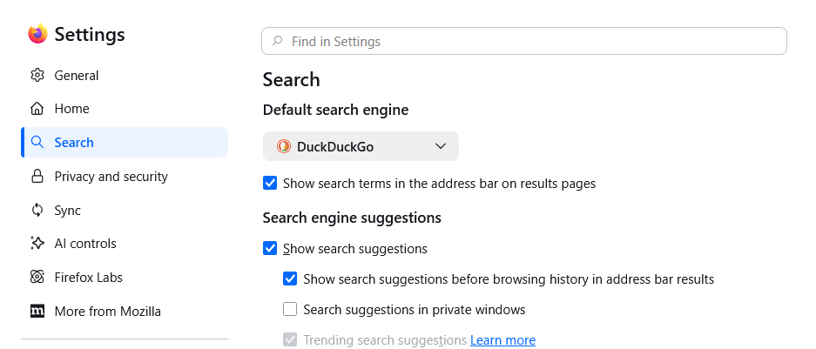
- To block ai features in firefox: settings > ai controls > turn on block ai enhancements
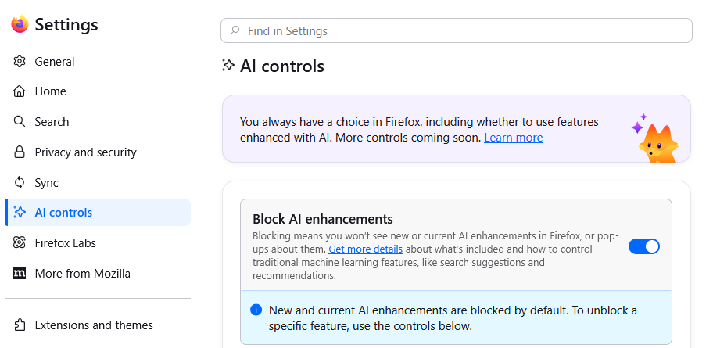
Open Office
Download open office here: https://www.openoffice.org/download/. There is also a way to put the MS office applications on here through WSU, but I am lazy and I just want a word processor without having to SSO into something all the time.

Notepad++
Download here: https://notepad-plus-plus.org/downloads/. Not strictly necessary, but I like notepad++ better than the default windows text app.

Applications etc Needed for the Data Collection Software
Git
- Download Git for windows at https://github.com/git-guides/install-git
- During installation, select the option to install the GitBash terminal.
- You can also install GitHub if you want a more visual git interface, but you're on your own for figuring that out.

VS Code
- Download VS code at https://code.visualstudio.com/download
- Once the base installation is complete, install VS code plugins for python and Jupyter Notebooks.

Anaconda
- Download Anaconda here: https://www.anaconda.com/download
- Once installation is complete, open anaconda navigator. On the home tab, find the anaconda_prompt application and click install.
- After that completes, navigate to the Environments tab. We will need to create a new environment (this will be what we use for running the homebrew lab software)
- Click the “create” button at the bottom
- Name your new environment
- Check “python” and select the version you wish to use
- Click “create”
- Now we want to install all the packages we're going to need.
- In the environments list, click on your new environment
- Select “Not installed” from the drop down above package window
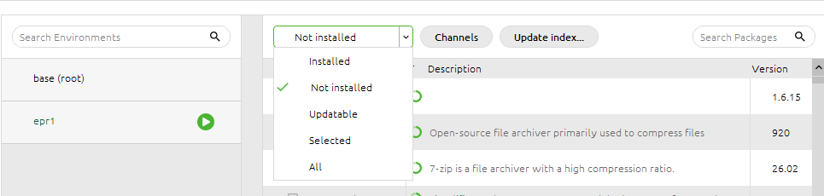
- Search for and install the following libraries to your new environment
  - numpy
  - pandas
  - matplotlib
  - pyqt
  - nidaqmx
  - pyvisa
  - pymeasure
  - telnetlib3 (This one was a dependency for some other library and was not automatically installed with the library dependent on it for some reason.)

pglive Library
You will also need the pglive library to run the EPR data collection software. Unfortunately that can only be also need to pip install because it is not available through Anaconda.
- In Anaconda Navigator, go to the home tab.
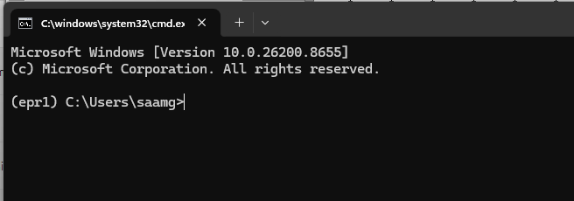
- Launch anaconda_prompt. This should launch a command prompt window with your current environment activated (the active environment is listed to the left of the prompt line, in this example the activated environment is epr1)
- If the environment you wish to pip install into is not the active environment enter `activate {name of env}` into the terminal
- With the target environment activated, enter `pip install pglive` into the terminal. This will install the pglive library into your environment.
- Once the installation is complete you can close the prompt window.
- Pglive docs can be found here: https://pypi.org/project/pglive/

Keysight I/O Libraries
In order to properly connect with and talk to the keysight/agilent frequency counter, you will need to download Keysight's proprietary I/O libraries. Those can be found here: https://www.keysight.com/us/en/lib/software-detail/computer-software/io-libraries-suite-downloads-2175637.html

National Instruments
NI Package Manager
- Download and Install NI Package Manager: https://www.ni.com/en/support/downloads/software-products/download.package-manager.html#322516
- Once installation is complete, open NI Package Manager and download the following:
  - NI-DAQmx
  - keysight 532xx multienvironment ivi
  - VISA interactive control

Copying the Lab Repo onto your Local Computer
Once you have all of that done, you need to get the code for the data collection software from the lab repo.

- Log into github (or create an account if you do not have one already)
- Go to https://github.com/orgs/Saam-SEOP-Lab/repositories to see the Saam lab repositories. If you do not have access, ask Eleanor (eleanor.terry-welsh@wsu.edu) they will give you access.
- Follow the instructions in github's documentation to set up an SSH key. This will allow you to write to the repository.
  - https://docs.github.com/en/authentication/connecting-to-github-with-ssh/generating-a-new-ssh-key-and-adding-it-to-the-ssh-agent
  - https://docs.github.com/en/authentication/connecting-to-github-with-ssh/working-with-ssh-key-passphrases
  - https://docs.github.com/en/authentication/connecting-to-github-with-ssh/adding-a-new-ssh-key-to-your-github-account
- Once you have completed the SSH set up, open a terminal window and navigate to the location you wish to save your repo to.
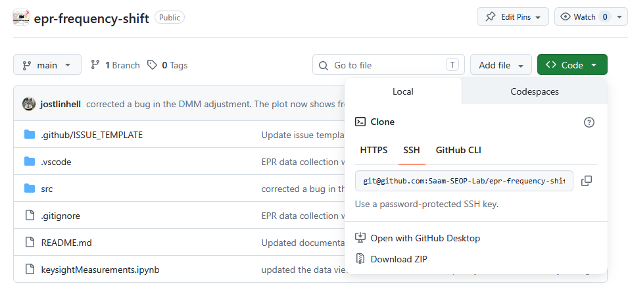
- Back in the github window, go to the repo you wish to clone, click on the “code” button, and select SSH
- Copy the line of text into your terminal window and run.
- Once the repo has finished copying, open VS code and select the repo folder as your project folder.
- You should now be able to view, edit, and run the code from VS code.

