Saamiya Master
ITMD 541-01
Lab 01

Part 1 — Installing Your Toolkit
- Visual Studio Code Version
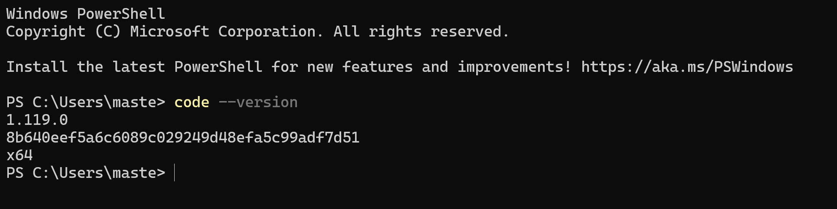
- Firefox Browser
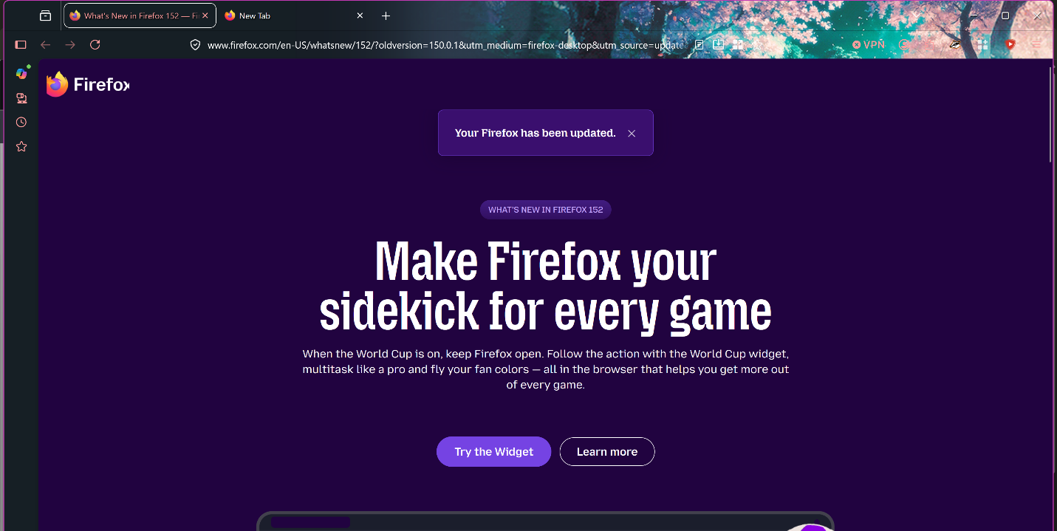

- Git Version
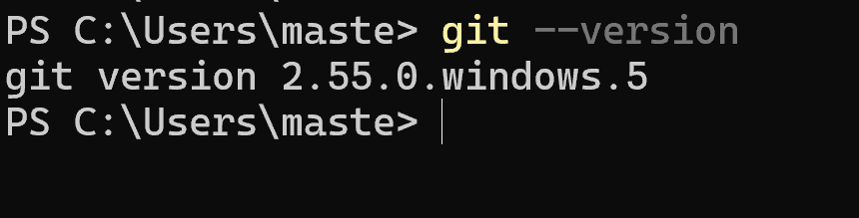
- Node.js Version
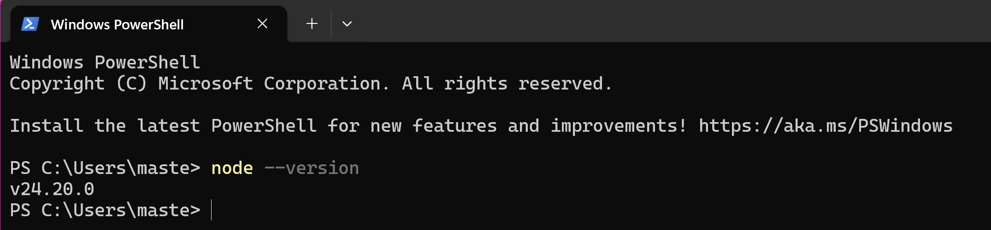
- NPM Version
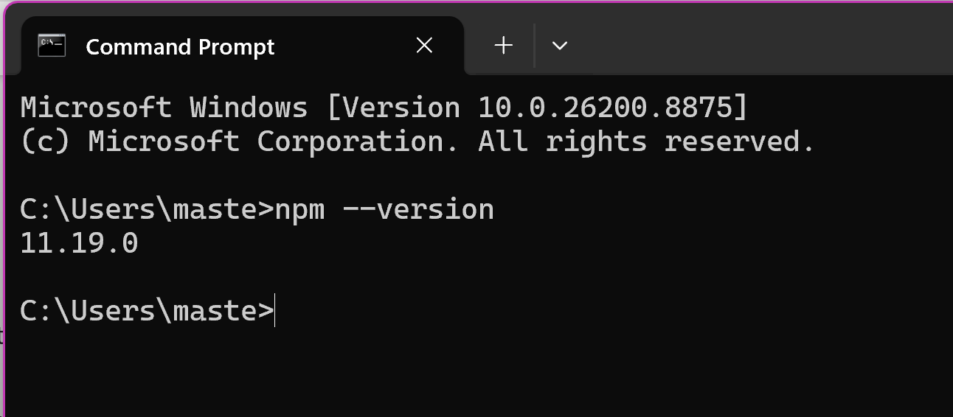

Part 2 — Creating Your Developer Accounts
GitHub Username: SaamiyaMaster
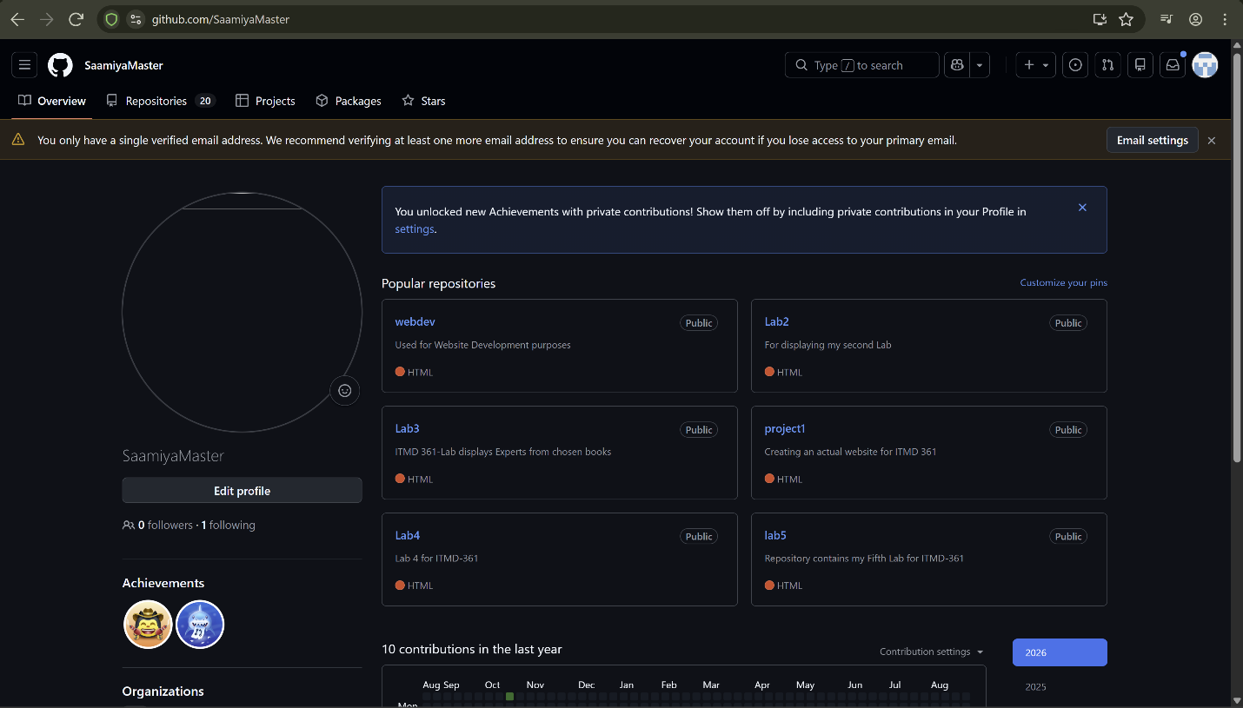
Part 3 — Environment Check
