LAB 2
Development Tools & HTTP Fundamentals
Week 2 • Tutorial 1 • Estimated Time: 75–90 minutes
Part 2 — Inspecting Real HTTP Traffic findings
Question | Your Answer
Request method for the HTML document | GET
Status code for the HTML document | Green Dot 200 OK
Content-Type of the HTML document | text/html; charset=utf-8
Content-Type of the image or CSS file | image/png

Part 3: Creating my first HTML5 Document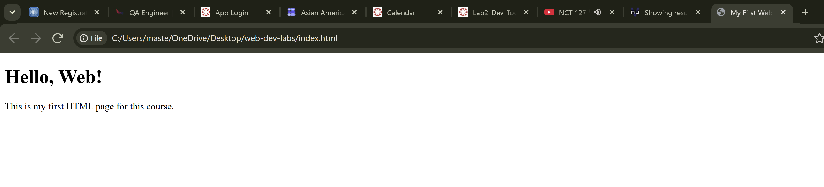

Part 4: Validating My Code

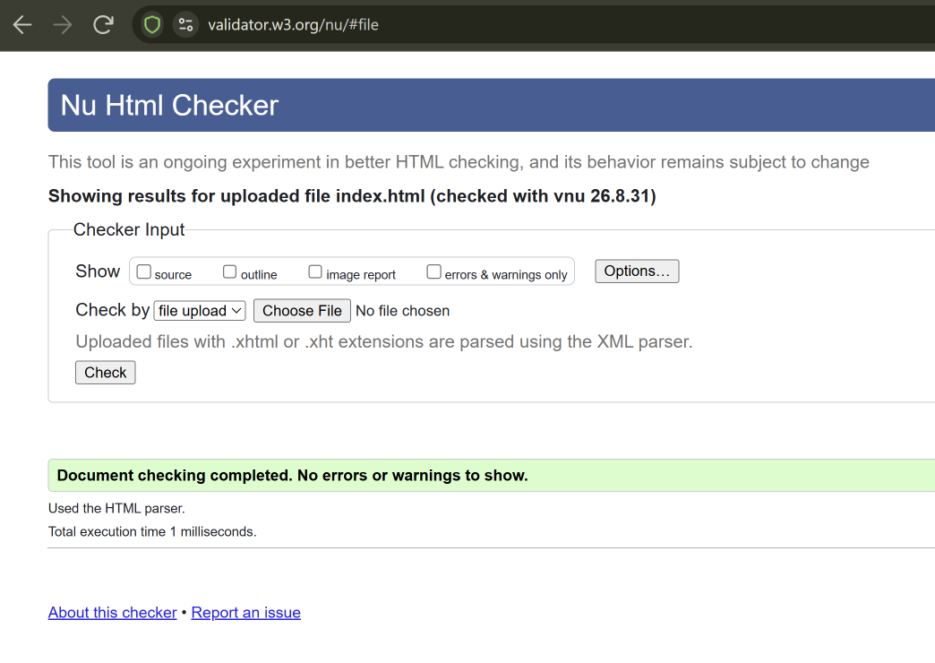

Part 5: Screenshot of Request’s Protocol and its Payload Tab.
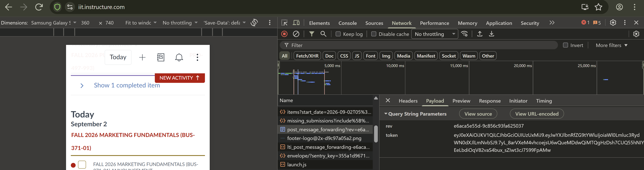
Part 6: HTTPS’s Encryption Written Response
Based on what I have read and experienced from the Lab, if this exact form had been submitted over HTTP, my username and password would’ve been very visible to someone on my public Wi-Fi network. The Eavesdropper could see the POST, Host name, Content – Type, Username and Password, this information would be available with out any encryption. HTTPS’s encryption prevents the eavesdropper from seeing the username, password, and more, of a user. The encrypted information would be available, but the Eavesdropper won’t know login information since they do not have the decryption key. The eavesdropper can still see that a request happened, but they won’t know sensitive information due to the encryption. Encryption is very important especially if you view important information such as your bank account, medical information, etc. If there was no HTTPS encryption, all the login information would be available to the eavesdropper. Which is not something you’d want, because you don’t know where none of the encrypted information will go. Since the decryption key is known only by the browser and the server, eavesdroppers have no use for the encrypted information. In my screenshot you can see the rev and token information in Payload. I believe this is my encrypted login information; I do not know what those random letters and numbers mean.

