**IMPROVEMENT :**

The below graph shows the values of fps when run through normal environment.The x-axis shows the nth time the code is executed.

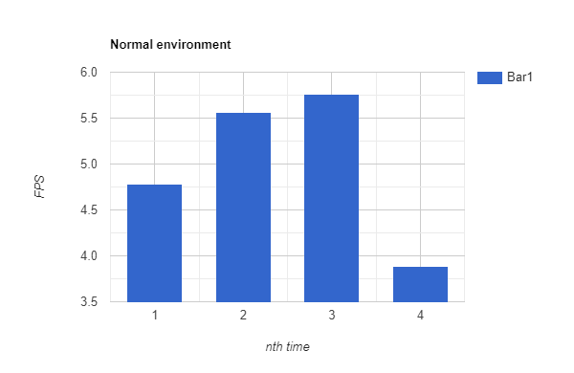

The below graph shows the values of fps when run through openVINO environment.The x-axis shows the nth time the code is executed.

