CS2801T – Database Management System Lab
SETS & JOINS

Name : Bagiya Lakshmi (21011101029)

SETS
1. Display the cities of the companies Acc and TATA.
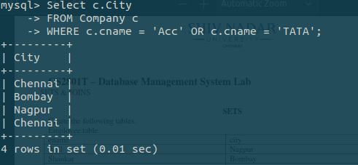

2. Display the names of the city that is common to companies Acc and TATA.
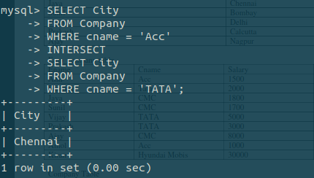

3. Find the cities where Acc is located, but not TATA.
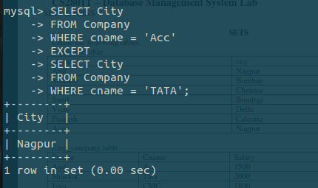

4. Display the names of employees living in Nagpur, and working with company Acc.
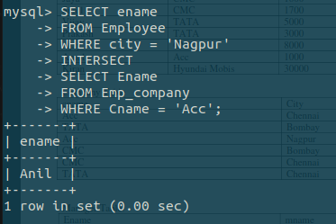

5. Display the names of employees living in Nagpur, but not working in company Acc.
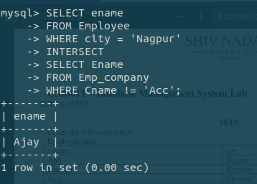

6. List the names of the employees living in city Bombay and having salary >1500
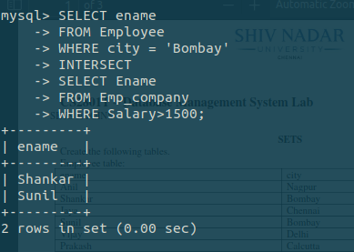

7. Display the names of the employees living in the city Chennai and working with the company CMC.
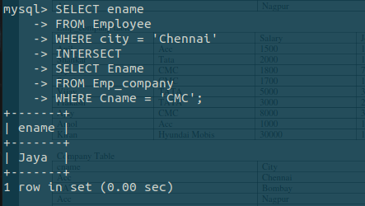

8. Display the names of the employees living in Nagpur, working in Acc, and having shift A.
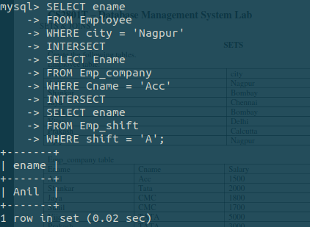

9. Display the names of the employees living in Nagpur, working in company Acc and not working in shift B.
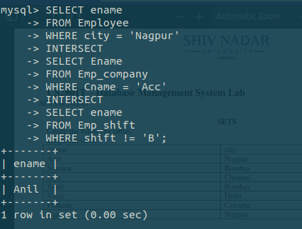

10. Display the names of employees who are living in Nagpur or Bombay.
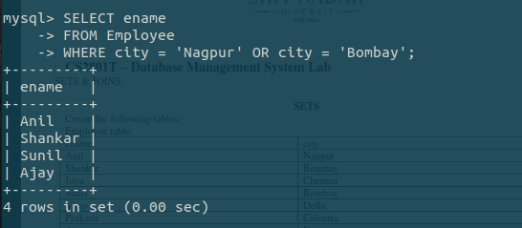

11. Display the employee names using union and union all operator.
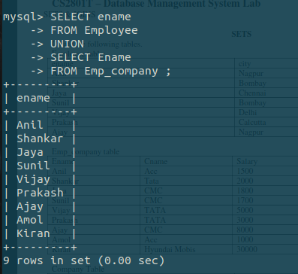

12. Display the employee name whose joining date is 18-DEC-98 and whose working shift is ‘E’.
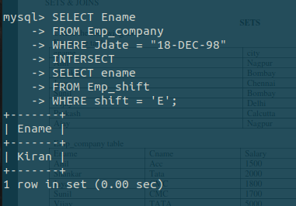

13. Use in operator to display the names of the employees living in the same city where Sunil is residing.

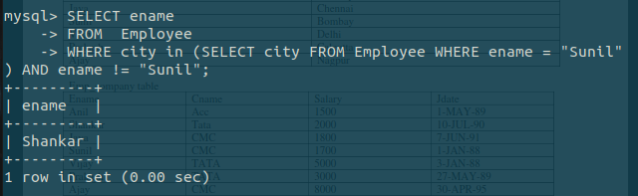
14. Use in operator to display the employees living in the city Bombay and having their company located in the city Delhi.
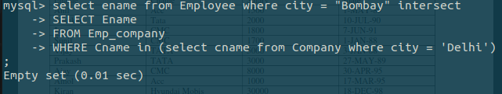
15. Display the names of the employees having same city as Ajay

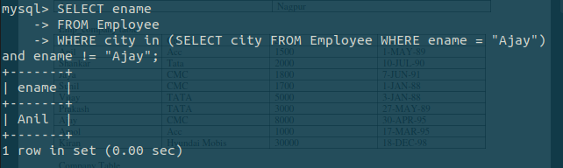

JOINS

1. Write a query to display the name, living city, company name, salary and joining date of employees using natural join.
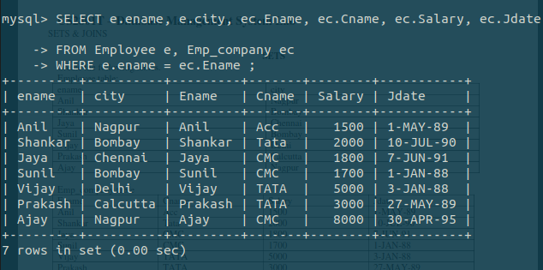

2. Write a SQL statement to make a cartesian product between manager name and employee name.

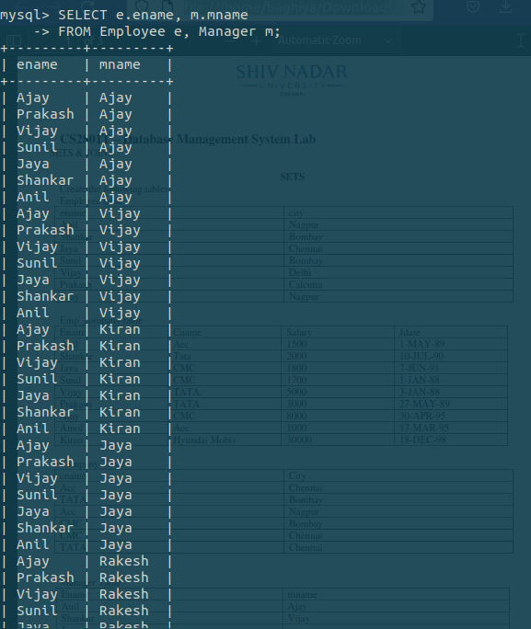

3. Display the employee name, manager name and salary of the employees whose salary is greater than 3000.[using where clause]
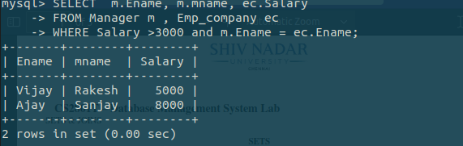

4. Display the employee name, manager name and salary of the employees whose salary is greater than 3000.[using on clause]
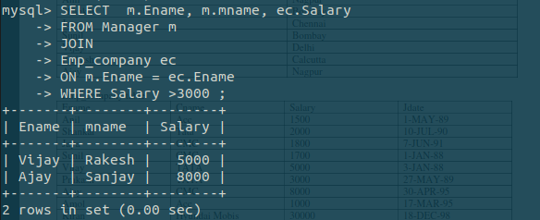

5. Write a SQL statement to prepare a list with employee names who live and work in the same city.

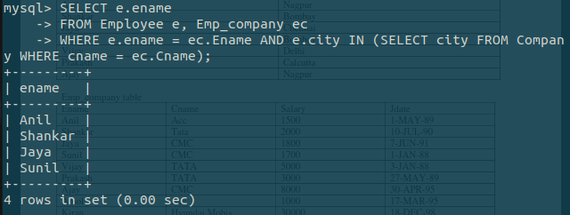

6. Write a SQL statement to make a list with employee name who live in the city Chennai and whose salary is between 1500 and 10000.
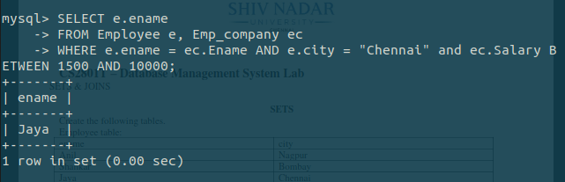

7. Display the names of the employees, company name and salary of the employees who are not assigned any living city.

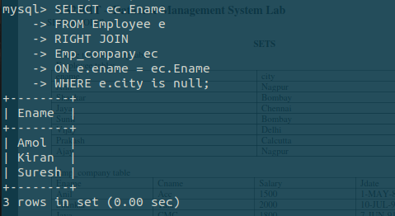

8. Display the employee name, manager name and shift of all the employees. [use left outer join]
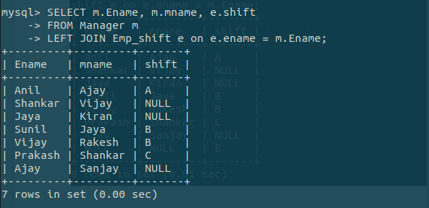

9. Display cities of the employees in which a company is not located.[using right outer join]
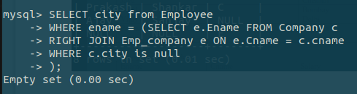

10. Display the employee name, manager name and shift of the employees. [using full outer join]

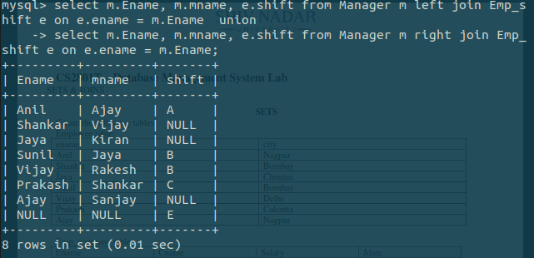

11. Display the employee name and cities of the employees who are assigned a manager and live in the same city at that of the manager [Use Inner Join].
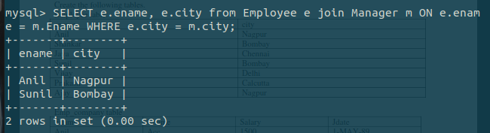

12. Display the ascending list of customers who are either assigned a manager or not.

