CS2801T – Database Management System Lab
Exercise: Subqueries & Co-related Subqueries

Name: Bagiya Lakshmi S

1. List the names of customers having maximum deposit.

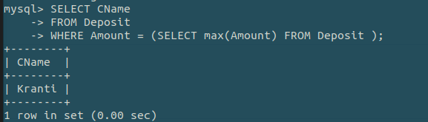
2. List the name of customers having deposit in the customers living in Nagpur.
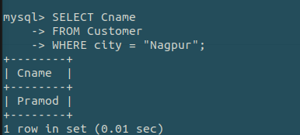

3. Give the names of customers in Karolbagh branch having more deposit than any other customer in VIRAR branch.
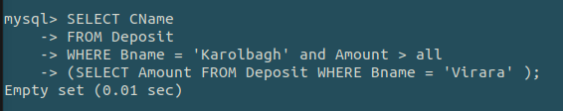

4. List all the depositors living in city Nagpur.

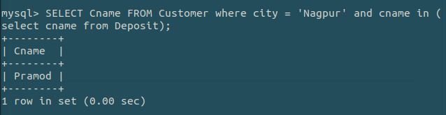

5. List the branch cities of Anil and Sunil.
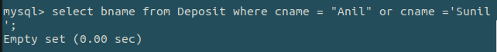
6. List all the cities where branches of Anil and Sunil are located.
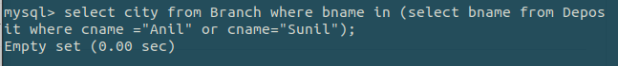
7. Give the loan no, loan amount of borrowers having same branch as that of depositor Sunil.
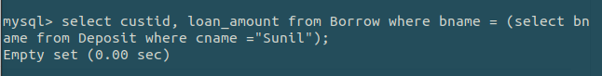
8.Give the names of borrowers having loan amount greater than the loan amount of Anil.
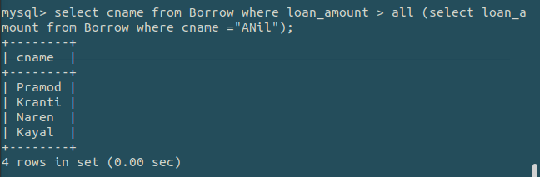
9.List the names of customers whose deposit amount deposit amount greater than 1000 and loan amount less than 10000.
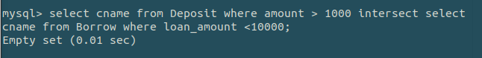
10. List all the depositors having deposit in all branches where Sunil is having account.

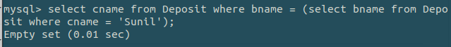
11. List all the customers living in city Nagpur and having branch city Bombay or Delhi.
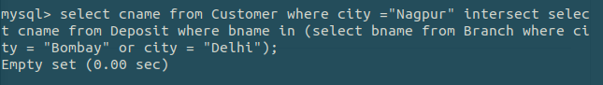

12. Display the details of the customers whose deposit amount is greater than their sum of borrow amount.
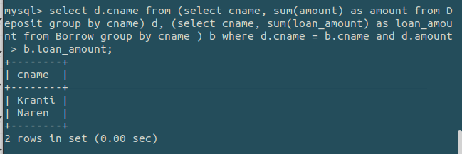

13. Display the customer details whose branch and the living city are the same.

