CS2801T – Database Management System Lab
Exercise : VIEWS

Name : Bagiya Lakshmi S (211101029)

1. Create a view to display the employee name, company name, salary, jdate, employee city and company city of the employees.
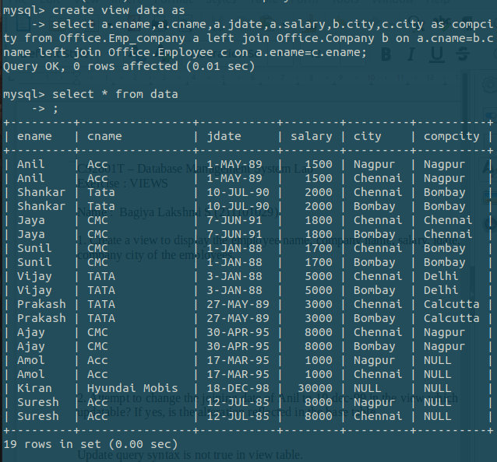

2. Attempt to change the joining date of Anil to 10-dec-99 in the view which is created. Is the view
updatable? If yes, is the alteration reflected in the base table.

Update query syntax is not true in view table.

3. Create a view v1 to display the employee name, salary and company name of the employees who work in the company Acc.

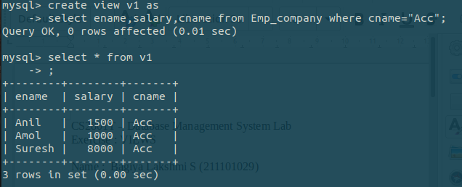

4. Insert the following data into the base table.
<ename: Ashok,cname:Acc,Salary:1200,jdate:NULL>

INSERT INTO Emp_company(Ename, Cname, Salary, Jdate)VALUES('Ashok', 'Acc', 1200, null );

5. Display the inserted tuple by using v1.

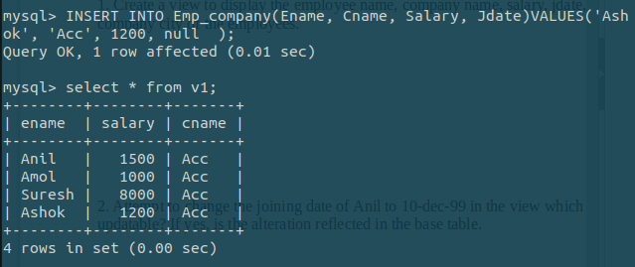

6. Create the same with check option.

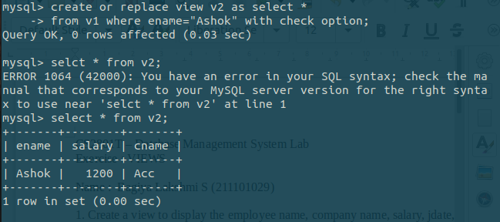

7. Create a view for retrieving company name, its average salary, its maximum and minimum salary.
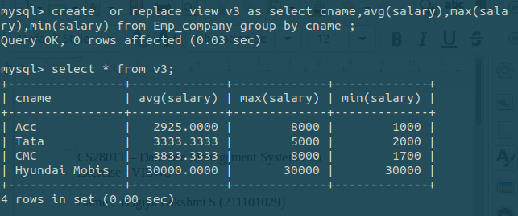
8. Write SQL query to create a view consisting of ename, cname and salary of the employees who joined
later than the year 1-Feb-98. Concatenate the columns ename and cname and provide new column name
as “Employee Company_Name”.
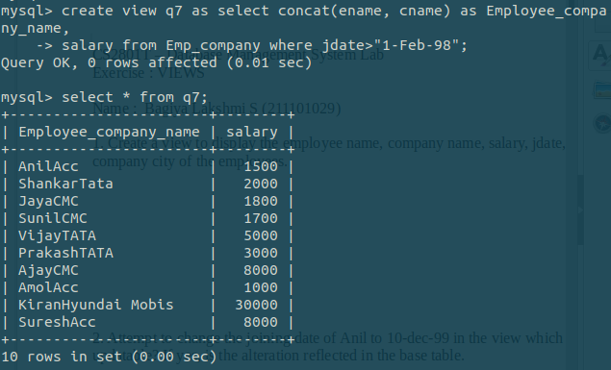
9. Create a view that gives information about employee name, salary and living city.
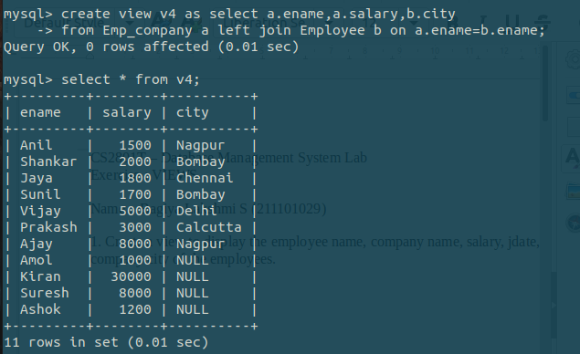
10. Perform inline view to display the top five salaried employee names and their salaries.
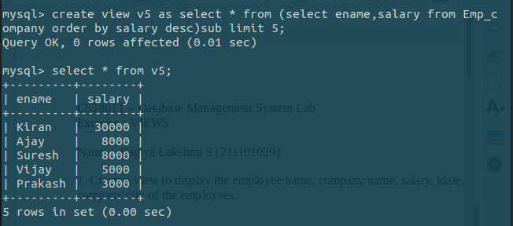
11. Write an SQL query to display the details of five employees who have recently joined the companies.

