TRANSFORMERS
SAANVI VENKATESH KULKARNI,1RVU23CSE391
A transformer is a deep learning architecture designed to process sequences such as:
- words in a sentence
- tokens in a paragraph
- audio frames
- image patches
- time-series values
It became famous because it works extremely well for:
- machine translation
- text generation
- question answering
- summarization
- code generation
- vision tasks
Instead of reading sequence elements one-by-one like an RNN, a transformer looks at all tokens together and learns which tokens should pay attention to which other tokens. That “paying attention” part is called self-attention.

NEED FOR TRANSFORMERS
Before transformers were introduced, most sequence-based tasks in natural language processing were handled using Recurrent Neural Networks (RNNs), Long Short-Term Memory networks (LSTMs), and Gated Recurrent Units (GRUs). These models process input data one element at a time in sequence. Although they were effective for many tasks, they had important limitations.
One major problem was that they processed words sequentially, which made training slow and prevented full parallel computation. Another issue was their difficulty in handling long-range dependencies. In long sentences, a word appearing later may depend on a word that appeared much earlier, but traditional recurrent models often struggled to preserve such information over long distances. Even though LSTMs and GRUs improved memory handling, they still could not completely solve this problem.
Transformers were introduced to overcome these limitations. Instead of processing tokens one by one, they process the entire sequence at the same time and use an attention mechanism to determine which parts of the input are most relevant to each token. This made transformers faster, more scalable, and better at capturing long-distance relationships in data.

BASIC IDEA OF A TRANSFORMER
A transformer is a deep learning architecture designed to handle sequential data such as text, speech, and time-series signals. Its main idea is to allow every token in the input sequence to directly interact with every other token. This is achieved using a mechanism called attention.
Unlike recurrent models, transformers do not rely on step-by-step processing. They analyze the entire sequence together, making them highly efficient and powerful for language understanding and generation.

ARCHITECTURE OF A TRANSFORMER
The original transformer architecture consists of two major parts: the encoder and the decoder.
The encoder reads the input sequence and converts it into a set of contextual representations. These representations capture the meaning of each token in relation to all other tokens in the input.
The decoder takes these encoder representations and generates the output sequence one token at a time. It uses both the encoded input and the previously generated output tokens to predict the next token.
This encoder-decoder structure is especially useful for tasks such as machine translation, where one sequence is converted into another.
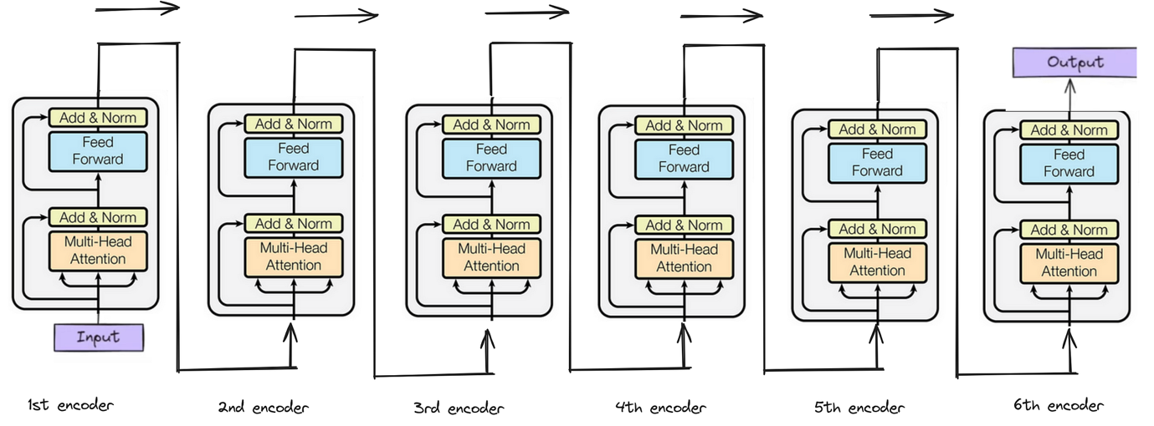

INPUT REPRESENTATION
Before a transformer can process text, the text must be converted into numerical form. This is done in two steps: token embedding and positional encoding.
A sentence is first broken into smaller units called tokens. Each token is then mapped to a dense vector called an embedding, which represents its meaning in numerical form.
However, since transformers process all tokens simultaneously, they do not automatically know the order of words in a sentence. To provide this order information, positional encoding is added to the embeddings. Positional encoding tells the model the position of each token in the sequence.
Thus, the final input to the transformer is the combination of token embeddings and positional information.

SELF-ATTENTION MECHANISM
The most important component of a transformer is the self-attention mechanism. Self-attention allows each token in a sequence to examine all other tokens and determine which ones are most important for understanding its meaning.
For each token, the transformer creates three vectors called:
- Query (Q)
- Key (K)
- Value (V)
These vectors are learned from the input embeddings.
The query vector represents what the token is looking for. The key vector represents what the token contains. The value vector contains the actual information passed forward.
The similarity between a query and all keys is computed using a dot product. These scores are then normalized using the softmax function to produce attention weights. Finally, a weighted sum of the value vectors is computed. This gives a new representation of the token that includes information from other relevant tokens.
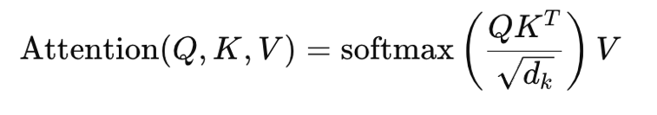
The mathematical formula for self-attention is:

where $d_{k}$is the dimension of the key vectors. The scaling factor $\sqrt{d_{k}}$prevents the dot-product values from becoming too large.
Self-attention helps the transformer understand context more effectively than traditional sequential models.

CODE:
import torch
import torch.nn as nn
import math

# -----------------------------
# Positional Encoding
# -----------------------------
class PositionalEncoding(nn.Module):
def __init__(self, d_model, max_len=5000):
super(PositionalEncoding, self).__init__()

pe = torch.zeros(max_len, d_model)
position = torch.arange(0, max_len, dtype=torch.float).unsqueeze(1)

div_term = torch.exp(torch.arange(0, d_model, 2).float() *
(-math.log(10000.0) / d_model))

pe[:, 0::2] = torch.sin(position * div_term)
pe[:, 1::2] = torch.cos(position * div_term)

pe = pe.unsqueeze(0) # shape: (1, max_len, d_model)
self.register_buffer('pe', pe)

def forward(self, x):
x = x + self.pe[:, :x.size(1), :]
return x

# -----------------------------
# Transformer Model
# -----------------------------
class SimpleTransformer(nn.Module):
def __init__(self, input_dim, d_model, nhead, num_layers, output_dim, max_len=100):
super(SimpleTransformer, self).__init__()

self.embedding = nn.Embedding(input_dim, d_model)
self.pos_encoder = PositionalEncoding(d_model, max_len)

encoder_layer = nn.TransformerEncoderLayer(
d_model=d_model,
nhead=nhead,
dim_feedforward=128,
dropout=0.1,
batch_first=True
)

self.transformer_encoder = nn.TransformerEncoder(
encoder_layer,
num_layers=num_layers
)

self.fc_out = nn.Linear(d_model, output_dim)

def forward(self, src):
# src shape: (batch_size, seq_len)
x = self.embedding(src) * math.sqrt(self.embedding.embedding_dim)
x = self.pos_encoder(x)
x = self.transformer_encoder(x)
out = self.fc_out(x)
return out

# -----------------------------
# Example Usage
# -----------------------------
if __name__ == "__main__":
input_dim = 20 # vocabulary size
d_model = 32 # embedding dimension
nhead = 4 # number of attention heads
num_layers = 2 # number of encoder layers
output_dim = 20 # output vocabulary size
seq_len = 5
batch_size = 2

model = SimpleTransformer(input_dim, d_model, nhead, num_layers, output_dim)

# Example input: batch of 2 sequences, each of length 5
src = torch.tensor([
[1, 5, 7, 3, 2],
[4, 6, 8, 9, 1]
])

output = model(src)

print("Input shape:", src.shape)
print("Output shape:", output.shape)
print("Output tensor:\n", output)

OUTPUT:

