ENCODER DECODER
SAANVI VENKATESH KULKARNI,1RVU23CSE391
In deep learning, the encoder-decoder architecture is a type of neural network most widely associated with the transformer architecture and used in sequence-to-sequence learning. Much machine learning research focuses on encoder-decoder models for natural language processing (NLP) tasks involving large language models (LLMs).
Encoder-decoder models are used to handle sequential data, specifically mapping input sequences to output sequences of different lengths, such as neural machine translation, text summarization, image captioning and speech recognition. In such tasks, mapping a token in the input to one in the output is often indirect. For example, take machine translation: in some languages, the verb appears near the beginning of the sentence (as in English), in others at the end (such as German) and in some, the location of the verb may be more variable (for example, Latin). An encoder-decoder network generates variable length yet contextually appropriate output sequences to correspond to a given input sequence.
THE ENCODER-DECODER ARCHITECTURE
Both the encoder and decoder are separate, fully connected neural networks.
Each encoder consists of two layers: the self-attention layer (or self-attention mechanism) and the feed-forward neural network. The first layer guides the encoder in surveying and focusing on other related words in a given input as it encodes one specific word therein. The feed-forward neural network further processes encodings so they are acceptable for subsequent encoder or decoder layers.
The decoder part also consists of a self-attention layer and feed-forward neural network, as well as an additional third layer: the encoder-decoder attention layer. This layer focuses network attention on specific parts of the output of the encoder. The multi-head attention layer thereby maps tokens from two different sequences.

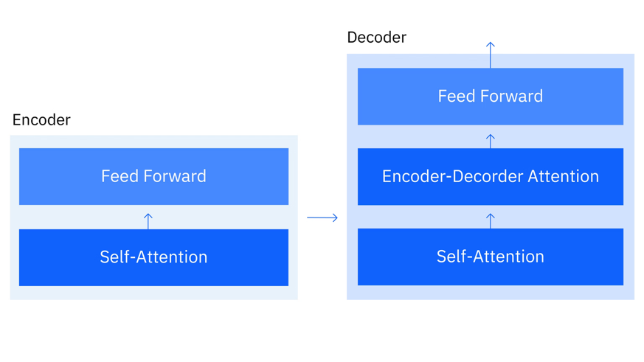

Encoder
The principal component of the encoder is the self-attention mechanism. The self-attention mechanism determines token weights in a text input to reflect inter-token relationships. In contrast to a traditional word embedding that ignores word order, self-attention processes the whole input text sequence to compute each token’s weighted average embedding that takes into account that token’s distance from all of the other tokens in the text sequence. It computes this average embedding as a linear combination of all embeddings for the input sequence according to following formula:
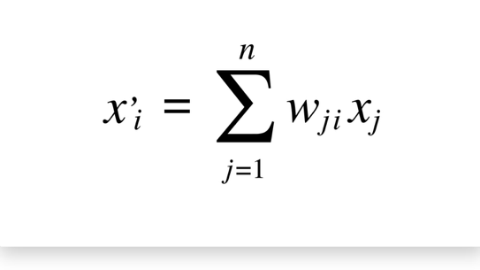

In this context, x_{j} represents the input token located at position j in the input sequence, while x_{i} represents the corresponding output token at position i in the sequence. The value w_{ij} denotes the attention weight between these tokens. This weight is calculated using the softmax function and indicates the level of importance of a particular input token when generating the output token. In simple terms, the attention weight determines how much focus the encoder should place on each input token based on its relevance to the token being produced in the output sequence.
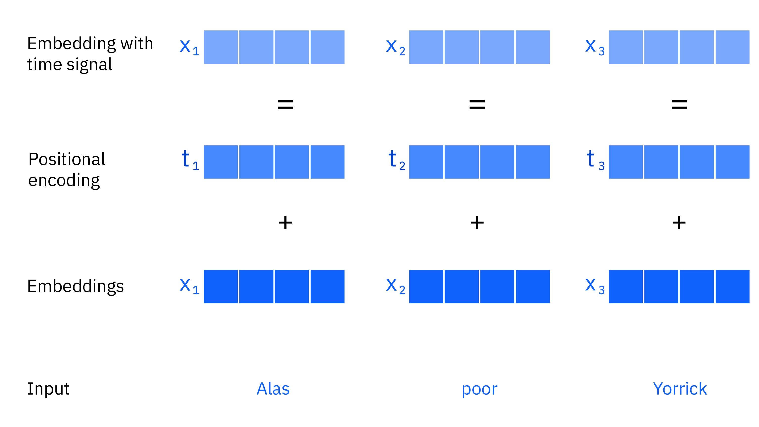

The encoder sends the token embedding to a feed-forward layer, where positional encoding (or positional embedding) is added to it. This positional information helps the model understand the order of tokens in the sequence and the relative distance between them. The combination of the token embedding and positional embedding forms the hidden representation, which is then passed to the decoder for further processing.
A context vector is a numerical representation that summarizes the important information from the input sequence in a neural network model, especially in encoder–decoder architectures used for tasks like machine translation.

When the encoder processes an input sentence, it converts each word into embeddings and analyzes their relationships. After processing the entire sequence, the encoder produces a final hidden representation that captures the overall meaning of the input. This representation is called the context vector.

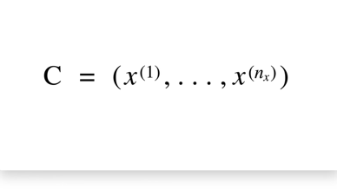
In simple terms, the context vector contains the essential information of the whole input sentence in a compact vector form. The decoder then uses this vector to generate the output sequence, such as translating the sentence into another language or producing a response.

Decoder
Similar to the encoder, the decoder is also composed of a self-attention layer and a feed-forward neural network. However, unlike the encoder, the decoder includes a multi-head attention masking layer. This masking mechanism is what distinguishes the decoder from the encoder. While the encoder processes and generates contextualized token embeddings for the entire input sequence at the same time, the decoder applies autoregressive masking during attention.

The decoder first receives the context vector produced by the encoder. Using the positional embeddings, it computes attention scores for each token in the sequence. These attention scores determine how much influence each input token has when generating the output sequence. In other words, they assign weights that indicate the importance of each token when predicting the next token in the output.

An important characteristic of the decoder is that it does not consider future tokens when generating the current token. Each output token is generated based only on the tokens that come before it. This means the decoder cannot look ahead in the sequence while making predictions. Instead, it predicts tokens step by step, relying only on previously generated tokens. This sequential method of prediction is known as autoregressive processing and is designed to resemble how humans naturally process and generate language.
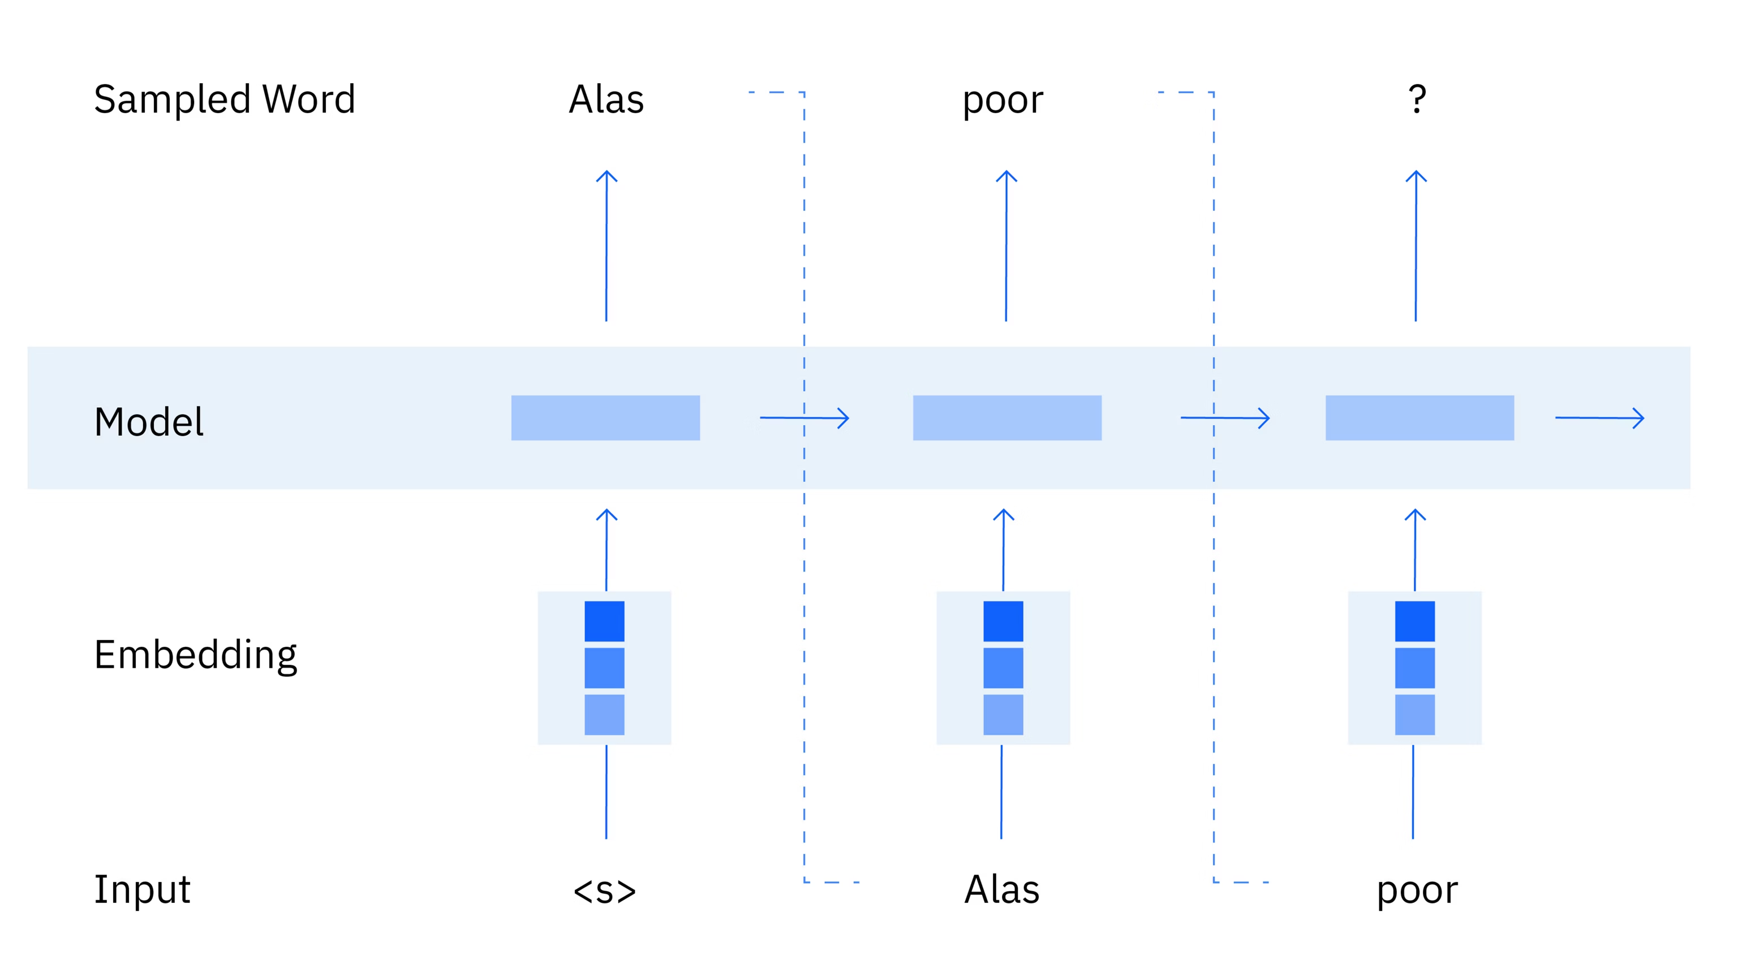
Encoder–decoder models are widely used in NLP tasks such as sentiment analysis, machine translation, and masked language modeling because they generate contextualized embeddings. These embeddings capture the meaning of words based on the context in which they appear, unlike traditional fixed word embeddings used in bag-of-words models.

Fixed embeddings assign a single vector representation to each word regardless of its position or meaning in different sentences. They also ignore the order of words, which means they cannot capture relationships between tokens in a sequence.

In contrast, encoder–decoder models consider both the order and relationships between words. They use positional encoding to understand the sequence order and attention mechanisms to analyse how tokens relate to one another within a sentence. This allows the model to generate embeddings that change depending on the surrounding words.

Another advantage is handling polysemous words, which are words with multiple meanings. Fixed embeddings produce only one representation for such words. However, encoder–decoder models generate different contextual embeddings for each occurrence of a word. For example, the word “flies” could refer to an insect or the action of flying. Encoder–decoder models create separate embeddings for each meaning depending on the context in the sentence.

Therefore, encoder–decoder architectures provide richer and more accurate representations of language compared to traditional word embedding methods.

TYPES OF ENCODER–DECODER VARIANTS
The encoder–decoder architecture has several variations, each designed for different machine learning and NLP tasks.
Encoder-only models use only the encoder part of the architecture and do not include a decoder. Because of this, they do not use autoregressive masking and can view the entire input sequence at once. These models are considered bidirectional since they analyze both the preceding and following tokens to understand the meaning of a word. Well-known encoder-only models include BERT, RoBERTa, ELECTRA, and IBM Slate models. These models are commonly used for tasks that require understanding the complete text, such as text classification, sentiment analysis, and named entity recognition.

Decoder-only models use only the decoder component and do not include an encoder. These models are autoregressive, meaning that when predicting the next token, they can only look at the tokens that appear before it in the sequence. They generate text step by step, using previously generated tokens to produce the next one. Decoder-only models are widely used for text generation tasks such as question answering, chatbot systems, and code generation. Examples include models used in systems like ChatGPT and the IBM Granite family of foundational models.

CODE:
Example task used below: reverse a sequence of integers.
import torch
import torch.nn as nn
import torch.optim as optim
import random

# -----------------------------
# 1. Hyperparameters
# -----------------------------
INPUT_DIM = 15 # vocabulary size for input tokens
OUTPUT_DIM = 15 # vocabulary size for output tokens
EMB_DIM = 16
HID_DIM = 32
NUM_LAYERS = 1
LEARNING_RATE = 0.01
EPOCHS = 300

SOS_TOKEN = 1
EOS_TOKEN = 2
PAD_TOKEN = 0

device = torch.device("cuda" if torch.cuda.is_available() else "cpu")

# -----------------------------
# 2. Encoder
# -----------------------------
class Encoder(nn.Module):
def __init__(self, input_dim, emb_dim, hid_dim, num_layers):
super().__init__()
self.embedding = nn.Embedding(input_dim, emb_dim, padding_idx=PAD_TOKEN)
self.rnn = nn.LSTM(emb_dim, hid_dim, num_layers, batch_first=True)

def forward(self, src):
# src shape: [batch_size, src_len]
embedded = self.embedding(src) # [batch_size, src_len, emb_dim]
outputs, (hidden, cell) = self.rnn(embedded)
return hidden, cell

# -----------------------------
# 3. Decoder
# -----------------------------
class Decoder(nn.Module):
def __init__(self, output_dim, emb_dim, hid_dim, num_layers):
super().__init__()
self.embedding = nn.Embedding(output_dim, emb_dim, padding_idx=PAD_TOKEN)
self.rnn = nn.LSTM(emb_dim, hid_dim, num_layers, batch_first=True)
self.fc_out = nn.Linear(hid_dim, output_dim)

def forward(self, x, hidden, cell):
# x shape: [batch_size]
x = x.unsqueeze(1) # [batch_size, 1]
embedded = self.embedding(x) # [batch_size, 1, emb_dim]
output, (hidden, cell) = self.rnn(embedded, (hidden, cell))
prediction = self.fc_out(output.squeeze(1)) # [batch_size, output_dim]
return prediction, hidden, cell

# -----------------------------
# 4. Seq2Seq Model
# -----------------------------
class Seq2Seq(nn.Module):
def __init__(self, encoder, decoder):
super().__init__()
self.encoder = encoder
self.decoder = decoder

def forward(self, src, trg, teacher_forcing_ratio=0.5):
# src: [batch_size, src_len]
# trg: [batch_size, trg_len]
batch_size = src.shape[0]
trg_len = trg.shape[1]
trg_vocab_size = OUTPUT_DIM

outputs = torch.zeros(batch_size, trg_len, trg_vocab_size).to(device)

hidden, cell = self.encoder(src)

# first input to decoder is SOS token
x = trg[:, 0]

for t in range(1, trg_len):
output, hidden, cell = self.decoder(x, hidden, cell)
outputs[:, t, :] = output

best_guess = output.argmax(1)
teacher_force = random.random() < teacher_forcing_ratio
x = trg[:, t] if teacher_force else best_guess

return outputs

# -----------------------------
# 5. Create Toy Dataset
# -----------------------------
def generate_sample(seq_len=5):
# tokens from 3 to 14; 0=PAD, 1=SOS, 2=EOS
seq = [random.randint(3, 14) for _ in range(seq_len)]
src = seq
trg = [SOS_TOKEN] + list(reversed(seq)) + [EOS_TOKEN]
return src, trg

data = [generate_sample(seq_len=5) for _ in range(1000)]

def to_tensor_batch(batch):
src_batch = [item[0] for item in batch]
trg_batch = [item[1] for item in batch]

src_tensor = torch.tensor(src_batch, dtype=torch.long).to(device)
trg_tensor = torch.tensor(trg_batch, dtype=torch.long).to(device)

return src_tensor, trg_tensor

# -----------------------------
# 6. Initialize Model
# -----------------------------
encoder = Encoder(INPUT_DIM, EMB_DIM, HID_DIM, NUM_LAYERS)
decoder = Decoder(OUTPUT_DIM, EMB_DIM, HID_DIM, NUM_LAYERS)
model = Seq2Seq(encoder, decoder).to(device)

optimizer = optim.Adam(model.parameters(), lr=LEARNING_RATE)
criterion = nn.CrossEntropyLoss(ignore_index=PAD_TOKEN)

# -----------------------------
# 7. Training
# -----------------------------
for epoch in range(EPOCHS):
model.train()
batch = random.sample(data, 32)
src, trg = to_tensor_batch(batch)

output = model(src, trg) # [batch_size, trg_len, output_dim]

# ignore first token for loss
output_dim = output.shape[-1]
output = output[:, 1:, :].reshape(-1, output_dim)
trg = trg[:, 1:].reshape(-1)

loss = criterion(output, trg)

optimizer.zero_grad()
loss.backward()
optimizer.step()

if (epoch + 1) % 50 == 0:
print(f"Epoch [{epoch+1}/{EPOCHS}], Loss: {loss.item():.4f}")

# -----------------------------
# 8. Inference
# -----------------------------
def predict(model, src_seq, max_len=10):
model.eval()
src_tensor = torch.tensor([src_seq], dtype=torch.long).to(device)

with torch.no_grad():
hidden, cell = model.encoder(src_tensor)

x = torch.tensor([SOS_TOKEN], dtype=torch.long).to(device)
outputs = []

for _ in range(max_len):
with torch.no_grad():
output, hidden, cell = model.decoder(x, hidden, cell)

best_token = output.argmax(1).item()

if best_token == EOS_TOKEN:
break

outputs.append(best_token)
x = torch.tensor([best_token], dtype=torch.long).to(device)

return outputs

# -----------------------------
# 9. Test
# -----------------------------
test_seq = [10, 4, 6, 7, 8]
prediction = predict(model, test_seq)

print("\nInput sequence: ", test_seq)
print("Expected output: ", list(reversed(test_seq)))
print("Model prediction: ", prediction)

OUTPUT:
