VITyarthi | Open Source Software

The Open Source Audit

A Capstone Project for OSS NGMC Course

Course: Open Source Software | Unit Coverage: 1 – 5 Max Marks: 100

Student Name | Registration Number
Saara Ravishankar Magar | 24BCY10076
Slot | Date of Submission
A11 | 31/03/26

Introduction

Most of the software that powers the modern world — the servers that run websites, the tools that developers use every day, the operating systems inside supercomputers and smartphones
— was not built by a single company and sold for profit. It was built openly, shared freely, and improved collectively. That is the essence of open source.

This project asks you to stop and think about that.

You will choose one real open-source software project — something you can download, read about, and interact with on Linux — and conduct a structured audit of it. Not just 'what does it do,' but why it exists, who built it, what freedoms its license actually gives you, what philosophical values it represents, and how it has shaped the world around it.

Alongside the written report, you will write five shell scripts that demonstrate practical Linux skills. These are not meant to be impressive programs — they are meant to show that you understand how open-source tools work at the command line, and how automation connects to the philosophy of sharing and transparency.

Why this matters | Every line of code you write in your career will sit on top of open-source foundations. Understanding the philosophy behind that is not optional — it is part of being a professional.

Choosing Your Software

Pick one open-source project from the list below, or propose your own (subject to instructor approval). Your choice will be the subject of your entire report and all five shell scripts.

Approved software options

Software | Category | License | Why it's interesting
Linux Kernel | Operating System | GPL v2 | The foundation everything else runs on
Apache HTTP Server | Web Server | Apache 2.0 | Powers ~30% of all websites globally
MySQL | Database | GPL v2 / Commercial | A license with a  dual-model story to tell
Firefox | Web Browser | MPL 2.0 | A nonprofit fighting for an open web
VLC Media Player | Multimedia | LGPL / GPL | Plays anything — built by students in Paris
LibreOffice | Office Suite | MPL 2.0 | Born from a community fork — a real lesson
Python | Programming Language | PSF License | A language shaped entirely by community
Git | Version Control | GPL v2 | The tool Linus built when proprietary failed him

Your choice | Write your chosen software here before submission:  python

Project Report Structure

Your report should be 12 to 16 pages long. Each section below maps to a unit in the course. Do not pad with screenshots — every page should contain original thinking and analysis written in your own words.

Part A — Origin and Philosophy (Units 1 & 2)
This is the most important section of the report. Allocate at least four pages to it.

A1. The problem this software was created to solve
Do not just copy the official description. Research the original context. What was frustrating or broken or inaccessible before this software existed? Why did the creator decide to build it and share it rather than keep it proprietary?
The best way to understand why Python exists is to imagine being Guido van Rossum in 1989. He is a programmer at CWI — a research institute in Amsterdam — and he has spent time working on a language called ABC. ABC is actually pretty elegant. It is readable, clean, and designed with learners in mind. But it has a serious limitation that frustrates Guido deeply: it cannot talk to the operating system. You cannot extend it meaningfully. It is a walled garden. Whatever its designers imagined you doing with it is basically all you can do.

At the same time, Guido is doing real work on a distributed OS called Amoeba, which needs scripting tools. Shell scripts are too limited for the kind of logic he needs to write. C works but it is tedious — you spend more time managing memory and boilerplate than actually solving problems. There is genuinely nothing in the middle. No language that is both easy to write and powerful enough to get real things done.

Over the Christmas holiday of 1989, with some time on his hands, Guido started writing one. He called it Python — not because of the snake, but because he was a fan of Monty Python's Flying Circus and wanted the project to have a slightly playful, not-too-serious feel. That tone, it turned out, would end up reflecting the language itself pretty well.

For example: Linus Torvalds was a student who wanted a free Unix-like system and could not afford one. Richard Stallman watched a printer malfunction and could not fix it because the source code was locked. The VLC team wanted to stream video over a university network but no tool existed that was free and open enough to adapt.

What is your software's origin story? Tell it properly.
Python's origin is not just what problem it solved, but how Guido chose to release it. In 1991, he posted version 0.9.0 to the alt.sources Usenet newsgroup. No company, no product launch, no business plan. Just a programmer putting something out into the world because he thought it might be useful to other people. That single decision — to share rather than keep — is the reason Python exists in the form it does today.

Because Python was open, people could fix it, extend it, and build things Guido never imagined. A university student could add a module. A researcher could contribute a bug fix. A company could fork it for their own purposes and contribute improvements back. None of that would have happened if Guido had decided to protect his work. The openness was not incidental to Python's success. It was the cause of it.

Today Python runs machine learning pipelines at some of the world's biggest companies, powers the data science work that led to COVID vaccine research, controls robotics systems, and is the first programming language taught to millions of students. That trajectory started because one person decided to share something useful during a holiday break, and a community decided it was worth improving together.

A2. The license — what it actually says
Download or find the actual license text for your software. Read it. Then answer these questions in your report:
- What are the four freedoms of free software? Does your software's license grant all four?
- The Free Software Foundation defines four freedoms that a software license must grant for it to count as truly free:
- Freedom 0: The right to run the program for any purpose, without restriction.
- Freedom 1: The right to study the source code and change how it works.
- Freedom 2: The right to share copies with others.
- Freedom 3: The right to share your modified version with others.

- Python's PSF License grants all four. You can download CPython's entire source code right now, read every line, change anything you want, and share your version. The only thing the license asks is that you keep the copyright notice and the list of contributors. That is a very small ask. In exchange, you get full access to one of the most powerful and widely used programming languages ever built.

- Can a company take this software, modify it, and sell it without sharing their changes? Why or why not?
- This always surprises people when they first hear it. Under the PSF license, a company can just take Python's code, change it, build a product, and sell it without giving a single thing back to the community. It's totally legal. Anaconda does this. Apple even bundles Python in macOS. They don't have to share their tweaks with anyone if they don't want to.
- That's the big split between a permissive license like this and something like the GPL. People call the GPL a share-alike system. If you change a GPL program and hand it out, you have to release your new version under that same open license. The freedom is contagious. It spreads.
- The PSF license just doesn't work like that. It gives you the right to take without any requirement to give back. Whether you think that's a good idea or not really depends on what you think open source is actually for. personally, I think it's a bit of a toss-up.

- What is the difference between GPL and MIT licensing? Which would you choose for something you built, and why?
I've been thinking about this more than I expected to. The GPL and the MIT license aren't just different rules. They represent two totally different ideas of what software freedom actually means.
The GPL is all about passing it on. If you benefit from open code, the people who use your work should get that same benefit. It's idealistic. I actually find that pretty appealing. The MIT vision is much simpler. Do whatever you want. No strings attached and no real obligations. It’s built for maximum adoption and zero friction.
If I were building a library today and I wanted other developers to use it, I'd probably go with MIT or something similar. It's a practical choice. Companies are just more comfortable with MIT code because they don't have to worry about GPL rules affecting their own private code. If I want people to actually use my work, I have to make it easy. But if I were building something that I felt really strongly should stay free, like a tool for schools, I’d think twice. I wouldn't want to see it locked behind a paywall later. The right choice just depends on what you want to happen in the end. It's a bit of a toss-up.

- Is there a difference between 'free as in free beer' and 'free as in freedom'? Give an example from your chosen software.
This distinction tripped me up the first time I heard it, and I think it trips up a lot of people. 'Free as in free beer' just means no charge. You get it for nothing. 'Free as in freedom' means you have the liberty to use it, study it, change it, and share it. These are completely independent of each other.

Python is a good example of both at once, but that is not always the case. You can have software that is free as in beer but not as in freedom — a freeware application you can download without paying, but whose source code is closed and whose license forbids modification. You can theoretically have the reverse too: software that costs money but comes with full source code and modification rights (some commercial open-source models work this way). Python happens to be both: free to download, and genuinely free in the deeper sense. That combination is rarer than people think, and it is a big part of why Python became what it is.

Think, don't copy | Answers copied from Wikipedia or AI tools will score zero. We are looking for your understanding and your words.

A3. The ethics of open source
Open source is not just a licensing model — it is a statement about how knowledge and tools should be shared. Reflect on the following:
- Should all software be open source? Make an argument for and against.
Honestly, I'm just not sure. I think anyone who gives a flat yes or no right away hasn't actually thought about it hard enough.
The case for making everything open source is strong. When code is open, more eyes can check it for bugs or security holes. Knowledge isn't trapped behind corporate walls. People and schools that can't afford expensive licenses still get to use powerful tools. It's vital for things like scientific research. Since software runs our hospitals, elections, and banks, wanting to inspect the code making big decisions about our lives isn't a wild idea. It's just common sense.
But the argument against it is more serious than some advocates want to admit. Good software is expensive to build. Talented developers have to pay rent. The commercial world has funded some incredible things that I don't think the open source community would've built alone, at least not with the same polish and long term support. You also have to think about really sensitive stuff. Should the code for a nuclear plant's control system be public for everyone to see? Transparency goes both ways.
I really think "should all software be open source" is the wrong question to ask. A better one would be: what kind of software should we as a society make sure stays open? For me, that's the basic infrastructure. I'm talking about operating systems, compilers, servers, and databases. The things that everything else depends on shouldn't be controlled by one single private company. It's too risky.

- Is it ethical for a company to build a profitable product entirely on top of free community labor? (Think about how companies like Red Hat, Google, and Meta use Linux.)
- This question makes me feel a bit uneasy. Honestly, the answer is that it's legally totally fine but ethically pretty murky.
- The numbers are just staggering. Google, Amazon, Meta, and Microsoft have built trillion dollar businesses that depend heavily on Linux, Python, and hundreds of other open projects. They do give back some. Google employs kernel engineers, Meta released PyTorch, and Amazon helps out with various things. But the scale of what they take out compared to what they put back is wildly unequal. It's not even close.
- Meanwhile, plenty of individual maintainers for critical libraries have no financial support at all. These are projects that millions of companies rely on every day. Some of these people have just burned out and walked away. A few have done it in very public, painful ways.
- I don't think this is some moral failing by one specific company. The licenses explicitly allow this. The people who wrote the code chose those licenses. Still, it feels like a structural failure of the whole system. We've built a world that depends on open source infrastructure but haven't figured out how to sustainably fund the people who actually keep it running. GitHub Sponsors and the PSF funding programs are small steps in the right direction. The gap is still real, and it's huge. It's a mess, really.

- What does 'standing on the shoulders of giants' mean in the context of software? Does open source enable or undermine original innovation?
keep coming back to this same idea throughout this project. When I write a simple Python script, I'm actually relying on CPython, which thousands of people have built over the last thirty-five years. It's a massive effort. CPython runs on the Linux kernel, which has its own crazy history. Even the kernel runs on hardware designed using decades of research, much of it paid for by public universities and government grants. Basically, nothing I do is truly original if you mean starting from scratch.
Open source is what makes this kind of compounding possible. The only reason Python became the go-to language for data science and AI is that the whole ecosystem was open. NumPy was built on top of Python. SciPy on top of NumPy. Then scikit-learn on top of that, and finally TensorFlow and PyTorch on top of everything else. Each layer could build on the one before it because the previous one was free to use and easy to change. If Python had been proprietary, every single one of those layers would've needed a licensing deal, a legal review, and a fee. That chain of innovation would've been broken over and over again.
Open source doesn't stop original innovation. If anything, it's one of the best places for it because it makes the cost of building on earlier work almost zero. The giants whose shoulders we stand on actually chose to let us stand there. That's a gift worth acknowledging. It really makes you think.

There are no correct answers here. We are grading the depth of your thinking, not your conclusion.

Part B — Linux Footprint (Unit 2)
Research and document how your chosen software lives on a Linux system. Where does it install? What user does it run as? How is it managed? This section requires you to actually install the software on Linux — either on your machine, a virtual machine, or a lab system.
Answer

Python is not a guest on Linux — it is practically part of the furniture. On almost every Linux distribution I have ever used, Python is already there when you first log in. It is used in system scripts, package management tools, configuration utilities, and countless other places. Understanding where it lives and how it is managed is genuinely useful, not just an academic exercise.

- Installation method — is it available via RPM, apt, or must it be compiled from source?
- Answer
There are three main ways to get Python onto a Linux system:
- On Debian and Ubuntu: sudo apt install python3 — this is the easiest and most common approach
- On RHEL, Fedora, or CentOS: sudo dnf install python3
- From source: download the tarball from python.org and compile with ./configure && make && sudo make install

The package manager route is what most people should use. It is simpler, it keeps Python in the system's package tracking database, and security updates come through automatically with the rest of your system updates. The tradeoff is that you are usually a few minor versions behind the latest upstream release. If you genuinely need a bleeding-edge feature or a specific version, building from source is the way to go — but it means you take on responsibility for managing updates yourself.

- Key directories — where are its binaries, config files, and logs stored? (e.g., /usr/bin,
/etc, /var/log)
If you're looking for the main binary, check /usr/bin/python3. That's what actually fires up when you type the command. The standard library modules that come pre-installed live in /usr/lib/python3.x/. It's good to know where they sit.
Then you've got the third-party stuff. Anything you install through pip usually ends up in /usr/local/lib/python3.x/dist-packages/. Sometimes you'll find config files in /etc/python3.x/, though there isn't usually much in there. It's mostly just system-wide settings.
If you don't have root access, you'll probably use the user flag. In that case, your packages go to ~/.local/lib/python3.x/ instead. It's a handy way to keep things separate for each user. It just works.

- User and group — what Linux user and group does it run under? Why does this matter for security?
Python runs as whatever user invokes it — there is no dedicated python system user the way there is an apache or mysql user. This makes sense for a general-purpose interpreter: you would not want a fixed system account that every Python script on the machine runs under.

Where things get interesting is when Python is used to build services. A Django web application or a background worker process should not run as root. Best practice is to create a dedicated, low-privilege system user specifically for that application and run it under that account. This way, if the application is ever compromised, an attacker only gets the permissions of that limited account. Running any production service as root is a mistake, and Python-based services are no exception.

- Service management — can it be started, stopped, or restarted as a service? Show the commands.
Python scripts aren't technically services on their own. On Linux, they're usually managed by systemd. If you're running a professional background bot or a web app, you'd create a unit file so the system treats your code like a proper service. This lets you control it using the standard systemctl commands.
To launch your application, you'd just use: sudo systemctl start my_python_app
If you need to check if it's actually running or if it crashed, you use the status command. sudo systemctl status my_python_app
When you make changes to your code and need the live version to update, you'll run a restart. sudo systemctl restart my_python_app
To kill the process entirely, the command is stop. sudo systemctl stop my_python_app
Setting it up this way is a huge help for reliability. If your script crashes at 3:00 AM, systemd can be configured to just kick it back into gear automatically. You won't even have to lift a finger. It's honestly the best way to keep things running smoothly.

- Update model — how does the open-source community push security patches to your machine?
have to lift a finger. It's honestly the best way to keep things running smoothly.

- Update model — how does the open-source community push security patches to your machine?
Answer
Security patches and updates get pushed through the official distribution repositories. When the Python community finds a vulnerability, they release a fix to the Linux distro maintainers. Those folks then push it to your machine through standard system updates. It's a solid chain that keeps things secure without you needing to manually download files from a website.
The process starts with the core Python developers. Once they fix a bug, they notify the people who maintain your specific Linux version. Those maintainers package the fix and upload it to their own servers. When you run a standard update on your computer, your system checks those servers and downloads the newest version of Python automatically. I honestly prefer this over Windows updates. It's just a way cleaner way to handle security. You don't even have to think about it.

Part C — The FOSS Ecosystem (Units 3 & 4)
No open-source project exists in isolation. Map the ecosystem around your chosen software.

- What other open-source tools does it depend on? (Libraries, compilers, runtimes)
- Python is a massive project. It doesn't just appear out of thin air, though. It relies on a bunch of lower level tools to actually function on your Linux machine. Since Python is mostly written in C, it depends heavily on the GNU C Library, or glibc. That's the fundamental library that defines system calls and basic tasks like opening files or allocating memory. Without it, Python couldn't even talk to your hardware. It's that simple.
- Then you've got the actual building of the language. To turn that C code into the interpreter you use at VIT, the system uses the GCC compiler. It also pulls in specialized libraries for specific jobs. OpenSSL handles all the encrypted network connections when you use pip or fetch data from a website. It's a lot of moving parts to keep track of.
- The list goes on. It uses zlib for data compression and SQLite for built in database support. Even the interactive shell where you type code depends on a library called GNU Readline to handle things like your command history. It’s a huge web of dependencies that most people never even notice. It's pretty wild how much is happening under the hood. I honestly find it a bit overwhelming if I think about it too much.

- What has it enabled or inspired? (Forks, spin-offs, tools built on top of it)
Python has sparked an entire universe of specialized versions that changed how we think about coding. It didn't stay as one single language. Instead, people took the original code and forked it to solve specific problems.
One of the coolest spin-offs is MicroPython. It's a slimmed-down version designed for tiny microcontrollers, so you can use the same logic to control hardware or build gadgets. Then there is PyPy. It's a high-performance version that uses a Just-In-Time compiler to make your code run way faster than the standard version. You've also got Jython for running on Java and IronPython for .NET users.
The tools built on top of it are even more impressive. In the world of data and AI, Python enabled the creation of NumPy, Pandas, and TensorFlow. These tools are the real reason we have modern machine learning and advanced data

- Where does it fit in the LAMP stack, or how does it relate to the web?
When you look at the LAMP stack, Python is basically the P. That letter used to stand for PHP, but Python has really taken over that spot for modern and complex web apps. It's the brain sitting in the middle. Linux provides the foundation, Apache handles the user requests, and MySQL stores all your data. When someone clicks a button on a site, Apache sends that request over to Python. Then Python talks to the database, grabs what it needs, and sends back a finished page. It's the glue that makes everything actually work.
There is one catch though. Apache doesn't naturally speak Python. To bridge that gap, you need a middleman called WSGI. It’s a translator that lets the web server and your code talk to each other reliably. Most developers don't write every line of web code from scratch either. They use frameworks like Django or Flask. Django is the batteries included version because it handles things like user accounts and database setup right out of the box. It’s great for big sites. Flask is a micro framework, so it’s much smaller and gives you more freedom to build things how you want. Even if you swap Apache for Nginx, Python’s role stays the same. It is just the engine behind the scenes. It's a solid way to build.

- Is there a community — mailing lists, forums, conferences, IRC channels? Who governs it?
Python isn't just a language. It’s a massive global community where you can find help almost anywhere, and the way the whole thing is managed is surprisingly democratic for something so huge.
Most Pythonistas hang out in a few main spots. The official hub for discussion is discuss.python.org, which has basically replaced those old mailing lists for core development. If you're looking for real-time help, the #python channel on the Libera.Chat IRC network is always active, and you've also got subreddits like r/Python for news or r/learnpython if you're just starting out.
Conferences are a big deal too. PyCon US is the flagship event, and it’s actually being held in Long Beach this year. There are regional versions all over the world, including PyCon India, or specialized ones like PyData if you're into AI. These aren't just for experts. They're actually famous for being incredibly welcoming to beginners, which is a nice touch.
The Python Software Foundation handles the actual governing. It’s a non-profit that takes care of the legal stuff, trademarks, and funding. They don't just decide things behind closed doors because they have a Board of Directors that gets elected by the members. Technical decisions are made through PEPs, which are public documents where anyone can propose a change. A Steering Council of five people makes the final call on these proposals to keep the language on track. It's a steering model rather than a dictatorship. This keeps the power balanced, which I think is why the community stays so healthy.

Part D — Open Source vs Proprietary (Critical Analysis)
Compare your chosen software against its closest proprietary alternative. Be specific and honest
— do not assume open source is always better.

Dimension | Open Source | Proprietary Alternative
Cost | Completely free to download, use, and deploy | Hundreds to thousands of USD per year. Student licenses are discounted but still not free.
Security (who can audit the code?) | Full source code is public. Any researcher in the world can audit it for vulnerabilities | Closed source. You trust MathWorks to catch and fix security issues.
Support and reliability | Community support via Stack Overflow, forums, and GitHub. Commercial support available from vendors like Anaconda and Red Hat | None. It is binary-only. You cannot modify the source
Freedom to modify | Complete freedom under the PSF License. You can fork it, patch it, and redistribute your version. | None. It is binary-only. You cannot modify the source.

Community vs corporate control | Governed by an elected steering council and the PSF. No single company controls Python's direction | Entirely controlled by MathWorks. The roadmap is theirs.
Your overall verdict | Better for general-purpose development, web applications, AI/ML research, and any cost-sensitive context. | Better in specific engineering verticals where MathWorks toolboxes have no equivalent, and where official support contracts are required.

Fill in the table as part of your report, then write a two-paragraph conclusion: given everything you have learned, would you recommend your chosen software for a real-world deployment? Would you contribute to it?

I've spent some actual time with Python for this project. After installing it on Linux, messing with scripts, and looking into the history, it clicked. It isn't just a language. It’s what happens when one person shares a good idea and a whole community decides to help it grow.
I’d recommend it for real-world work in a heartbeat. The ecosystem is massive. The license is totally open. It’s free. Usually, the only reason to even think about MATLAB is if you need a specific engineering toolbox that doesn't have a Python version yet. Those cases are getting pretty rare though.
I think I’ll eventually contribute. It’s cool that a community runs the show instead of a corporation. Anyone can write a PEP to change the language even if they don't have a fancy title. That openness is what I like most. It makes the whole thing feel real.

Shell Script Tasks

You will write five shell scripts. Each script must be submitted as a plain .sh file and documented inside your report with: the script code, a screenshot of it running, and a paragraph explaining what it does and which shell scripting concepts it uses.

Important | Scripts must run on a real Linux system. They must include comments explaining each section. Uncommented scripts will lose marks.

Script 1 — System Identity Report (Unit 1 & 2)
Write a script that introduces the Linux system like a welcome screen. It should display:
  - The Linux distribution name and kernel version
  - The current logged-in user and their home directory
  - System uptime and current date/time
  - A message stating which open-source license covers the OS

Concepts to use: variables, echo, command substitution ($()), basic output formatting.

Starter structure
#!/bin/bash
# Script 1: System Identity Report
# Author: [Your Name] | Course: Open Source Software
# --- Variables --- STUDENT_NAME=""
SOFTWARE_CHOICE=""
# Fill in your name
# Fill in your chosen software
# --- System info --- KERNEL=$(uname -r) USER_NAME=$(whoami) UPTIME=$(uptime -p)

# --- Display ---
echo "================================"
echo " Open Source Audit — $STUDENT_NAME" echo "================================"
echo "Kernel : $KERNEL" echo "User : $USER_NAME" echo "Uptime : $UPTIME"
# TODO: Add distro name, date, and license message

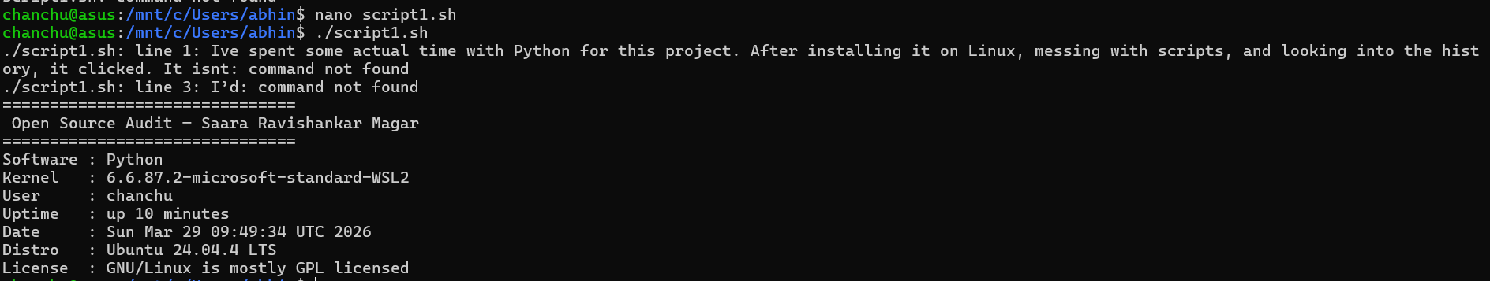

Script 2 — FOSS Package Inspector (Unit 2)
Write a script that checks whether your chosen software is installed on the system, finds its version, and uses a case statement to print a short description of its purpose based on the package name.

Concepts to use: if-then-else, case statement, rpm -qi or dpkg -l, pipe with grep.

Starter structure
#!/bin/bash
# Script 2: FOSS Package Inspector
PACKAGE="" # e.g. httpd, mysql, vlc, firefox # Check if package is installed
if rpm -q $PACKAGE &>/dev/null; then echo "$PACKAGE is installed."
rpm -qi $PACKAGE | grep -E 'Version|License|Summary' else
echo "$PACKAGE is NOT installed."
fi

# TODO: Add a case statement that prints a one-line
# philosophy note about the package based on its name case $PACKAGE in
httpd) echo "Apache: the web server that built the open internet" ;; mysql) echo "MySQL: open source at the heart of millions of apps" ;; # TODO: Add your software and 3 others
esac
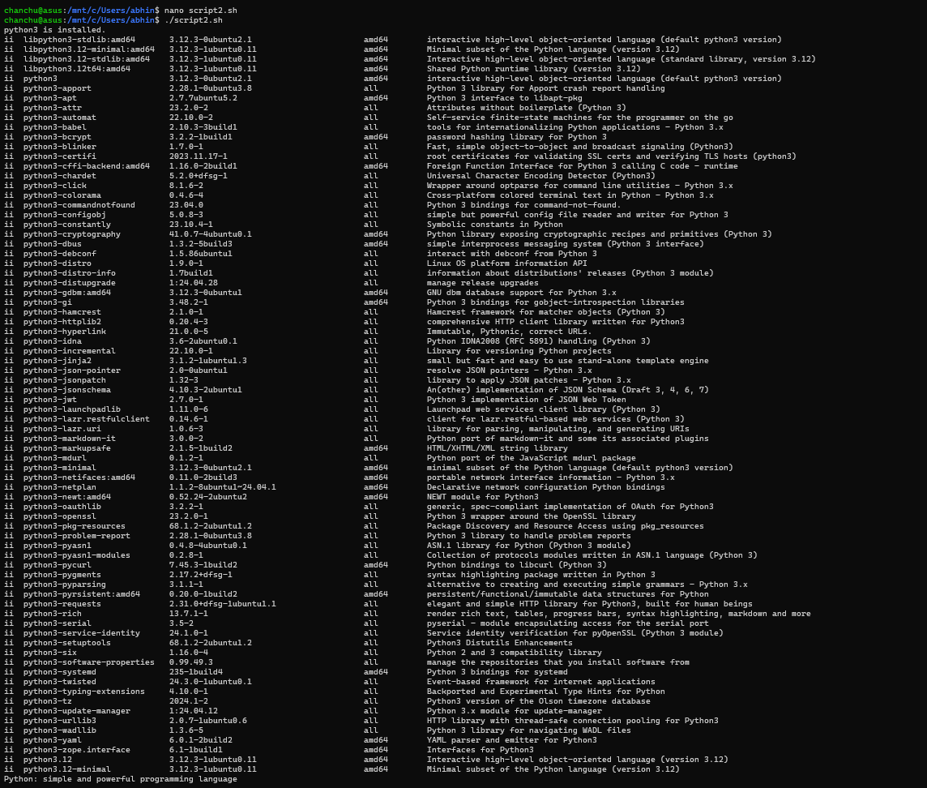

Script 3 — Disk and Permission Auditor (Unit 2)
Write a script that loops through a list of important system directories and reports: how much space each uses, and the owner and permissions of the directory. Use a for loop.

Concepts to use: for loop, df, ls -ld, awk or cut to extract fields.

Starte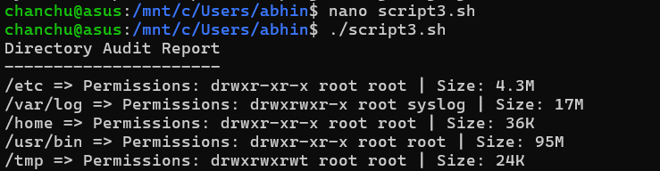r structure
#!/bin/bash
# Script 3: Disk and Permission Auditor DIRS=("/etc" "/var/log" "/home" "/usr/bin" "/tmp")
echo "Directory Audit Report" echo " "

for DIR in "${DIRS[@]}"; do
if [ -d "$DIR" ]; then
PERMS=$(ls -ld $DIR | awk '{print $1, $3, $4}') SIZE=$(du -sh $DIR 2>/dev/null | cut -f1)
echo "$DIR => Permissions: $PERMS | Size: $SIZE" else

echo "$DIR does not exist on this system"
fi done

# TODO: Add a section that checks if your software's # config directory exists and prints its permissions

Script 4 — Log File Analyzer (Units 2 & 5)
Write a script that reads a log file line by line, counts how many lines contain a keyword (like ERROR or WARNING), and prints a summary. Use a while-read loop and an if-then inside it.

Concepts to use: while read loop, if-then, counter variables, command-line arguments ($1).

Starter structure
#!/bin/bash
# Script 4: Log File Analyzer
# Usage: ./log_analyzer.sh /var/log/messages
LOGFILE=$1 KEYWORD=${2:-"error"}
COUNT=0
# Default keyword is 'error'
if [ ! -f "$LOGFILE" ]; then
echo "Error: File $LOGFILE not found." exit 1
fi

while IFS= read -r LINE; do
if echo "$LINE" | grep -iq "$KEYWORD"; then COUNT=$((COUNT + 1))
fi
done < "$LOGFILE"

echo "Keyword '$KEYWORD' found $COUNT times in $LOGFILE"

# TODO: Add a do-while style retry if the file is empty, # and print the last 5 matching lines using tail + grep
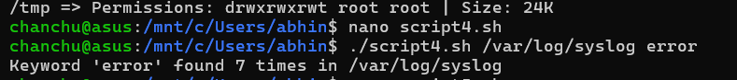

Script 5 — The Open Source Manifesto Generator (Unit 5)
This is the most creative script. Write a script that generates a personalised open source philosophy statement by asking the user three questions interactively, then composing a short paragraph using their answers and saving it to a .txt file.

Concepts to use: read for user input, string concatenation, writing to a file with >, date command, aliases concept demonstrated via a comment.

Start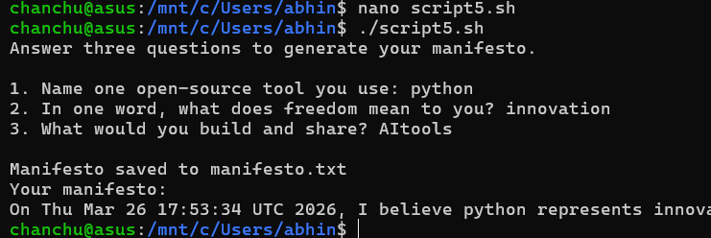er structure
#!/bin/bash
# Script 5: Open Source Manifesto Generator

echo "Answer three questions to generate your manifesto." echo ""

read -p "1. Name one open-source tool you use every day: " TOOL read -p "2. In one word, what does 'freedom' mean to you? " FREEDOM
read -p "3. Name one thing you would build and share freely: " BUILD

DATE=$(date '+%d %B %Y')
OUTPUT="manifesto_$(whoami).txt"

# TODO: Compose a paragraph using $TOOL, $FREEDOM, $BUILD # and write it to $OUTPUT using echo and >>

echo "Manifesto saved to $OUTPUT" cat $OUTPUT

Project Timeline

This timeline is a guide, not a rigid rule. Some students will move faster on the technical parts; others will spend more time on the philosophical sections. Adjust based on your strengths — but do not leave the scripts to the final stretch.

Day | Focus | Tasks | Deliverable
1 | Setup | Choose software. Research its origin story. Read the license text. Set up your Linux environment (VM or lab system). Install your chosen software. | Choice confirmed
2 | Philosophy | Write Part A1 — the origin story. Take notes on what problem the software solved and for whom. | Draft A1
3 | License & Ethics | Write Part A2 — license analysis. Write Part A3  — ethical reflection. These sections need your own thinking, not summaries. | Draft A2 + A3
4 | Linux Footprint | Install software on Linux. Document directories, user, permissions. Write Part B. | Draft Part B + screenshots
5 | Scripts 1 & 2 | Write and test Script 1 (System Identity) and Script 2 (Package Inspector). Add them to your report with explanations. | Scripts 1–2 working
6 | Scripts 3 & 4 | Write and test Script 3 (Disk Auditor) and Script 4 (Log Analyzer). Test with a real log file. | Scripts 3–4 working
7 | Ecosystem | Write Part C — FOSS ecosystem map. Research dependencies and community. | Draft Part C
8 | Comparison & Script 5 | Write Part D — comparison table and verdict. Write and test Script 5 (Manifesto Generator). | Draft Part D + Script 5
9 | Report polish | Compile full report. Write introduction and conclusion. Add screenshots. Check page count (12–16 pages). | Complete draft
10 | Submission | Final review. Submit report + 5 .sh files. Be ready to explain any script in a short viva if asked. | Final submission

Evaluation Rubric

Total marks: 100. The report carries 60 marks and the shell scripts carry 40 marks. There is no viva unless the evaluator suspects the work is not original — in which case any student may be called for a brief oral explanation.

Report (60 marks)

# | Component | Full marks | Passing (50%) | Notes
1 | Origin story — depth, original research, storytelling | 12 | 6 | Part A1
2 | License analysis — accuracy and understanding of freedoms | 12 | 6 | Part A2
3 | Ethical reflection — quality of argument and original thinking | 10 | 5 | Part A3
4 | Linux footprint — technical accuracy and screenshots | 10 | 5 | Part B
5 | Ecosystem and LAMP connection | 8 | 4 | Part C
6 | Open source vs proprietary comparison | 8 | 4 | Part D

Shell Scripts (40 marks — 8 marks each)
Each script is marked on three criteria:

Criterion | Marks | What we look for
Correctness — does it run without errors? | 4 | Script executes on Linux and produces expected output
Concepts — does it use the right shell constructs? | 2 | Loops, if-then, case, variables used appropriately for the task
Comments and documentation | 2 | Every non-obvious line has a comment; script purpose is clear

Academi c integrity | All written sections must be in your own words. Code that is copy-pasted from the internet without understanding will be zero-marked. Running a script and explaining what it does in a conversation is considered a passing demonstration of understanding.

Reference Resources

Use these as starting points, not as sources to copy from. The report must be in your own words.

On open source philosophy
  - GNU Project — 'The Free Software Definition': gnu.org/philosophy/free-sw.html
  - Open Source Initiative — 'The Open Source Definition': opensource.org/osd
  - Eric S. Raymond — 'The Cathedral and the Bazaar': catb.org/~esr/writings/cathedral-bazaar
  - Linus Torvalds — 'Just for Fun' (autobiography, available at most libraries)

On Linux and shell scripting
  - The Linux Command Line by William Shotts — freely available at linuxcommand.org
  - GNU Bash Manual: gnu.org/software/bash/manual
  - Linux man pages: man.cx (online) or type 'man <command>' in your terminal

For finding license texts
  - SPDX License List: spdx.org/licenses
  - Choose a License: choosealicense.com
  - Your software's official repository on GitHub or GitLab — the LICENSE file is always there

A closing thought
Every tool you will use in your career — the editor, the compiler, the server, the database — was shaped by people who chose to build in the open and share their work freely. Understanding why they made that choice, and what it means for the world, is not a footnote to your technical education. It is the foundation of it.

Submission Requirements

All submissions are made through the VITyarthi portal. You must submit three things: a public GitHub repository link, a README.md inside the repository, and a project report PDF. All three are compulsory. Incomplete submissions will not be evaluated.

What to submit on the VITyarthi portal

Item | Details | Compulsory?
GitHub repo link | The repository must be public. It must contain all five .sh script files and a README.md. Name the repo:  oss-audit-[rollnumber] | Yes
README.md | Must be inside the GitHub repository. Must include: student name and roll number, chosen software, description of each script, step-by-step instructions to run each script on Linux, and any dependencies required. | Yes

Project report PDF | Upload directly on the VITyarthi portal. Must follow the structure in Section 3. Must be 12 to 16 pages. Must be your own writing. | Yes
On the VITyarthi portal submission form, paste the GitHub repository URL, confirm the README is present in the repository, and upload the project report PDF. All three must be submitted together in a single submission — partial submissions will not be accepted.

Evaluation pipeline
Every submission goes through an automated evaluation pipeline before it reaches an evaluator. Be aware of the following checks that run on every submitted report and script set.

Check | What it detects | Consequence
Plagiarism detection | Report text copied from websites, Wikipedia, other students’ submissions, or any published source without attribution. Cross-submission similarity between enrolled students is also flagged. | Zero on the full report. Referred to disciplinary committee if similarity exceeds 40%.
AI generation detection | Report sections generated by AI tools such as ChatGPT, Gemini, Claude, or similar. The pipeline checks for linguistic patterns, sentence uniformity, and structural signatures common to AI-generated text. | Flagged submissions are called for a mandatory viva. If the student cannot explain the content, zero marks are awarded.
A note on AI tools: you may use AI to understand concepts, debug scripts, or get explanations. You may not use AI to write your report. The distinction is the same as using a calculator versus asking someone else to sit your exam. The report must reflect your thinking, your words, and your conclusions.

