**Evaluation of the Effectiveness of Placement Cell Offered by Clg XYZ**

***Sampling Techniques***

**Submitted By,**

**SAARA**

| **S No.** | **Topic** | **Pg No.** |
| --- | --- | --- |
| **1** | **Introduction** | **3** |
| **2** | **Objective of the Study** | **4** |
| **3** | **Methodology** | **5** |
| **4** | **Data Analysis** | **6-9** |
| **5** | **Results** | **10** |
| **6** | **Conclusion** | **10** |

**Introduction**

The placement cell at XYZ is a vital resource for final year students, offering crucial assistance as they make the shift from college to working life. This evaluation aims to evaluate the effectiveness and satisfaction levels among final year students with regard to the placements offered by the placement cell.

By planning various events to improve students' employability and connect them with job opportunities, the placement cell serves as a point of contact between students and potential employers. Assisting with networking events with people from the business, organizing recruitment campaigns, and holding job fairs are all included in this. In order to better prepare students for the job market, the placement cell also provides career counseling and interview preparation sessions.

Understanding final year students' satisfaction levels is essential to assessing the placement cell's efficacy. It is possible to conduct surveys and feedback sessions to find out what the students think about the placement cell's help during the recruiting process, the quality of placements, and the relevance of job possibilities to their subject of study.

Furthermore, it is crucial that the placement cell be accommodating to the needs and interests of the students. In order to fully understand students' preferred employment responsibilities, industry interests, and career aspirations, it should actively engage with them. Student satisfaction can be greatly increased by customizing placement strategies to each student's needs.

The placement success rate is an additional component of evaluation. This involves tracking the number of students placed, the companies they join, and the salary packages offered. Furthermore, evaluations from students who have been placed might offer valuable perspectives on their overall experience and the efficiency of the placement procedure.

The satisfaction levels, responsiveness to students' needs and placement success rates are all factors that are taken into consideration while analyzing the efficacy of placement cell for final year students.

**OBJECTIVE OF THE STUDY**

The objective of this study is to assess the satisfaction levels of final year students with the placement cell services provided by XYZ University , considering their respective departments. We aim to analyze the effectiveness of the placement cell's services in meeting the career needs of students across various departments, identifying any discrepancies or areas for improvement.

**Problem Statement:**

We aim to evaluate Xyz University placement cell, assessing final year students' satisfaction across departments.

The objectives we aim to achieve:

* Assess the overall satisfaction of final year students with the placement support services provided by XYZ.
* Determine the satisfaction levels with the quality and relevance of job/internship opportunities provided by the placement support services.
* Evaluate the satisfaction levels with the interview preparation assistance provided by the placement support services.
* Determine the extent of students' engagement with mock interviews or interview preparation sessions provided by the placement support services.
* Determine if the placement support services offer networking opportunities or events that facilitate interactions with potential employers.

**Methodology**

**Data Collection Method**

Data for this study was collected through Google Forms, containing various evaluation questions to gauge placement cell satisfaction. Responses were collected using an ordinal scale, allowing participants to rate their satisfaction levels.

**Sampling Technique**

Stratified random sampling was employed for sampling. This technique involved dividing the population into different strata based on departmental divisions. The proportionate stratified random sample will be obtained using this formula: (sample size/population size) × stratum size. The number of samples to be taken from each department was determined as follows:

Department of Data Science: 64 samples

School of Law: 9 samples

Department of Business Administration (UG): 67 samples

Department of Business Administration (PG): 22 samples

Department of Commerce and Finance: 38 samples

**Computer Random Number Generation Method**

In this study, participant selection was conducted using the Computer Random Number Generation method, where each student's registration number served as the basis for generating random numbers. However, due to non-response bias from the selected individuals, the form was circulated randomly to mitigate this issue.

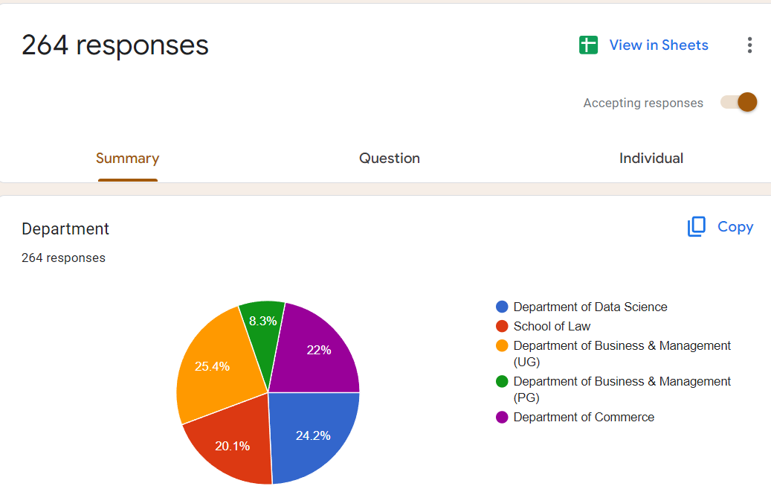

**Tools and Techniques for Analysis**

The primary tool for analysis in this study was Python, a programming language commonly used for data analysis and manipulation. Python offers various **libraries** and functionalities that facilitate data analysis, making it an ideal choice for this research.

**Data Analysis**

1. **Calculating average satisfaction for each department**

We conducted an ANOVA test to evaluate the average satisfaction levels of final year students across different departments with the placement cell services at XYZ . We considered the following hypotheses:

* Null Hypothesis (H0): The average satisfaction across all departments with the Placement Cell is equal.
* Alternative Hypothesis (H1): The average satisfaction across all departments with the Placement Cell is not equal.

**The ANOVA test results:**

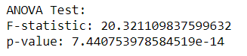

The F-statistic of 20.32 indicates a substantial difference between the mean satisfaction scores of the departments. The very small p-value (7.440753978584519e-14) suggests that the observed differences in satisfaction scores between departments are highly unlikely to be due to random chance alone.

**Further Analysis**

* Department of Business & Management (PG):

- Satisfaction Score: 1.18 out of 5

- While students in this department express some level of satisfaction, there may be room for improvement in the services provided by the Placement Cell.

* Department of Business & Management (UG):

- Satisfaction Score: 1.56 out of 5

- Students in this department show relatively higher satisfaction compared to others. However, further enhancements could still be considered.

* Department of Commerce:

- Satisfaction Score: 1.46 out of 5

- Similar to the UG Business & Management department, students in Commerce also indicate moderate satisfaction levels.

* Department of Data Science:

- Satisfaction Score: 1.06 out of 5

-Students studying data science had a lower satisfaction rating, which suggests that the Placement Cell's services may not be optimal for their career goals.

* School of Law:

- Satisfaction Score: 0.80 out of 5

- Law students exhibit the lowest satisfaction levels among all departments. This indicates a significant gap between the services provided by the Placement Cell and the career expectations of law students.

Overall, the final year students express dissatisfaction with the placement cell, as the satisfactory level falls below 2 out of 5 across departments. The placement cell can do a better job in understanding and meeting the specific needs of each department.

### **Calculating the Overall Average satisfaction of the Students in the Interview Training Programme held by the Placements Cells**

**Hypotheses:**

* Null Hypothesis (H0): All departments are equally satisfied with Interview Training Programmes.
* Alternative Hypothesis (H1): All departments are not equally satisfied with Interview Training Programmes.

**Data Overview:**

* Department of Business & Management (PG): 1.652
* Department of Business & Management (UG): 2.334
* Department of Commerce: 1.471
* Department of Data Science: 1.409
* School of Law: 1.206

**ANOVA Test Results:**

* F-statistic: 33.947
* p-value: 3.739e-21

**Interpretation:**

The F-statistic measures the ratio of variation between group means to the variation within the groups. The obtained F-statistic of 33.947 is significant (p < 0.001), suggesting substantial differences among departmental satisfaction scores.

**Inferences:**

1. Overall Dissatisfaction: The majority of departments express dissatisfaction with the Interview Training Programmes, evident from the low satisfaction scores.
2. Potential Causes: It's possible that the Interview Training Programmes were not held or were insufficient in addressing students' needs.
3. Actionable Insights: Determine if Interview Training Programmes were indeed conducted in all departments.

**3. GRAPHICAL ANALYSIS**

1. **Composite Satisfaction Score by Department**

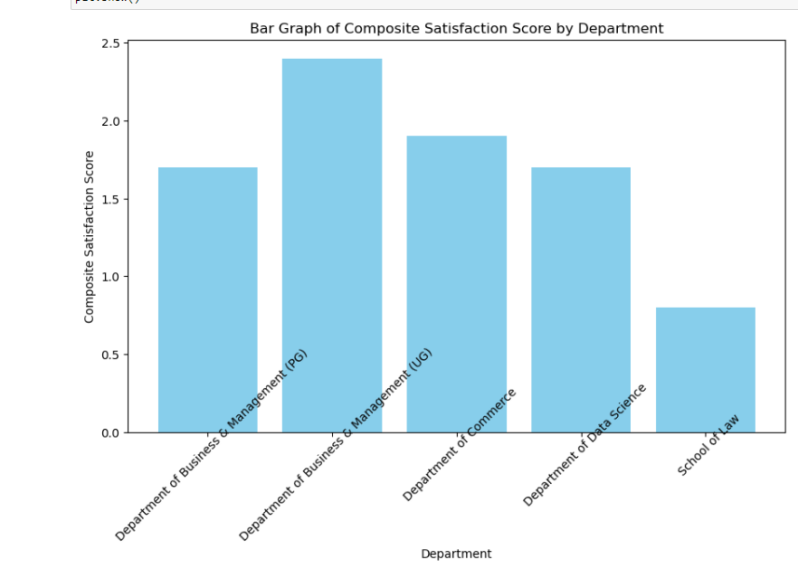

This graph illustrates the satisfaction levels of students across all departments. School of Law exhibits the lowest satisfaction, while Business and Management (UG) shows comparatively higher satisfaction at 2.4. However, all departments score below 2.5 out of 5, indicating significant dissatisfaction among students. The majority of students are unsatisfied with the services provided by the placement cell.

1. **Specialized Resources Offered**

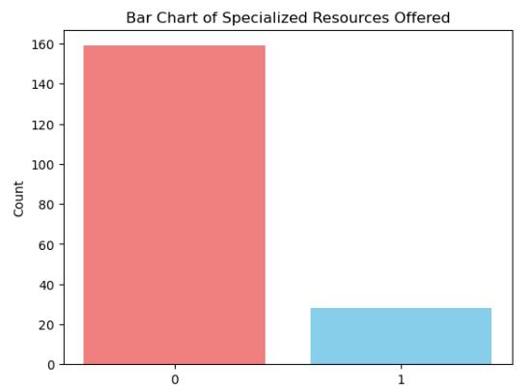

According to the count, 93 respondents answered 'No' (indicating that the placement support services did not offer specialized interview preparation resources), while 21 respondents answered 'Yes' (indicating that the services did offer such resources).

Room for Improvement: Despite the majority of respondents indicating that specialized resources were not offered, there is still a notable count of 'Yes' responses (21). This suggests that there may be room for improvement in the services provided by the placement support team. Identifying areas where additional resources or support are needed could lead to better satisfaction among students.

**Results**

The overall analysis reveals that final year students are dissatisfied with the placement services provided by Placement cell. Across all departments, satisfaction scores are below 2.5 out of 5, indicating a significant level of dissatisfaction. The School of Law exhibits the lowest satisfaction, while Business and Management (UG) shows relatively higher satisfaction.

The ANOVA test indicates a significant difference in satisfaction scores among the departments (F-statistic: 20.32, p < 0.001), suggesting that the observed variations are **not due to random chance** alone.

Furthermore, the examination of specialized resources for interview preparation reveals that, despite the majority of respondents' claims that these resources were unavailable, a sizable percentage of responses indicated "Yes." This shows that there can be space for improvement in the placement support team's services, especially when it comes to providing resources that are specifically designed to address the varied requirements of students.

**Conclusion**

In conclusion, our study evaluated the satisfaction levels of final year students with the placement cell services at XYZ, focusing on departmental variations. We were able to obtain insights into students' experiences by utilizing Python to analyze data that was gathered via Google Forms. The stratified random sampling technique ensured a representative sample from each department. The necessity for specialized placement cell services was highlighted by our findings, which showed low and inconsistent satisfaction ratings across departments. Understanding these differences will help the institution improve the efficiency of its placement cell, which will eventually better prepare students for fulfilling employment in their fields of study.