**ARRAY – IMPORTANT PROBLEM**

**Problem 1:**

Given an unsorted array A of size N of non-negative integers, find a continuous subarray which adds to a given number S.

**Constraints:**

1 <= N <= 105

0 <= Ai <= 1010

**Example:**

Input: N = 5, S = 12

A[] = {1,2,3,7,5}

**Output:** 2 4

**Explanation:** The sum of elements from 2nd position to 4th position is 12.

_______________________________________________________________________________________

**Problem 2:**

Find the smallest positive missing number in the given array.

**Example:**

[0, -10, 1, 3, -20], Ans = 2

_______________________________________________________________________________________

***The following Problem in Leetcode website:***

**Problem 3:**

Remove Duplicates from Sorted Array

**Example:**

**Input:** nums = [1,1,2]

**Output:** 2, nums = [1,2,_]

**Explanation:** Your function should return k = 2, with the first two elements of nums being 1 and 2 respectively.

It does not matter what you leave beyond the returned k (hence they are underscores).

<https://leetcode.com/problems/remove-duplicates-from-sorted-array/>

_______________________________________________________________________________________

**Problem 4:**

Given an array, rotate the array to the right by k steps, where k is non-negative.

**Example :**

**Input:** nums = [1,2,3,4,5,6,7], k = 3

**Output:** [5,6,7,1,2,3,4]

**Explanation:**

rotate 1 steps to the right: [7,1,2,3,4,5,6]

rotate 2 steps to the right: [6,7,1,2,3,4,5]

rotate 3 steps to the right: [5,6,7,1,2,3,4]

<https://leetcode.com/problems/rotate-array/>

_______________________________________________________________________________________

**Problem 5:**

You are given an n x n 2D matrix representing an image, rotate the image by **90** degrees (clockwise).

You have to rotate the image [**in-place**](https://en.wikipedia.org/wiki/In-place_algorithm), which means you have to modify the input 2D matrix directly. **DO NOT** allocate another 2D matrix and do the rotation.

**Example 1:**

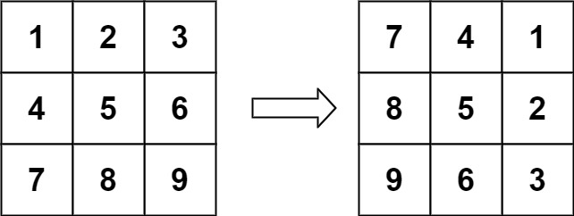

**Input:** matrix = [[1,2,3],[4,5,6],[7,8,9]]

**Output:** [[7,4,1],[8,5,2],[9,6,3]]

<https://leetcode.com/problems/rotate-image/>

_______________________________________________________________________________________

**Problem 6:**

Find the frequency of a number in an array

Given an array, a[], and an element x, find a number of occurrences of x in a[].  
**Examples:**

Input : a[] = {0, 5, 5, 5, 4}

x = 5

Output : 3

Input : a[] = {1, 2, 3}

x = 4

Output : 0

_______________________________________________________________________________________

**Problem 7:**

Given a **non-empty** array of integers nums, every element appears twice except for one. Find that single one.You must implement a solution with a linear runtime complexity and use only constant extra space.

**Examples:**

**Input:** nums = [2,2,1]

**Output:** 1

**Input:** nums = [4,1,2,1,2]

**Output:** 4

_______________________________________________________________________________________

**Problem 8:**

Intersection of Two Arrays II

**Example**

**Input:** nums1 = [4,9,5], nums2 = [9,4,9,8,4]

**Output:** [4,9]

**Explanation:** [9,4] is also accepted.

**ALL THE BEST 😊**