National Testing Agency
B.Tech | 2nd April 2026 | Shift 1
Duration: 180 min | Total Marks: 300

MATHEMATICS

Section A — MCQ (20 Questions × 4 Marks each)
Q1. Let α, α+2, α∈Z, be the roots of the quadratic equation x(x+2) + (x+1)(x+3) + (x+2)(x+4) + … + (x+n−1)(x+n+1) = 4n, for some n∈N. Then n+α is equal to:
(A) 0 (B) 1 (C) 2 (D) 3
Q2. Let x and y be real numbers such that 50(2x/(1+3i) − y/(1−2i)) = 31+17i, i = √−1. Then the value of 10(x−3y) is:
(A) 20 (B) 31 (C) 35 (D) 75
Q3. Let α, β ∈ R be such that the system of linear equations has no solution:
x + 2y + z = 5
2x + y + αz = 5
8x + 4y + βz = 18
Then β/α is equal to:
(A) −4 (B) 4 (C) 8 (D) −8
Q4. Let A = [[1,2],[1,α]] and B = [[3,3],[β,2]]. If A²−4A+I = O and B²−5B−6I = O, then among the two statements:
(S1): [(B−A)(B+A)]ᵀ = [[13, 15],[7, 10]]
(S2): det(adj(A+B)) = −5
(A) Only (S1) is correct (B) Only (S2) is correct
(C) Both (S1) and (S2) are correct (D) Both (S1) and (S2) are wrong
Q5. Let A be the set of first 101 terms of an A.P. with first term 1 and common difference 5, and B be the set of first 71 terms of an A.P. with first term 9 and common difference 7. Then the number of elements in A∩B divisible by 3 is:
(A) 4 (B) 5 (C) 6 (D) 7
Q6. The number of seven-digit numbers that can be formed using the digits 1, 2, 3, 5 and 7 such that each digit is used at least once, is:
(A) 15400 (B) 17800 (C) 16800 (D) 29400
Q7. The number of elements in the set S = {(r, k) : k∈Z and ³⁶C_{r+1} = 6(³⁵C_r)/(k²−3)}, is:
(A) 2 (B) 4 (C) 8 (D) 16
Q8. If the mean of the data below is 21, then k is one of the roots of the equation:
Class | 5–10 | 10–15 | 15–20 | 20–25 | 25–30 | 30–35
Frequency | 2 | k | 28 | 54 | k+1 | 5

(A) 2x²−23x−10 = 0 (B) 4x²−35x+24 = 0
(C) 2x²−19x−10 = 0 (D) 2x²−35x+98 = 0
Q9. Let the midpoints of the sides of triangle ABC be (5/2, 7), (5/2, 3) and (4, 5). If its incentre is (h, k), then 3h+k is equal to:
(A) 11 (B) 12 (C) 13 (D) 14
Q10. Let an ellipse x²/a² + y²/b² = 1, a < b, pass through (4, 3) and have eccentricity √5/3. Then the length of its latus rectum is:
(A) 4√5/3 (B) 2√5 (C) 7√5/3 (D) 8√5/3
Q11. If sin(π/18) · sin(5π/18) · sin(7π/18) = K, then the value of sin(10Kπ/3) is:
(A) (√3+1)/(2√2) (B) (√3−1)/√2 (C) √3/2 (D) 1/2
Q12. Let S = {x∈[−π, π] : sinx (sinx + cosx) = a, a∈Z}. Then n(S) is equal to:
(A) 3 (B) 6 (C) 7 (D) 9
Q13. If the point of intersection of the lines (x+1)/3 = (y+a)/5 = (z+b+1)/7 and (x−2)/1 = (y−b)/4 = (z−2a)/7 lies on the xy-plane, then the value of a+b is:
(A) 2 (B) 5 (C) 7 (D) 9
Q14. If vectors a⃗ and b⃗ satisfy |a⃗| = 2 and |b⃗| = 3, then the maximum value of 3|3a⃗+2b⃗| + 4|3a⃗−2b⃗| is:
(A) 30 (B) 36 (C) 60 (D) 72
Q15. Let a line L passing through (1,1,1) be perpendicular to both 2î+2ĵ+k̂ and î+2ĵ+2k̂. If P(a,b,c) is the foot of perpendicular from origin on L, then 34(a+b+c) is:
(A) 50 (B) 80 (C) 100 (D) 120
Q16. If lim_{x→2} [sin(x³−5x²+ax+b) / ((√(x−1)−1)·log_e(x−1))] = m, then a+b+m equals:
(A) 5 (B) 6 (C) 8 (D) 10
Q17. If curve y = f(x) passes through (1, e) and satisfies dy = y(2+log_e x)dx, x > 0, then f(e) is:
(A) eᵉ (B) e^(e²) (C) e^(2e) (D) e^(2e)
Q18. The number of critical points of f(x) = |sinx|/x (x≠0), f(0) = 1, in (−2π, 2π) is:
(A) 1 (B) 3 (C) 5 (D) 7
Q19. Let [·] denote the greatest integer function. Then the value of ∫₀³ ((eˣ+e⁻ˣ)/[x]!) dx is:
(A) e²+e³−1/e²−1/e³
(B) (1/2)(e²+e³−1/e²−1/e³)
(C) e²+e³−1/(2e²)−1/(2e³)
(D) (1/2)(e²+e³)−1/e²−1/e³
Q20. Let y = y(x) satisfy (1+sinx)dy/dx + (y+1)cosx = 0, y(0) = 0. If the curve passes through (α, −1/2), then a value of α is:
(A) π/6 (B) π/4 (C) π/3 (D) π/2

Section B — Numerical Answer Type (5 Questions × 4 Marks each)
Write the exact numerical answer in the blank. No options provided.
Q21. If the domain of f(x) = √(log₀.₆(|2x−5|/|x²−4|)) is (−∞,a]∪{b}∪[c,d)∪(e,∞), then a+b+c+d+e = ________.
Q22. If Σₖ₌₁ⁿ aₖ = 6n³, then Σₖ₌₁⁶ ((a_{k+1}−aₖ)/36)² = ________.
Q23. Let a,b,c ∈ {1,2,3,4}. If probability that ax²+2√2·bx+c > 0 for all x∈R is m/n with gcd(m,n)=1, then m+n = ________.
Q24. A circle C has its centre in the first quadrant, intersects coordinate axes at exactly three points, and cuts equal intercepts. If chord length on x+y=1 is √14, then square of radius of C = ________.
Q25. If α = ∫₀^(2√3) log₂(x²+4)dx + ∫₂⁴ √(2ˣ−4)dx, then α² = ________.

PHYSICS

Section A — MCQ (20 Questions × 4 Marks each)
Q26. The dimensional formula of (1/2)ε₀E² (ε₀ = permittivity of vacuum, E = electric field) is MᵃLᵇTᶜ. The value of 2a−b+c is:
(A) 0 (B) 1 (C) −1 (D) 2
Q27. A wire's diameter measured by screw gauge (LC = 0.001 cm) is 0.08 cm. Length by scale (LC = 0.1 cm) is 150 cm. Extension under 100 N by micrometer (LC = 0.001 cm) is 0.5 cm. Error in Young's modulus is α×10⁹ N/m². Value of α is: (Ignore load contribution)
(A) 1.3 (B) 1.65 (C) 0.13 (D) 0.25
Q28. Velocity of a particle: v⃗ = −xî + 2yĵ − zk̂ m/s. Magnitude of acceleration at point (1, 2, 4) is ________ m/s².
(A) √6 (B) 9 (C) √33 (D) 0
Q29. Position of object (mass 0.1 kg): r⃗ = (10t²î + 5t³ĵ) m. At t = 1 s, which statements are correct?
A. Linear momentum p⃗ = (2î + 1.5ĵ) kg·m/s
B. Force F⃗ = (2î + 3ĵ) N
C. Angular momentum about origin L⃗ = 15k̂ J·s
D. Torque about origin τ⃗ = 20k̂ N·m
(A) A, B and C only (B) B, C and D only
(C) A, C and D only (D) A, B and D only
Q30. Planet P₁ orbits star of mass 2M at radius R. Planet P₂ orbits star of mass 4M at radius 2R. Ratio of time periods T_{P₂}/T_{P₁} is:
(A) 1/2 (B) 2 (C) 4 (D) 1/4
Q31. A particle rotates in a circular path: θ = 5t⁴/40 − t³/3. Angular acceleration after 10 seconds is ________ rad/s².
(A) 150 (B) 120 (C) 130 (D) 170
Q32. A parallel plate air capacitor has capacitance C. When half-filled with dielectric (K = 5) as shown below, the percentage increase in capacitance is:
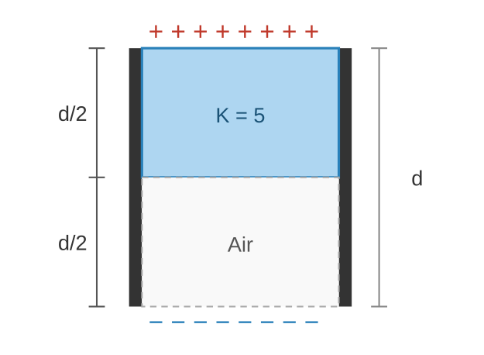
(A) 33.34% (B) 66.67% (C) 200% (D) 400%
Q33. Heat is supplied to a diatomic gas at constant pressure. The ratio ΔQ : ΔU : ΔW is:
(A) 2:3:5 (B) 5:3:2 (C) 2:5:7 (D) 7:5:2
Q34. Two charged conducting spheres S₁ (r=8 cm) and S₂ (r=18 cm) are connected by a wire. After equilibrium, the ratio E_{S1}/E_{S2} is:
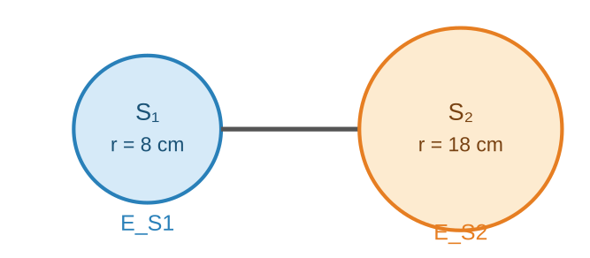
(A) 3/2 (B) 2/3 (C) 4/9 (D) 9/4
Q35. Equation of a plane progressive wave: y = 5cosπ(200t − x/150), where x and y are in cm and t in seconds. Velocity of the wave is ________ m/s.
(A) 120 (B) 150 (C) 200 (D) 300
Q36. Two short electric dipoles A (p₁, horizontal) and B (p₂, vertical) are placed with axes mutually perpendicular as shown. The resultant electric field at point x makes 60° with line OX. The ratio p₂/p₁ is:
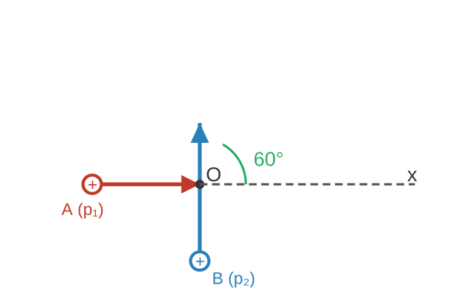
(A) √3/2 (B) 2√3 (C) 1/√3 (D) √3
Q37. For the given circuit (A), the input v_{in}(t) and output v_o(t) are shown in parts (B) and (C) respectively. Identify the components between points X and Y.
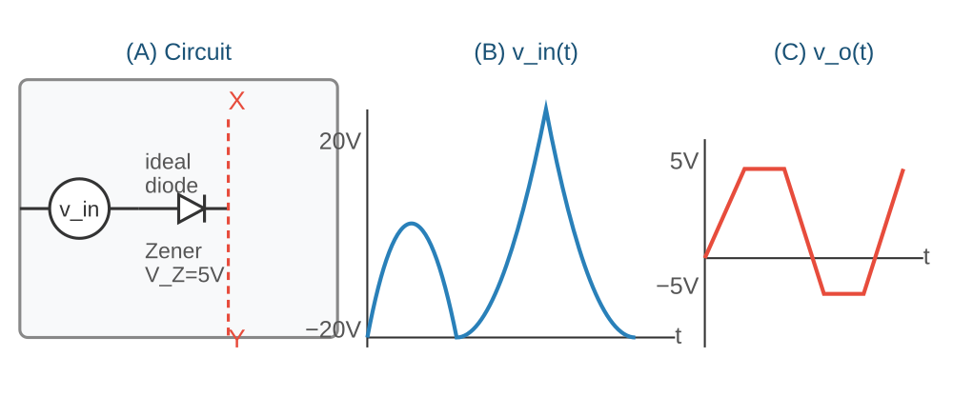
(A) X—resistor—ideal diode—Y (B) X—ideal diode—Zener diode—Y
(C) X—resistor—Zener diode—Y (D) X—ideal diode—ideal diode—Y
Q38. A coil (turns N, area A, wire radius r) dissipates power P in a time-varying B. A second coil has turns 2N, area 2A, wire radius 3r. Power dissipated by second coil is √2·αP. The value of α is:
(A) 36 (B) 128√2 (C) 16 (D) 64
Q39. Two identical long current-carrying wires are bent as shown in figures (I) and (II). Magnetic fields at centres P and Q of the semicircular arcs are B₁ and B₂. The ratio B₁/B₂ is:
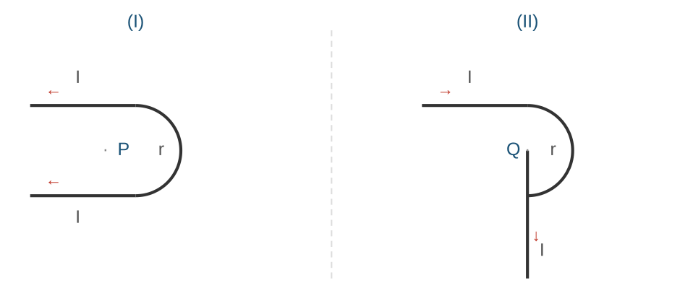
(A) (2+π)/(1+π) (B) (1+π)/(1−π)
(C) (2+π)/(1−π) (D) (1+π)/(2−π)
Q40. For a thin symmetric prism (refractive index 1.5), the ratio of incident angle to minimum deviation angle will be:
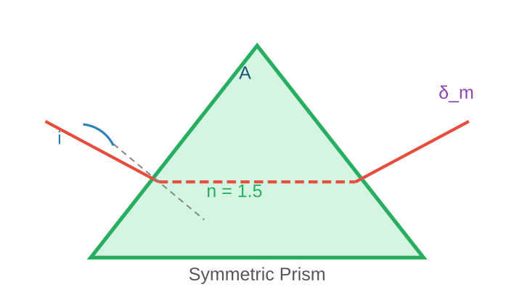
(A) 3:4 (B) 3:2 (C) 2:1 (D) 1:2
Q41. Refer to the figure: μ₁=1 (air), μ₂=1.54 (lens), object height = 2 cm, object at 40 cm from surface P, lens centre C at 20 cm from object. Height of image will be ________ cm.
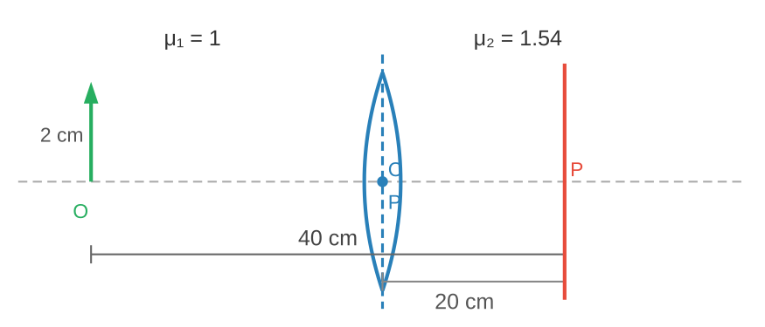
(A) 1 (B) 0.5 (C) 1.2 (D) 0.25
Q42. For a metal, monochromatic light of wavelength λ gives stopping potential 3V₀. Same metal with wavelength 2λ gives stopping potential V₀. Threshold wavelength = αλ. Value of α is:
(A) 1 (B) 4 (C) 2 (D) 3
Q43. EM wave in x-direction: E_y = 300sinω(t−x/c). Electron restricted to y-direction at speed 1.5×10⁶ m/s. Ratio of max electric force to max magnetic force on electron is:
(A) 200 (B) 150 (C) 400 (D) 300
Q44. Angular momentum of electron in H-atom is 3h/π. Energy of the electron is ________ eV.
(A) −1.51 (B) −0.85 (C) −0.38 (D) −0.28
Q45. A liquid drop (diameter 2 mm) breaks into 512 droplets. Change in surface energy = α×10⁻⁶ J. (Surface tension = 0.08 N/m). Value of α is:
(A) 10 (B) 7 (C) 8 (D) 11

Section B — Numerical Answer Type (5 Questions × 4 Marks each)
Write the exact numerical answer in the blank. No options provided.
Q46. Single slit diffraction: wavelength = 628 nm, slit width = 0.2 mm. Angular width of central maximum = α×10⁻² degrees. Value of α = ________.
Q47. A vessel contains 0.15 m³ of gas at 8 bar, 140°C with c_p = 3R, c_v = 2R. Expands adiabatically to 1 bar. Work done = ________ kJ. (R = gas constant)
Q48. A 1 μC charge moves with v⃗ = (î−2ĵ+3k̂) m/s in B⃗ = (2î+3ĵ−5k̂) T. Magnitude of force = √α×10⁻⁶ N. Value of α = ________.
Q49. Uniform wire (length l, weight w) suspended from roof with weight W at bottom. Stress at l/3 from top = (W/A + (2/γ)(w/A)). Value of γ = ________.
Q50. Wooden cube 10×10×10 cm floats in water. A coin placed on top increases the submerged depth by 3.87 cm. Mass of coin = ________ grams. (ρ_water = 1 g/cm³, ρ_wood = 0.4 g/cm³)

CHEMISTRY

Section A — MCQ (20 Questions × 4 Marks each)
Q51. The mass of iron converted into Fe₃O₄ by the action of 18 g of steam is: (Molar masses: H=1, O=16, Fe=56 g/mol; iron is in excess)
(A) 2.1 g (B) 4.2 g (C) 21 g (D) 42 g
Q52. Energy (in J atom⁻¹) required for Li²⁺(g) → Li³⁺(g) + e⁻? (IE of H in ground state = 2.18×10⁻¹⁸ J atom⁻¹)
(A) 8.72×10⁻¹⁸ (B) 1.962×10⁻¹⁸ (C) 1.962×10⁻¹⁷ (D) 6.54×10⁻¹⁷
Q53. Statement (I): Correct bond length order: O₂⁺ < O₂ < O₂⁻ < O₂²⁻. Statement (II): Correct unpaired electron order: O₂ > O₂⁺ > O₂⁻ > O₂²⁻.
(A) Both I and II true (B) Both I and II false
(C) I true, II false (D) I false, II true
Q54. Given: (i) 2Al(s)+6HCl(aq)→Al₂Cl₆(aq)+3H₂(g)+1200 kJ/mol (ii) H₂+Cl₂→2HCl(g)+164 kJ/mol (iii) HCl(g)+aq→HCl(aq)+83 kJ/mol (iv) Al₂Cl₆(s)+aq→Al₂Cl₆(aq)+663 kJ/mol. Enthalpy of formation of anhydrous solid Al₂Cl₆ is:
(A) −648 kJ/mol (B) −1350 kJ/mol (C) −2002 kJ/mol (D) −1527 kJ/mol
Q55. 19.5 g of fluoro acetic acid (M=78 g/mol) in 500 g water at 298 K shows ΔTf = 1°C. Ka of fluoro acetic acid? (Kf=1.86 K·kg/mol; molarity ≈ molality)
(A) 10⁻⁶ (B) 4×10⁻⁴ (C) 3×10⁻⁵ (D) 3×10⁻³
Q56. Ksp of Ag₂CrO₄ and AgBr are 32x and 4y respectively at 298 K. The value of (molarity Ag₂CrO₄)/(molarity AgBr) is:
(A) 2∛x/y (B) 2√(x/y) (C) √(x/y) (D) ∛x/√y
Q57. Electrochemical cell from half-reactions: Fe(OH)₂(s)+2e⁻→Fe(s)+2OH⁻(aq), E°=−0.88V and AgBr(s)+e⁻→Ag(s)+Br⁻(aq), E°=+0.07V. Which option is correct?
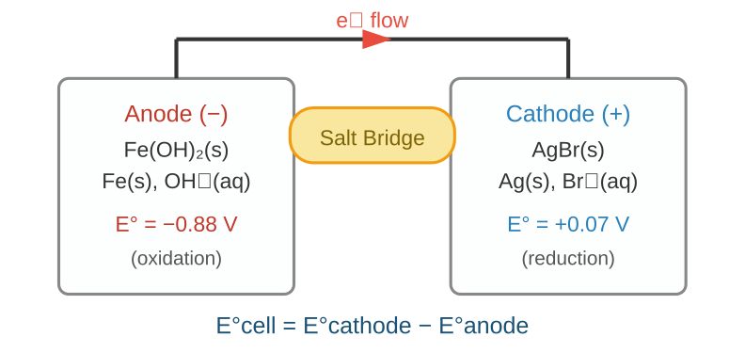
(A) Overall: Fe(s)+2OH⁻+2AgBr(s) ⇌ Fe(OH)₂(s)+2Ag(s)+2Br⁻
(B) E°cell = −0.95 V
(C) Fe is reduced in the cell
(D) E°cell is an extensive property
Q58. t₁₀₀% = time for 100% completion; t½ = time for 50% completion. Which correctly gives the t₁₀₀%–t½ relation for zero-order and first-order reactions respectively?
(A) t₁₀₀% = (t½)² and t₁₀₀% = (t½)^(−∞)
(B) t₁₀₀% = 2t½ and t₁₀₀% = (t½)^∞
(C) t₁₀₀% = 2t½ and t₁₀₀% = (2t½)²
(D) t₁₀₀% = (t½)^∞ and t₁₀₀% = 2t½
Q59. Statement (I): First IE order for Na, Mg, Cl, Ar is Na > Mg > Cl > Ar. Statement (II): Among Ca, Al, Fe and B, the 3rd IE is very high for Ca.
(A) Both I and II true (B) Both I and II false
(C) I true, II false (D) I false, II true
Q60. Statement (I): Oxidising power of halogens: F₂>Cl₂>Br₂>I₂ — basis of 'Layer test'. Statement (II): Layer test involves oxidation of Br⁻/I⁻ to Br₂/I₂ by Cl₂ (displacement redox).
(A) Both I and II true (B) Both I and II false
(C) I true, II false (D) I false, II true
Q61. Which set includes all species that change the orange colour of K₂Cr₂O₇ in acidic medium?
(A) Fe²⁺, Sn²⁺, I⁻, S²⁻
(B) S²⁻, Fe³⁺, I⁻, C₂O₄²⁻
(C) Fe²⁺, NO₂⁻, SO₂, Sn⁴⁺
(D) Fe³⁺, SO₄²⁻, S²⁻, Sn⁴⁺
Q62. Match the Chromium(III) complexes with their crystal field splitting Δ₀ (cm⁻¹): (en = ethylene diamine)
A. [Cr(CN)₆]³⁻ I. 15,060
B. [CrF₆]³⁻ II. 17,400
C. [Cr(H₂O)₆]³⁺ III. 22,300
D. [Cr(en)₃]³⁺ IV. 26,600
(A) A-I, B-II, C-III, D-IV (B) A-II, B-III, C-IV, D-I
(C) A-III, B-IV, C-I, D-II (D) A-IV, B-I, C-II, D-III
Q63. Statement (I): 1,2,3-Trihydroxypropane can be separated from water by simple distillation. Statement (II): An azeotropic mixture cannot be separated by fractional distillation.
(A) Both I and II true (B) Both I and II false
(C) I true, II false (D) I false, II true
Q64. Statement (I): Benzyl chloride reacts faster than ethyl chloride in SN1. Statement (II): Ethyl carbocation is less stabilised by hyperconjugation than benzyl carbocation by resonance.
(A) Both I and II true (B) Both I and II false
(C) I true, II false (D) I false, II true
Q65. In IUPAC nomenclature, correct decreasing priority order of functional groups is:
(A) −CONH₂, >C=O, −CHO, −NH₂, −C≡C−
(B) −CONH₂, −COOCH₃, −CHO, −NH₂, −OH
(C) −CONH₂, −CHO, >C=O, −NH₂, −C≡C−
(D) −CONH₂, −CHO, −CN, −NH₂, −C≡C−
Q66. For the molecule 'x' shown below, the preferred site for electrophilic attack is: (r, p, s, u are the labelled positions)
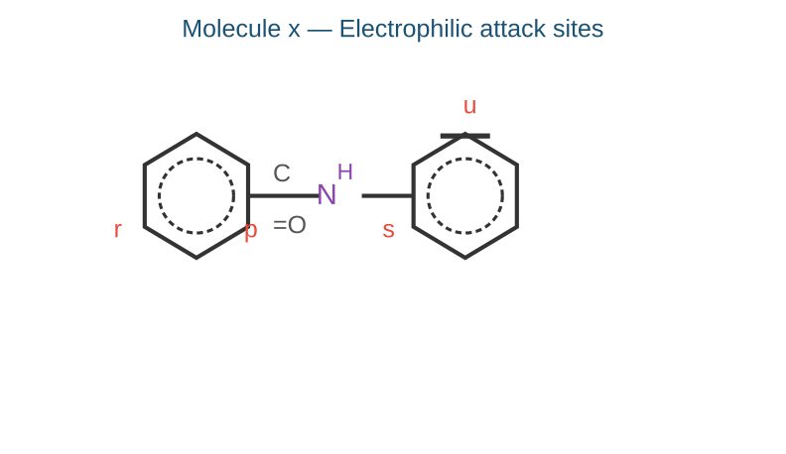
(A) Predominantly at 'r' (B) 'r' and 'u'
(C) 'p' and 's' (D) Predominantly at 'u'
Q67. Match List-I (Mixture) with List-II (Reagent to distinguish):
A. Diethylamine + Ethylamine I. Bromine water
B. Acetaldehyde + Acetone II. CHCl₃ + KOH, Δ
C. Ethanol + Phenol III. Neutral FeCl₃
D. Benzoic acid + Cinnamic acid IV. Ammoniacal silver nitrate
(A) A-IV, B-II, C-I, D-III (B) A-IV, B-II, C-III, D-I
(C) A-II, B-IV, C-I, D-III (D) A-II, B-IV, C-III, D-I
Q68. Three aromatic molecules P, Q and R are shown below. Correct order of reactivity with Ph−N≡N⁺Cl⁻ under slightly acidic medium is:
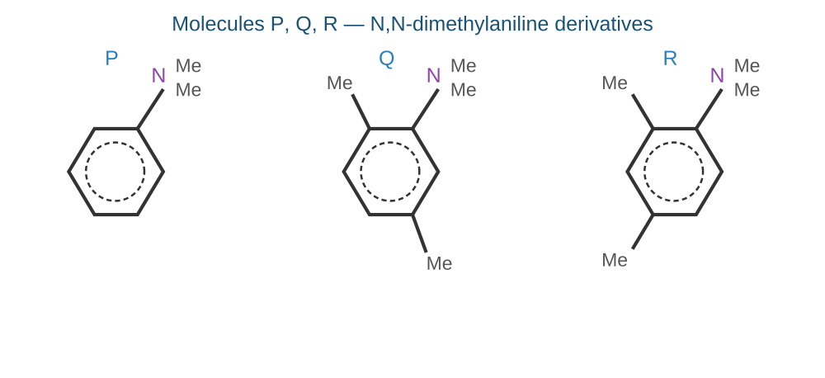
(A) P > Q > R (B) R > P > Q (C) R > Q > P (D) P > R > Q
Q69. Match List-I (Vitamins) with List-II (Names):
A. Vitamin B₁ I. Pyridoxine
B. Vitamin B₂ II. Ascorbic acid
C. Vitamin B₆ III. Thiamine
D. Vitamin C IV. Riboflavin
(A) A-II, B-I, C-III, D-IV (B) A-IV, B-III, C-II, D-I
(C) A-III, B-IV, C-I, D-II (D) A-I, B-III, C-II, D-IV
Q70. A salt gives apple green colour in flame test. Its group precipitate dissolves in acetic acid and gives yellow precipitate with K₂CrO₄. Sodium carbonate extract gives canary yellow precipitate with conc. HNO₃ and ammonium molybdate. Cation and anion are:
(A) Ca²⁺ and SO₄²⁻ (B) Ba²⁺ and PO₄³⁻
(C) Mn²⁺ and PO₄³⁻ (D) Ba²⁺ and SO₄²⁻

Section B — Numerical Answer Type (5 Questions × 4 Marks each)
Write the exact numerical answer in the blank. No options provided.
Q71. 5.33 g of CrCl₃·6H₂O (1:3 electrolyte) is dissolved and passed through a cation exchanger. The Cl⁻ ions in eluate give 8.61 g AgCl with AgNO₃. The ratio (moles of complex reacted)/(moles of AgCl formed) = ________ × 10⁻². (Nearest integer) [M: Cr=52, Ag=108, Cl=35.5, H=1, O=16]
Q72. Isomers of C₅H₁₀ that do NOT decolourise KMnO₄ are chlorinated with Cl₂/hν. Total number of monochloro structural isomers formed = ________.
Q73. One mole of alkane (x) requires 8 moles of O₂ for complete combustion. Sum of carbon and hydrogen atoms in (x) = ________.
Q74. For A→P, k = 1.5×10³ s⁻¹ at 27°C. Ea = 60 kJ/mol. Temperature (°C) at which k = 4.5×10³ s⁻¹ = ________. (Nearest integer) [log2=0.30, log3=0.48, R=8.3 J K⁻¹mol⁻¹, ln10=2.3]
Q75. At transition temperature T, A ⇌ B and ΔG° = 105 − 35logT. Transition temperature (°C) when pressure is 1 atm = ________. (Nearest integer)
— End of Question Paper —

