**COMPUTER NETWORK PROJECT**

**Title: REMOTE ACCESS OF APPLIANCES THROUGH WIRELESS CONNECTION**

**By:**

**Calambur Ajay (RA1811003010259)**

**Saarthak Mehta (RA1811003010271)**

**Aditya Sharma (RA1811003010275)**

**Shagun Yadav (RA1811003010310)**

# CONTENTS

1. **PROJECT SCOPE**
2. **NETWORKING REQUIREMENTS**
3. **REQUIREMENT ANALYSIS**
4. **NETWORK DESIGN STRATEGY**
5. **NETWORK DIAGRAM**
6. **NETWORK DIAGRAM EXLPANATION**
7. **RECOMMENDED PRODUCTS**
8. **HOW TO SETUP THE NETWORK**
9. **REFERENCES**

Project Scope

A wireless network has to be designed at home with remote access from office. There are 3 users at home. Two users have a desktop and the third user has a laptop. A high speed cable internet connections is available at home. A serial port printer is available for printing.

Network Requirement:

1. All the users should share the internet connection
2. The laptop should have secure wireless access to the internet.
3. The Desktop users should be able to access internet through the LAN.
4. The users should be transparent to the IP addressing system and should not be required to configure the same manually.
5. One of the desktop at home needs to be accessed from the office.
6. All the users should be able to use the printer.

Network Implementation plan

Features:-

* Local Area Network and a Wireless connection has been made.
* A PC, laptop and the printer is connected to an AccessPoint for wireless connection for the devices.
* A PC and The AccessPoint are then connected to the Switch.
* The Switch is connected to the Router.
* A Wireless Router has been setup for remote access and is the office network.
* A PC is connected to the wireless router.
* The wireless Router is finally connected to the switch.
* Messages can be sent and received from the office to the printer and PC.

Network Topology

Topology is the physical arrangement of various peripheral devices in a network. Basically, we know that multiple devices are connected in a network. When we talk about the way in which various devices are connected, then we call it as network topology. We implemented a Star Topology.

Star topology is a type of network configuration in which various physical devices are individually linked to the hub. This signifies that device in the network is connected separately to the hub, and there exists no direct interconnection between the multiple devices of the network

Devices in star network operate in a way that the central hub through which all the devices are connected broadcasts the data to the respective node from the respective node.

Thus, here the signal flow is centrally managed. This is the reason; the hub must be properly configured as any type of issues in the hub will cause, failure of the complete system.

Hence it offers flexibility of operation with other devices even when a single device of the network is faulty.

The whole network configuration resembles a star; thus, it is named so. However, its structure is quite complex, but it is preferred over bus topology due to the advantages associated with it.

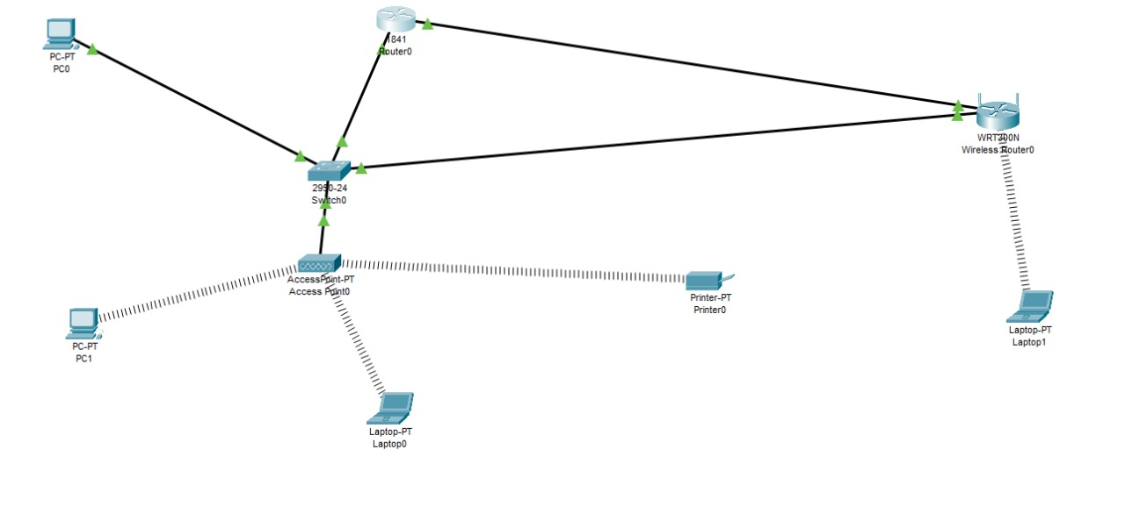

TCP/IP and UDP Configuration of Clients

Pc0

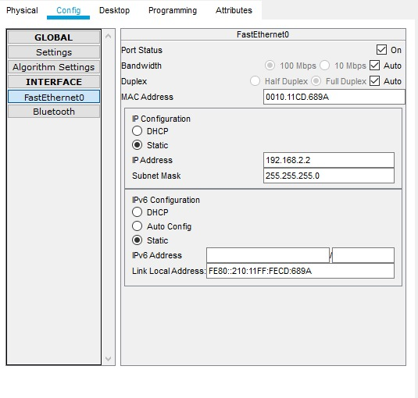

Pc1

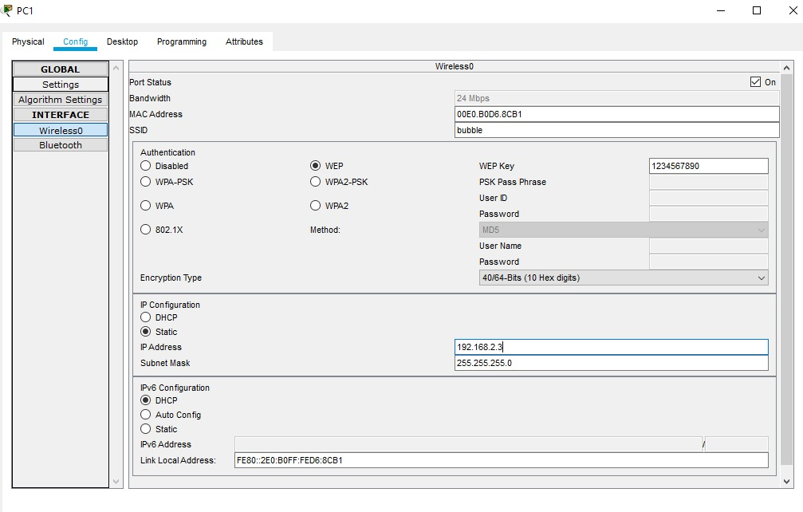

Lap 1 wireless

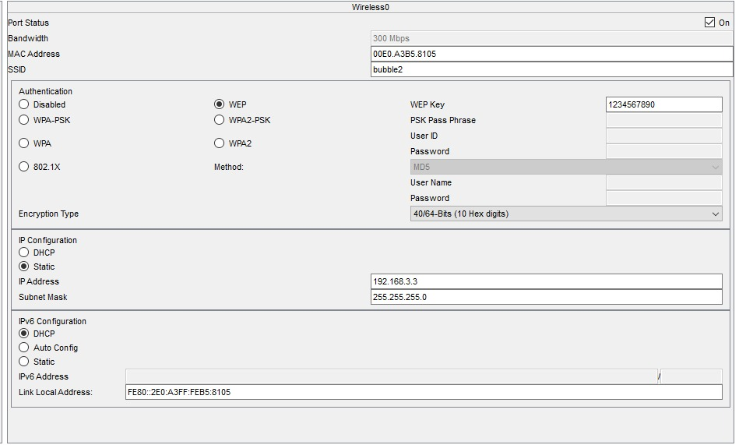

Printer 0 wireless

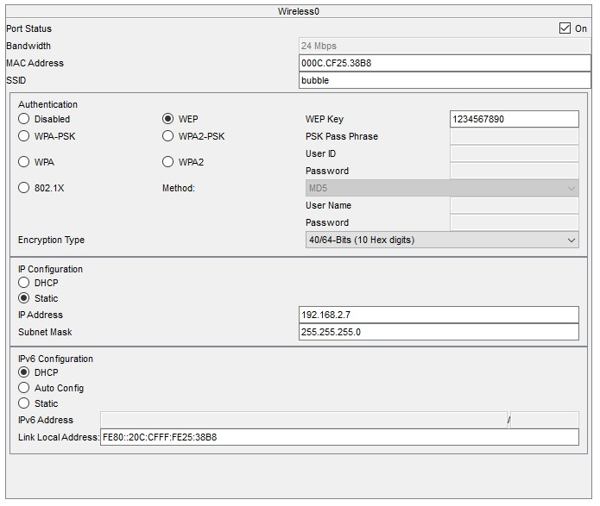

Lap0 wireless

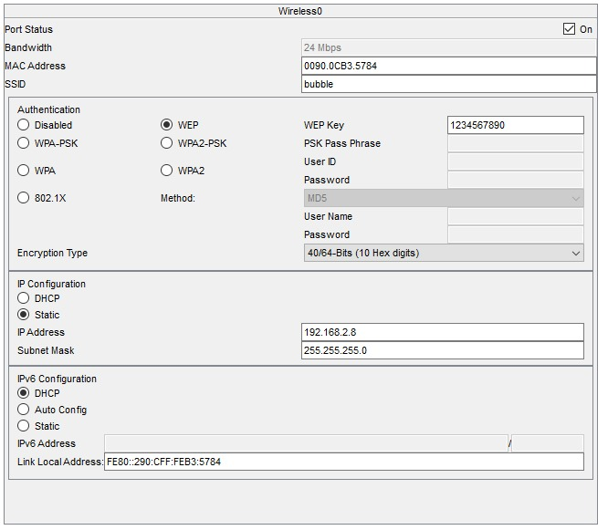

Router 0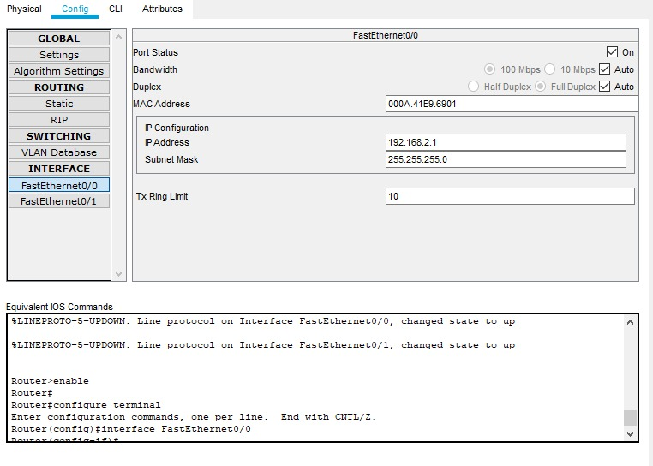

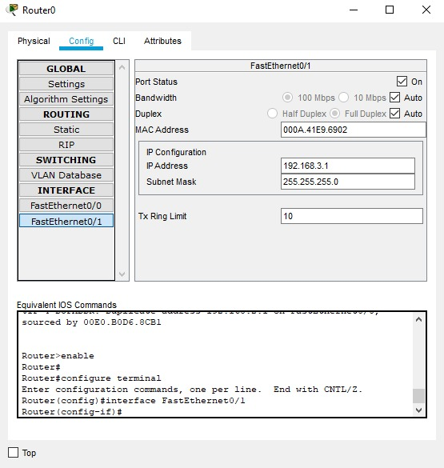

Wireless router LAN

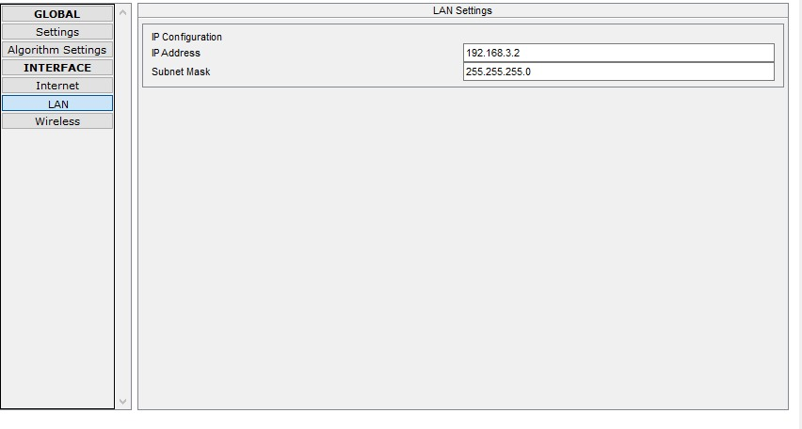

Requirement analysis and solutions

1. All the users should share the internet connection

* We connected the device to a router and gave the devices access to the net by connection with the Switch to host multiple devices.

1. The laptop should have secure wireless access to the internet.

* For wireless connection, we got an accesspoint through which the laptop connected wirelessly. And the module WPC300N is used for secured wireless connection.
* A WEP password which is a 9 key password setup by the user for secure connection.
* The laptop securely connects wirelessly once the WEP password is provided by the user.

1. The Desktop users should be able to access internet through the LAN.

* The PC is connected to the switch through an Ethernet Wire, where the switch in turn is connected to the router.
* The Module used for the Fast Wired connection of the PC is PT-HOST-NM-1CFE.

1. The users should be transparent to the IP addressing system and should not be required to configure the same manually.

* The server can see the users and do not manually configure.

1. One of the desktop at home needs to be accessed from the office.

* A wireless Router is setup and connected to the switch provided for the Home.
* The Wireless Router can send and receive messages from the PC.

1. All the users should be able to use the printer.

* This is made possible through the previous connections made through the Access Point and the wireless router which is connected to the switch.
* Messages can be sent to the Printer from the office as well as the home.

Recommended Products:-

1. There are many different technologies and scenarios to remotely control your Air Conditioning system.

**WIFI AIR CONDITIONING CONTROL CONCEPTS**

1.SmartAir Conditioners with WiFi connectivity that connects to a local network Wifi (LAN or WLAN).

2.Air Conditioners with WiFi connectivity (WiFi control adapter) that connect to the Internet in what is called “cloud” operation.

**LOCAL NETWORKS WIFI**

**WiFi Air Conditioning control** **– home** Local WiFi devices can be operated by smartphones within the local WiFi network, using native apps, developed by the manufacturer of the air conditioning system. Such HVAC systems won’t be controllable once the smartphone is out of the range of the local WiFi network.

Such a concept can fit some of the home appliances, such as TV, Audio Video devices, etc. that require control only when we are around

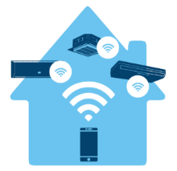

**"CLOUD" OPERATION**

Cloud Air Conditioning control: When remote access is required, cloud-based technology is used to fulfil this need. All the data can be hosted locally, at the client’s location, or it can be hosted at any of the modern internet cloud storage providers (e.g. Amazon Web Services (AWS)).

The main idea behind the cloud is that you can access all your information over the internet. In this concept, every “end” device - in our case Air Conditioning system, must have a proper Internet connection: wired or WiFi connection to the local network with internet access or 3G/4G.

