import matplotlib.pyplot as plt  
import pandas as pd  
import numpy as np

path = "./data/company_sales_data.csv"  
  
data = pd.read_csv(path)  
data

month_number facecream facewash toothpaste bathingsoap shampoo \  
0 1 2500 1500 5200 9200 1200   
1 2 2630 1200 5100 6100 2100   
2 3 2140 1340 4550 9550 3550   
3 4 3400 1130 5870 8870 1870   
4 5 3600 1740 4560 7760 1560   
5 6 2760 1555 4890 7490 1890   
6 7 2980 1120 4780 8980 1780   
7 8 3700 1400 5860 9960 2860   
8 9 3540 1780 6100 8100 2100   
9 10 1990 1890 8300 10300 2300   
10 11 2340 2100 7300 13300 2400   
11 12 2900 1760 7400 14400 1800   
  
 moisturizer total_units total_profit   
0 1500 21100 211000   
1 1200 18330 183300   
2 1340 22470 224700   
3 1130 22270 222700   
4 1740 20960 209600   
5 1555 20140 201400   
6 1120 29550 295500   
7 1400 36140 361400   
8 1780 23400 234000   
9 1890 26670 266700   
10 2100 41280 412800   
11 1760 30020 300200

# Q1)

data.set_index('month_number', inplace=True)  
  
plt.plot(data['total_profit'])  
  
plt.yticks(range(100000, 600000, 100000))  
plt.xticks(range(1, 13, 1))  
  
plt.xlabel('Month Number')  
plt.ylabel('Profit in dollars')  
  
plt.title('Company profit per month')  
  
plt.show()

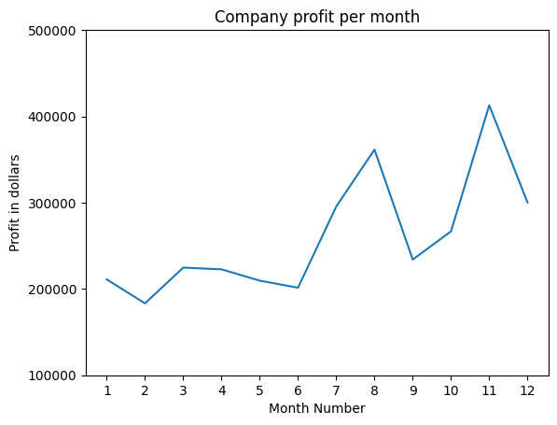

# Q2)

plt.plot(data['total_profit'], ls="dotted", color='red', marker='o', markerfacecolor='red', lw=3)  
  
plt.yticks(range(100000, 600000, 100000))  
plt.xticks(range(1, 13, 1))  
  
plt.xlabel('Month Number')  
plt.ylabel('Sold units number')  
  
plt.title('Company Sales data of last year')  
plt.legend(['Profit data of last year'], loc='lower right')  
  
plt.show()

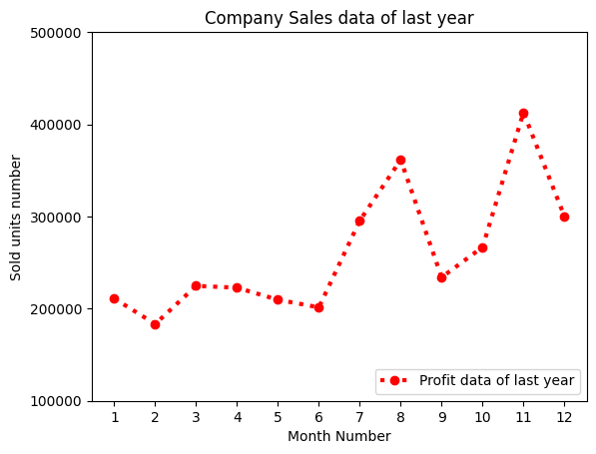

# Q3)

plt.subplots(2, 2, sharex='col')

(<Figure size 640x480 with 4 Axes>,  
 array([[<Axes: >, <Axes: >],  
 [<Axes: >, <Axes: >]], dtype=object))

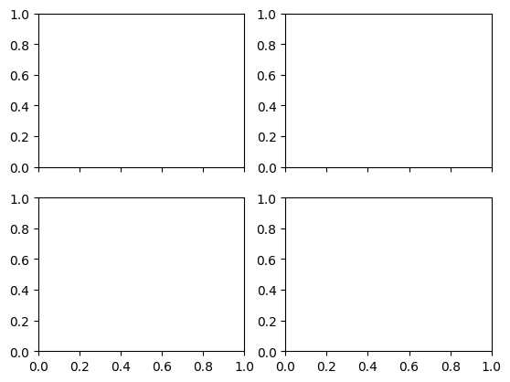

plt.subplots(2, 2, sharey='row')

(<Figure size 640x480 with 4 Axes>,  
 array([[<Axes: >, <Axes: >],  
 [<Axes: >, <Axes: >]], dtype=object))

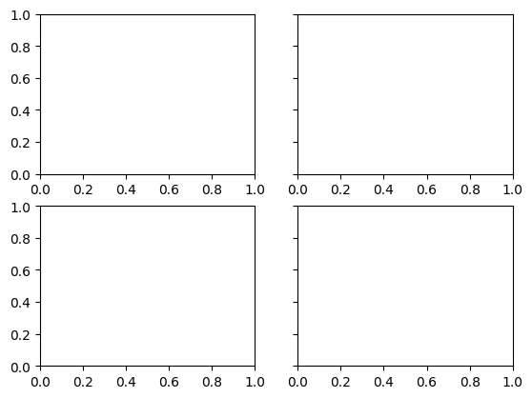

plt.subplots(2, 2, sharex='all', sharey='all')

(<Figure size 640x480 with 4 Axes>,  
 array([[<Axes: >, <Axes: >],  
 [<Axes: >, <Axes: >]], dtype=object))

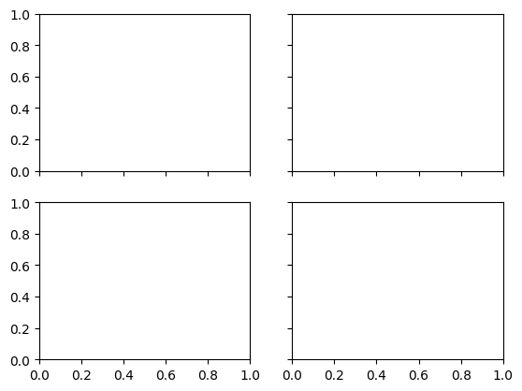

plt.subplots(2, 2, sharex=True, sharey=True)

(<Figure size 640x480 with 4 Axes>,  
 array([[<Axes: >, <Axes: >],  
 [<Axes: >, <Axes: >]], dtype=object))



# Q4)

x = range(1, 6)  
y = [i**2 for i in x]  
  
plt.plot(x, label='values', marker='o')  
plt.plot(y, label='square of values', marker='o')  
  
plt.legend()  
plt.show()

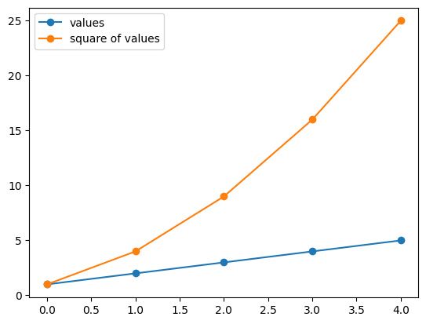

# Q5)

X = np.linspace(0, 10, 1000)  
  
plt.plot(np.sin(X), label='sin(x)')  
plt.plot(np.cos(X), label='cos(x)')  
  
plt.xlabel("Value of X")  
plt.ylabel("Value of sin(X) and cos(X)")  
  
plt.legend()  
  
plt.show()

