import pandas as pd  
import numpy as np  
import matplotlib.pyplot as plt

x = np.random.normal(170, 10, 250)  
  
plt.hist(x)  
plt.show()

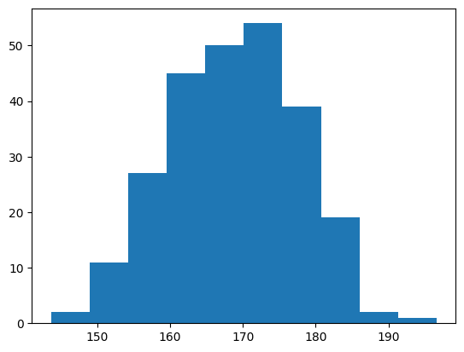

x = np.arange(0, 12, 0.1)  
  
plt.plot(x, np.sin(x))  
plt.plot(x, np.cos(x))  
  
plt.legend(['sin(x)', 'cos(x)'])  
  
plt.xlabel("Value of sin(x) & cos(x)")  
plt.ylabel("Value of x")  
  
plt.show()

