import matplotlib.pyplot as plt  
import numpy as np

# Q1)

age_g1 = [1, 3, 5, 10, 15, 17, 18, 16, 19, 21, 23, 28, 30, 31, 33, 38, 32, 40, 45, 43, 49, 55, 53,  
63, 66, 85, 80, 57, 75, 93, 95]  
  
age_g2 = [6, 4, 15, 17, 19, 21, 28, 23, 31, 36, 39, 32, 50, 56, 59, 74, 79, 34, 98, 97, 95, 67,  
69, 92, 45, 55, 77, 76, 85]

plt.hist(age_g1, bins=10, label='Age Group 1', edgecolor='red', alpha=0.8)  
plt.hist(age_g2, bins=10, label='Age Group 2', edgecolor='yellow', alpha=0.8)  
  
plt.legend()  
plt.show()

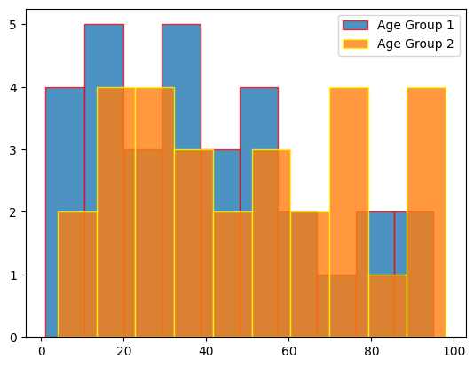

plt.hist(age_g1, bins=14, label='Age Group 1', edgecolor='red', alpha=0.8)  
plt.hist(age_g2, bins=14, label='Age Group 2', edgecolor='yellow', alpha=0.8)  
  
plt.legend()  
plt.show()

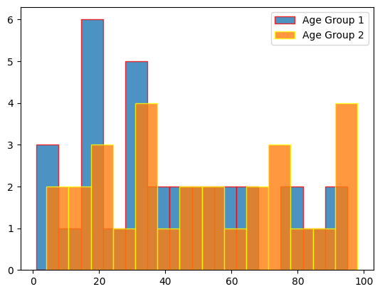

# Q2)

from sklearn import datasets  
  
iris = datasets.load_iris()

plt.hist(iris.data[:, 1], label="sepal_width", color='red', alpha=0.5)  
plt.hist(iris.data[:, 3], label="petal_width", color='green', alpha=0.5)  
plt.hist(iris.data[:, 2], label="petal_length", color='yellow', alpha=0.5)  
plt.hist(iris.data[:, 0], label="sepal_length", color='purple', alpha=0.5)  
  
plt.legend()  
plt.show()

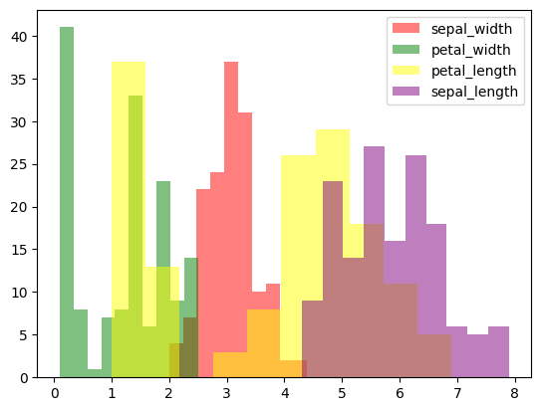

# Q3)

IT = [12, 30, 1, 8, 22]  
ECE = [28, 6, 16, 5, 10]  
CSE = [29, 3, 24, 25, 17]

date = np.array([2015, 2016, 2017, 2018, 2019])  
width = 0.2  
  
plt.bar(date-width, IT, width, color='red', label="IT", ec='grey')  
plt.bar(date, ECE, width, color='green', label="ECE", ec='grey')  
plt.bar(date+width, CSE, width, color='blue', label="CSE", ec='grey')  
  
plt.xlabel("Branch", fontweight='bold')  
plt.ylabel("Students passed", fontweight='bold')  
  
plt.legend()  
plt.show()

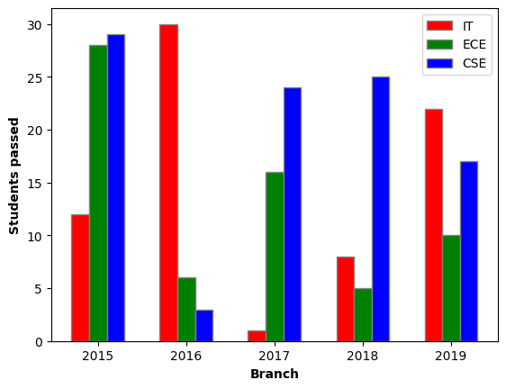

# Q4)

means_men = (22, 30, 35, 35, 26)  
means_women = (25, 32, 30, 35, 29)  
men_sd = (4, 3, 4, 1, 5)  
women_sd = (3, 5, 2, 3, 3)

group = ["Group1", "Group2", "Group3", "Group4", "Group5"]  
width=0.35  
  
plt.bar(group, means_men, width, color='red', label="Men", edgecolor='black', yerr=men_sd, error_kw=dict(ecolor='blue', capsize=5))  
plt.bar(group, means_women, width, bottom=means_men, color='green', label="Women", edgecolor='black', yerr=women_sd, error_kw=dict(ecolor='green', capsize=5))  
  
plt.xlabel("Groups")  
plt.ylabel("Scores")  
  
plt.yticks(range(0, 81, 10))  
  
plt.title("Scores by group \n and gender")  
  
plt.legend()  
plt.show()

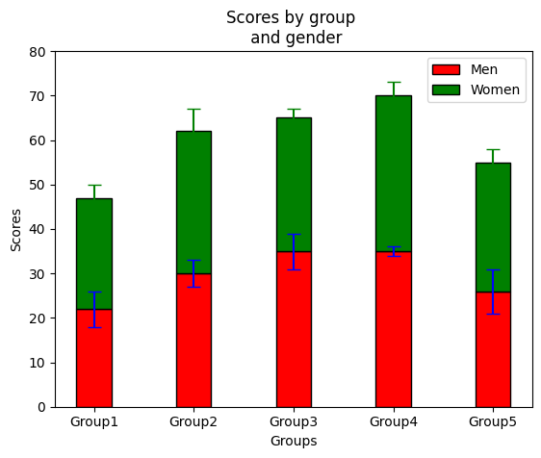

# Q5)

year = [2014, 2015, 2016, 2017, 2018, 2019]  
issues_addressed = [10, 14, 0, 10, 15, 15]  
issues_pending = [5, 10, 50, 2, 0, 10]

plt.figure(figsize=[7.50, 3.50])  
  
plt.barh(year, issues_addressed, color="red", label="Completed")  
plt.barh(year, issues_pending, left=issues_addressed, color="yellow", label="Pending")  
  
plt.ylabel("Year")  
  
plt.legend(title="Issues")  
plt.show()

