import numpy as np  
import pandas as pd  
import matplotlib.pyplot as plt

# Q1)

languages = ["Java", "Python", "PHP", "JavaScript", "C#", "C++"]  
popularity = [22.2, 17.6, 8.8, 8, 7.7, 6.7]

explode = [0.1, 0, 0, 0, 0, 0.1]  
  
plt.pie(popularity, labels=languages, autopct = '%1.1f%%', startangle=135, explode=explode, shadow=True, wedgeprops={"linewidth": 1, "edgecolor": "black"})  
  
plt.title("Popularity of Programming Language \n Worldwide, Oct 2017 compared to a year ago")  
plt.show()

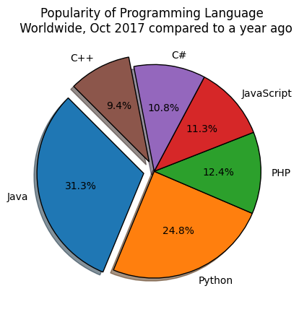

# Q2)

data = pd.read_csv("./data/medal.csv")  
  
total = data.gold_medal.sum()  
data['percentage'] = data['gold_medal']/total * 100  
  
data.set_index('country', inplace=True)  
  
data

gold_medal percentage  
country   
United States 46 34.074074  
Great Britain 27 20.000000  
China 26 19.259259  
Russia 19 14.074074  
Germany 17 12.592593

explode = [0.1, 0, 0, 0, 0]  
def format_pct(val):  
 return '{:.0f}'.format(val * total/100)  
  
# plt.pie(data.percentage, labels=data.country, autopct=format_pct, explode=explode)  
data.plot(kind='pie', y="percentage", autopct=format_pct, explode=explode, legend=False, ylabel='')  
  
plt.title("Gold medal achievements of five most successful countries \n in 2016 Summer Olympics.")  
plt.show()

