**EXPERIMENT 1**

**AIM: Installing Vagrant & Creating basic vagrant box using Virtual Box virtualization.**

Steps to Complete:

1. Download and Install Oracle Virtual Box 5.x and Vagrant 2.2.7.

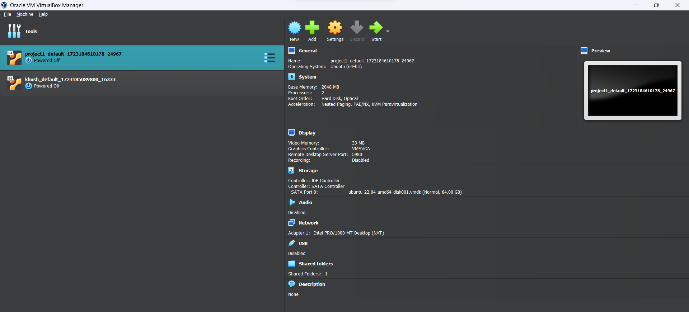

2. Check working of Vagrant using vagrant --version command.

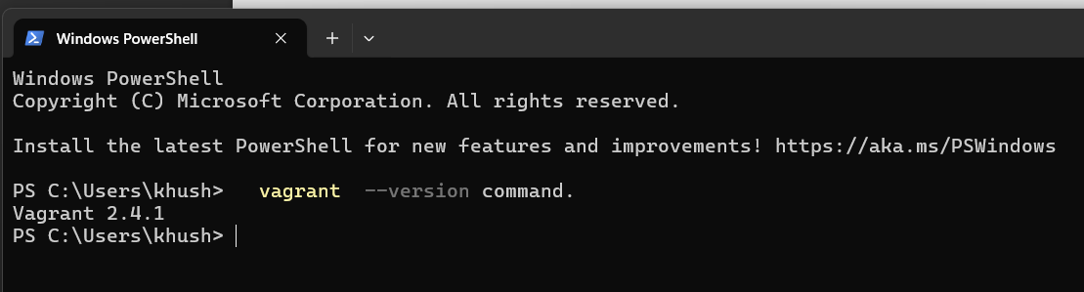

3. Create a new directory using CMD

4. Run vagrant init command

5. Edit vagrantfile and add ubuntu/xenial64 in box tag.

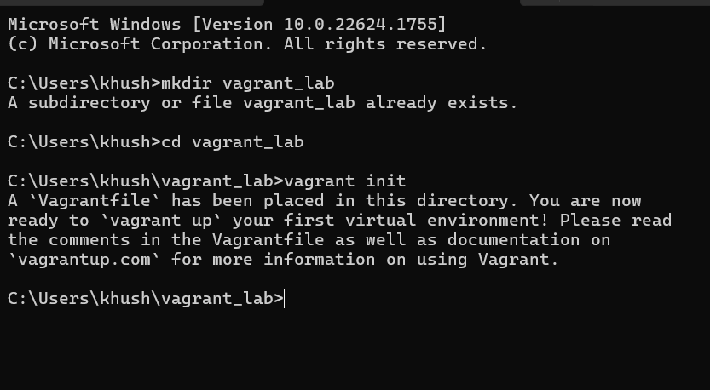

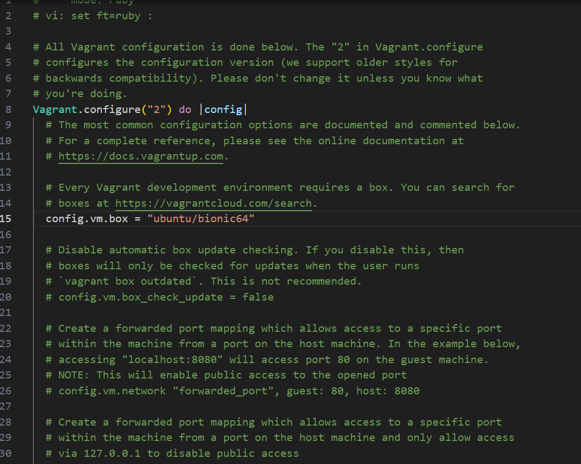

6. Run vagrant up command

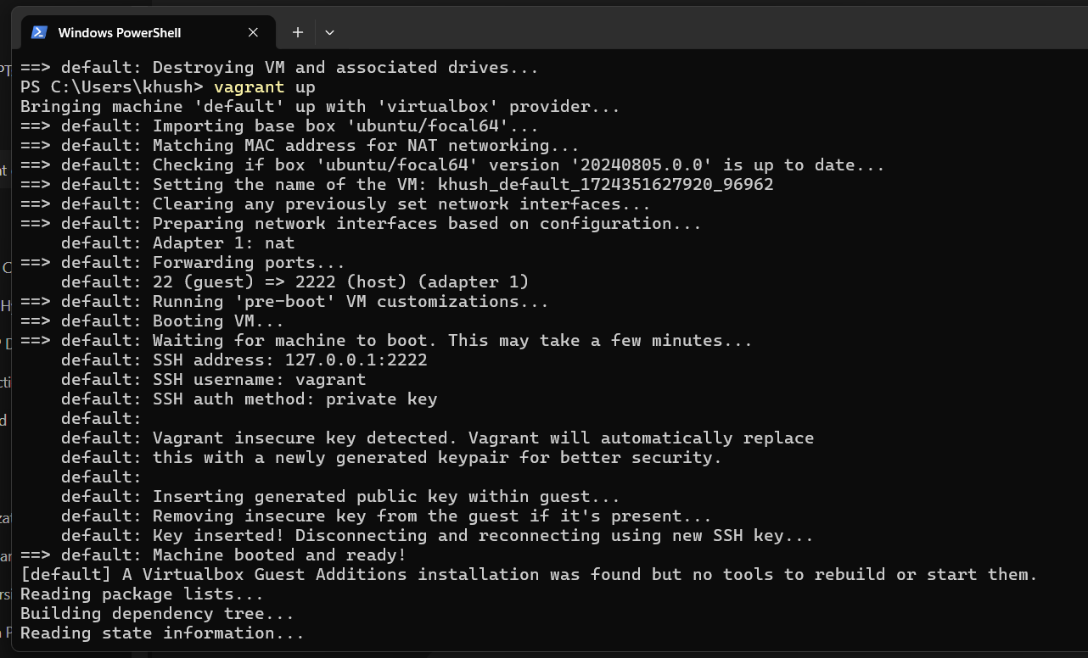

7. Run vagrant SSH command

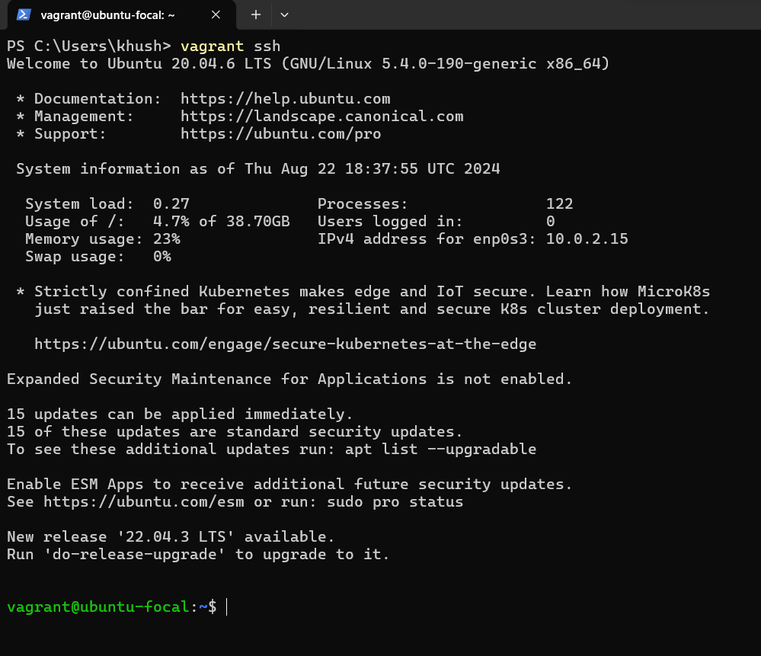

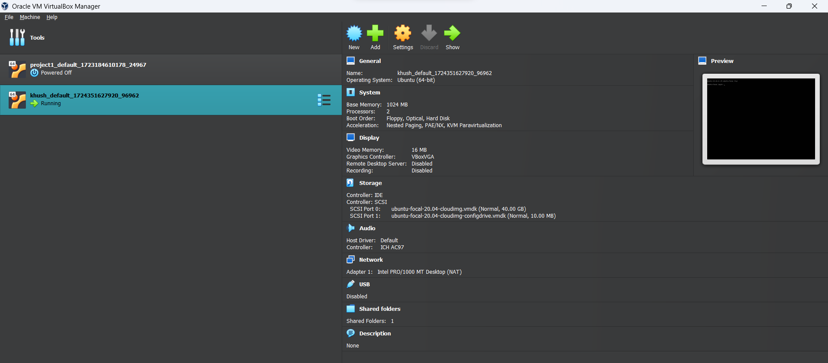

8. Run Vagrant Halt to stop VM

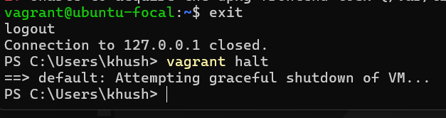

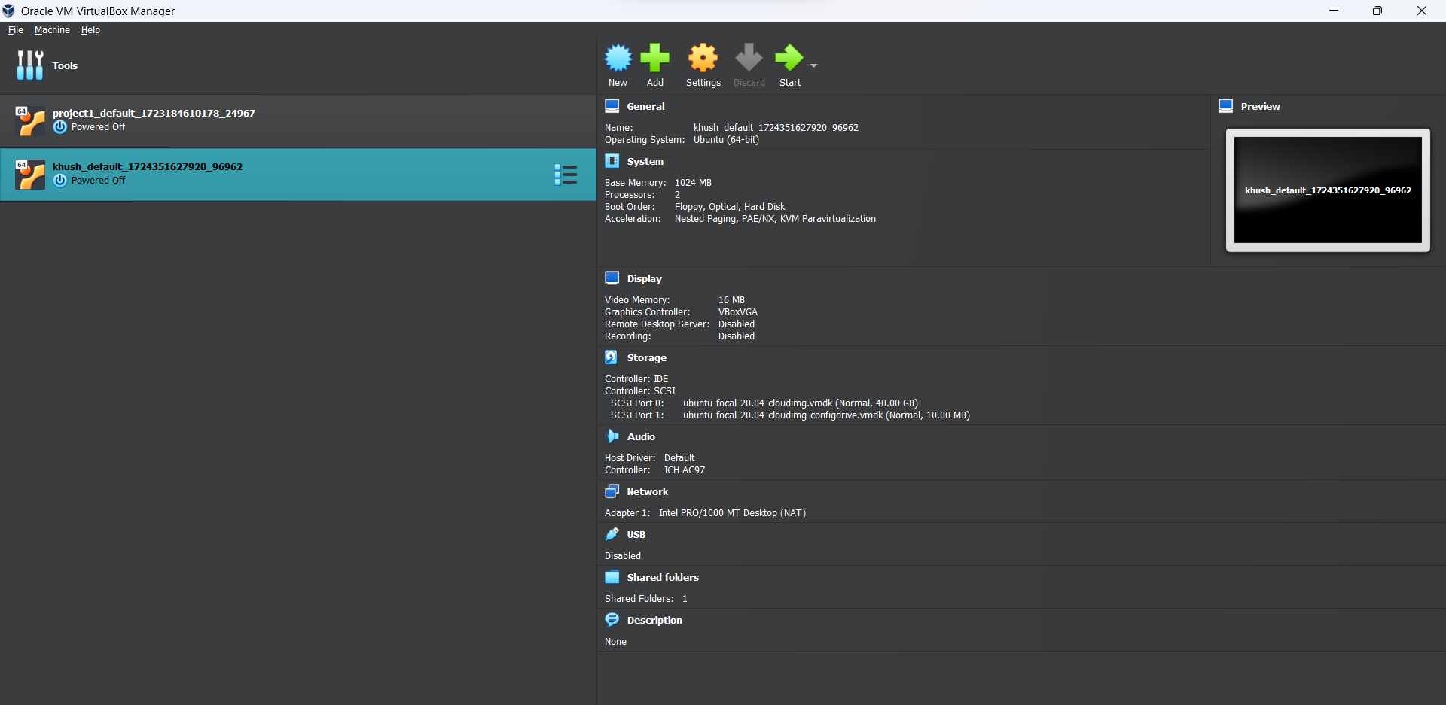

9. Run Vagrant Destroy to delete VM

