**School of Computer Science**

**UNIVERSITY OF PETROLEUM AND ENERGY STUDIES**

**DEHRADUN, UTTARAKHAND**



**Containers & Docker Security**

**Lab File (2022-2026)**

# **5th Semester**

|  |  |
| --- | --- |
| *Submitted To:*  ***Dr. Hitesh Kumar Sharma*** | *Submitted By:*  *Anuj Pawadia (500107126)*  *B Tech CSE*  *DevOps[5th Semester]*  *R2142220311*  *Batch - 1* |

**EXPERIMENT 3**

**AIM: Working with Docker Volumes**

**Objective:**

* Learn how to create and manage Docker volumes.
* Understand how Docker volumes can be used to persist data across container restarts.
* Practice mounting Docker volumes to containers.

**Prerequisites:**

* Docker installed on your system.
* Basic understanding of Docker commands and container concepts.

**Step 1: Create a Docker Volume**

Create a new Docker volume:

docker volume create my_data_volume

This command creates a Docker volume named my_data_volume.

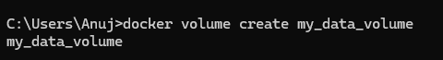

Verify that the volume was created:

docker volume ls

You should see my_data_volume listed among the volumes.

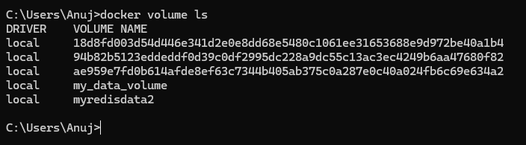

**Step 2: Run a Container with the Volume Mounted**

Run an Nginx container with the volume mounted:

docker run -d --name my_nginx -v my_data_volume:/usr/share/nginx/html -p 8008:80 nginx

This command starts an Nginx container named my_nginx and mounts the my_data_volume volume to the /usr/share/nginx/html directory inside the container.

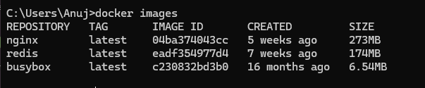

Verify that the container is running:

docker ps

You should see my_nginx listed as one of the running containers.

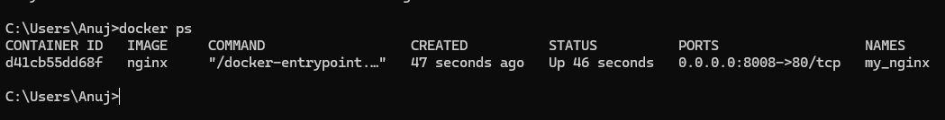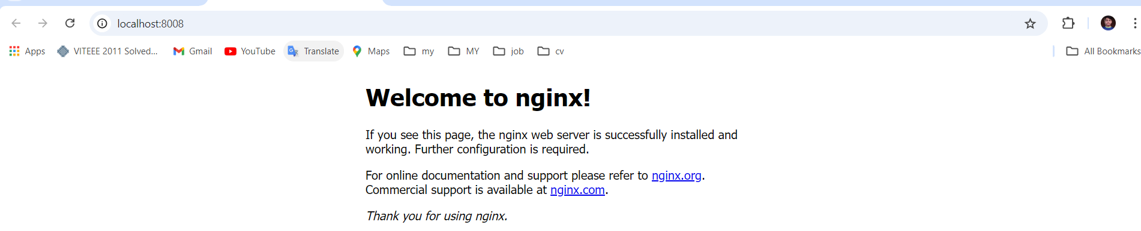

**Step 3: Interact with the Volume**

Create a simple HTML file in the volume:

docker exec -it my_nginx bash

echo "<h1>Hello, Docker Volume!</h1>" > /usr/share/nginx/html/index.html

exit

This command creates an HTML file inside the /usr/share/nginx/html directory, which is backed by my_data_volume.

Access the Nginx server to see your file: Open a browser and navigate to http://localhost:8008. You should see the message "Hello, Docker Volume!" displayed on the page.

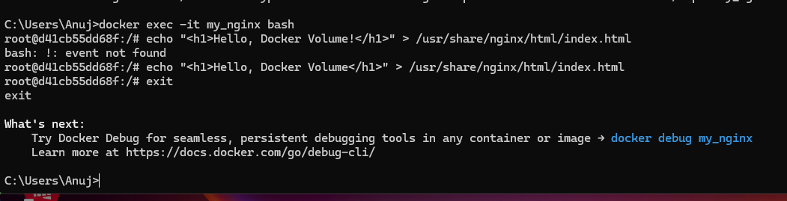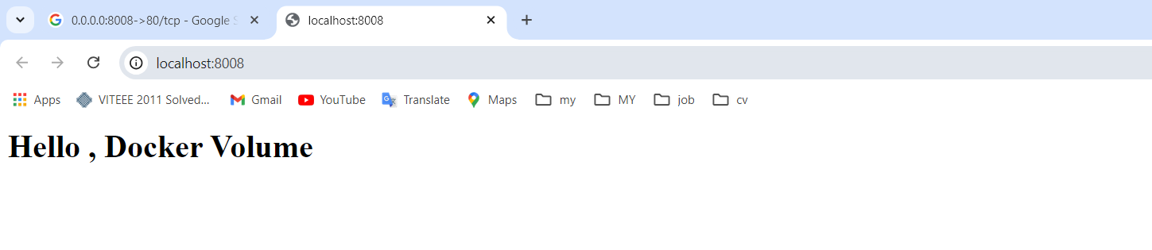

**Step 4: Test Data Persistence**

Stop and remove the container:

docker stop my_nginx

docker rm my_nginx

Run a new Nginx container using the same volume:

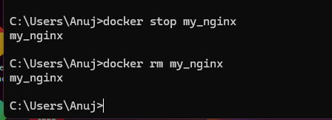



docker run -d -p 8011:80 -v my_data_volume:/usr/share/nginx/html nginx

Access the Nginx server again: Navigate to http://localhost in your browser. You should still see the "Hello, Docker Volume!" message, demonstrating that the data persisted across container instances.

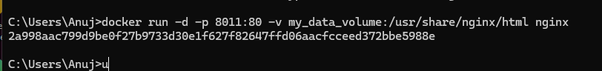

**Step 5: Clean Up**

Stop and remove the container:

docker stop new_nginx

docker rm new_nginx

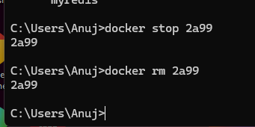

Remove the Docker volume:

docker volume rm my_data_volume

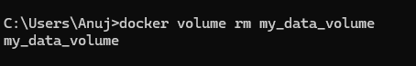

Verify that the volume is removed:

docker volume ls

Ensure that my_data_volume is no longer listed.

