LAB2

AIM: Working with Docker (Basic Commands)

Steps to Complete:

1.Search a Redis image on DockerHub

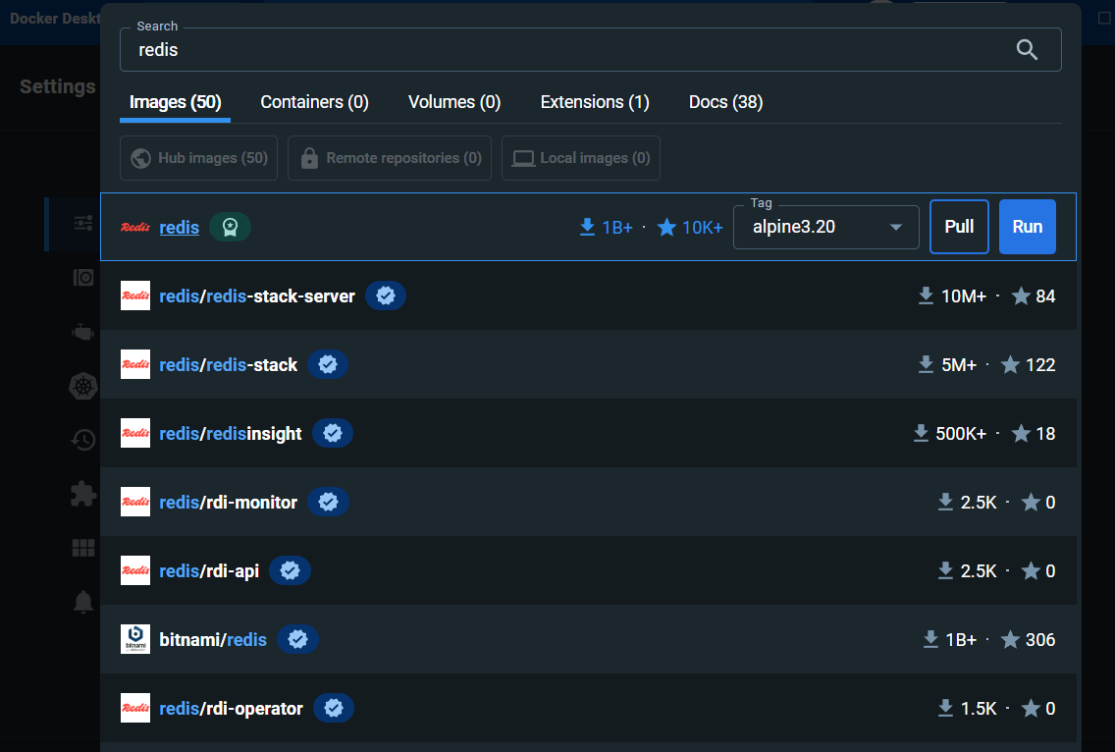

2.Run Docker Container of Redis Image in background.

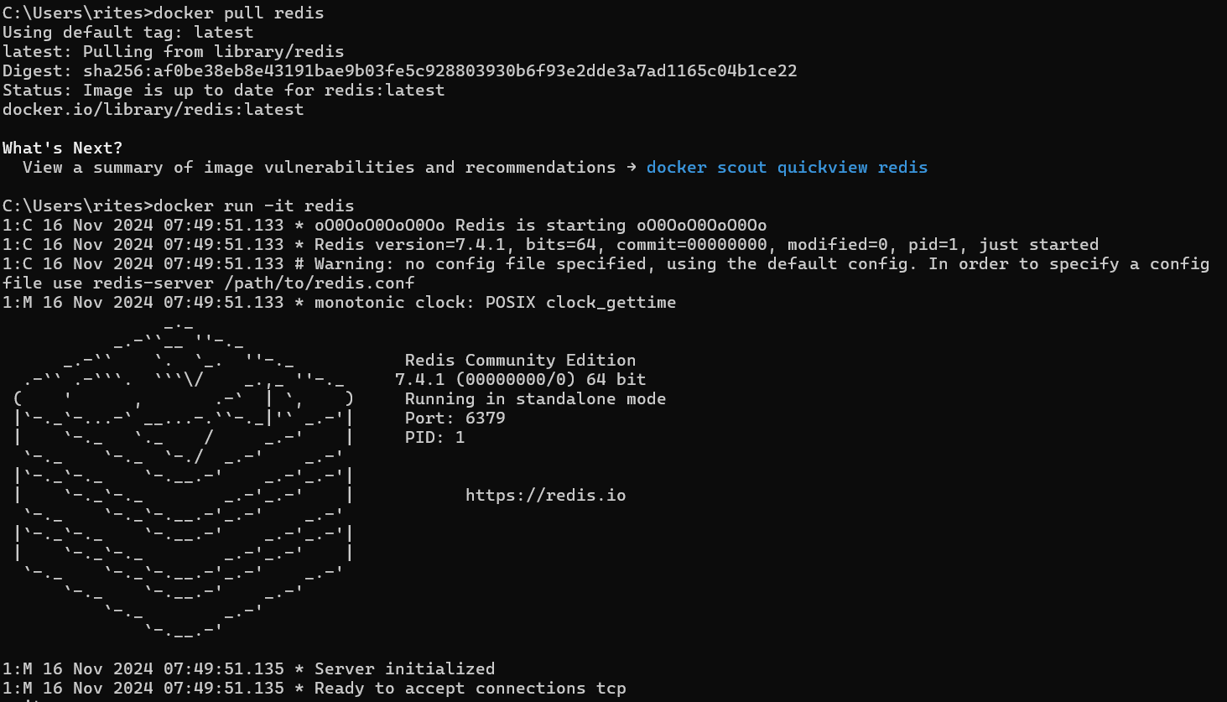

3.Run Docker PS and Docker PS –a

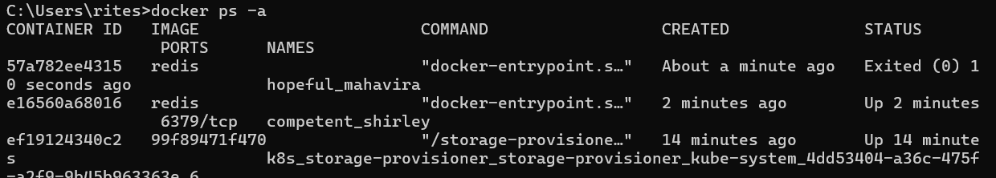

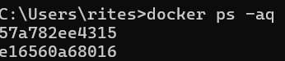

4.Run Docker Container and take its console.

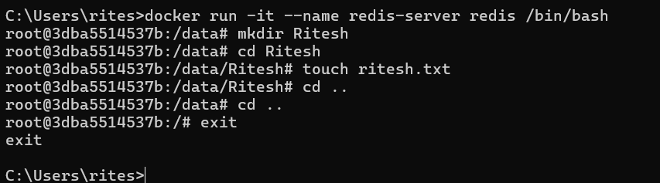

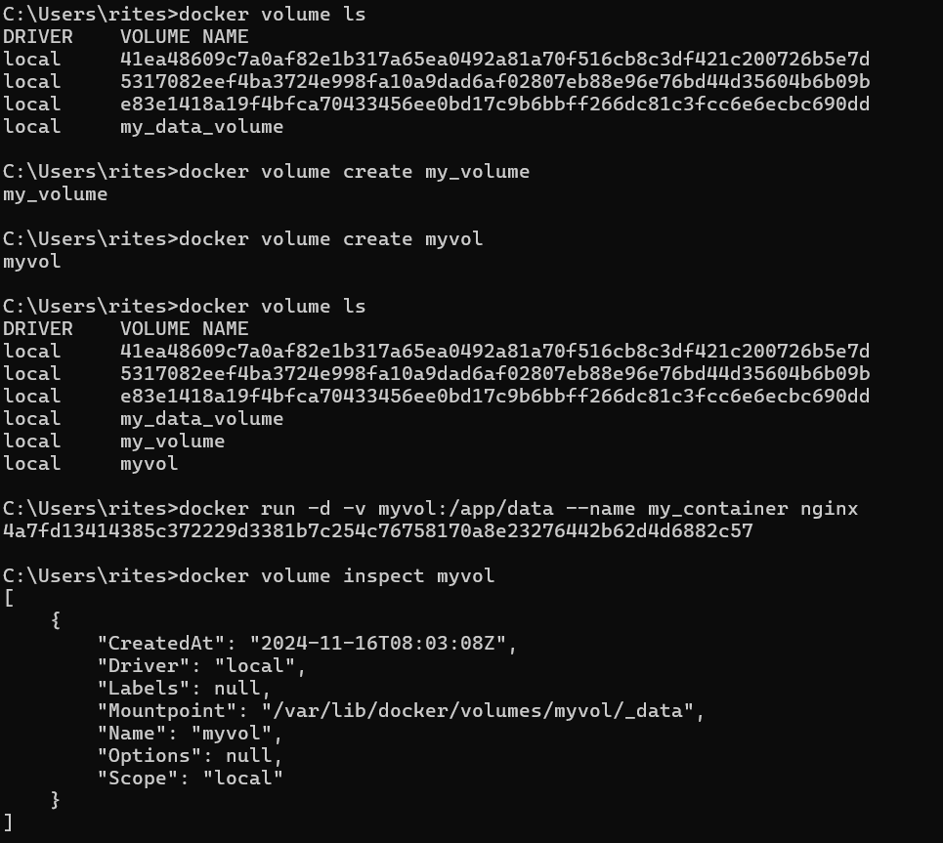

5.Create a Docker Volume and connect it

