EXPERIMENT 1

Name: Simranjeet kour

Sap Id: 500110713

# Lab Exercise: Introduction to Vagrant and Vagrantfile

This exercise will guide them through setting up a virtual environment using Vagrant, configuring the environment via a Vagrantfile, and managing the virtual machines (VMs) with basic Vagrant commands.

# Objective:

* Learn how to set up and configure virtual environments using Vagrant.
* Understand the structure and components of a Vagrantfile.
* Gain hands-on experience in managing virtual machines using Vagrant commands.

# Prerequisites:

* Basic knowledge of virtualization concepts.
* Familiarity with command-line interfaces.
* Installation of Vagrant and VirtualBox (or any other supported provider) on your local machine.

# Step-by-Step Exercise:

1. **Setting Up the Environment:**

# Install Vagrant:

* + Download and install Vagrant from the official website.
  + Ensure you have VirtualBox installed as it is a commonly used provider with Vagrant.
  + Verify Installation:
  + Open a terminal or command prompt.
  + Run the following commands to verify the installation:



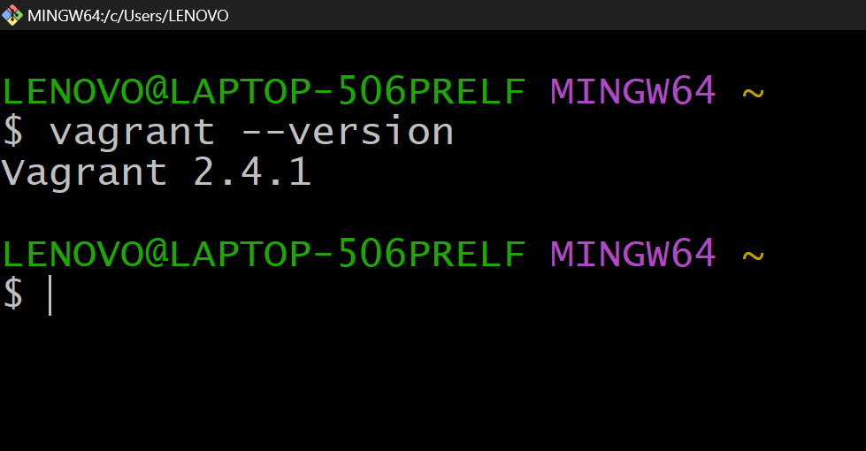

# Creating a New Vagrant Project:

* + Create a Project Directory:
  + In your terminal, create a new directory for your Vagrant project and navigate into it:



# Initialize Vagrant:

* + Run the following command to initialize a new Vagrantfile in your project directory:



This command will generate a Vagrantfile in the current directory.

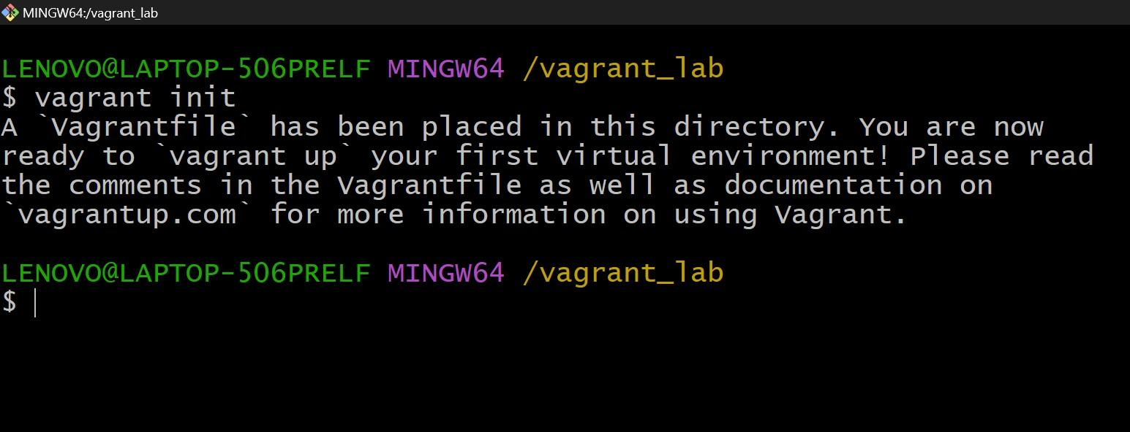

# Understanding the Vagrantfile:

* + Open the Vagrantfile:
  + Open the Vagrantfile in a text editor of your choice.
  + The Vagrantfile is a Ruby-based configuration file used to define the virtual environment.
  + Basic Vagrantfile Configuration:
  + Modify the Vagrantfile to configure a basic virtual machine. For example:





# Launching and Managing the VM:

Start the VM:

In the terminal, start the VM using the following command:



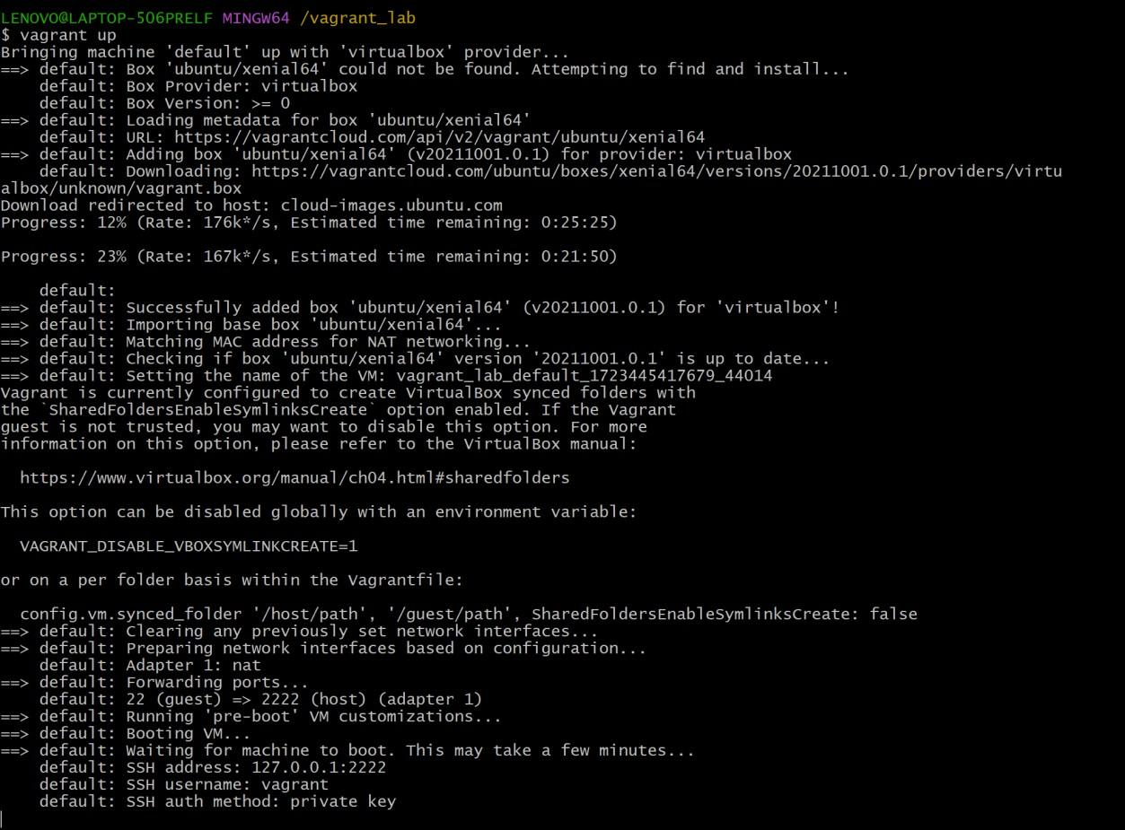

Vagrant will download the specified box (if not already downloaded) and launch the VM.

* + SSH into the VM:
  + Connect to the running VM using SSH:



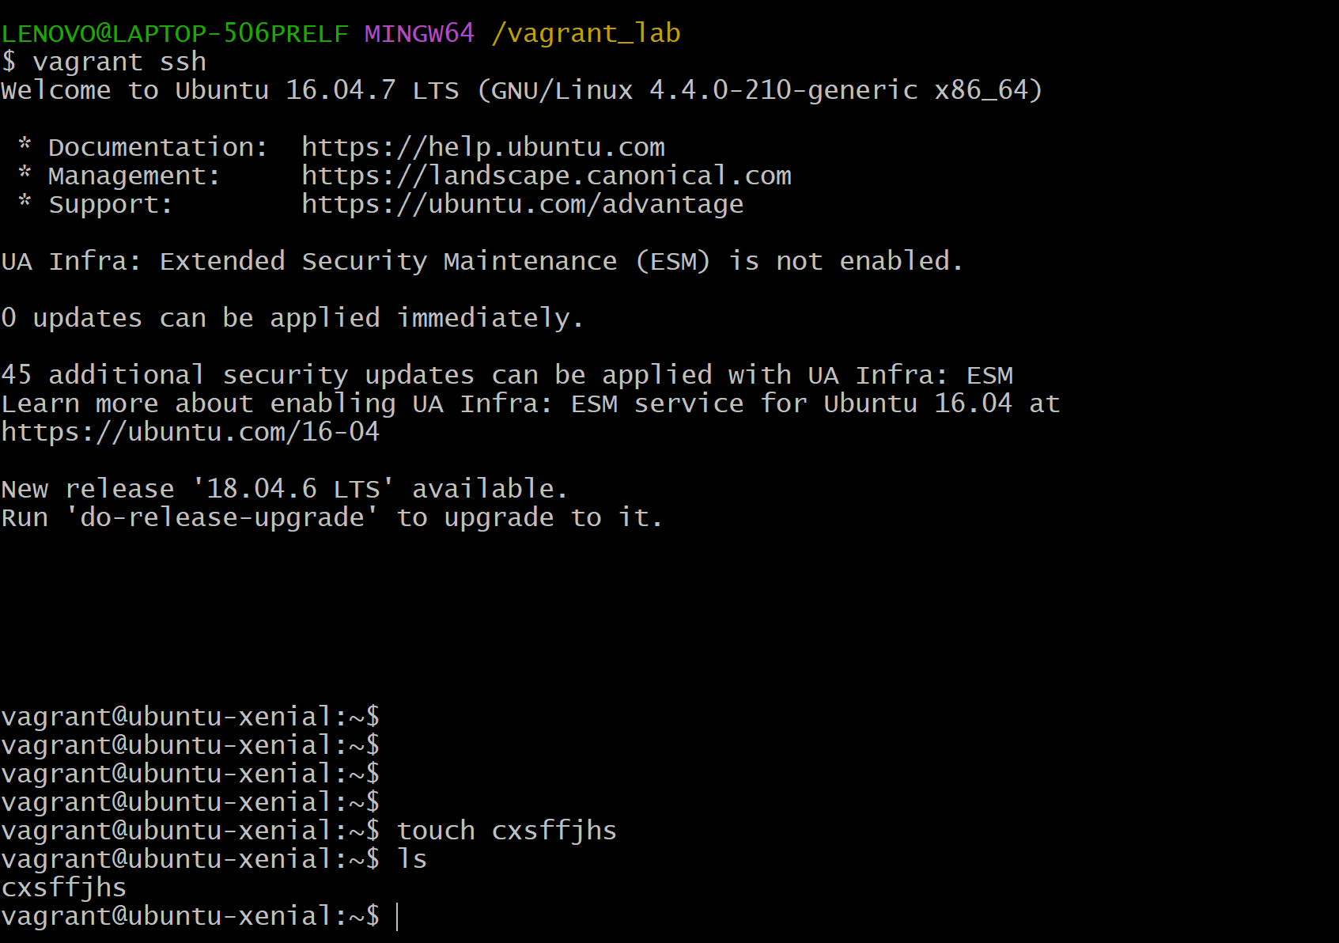

* + This command will log you into the VM’s shell.
  + Exploring the VM:
  + Inside the VM, explore the filesystem, install packages, and run commands to understand the environment.
  + Stop the VM:
  + Exit the SSH session by typing exit.
  + Stop the VM with the following command:

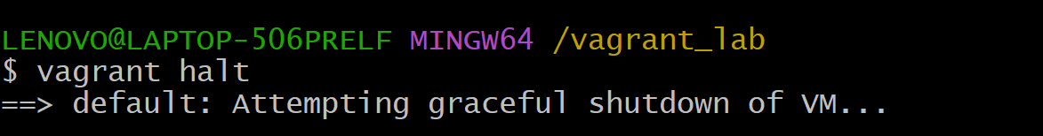

Destroy the VM (optional):

To remove the VM completely, use the following command:

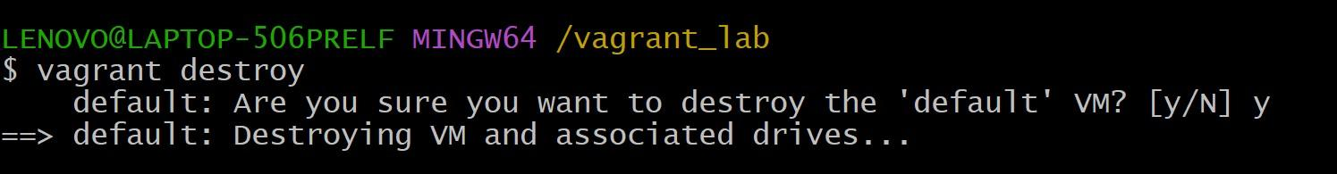

This will remove all traces of the VM, including any data stored on it.

Explore the benefits of using Vagrant for development and testing environments.

# Submission:

* + Submit a brief report including the Vagrantfile you configured, screenshots of the running VM, and the output of any commands run within the VM.
  + Reflect on the learning experience and any challenges faced during the exercise.

This lab exercise provides a hands-on introduction to Vagrant, focusing on creating and managing virtual environments through a Vagrantfile. It offers both foundational learning and opportunities to explore more advanced features.