**EXPERIMENT 2**

Name: Simranjeet kour

Sap Id: 500110713

**AIM: Working with Docker (Basic Commands)**

**Steps to Complete:**

1. Search a Redis image on DockerHub

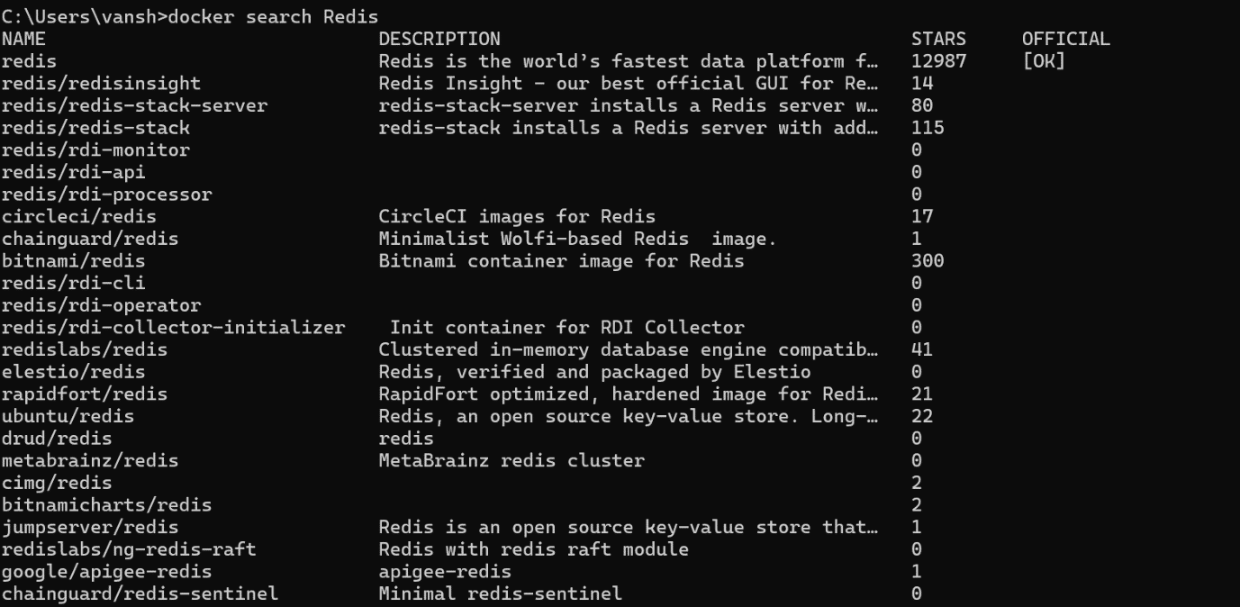

1. Run Docker Container of Redis Image in background

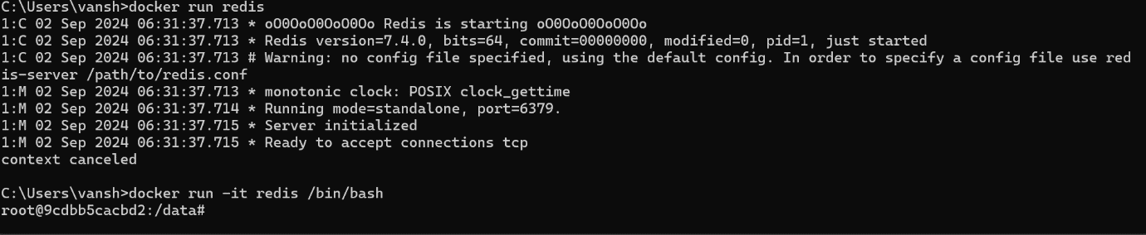

1. Run Docker PS and Docker PS –a

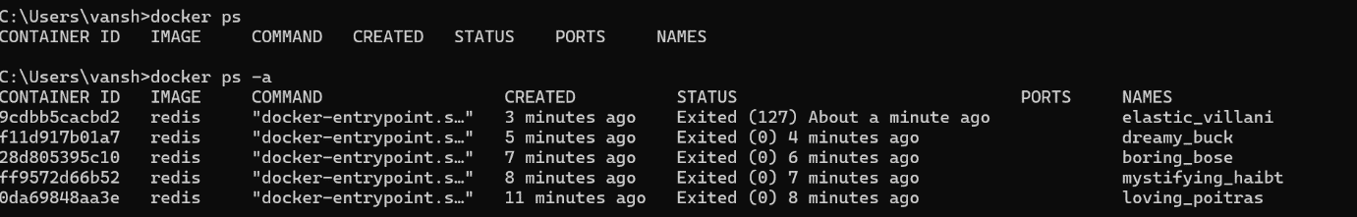

1. Run Docker Container and take its console

