Name: Simranjeet kour

Sap Id: 500110713

Lab Exercise 5- Building a Docker Image for an HTML App Using Nginx

# Setup

You will need:

* + Docker installed on your machine.
  + A simple HTML file for the app.

# Step 1: Create the HTML File

Create a directory for your HTML app and place an index.html file in it.

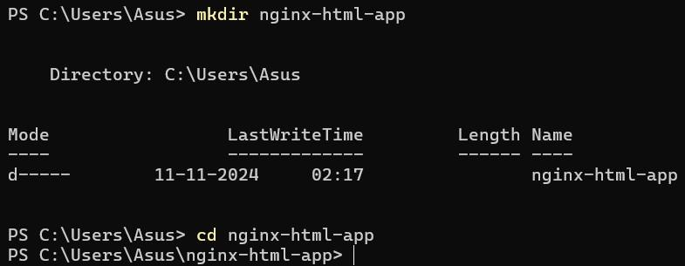

Inside the nginx-html-app directory, create the HTML file.



Edit the index.html file with the following content (or any custom HTML content you want):





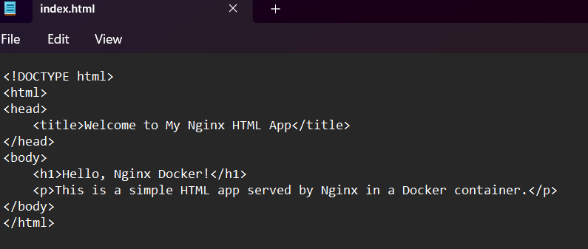

# Step 2: Create a Dockerfile

In the same directory, create a Dockerfile. This file will define how to build the Docker image using Nginx as the base image.



Edit the Dockerfile and add the following content:



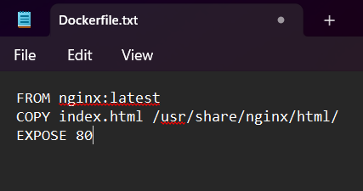

# Step 3: Build the Docker Image

Now that you have the Dockerfile and index.html, it’s time to build the Docker image. Run the following command to build the image, giving it a tag (e.g., nginx-html-app):



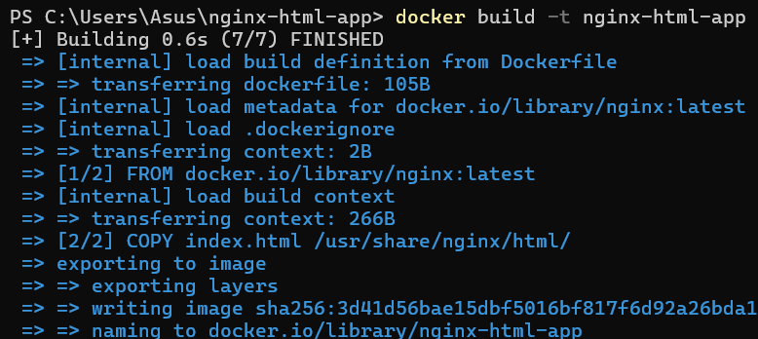

Docker will use the Nginx base image, copy your index.html into the appropriate directory, and build the image.

# Step 4: Run the Docker Container

After building the image, you can run the container with the following command:



This command runs the container in detached mode (-d) and maps port 8080 on your host machine to port 80 inside the container, where Nginx is serving your HTML app.

# Step 5: Verify

Open a browser and go to http://localhost:8080. You should see your HTML page with the message “Hello, Nginx Docker!”.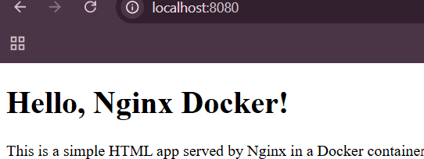

# Step 6: Stop and Remove the Container

Once you're done, you can stop and remove the container:

