Name: Simranjeet kour

Sap Id: 500110713

Lab Exercise 6- Create POD in Kubernetes

# Objective:

* Understand the basic structure and syntax of a Kubernetes Pod definition file (YAML).
* Learn to create, inspect, and delete a Pod in a Kubernetes cluster.

# Prerequisites

* Kubernetes Cluster: You need a running Kubernetes cluster. You can set up a local cluster using tools like Minikube or kind, or use a cloud-based Kubernetes service.
* kubectl: Install and configure kubectl to interact with your Kubernetes cluster.
* Basic Knowledge of YAML: Familiarity with YAML format will be helpful as Kubernetes resource definitions are written in YAML.

# Step-by-Step Guide

## Step 1: Create a YAML File for the Pod

We'll create a Pod configuration file named **pod-example.yaml**



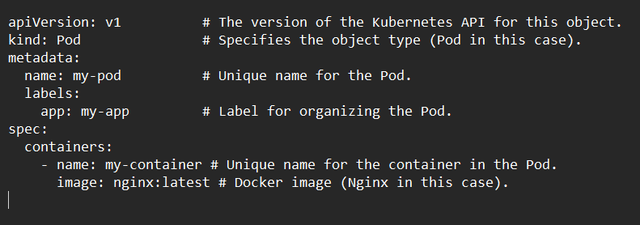

## Explanation of the YAML File

* apiVersion: Specifies the version of the Kubernetes API to use. For Pods, it's typically v1.
* kind: The type of object being created. Here it's a Pod.
* metadata: Provides metadata about the object, including name and labels. The name must be unique within the namespace, and labels help in identifying and organizing Pods.
* spec: Contains the specifications of the Pod, including:
  + containers: Lists all containers that will run inside the Pod. Each container needs:
    - name: A unique name within the Pod.
    - image: The Docker image to use for the container.
    - ports: The ports that this container exposes.
    - env: Environment variables passed to the container.

## Step 2: Apply the YAML File to Create the Pod

Use the kubectl apply command to create the Pod based on the YAML configuration file.



This command tells Kubernetes to create a Pod as specified in the pod-example.yaml file.

## Step 3: Verify the Pod Creation

To check the status of the Pod and ensure it's running, use:

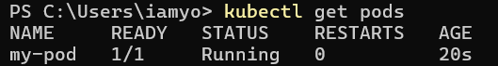

This command lists all the Pods in the current namespace, showing their status, restart count, and other details.

You can get detailed information about the Pod using:



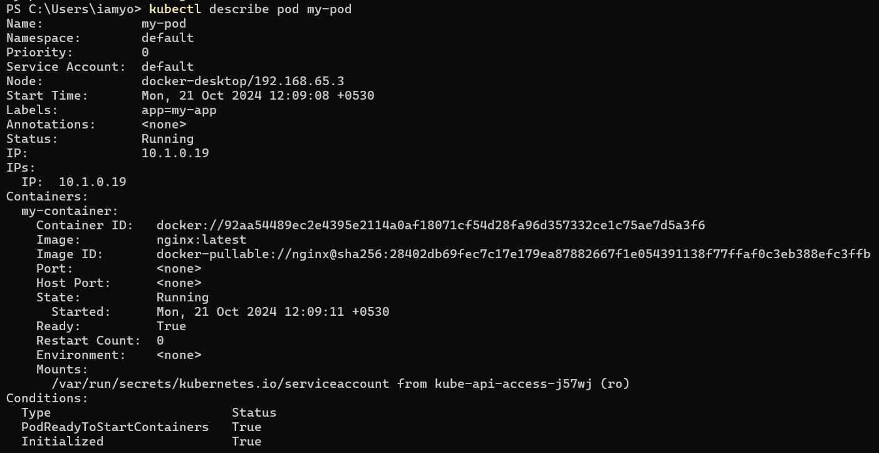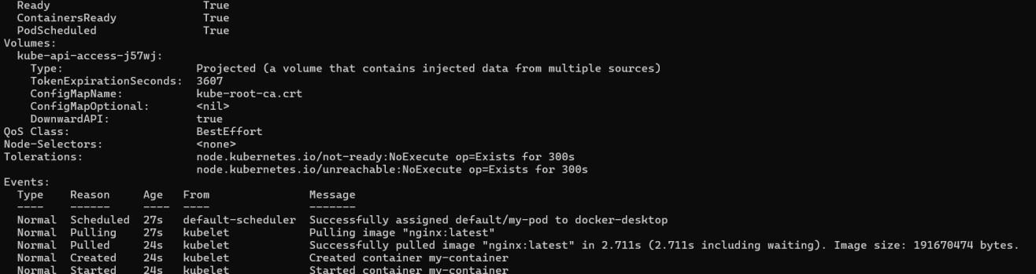

This command provides detailed information about the Pod, including its events, container specifications, and resource usage.

## Step 4: Interact with the Pod

You can interact with the running Pod in various ways, such as accessing the logs or executing commands inside the container.

## View Logs: To view the logs of the container in the Pod:



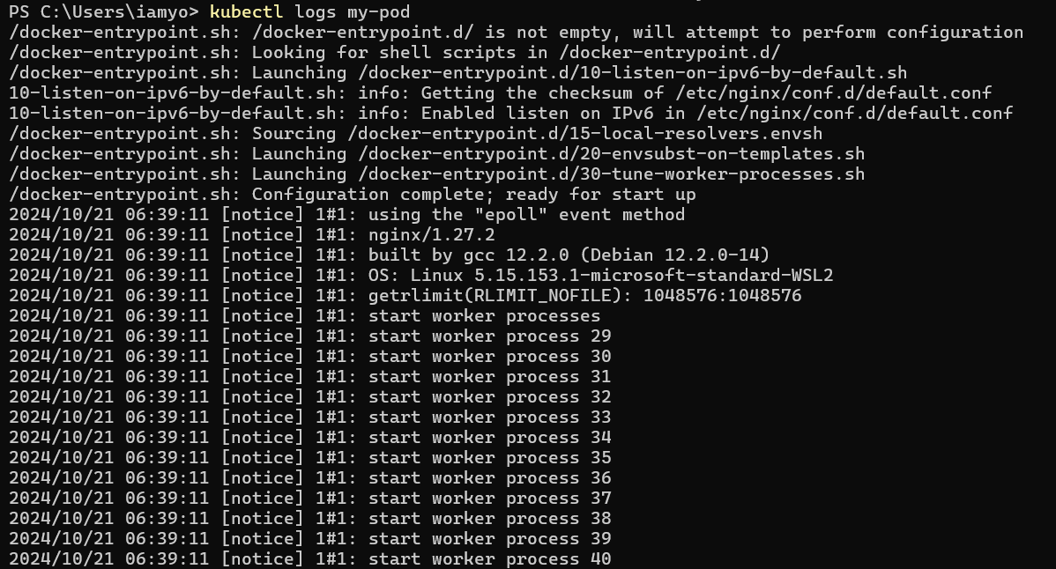

**Execute a Command: To run a command inside the container:**

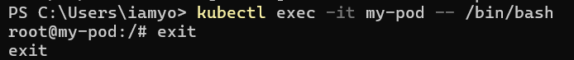

The -it flag opens an interactive terminal session inside the container, allowing you to run commands.

## Step 5: Delete the Pod

To clean up and remove the Pod when you're done, use the following command:



This command deletes the specified Pod from the cluster.