Name: Simranjeet kour

Sap Id: 500110713

Lab Exercise 9- Managing Namespaces in Kubernetes

# Step 1: Understand Namespaces

Namespaces provide a mechanism for scoping resources in a cluster. Namespaces can be used to:

* Create environments for different applications or teams.
* Apply policies like resource quotas or network policies on a per-namespace basis.
* Separate operational environments (like development and production).

# Step 2: List Existing Namespaces

To list all the namespaces in your Kubernetes cluster:



You will typically see default namespaces like default, kube-system, and kube-public.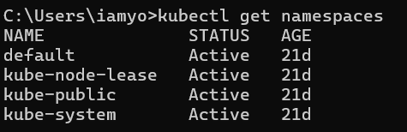

# Step 3: Create a Namespace

You can create a namespace using a YAML file or directly with the kubectl command.

# Using YAML File

Create a file named ***my-namespace.yaml*** with the following content:



Apply this YAML to create the namespace: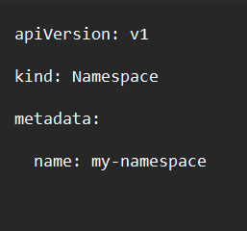



Verify that the namespace is created:



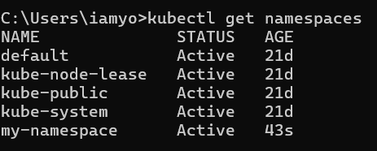

You should see my-namespace listed in the output.

# Step 4: Deploy Resources in a Namespace

Create resources such as Pods, Services, or Deployments within the new namespace. Deploy a Pod in the Namespace

Create a YAML file named ***nginx-pod.yaml*** with the following content:



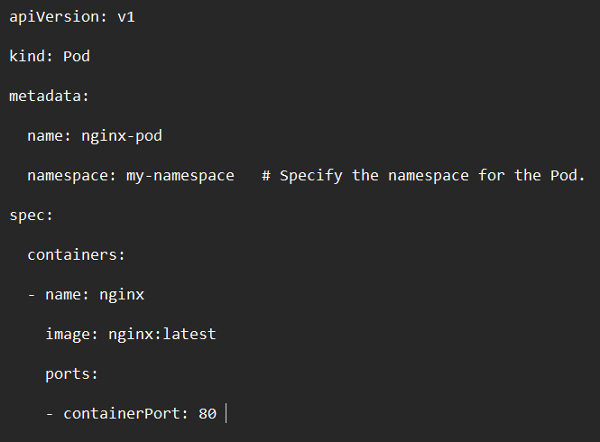

Apply this YAML to create the Pod:



Check the status of the Pod within the namespace: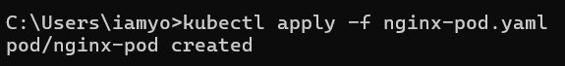



To describe the Pod and see detailed information: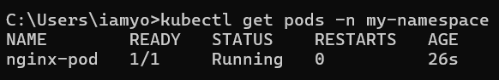



Create a Service in the Namespace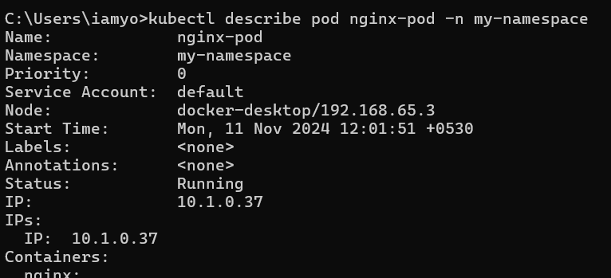

Create a YAML file named nginx-service.yaml with the following content:



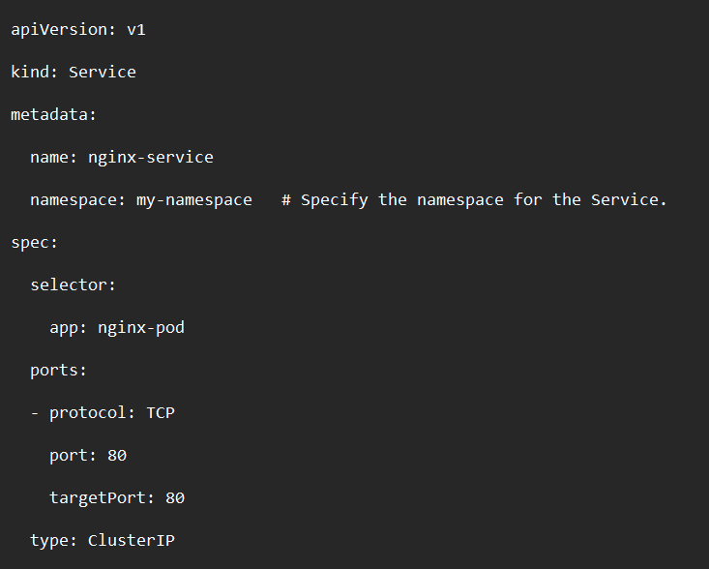

Apply this YAML to create the Service:



Check the status of the Service within the namespace: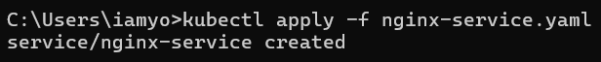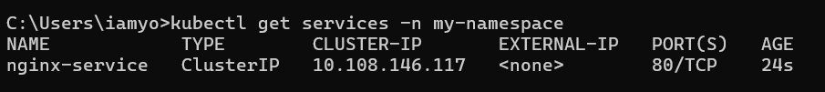



To describe the Service and see detailed information:

# Step 5: Switching Context Between Namespaces

When working with multiple namespaces, you can specify the namespace in kubectl commands or switch the default context.

# Specify Namespace in Commands

You can specify the namespace directly in kubectl commands using the -n or --namespace flag:



# Set Default Namespace for kubectl Commands

To avoid specifying the namespace every time, you can set the default namespace for the current context:



Verify the current context’s namespace:



# Step 6: Clean Up Resources

To delete the resources and the namespace you created:

Ensure that the namespace and all its resources are deleted: