
Project Title: Smart Life Scheduler. Batch-ID:DS20
Student Team Members:
- G.S Rohith, 2451-22-750-038
- D Saathvik, 2451-22-750-041
- N Pehlaj, 2451-22-750-044

Guide: T Laxmi, Asst Prof, Dept. of CSE, MVSREC

Problem Statement: In today’s fast-paced environment, individuals struggle to balance demanding schedules with maintaining proper health. Traditional task scheduling tools help users manage daily activities but fail to consider their physical and mental well-being. Similarly, existing health- monitoring applications operate independently, offering no connection between a user’s workload, habits, and health conditions. As a result, users lack awareness of how factors like sleep quality, stress levels, exercise patterns, and daily tasks influence one another. This leads to poor decision-making and unhealthy routines. Therefore, there is a need for an integrated system that unifies task planning, health tracking, data analysis, and automated health reporting to support balanced lifestyle management.

Project Scope:
- Build a mobile app for task scheduling and health monitoring.
- Integrate APIs like Google Fit/Apple Health for activity data.
- Use Firebase/MongoDB for data management and ML for analysis.
- Generate automated health reports with insights and trends.

Project Objectives:
- Provide an easy tool to plan daily tasks. 2.Track, sleep, exercise, stress and symptoms.
3.Analyze links between tasks and health patterns.
4.Offer personalized health reports and suggestions.

Application Areas | Challenges
- Personal Health Tracking-Helps users monitor sleep, stress and activity daily.  - Task and Routine Management-Allows users to plan and organize their daily tasks efficiently.  - Fitness Monitoring-Tracks steps, workouts and physical activity trends.  - Employee Wellness Programs-Supports companies in improving employee’s health and productivity.  - Preventive Health-Provides early insights into unhealthy patterns through reports. | - Data Integration Issues-Syncing accurate data from Google Fit/Apple Health can be complex.  - Privacy and Security Concerns-Sensitive health data must be protected with strong security.  - Limited ML Training Data-Health insights may be Less accurate with small datasets.  - User Engagement-Users may not consistently input their tasks or symptoms.  - Cross-platform Performance-Ensuring smooth functionality on both android and iOS is difficult.

Literature Survey

SL | Major Reference(s) | Finding(s)
1 | Google Fit API Documentation | Provides accurate step count, activity type and heart-rate success for integrating real time health data into mobile apps.
2 | Apple Health Kit API Documentation | Enables secure collection of sleep, heart rate and exercise metrics from IOS devices for personalized health monitoring.
3 | Firebase Fire store Documentation | Offers scalable, real-time cloud storage for user tasks, health records and reports with built in authentication and security rules.
4 | Research on Digital Wellness & Productivity Tools | Suggests that task scheduling apps reduce stress and increase productivity when combined with timely reminders and health insights.
5 | WHO Health Monitoring Guidelines | Highlights the importance of tracking the daily physical activities of an individual for early detection of lifestyle-based health records.
Comparison Table
SI no | Title | Paper/Reference | Methodology Used | Dataset Used
1. | Smart Life Scheduler: An AI-Based Personalized Daily Scheduling System. | Proposed System. | Machine Learning, Rule-Based Logic, AI Chat bot. | User schedules, personal preferences, lifestyle data.
2. | AI-Driven Task Scheduling and Productivity Optimization. | Related Work – 2022. | Machine Learning Algorithms. | User activity logs and task history.
3. | Health-Aware Lifestyle Recommendation System. | Related Work – 2021. | Data Analytics and Recommendation Models. | Health records and fitness tracking data.
4. | Automated Personal Planner Using Rule-Based Systems. | Related Work – 2020. | Rule-Based Expert System. | Static user schedule datasets.

Performance Metrics, Domain, Limitations & Future Scope Table:
Sl. No. | Performance Metrics | Domain | Limitations / Research Gaps | Future Scope
1. | Schedule accuracy, task completion rate | AI-Based Scheduling | Does not consider health parameters | Health-aware personalized scheduling
2. | User productivity improvement | Smart Lifestyle Management | Static schedules without adaptation | Dynamic rescheduling using AI
3. | Health balance, wellness score | Health Informatics | No integration with fitness apps | Integration with wearable devices
4. | User satisfaction, system adaptability | Intelligent Systems | Rule-based and non-learning systems | ML-driven adaptive life scheduling models

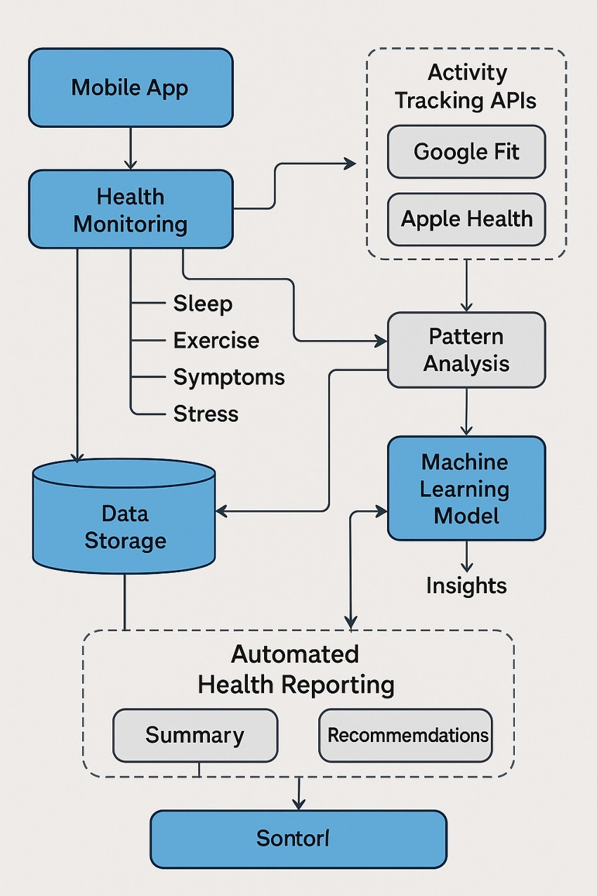
Generic Architecture of the Existing Systems:

<< Block Diagram / Flow Chart>>

Software / Hardware requirements for development / deployment

Tool / Technology | Usage
Flutter/React Native | Used to build a cross-platform mobile app with a smooth and responsive UI.
Node js/Django REST | Used to create backend API for data handling, Authentication and communication between app and database.
Firebase Fire store/MongoDB/SQL | Used to store tasks, health data, activity logs and system generated reports securely.
Python (Scikit- learn, Pandas, Numpy) | Used to perform health data analysis and run machine learning models for pattern detection and insights.
Google Fit API/Apple Health kit API | Used to fetch step count, sleep data, heart rate and physical activity directly from a user device.
Firebase Cloud Messaging/Report lab | Used for sending real time push notifications and generating downloadable Pdf health reports.
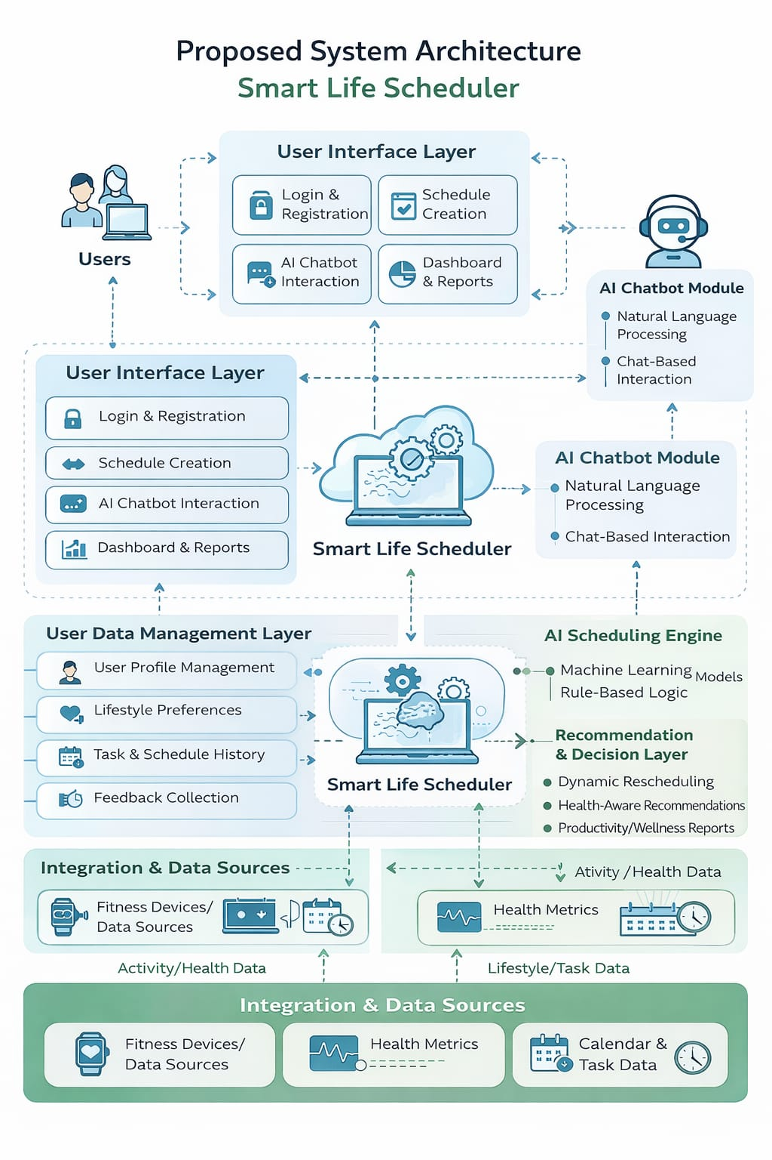
Module Description:

Name of Module | Description
User Authentication Module | Handles User Registration, Login, JWT-based authentication and secure session management using token verification and blacklist mechanism.
Task Management Module | Allows Users to create, view, update, toggle and delete tasks with full CRUD functionality.
Auto Scheduling Optimization Module | Detects scheduling conflicts between tasks. Automatically adjusts task start times to prevent overlapping and optimize time utilization.
Smart Rescheduling & Health Scoring Module | Analyzes user sleep hours, stress levels, workload, and missed tasks.  Calculates a health score and intelligently reschedules overdue tasks based on user well-being.
Analytics & Productivity Module | Computes key productivity metrics such as Total tasks, Completed tasks, Overdue tasks, Average health score. Provides insights for better decision-making.
Recommendation Engine Module | Generates personalized productivity and health recommendations.  Uses user performance data to suggest improvements and optimize daily routines.
Dashboard Visualization Module | Displays structured summaries of tasks and analytics.
Deployment & Cloud Integration Module | Deploys the backend application on Render. Integrates MongoDB Atlas for scalable cloud-based database management.
Workflow of the System:
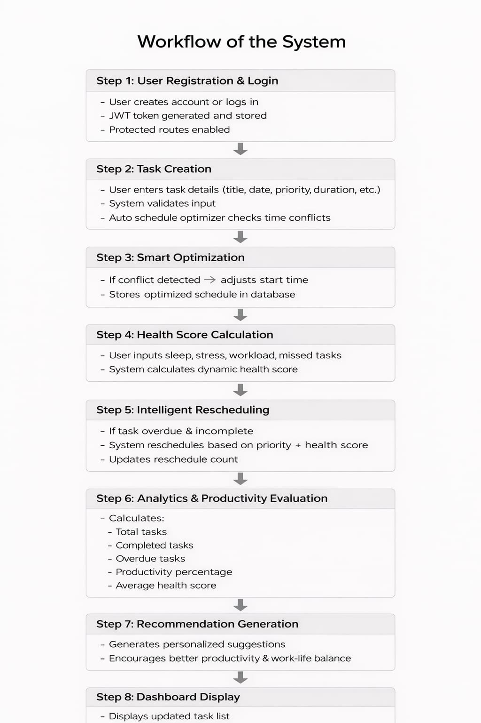
Environmental Setup:
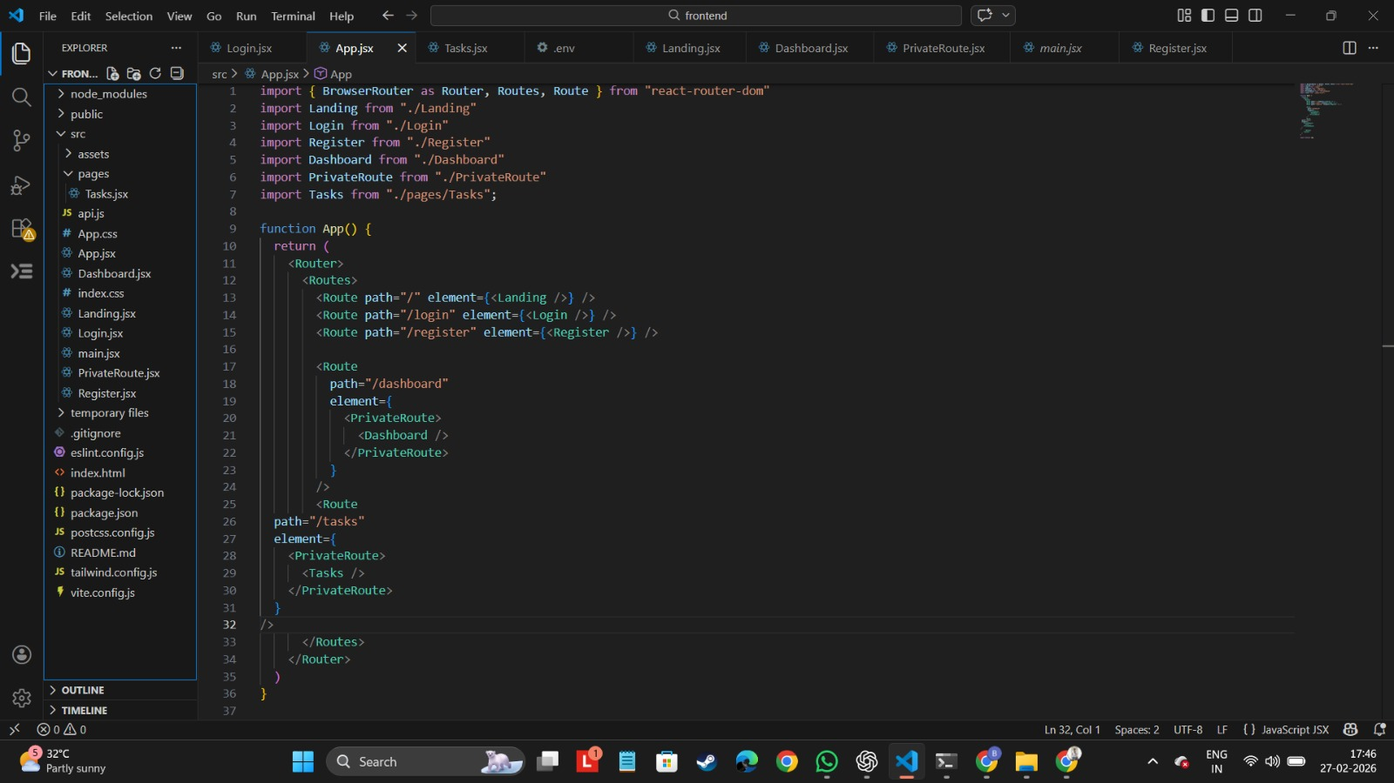
The Project is implemented using VS Code Text Editor.
Frontend: 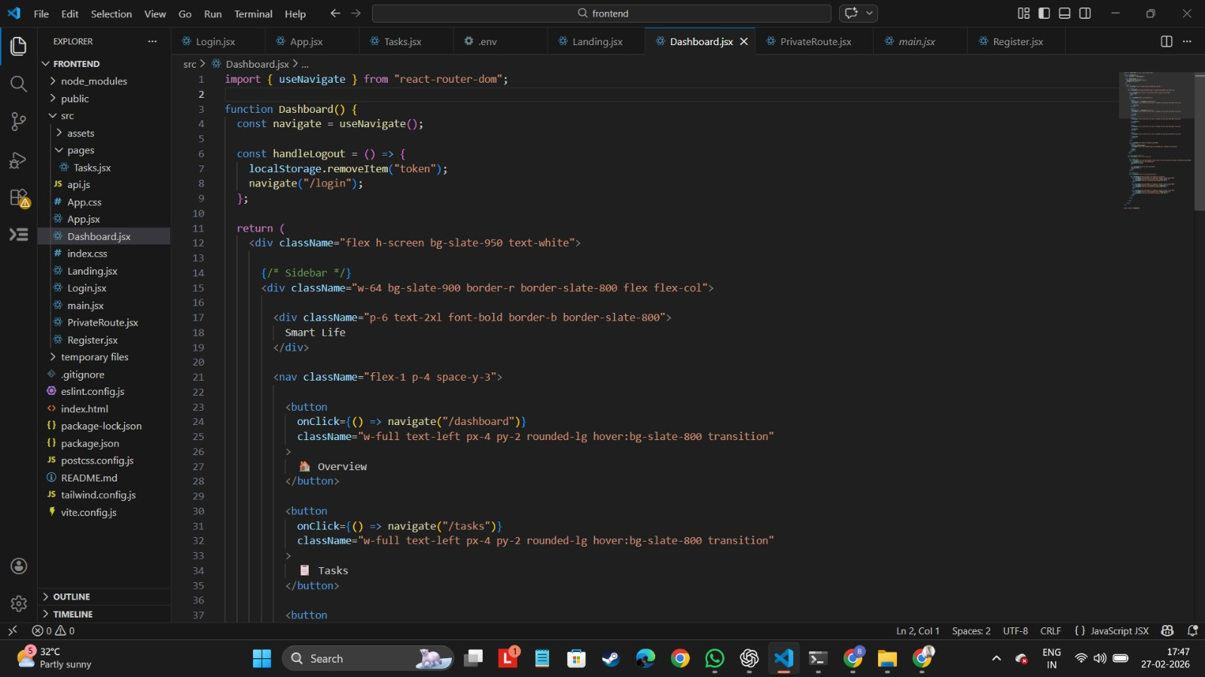
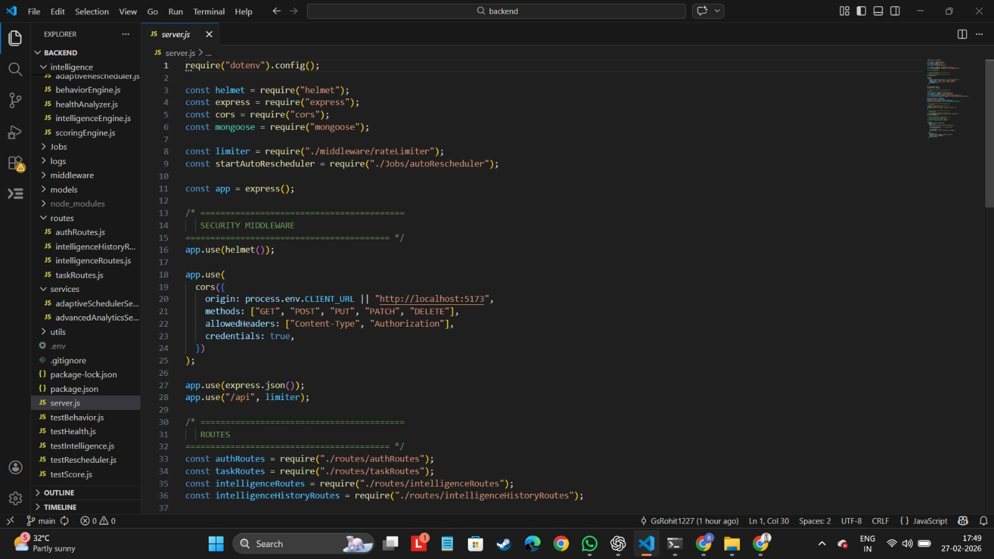

Backend:

Backend running on Server:
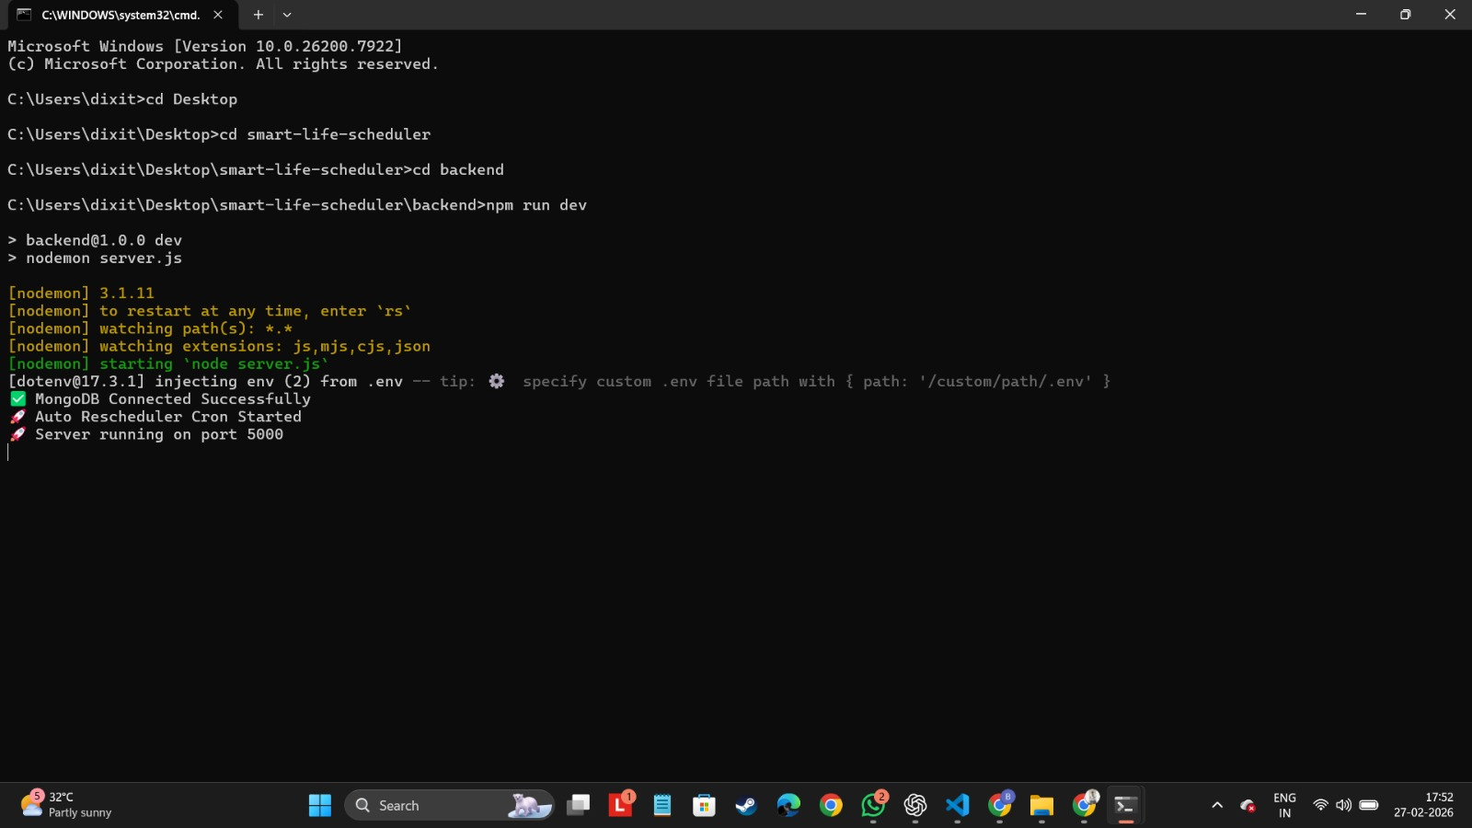

Backend deployed using render.com:
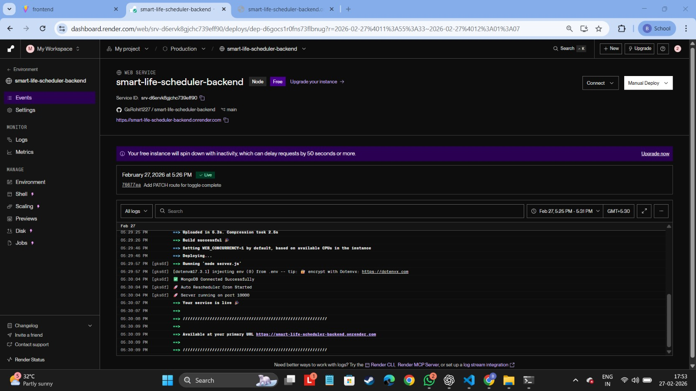

Frontend Running in local:
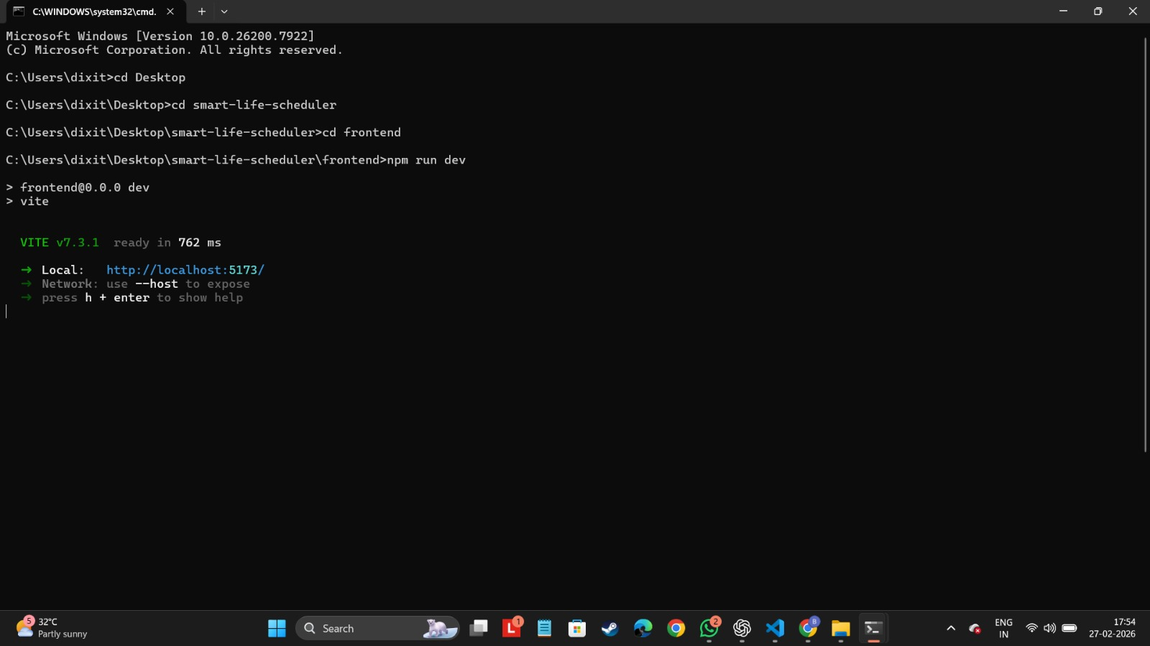

Implementation:
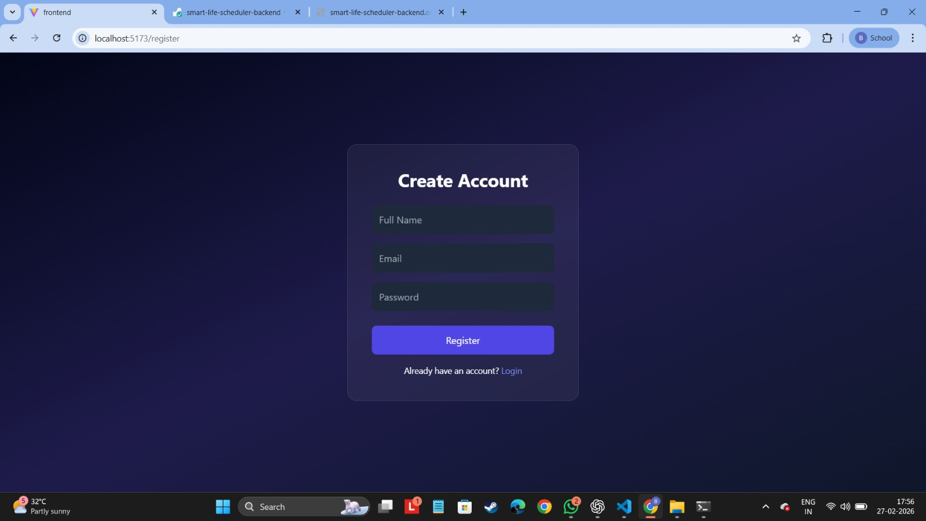

Register page:
Login page:

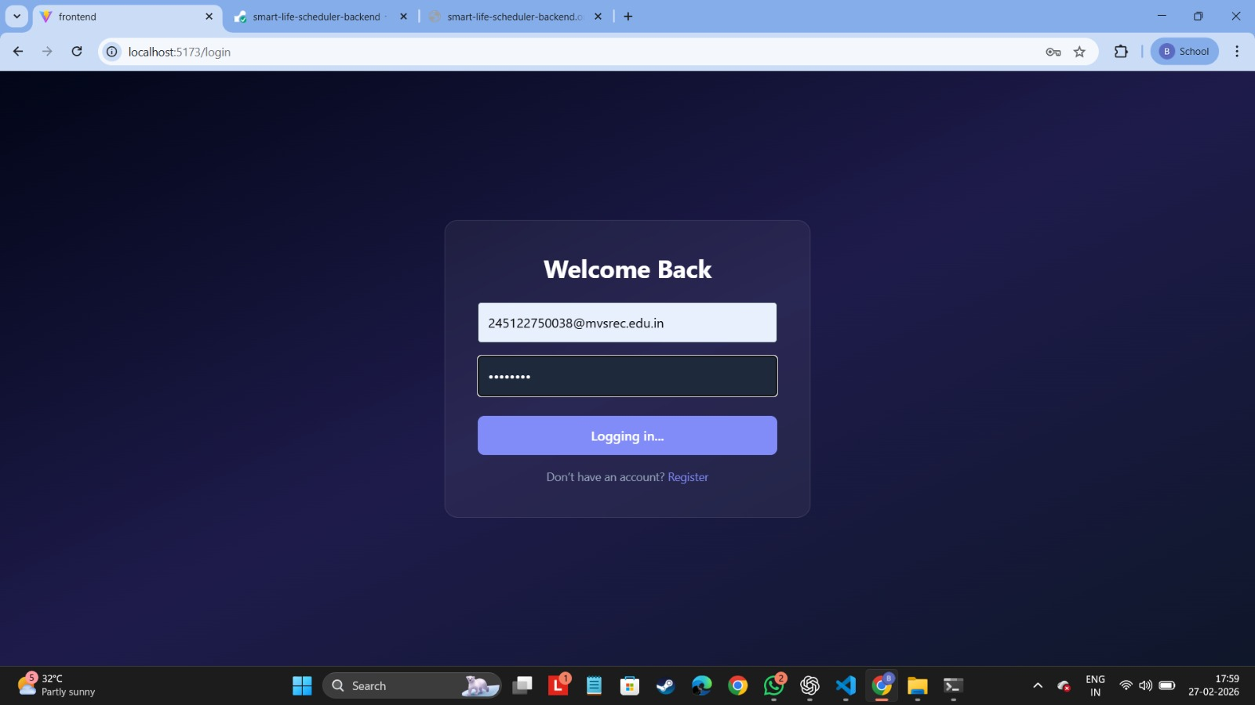

Dashboard:

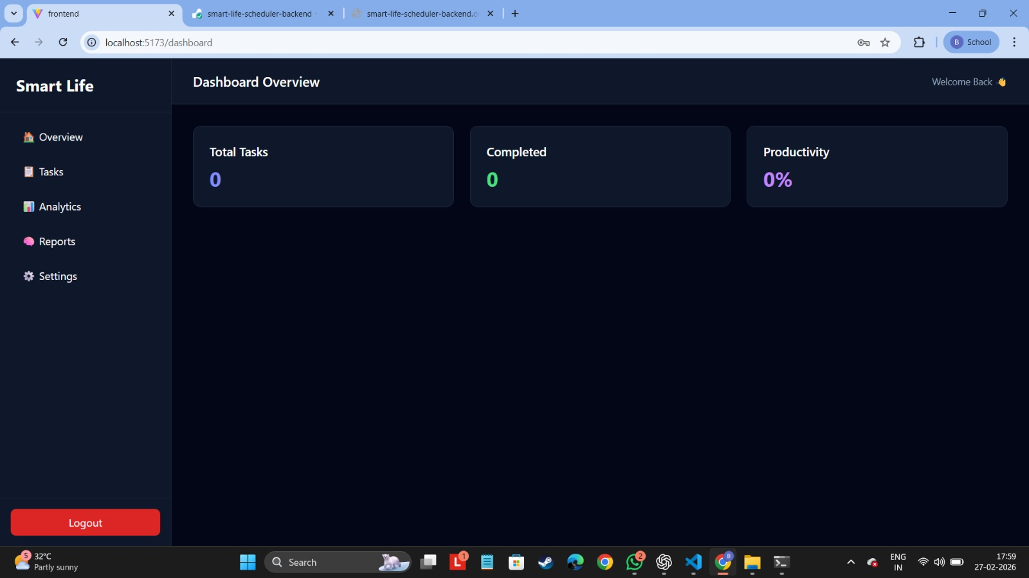

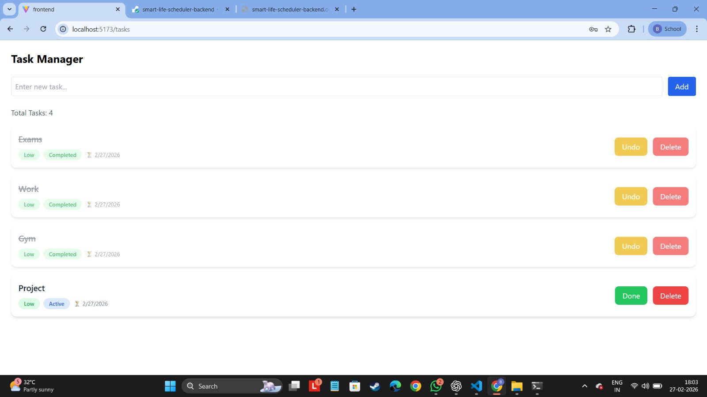

Task manager:
The image reflects completed tasks and pending tasks.

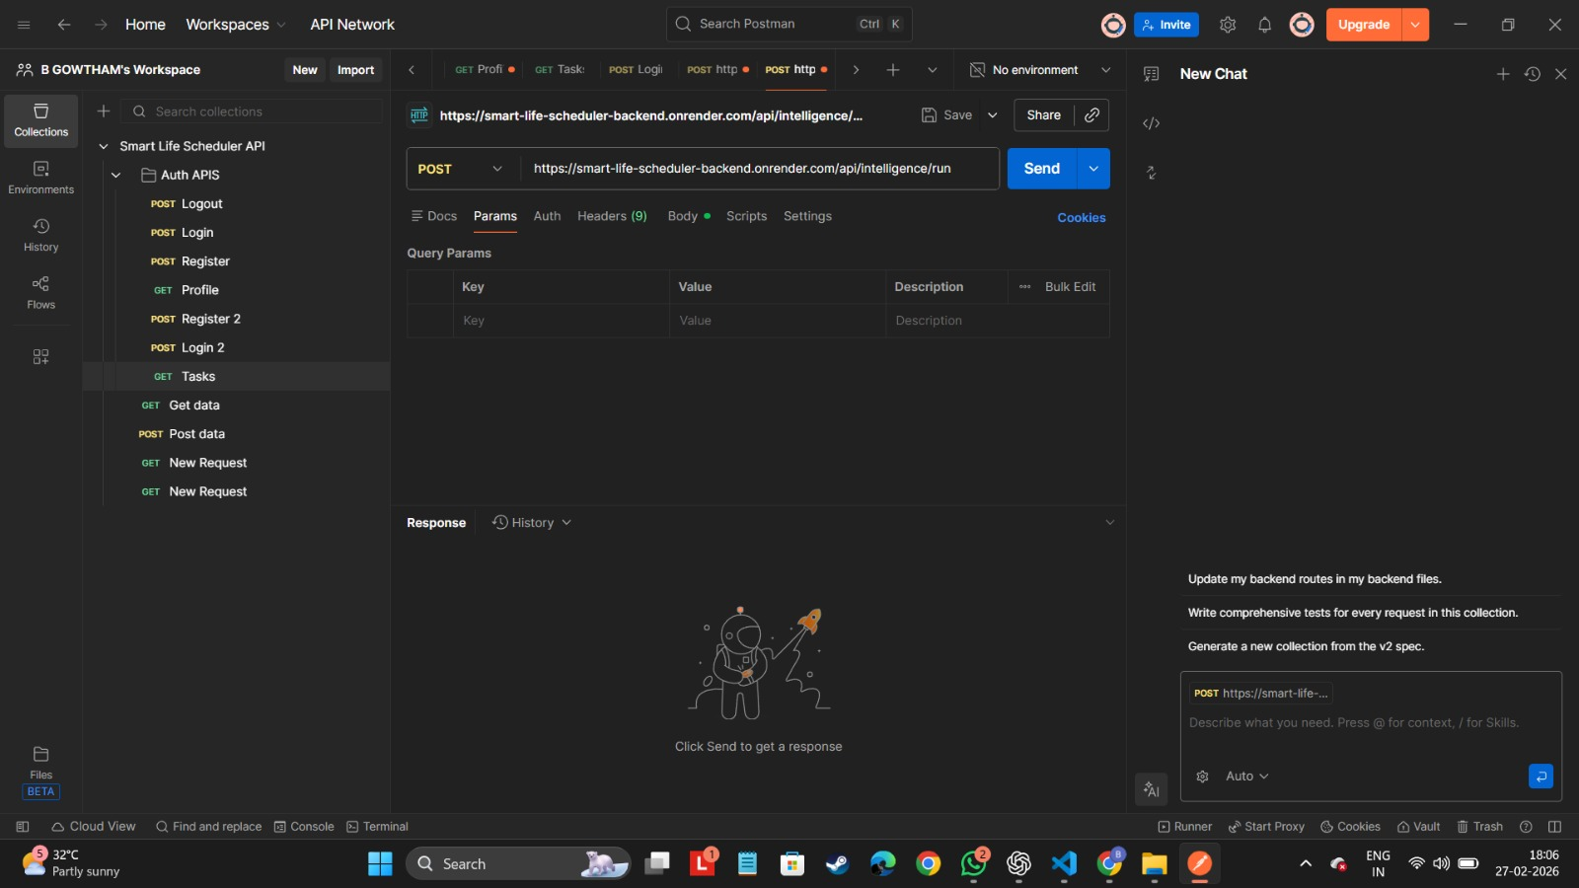

Requests are done using the postman.com.

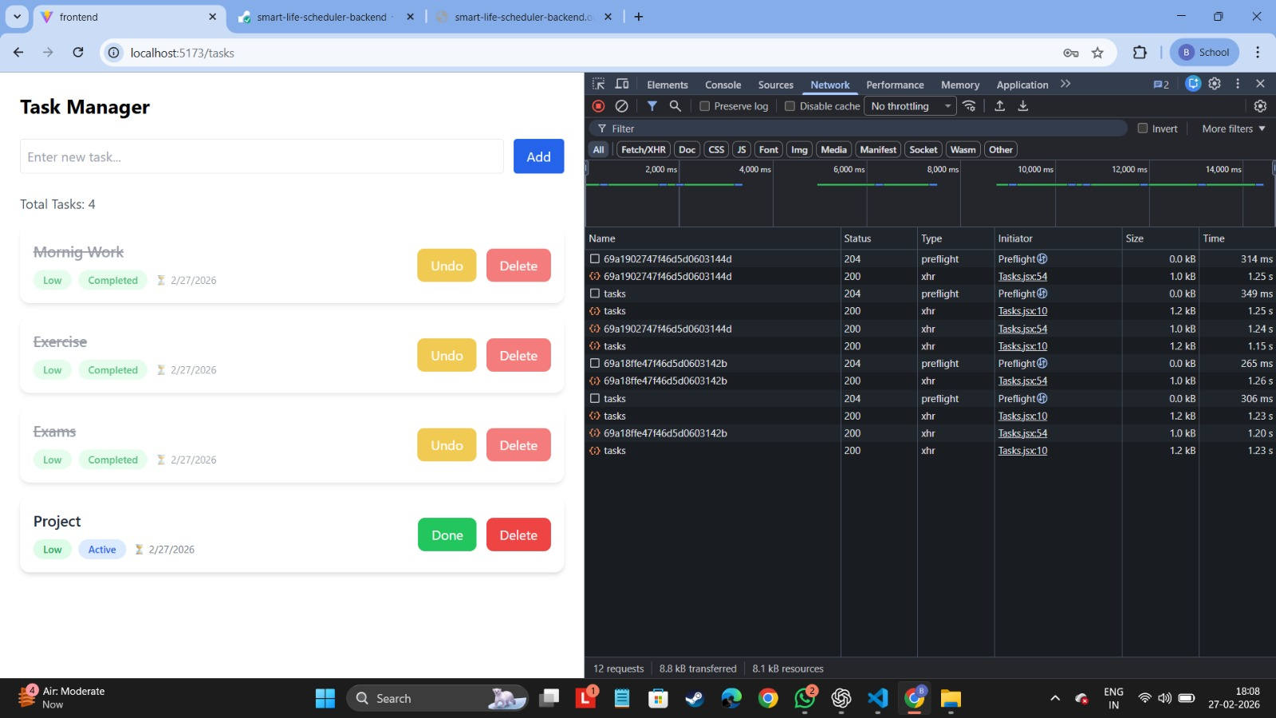

Network Status working properly in the dev tools of the browser.

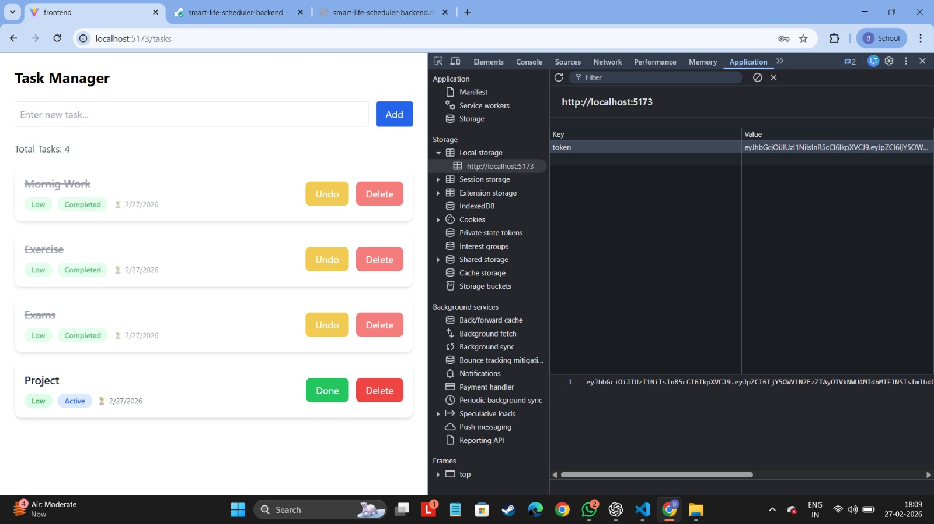

Local storage is working and generating the JWT_SECRET token.
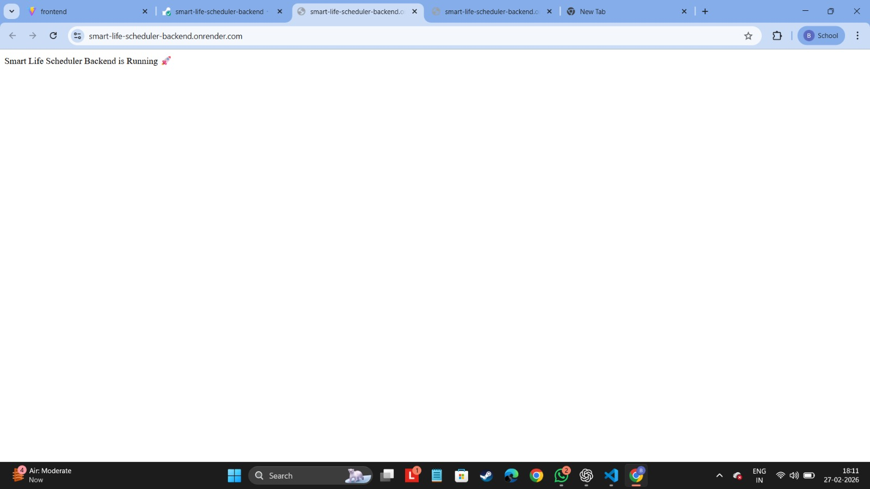

Deployed Backend link: https://smart-life-scheduler-backend.onrender.com/

Sustainability
The proposed Smart Daily Scheduler with Integrated Health Monitoring and Automated Reporting is highly sustainable across environmental, economic, and social dimensions. By replacing paper-based planners, manual health logs, and physical reports, the system significantly reduces paper consumption and minimizes the environmental footprint associated with traditional scheduling and health-tracking methods. The solution is developed using open-source and resource-efficient technologies such as Flutter/React Native, Firebase/MongoDB, and Python-based machine learning, making it cost-effective to build, deploy, and maintain over time. Its modular architecture—combining task management, health tracking, ML-driven insights, and automated reporting—ensures long- term technological sustainability and allows easy integration of new features or additional health metrics without major redesign.

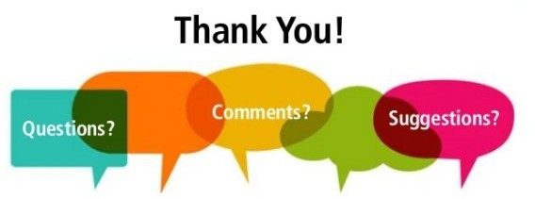
Project Title: Smart life Scheduler
Batch-ID:DS20
Student Team Members:
- G.S Rohith, 2451-22-750-038
- D Saathvik, 2451-22-750-041
- N Pehlaj, 2451-22-750-044

Guide: T Laxmi, Asst Prof, Dept. of CSE, MVSREC

