Question1:

I have made two files :

question1.asm

callCheckGreater.c

question.asm:

This file contains the assembly code for declaring a function by the name of _start, in _start I have used the registers rax and rbx to store the variables x and y

respectively (they are being input from callCheckGreater.c).

Afterinf storing the values in rax and rbx, I have used JMP tp unconditionally jump to the checkGreater function where i have used the CMP instruction to compare

x and y, if x is less than or equal to y then i jump to another function called lesser which prints the string "0" and returns. If the x is not less than or equal to

y then I have printed the string "1" and returned.

callCheckGreater.c:

In this file I have firstly given the function prototype for the checkGreater function, so that it is unresolved till the linking phase and then it is resolved in the

linking phase and it can be called. Inside the main i have used scanf to get two inputs from the user and then called the checkGreater function.

This theoretically looks fine, but when linked then we get this error

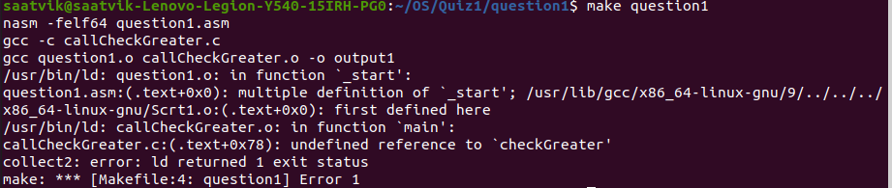

Which clearly tells us that our hypothesis is correct and a program can have only entry point.

This error occurs because the .c file when compiled it has an instruction **.cfi_startproc** which defines the entry point1 in the .s file. In the .asm that we have written on our own has a _start label which provides a second entry point and thus we get this error of multiple definition _start

